Assignment 5
Seth Ahrenbach

Objective: The objective of this assignment is to estimate the 3D position of a target by filtering a sequence of 1D and 2D sensor observations from a given text file.

Results:

1. A plot of the normalized innovations

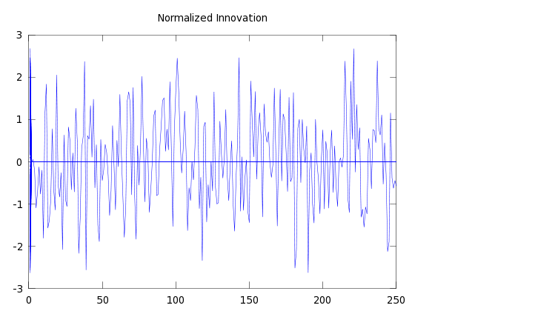

2. A plot of 250 calls to randn()

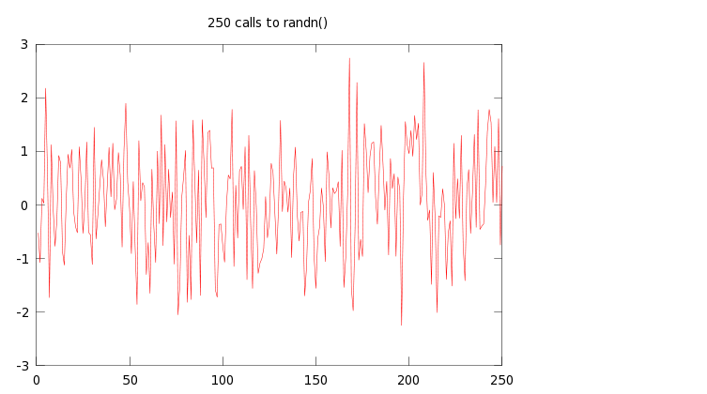
For comparison, the two plots overlaid:
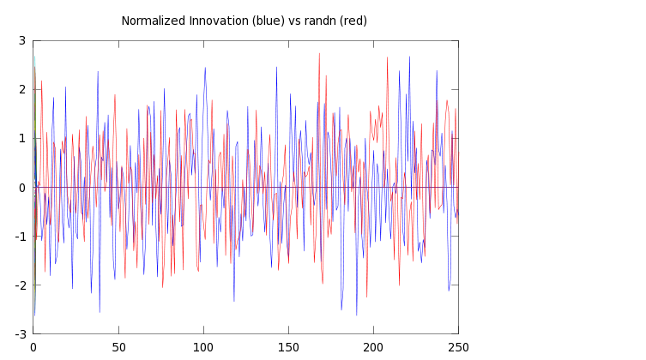

3. Final estimated 3D mean and covariance (x, P):

x = [6.0941
27.9668
495.9665 ]

P = [ .0077945 .00021782 .00025795
.00021782 .0079013 .00010709
,00025795 .00010709 .0078352 ]

APPENDIX

# Assignment 5: Estimate the 3D position of a target by filtering sequence of 1D and 2D sensor
# observations.
# Seth Kurtenbach

data = dlmread('A5-MeasurementData.txt', ' ');
function [z R H] = getObservation(file,n,k)
if (n == 1)
z = [file(k+1)];
R = [file(k+2)];
H = [file(k+3),file(k+4),file(k+5)];
else
z = [file(k+1);file(k+2)];
R = [file(k+3),file(k+4);file(k+4),file(k+5)];
H = [file(k+6),file(k+7),file(k+8);file(k+9),file(k+10),file(k+11)];
endif
endfunction

function [x P v] = update(x, P, z, R, H)
S = (H*P*H') + R;
W = (P*H'*inv(S));
v = inv((S^(.5)))*[z - (H*x)];
P = P - W*S*W';
x = x + W*(z-(H*x));
endfunction

x = [0;0;0];
P = [10^10,0,0;
0,10^10,0;
0,0,10^10];
i = 1; j = 1; k = 1;
while (i <= length(data))
if ((data(i)==1) | (data(i)==2))
[z R H] = getObservation(data,data(i),i);
[x P v] = update(x,P,z,R,H);
if (columns(v)==1)
vs(1,k) = v(1,1);
k = k+1;
else
vs(1,k) = v(1,1);
vs(1,k+1)=v(1,2);
k = k +2;
endif
j=j+1;
endif
i = i + 6;
endwhile

