Assignment 6: Move the Rover
Seth Ahrenbach

Objective: The objective of this assignment is to implement procedures that maintain an estimate of a rover's 2D position as it moves around.

Deliverables:

1. A single plot of the normalized innovations. Note that some elements are scalars and others are two dimensional vectors. Scalars are plotted with a black line, and the 2D vectors are plotted with blue and red lines.

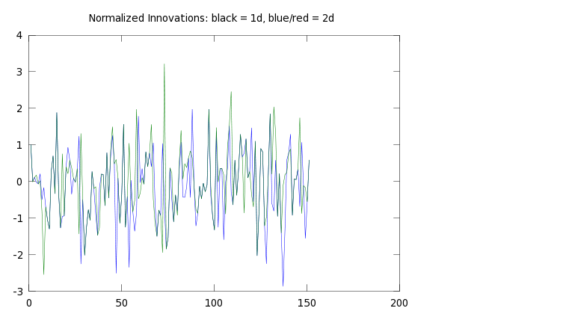

2. A single plot of the square root of the trace of the rover covariance matrix.

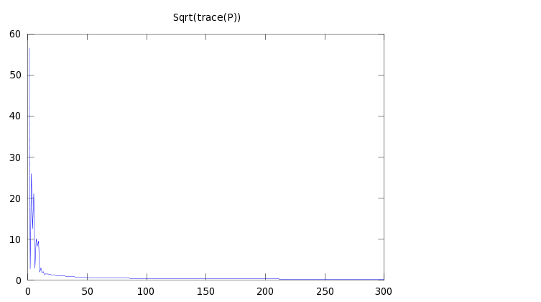
3. Plots showing rover's path, at various levels of zoom:

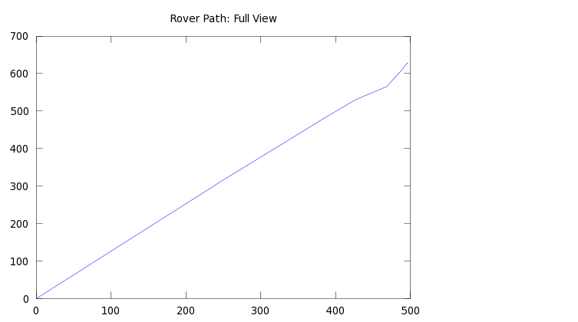

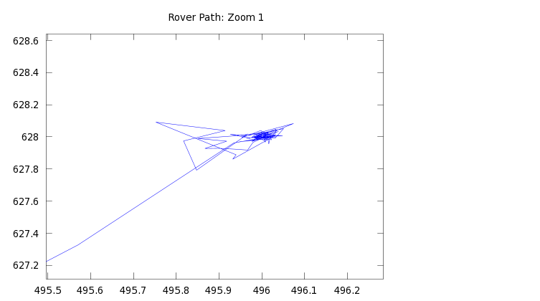
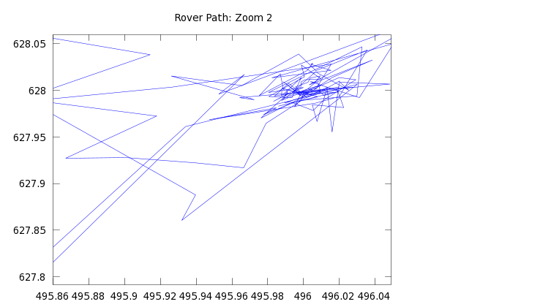

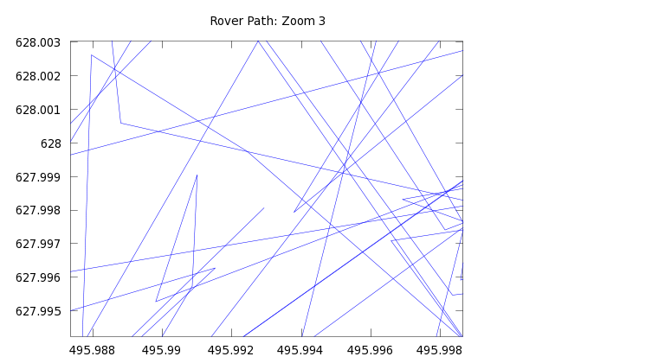

4. Percentage of observations with innovation size <= 1: 64.6667%

5. Final position estimate x and standard deviation of error on each coordinate:
x = [496.001211
628.004994 ]
sig1 = 0.158488
sig2 = 0.157854

Appendix:

# Assignment 6: Maintain an estimate of the Rover's state as it traverses a 2D environment.
# Seth Kurtenbach

data = textread('RoverData2.txt');

x = [0;
0];
P = sqrtm([0.00000000000000000001,0;
0,0.00000000000000000001]);

function [u U] = command(data, i)
u = [data(i+1);data(i+2)];
R1 = [data(i+3), data(i+4); data(i+4), data(i+5)];
U = R1 * R1';
endfunction

function [x P v] = moveRover(x, P, u, U)
x = x + u;
P = P + U;
v = u - x;
endfunction

function [z R H] = getObservation(file, n)
if (file(n) == 1)
z = [file(n+1)];
R = [file(n+2)] * [file(n+2)]';
H = [file(n+3),file(n+4)];
else
z = [file(n+1);file(n+2)];
R1 = [file(n+3),file(n+4);file(n+4),file(n+5)];
R = R1 * R1';
H = [file(n+6),file(n+7);file(n+8),file(n+9)];
endif
endfunction

function [x P v1 vSize] = update(x, P, z, R, H)
S = (H*P*H') + R;
W = (P*H'*inv(S));
v = [z - (H*x)];
v1 = (S^(-0.5))*[z - (H*x)];
vSize = v'*inv(S)*v;
P = P - W*S*W';
x = x + W*(z-(H*x));
endfunction

j = 1;
i = 1;
k = 1;
pos1(1,1) = 0;
pos2(1,1) = 0;
while (i <= 1960)
if (data(i) == 0)
[u U] = command(data,i);
[x P v] = moveRover(x, P, u, U);
pos(j,1:2) = x;
traces(j) = sqrt(trace(P));
j = j + 1;
i = i + 6;
elseif (data(i) == 1)
[z R H] = getObservation(data, i);
[x P v1 vSize] = update(x, P, z, R, H);
i = i + 5;
vs(j,1:2) = [v1,v1];
traces(j) = sqrt(trace(P));
if (vSize <= 1)
sizes(k) = 1;
else
sizes(k) = 0;
endif
j = j + 1;
k = k + 1;
else
[z R H] = getObservation(data, i);
[x P v1 vSize] = update(x, P, z, R, H);
i = i + 10;
vs(j,1:2) = [v1(1,1),v1(2,1)];
if ((vSize/2) <= 1)
sizes(k) = 1;
else
sizes(k) = 0;
endif
traces(j) = sqrt(trace(P));
j = j + 1;
k = k + 1;
endif
endwhile
sigmas = sqrt(diag(P));
printf("x = %f %f\n",x(1,1),x(2,1));
printf("sigx = %f\nsigy = %f\n", sigmas(1,1), sigmas(2,1));
for i = 2 : length(pos)
pos1(i) = pos(i,1);
pos2(i) = pos(i,2);
end

obsPerc = ((sum(sizes))/(length(sizes)));
printf("Percentage of Observations <= 1: %f\n", obsPerc);

