Assignment 7
Seth Ahrenbach

Objective: The objective of this assignment is to implement the routines necessary to estimate the state of a moving target using a constant velocity model. The assignment involves applying these routines to two data sets, corresponding to two targets, Target 1 and Target 2.

Target 1
1. The state of the target at the time of the final observation is provided in two forms. First, the state variables and their associated standard deviations:

x = 245.277998, with std = .0025364
y = 510.449501, with std = .0003216
vx = 0.280005, with std = .0000069
vy = 0.6, with std = 0

Second, the full mean and covariance estimate:

([ 245.277998; 510.449501; 0.280005; 0.6],
[ 0.0000064335, -0.00000045472, 0.000000015847, -0.00000000164;
-0.000000454, 0.00000010341, -0.00000000345, -0.000000001301;
0.000000017709, -0.0000000034504, 0.000000000048, -0.0000000000081;
-0.00000000164, 0.00000000056126, -0.00000000000813, 0.0000000000011337] ). The covariance values can all be considered equal to 0, as they most likely include error accrued during computation.

2. Prediction of Target 1 an hour after time of final observation, in mean/covariance form:
[993.46; 2113.7; .28; .6], [.000438, -.000072, .00000014, -.00000002;
-.000072, .0000099, -.000000025, -.0000000043;
-.000000023, -.0000000025, -.000000000008, .000000000001]

3. Plot of the sequence of normalized x innovations:

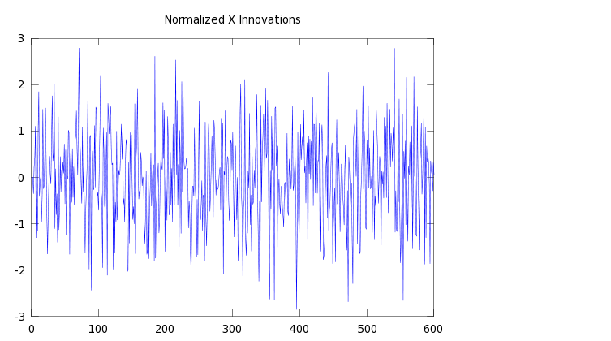

Plot of normalized y innovations:

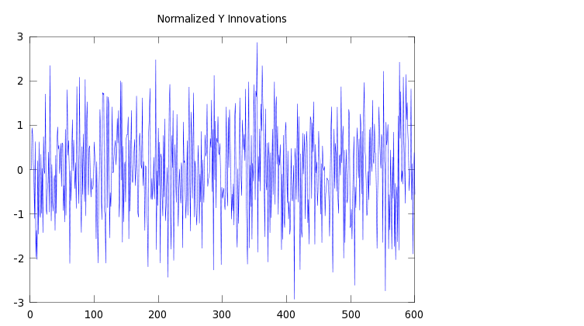
4. Percentage of x innovations less than 0: 48.5%
Plot of running x innovations % less than 0:

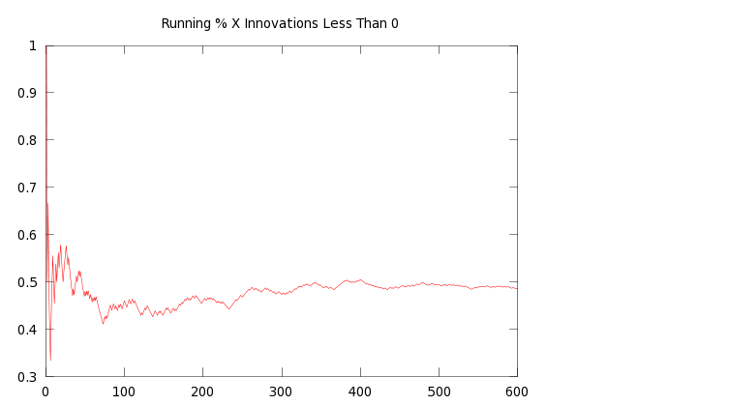
Percentage of y innovations less than 0: 49%
Plot of running y innovations % less than 0:
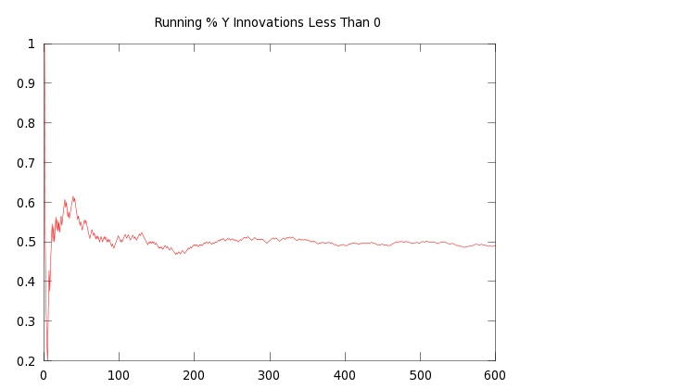

Target 2, with qconst

Chosen qconst value: 0.5

1. State of target at final observation:
x = -441.4, std = .503
y = 249.725, std = .5247
vx = -0.49, std = .01911
vy = .2773, std = .01911

([-441.4; 249.725; -0.49; .2773],
[.25309, -.01095, .000277, -.00002012;
-.01095, .275, -.0000113, .000285;
.000277, -.0000113, .000365, -.0000003;
-.00002012, .000285, -.0000003, .0003652])

2. One Hour Prediction: [-.0017586; .098541; -.49653; .27732],
[ .0025712, -2.1361, .96865, -.00078974;
-2.1361, .0025722, -.00078096, .96903;
.96865, -.00078096, .00036503, -.00000029011;
-.00078984, .96903, -.00000029011, .00036517]

3. Plot of normalized x innovations
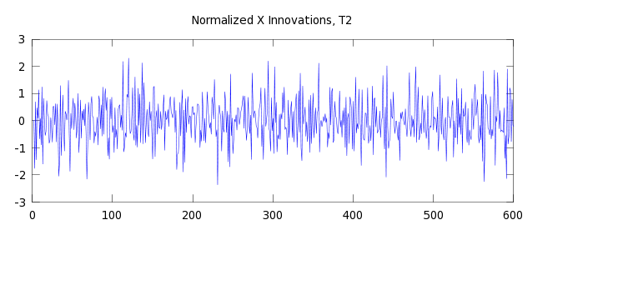

Plot of normalized y innovations:
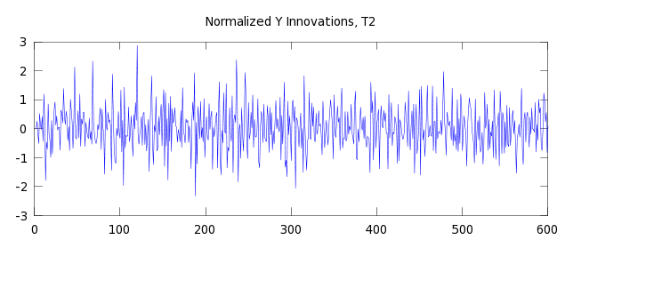
4. Percentage of x innovations less than 0 : 50%
Plot of running x innovations % less than 0:
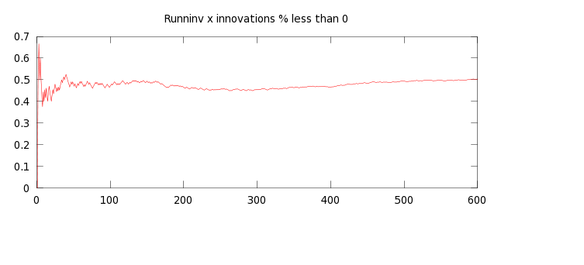
Percentage of y innovations less than 0: 49%
Plot of running y innovations % less than 0:

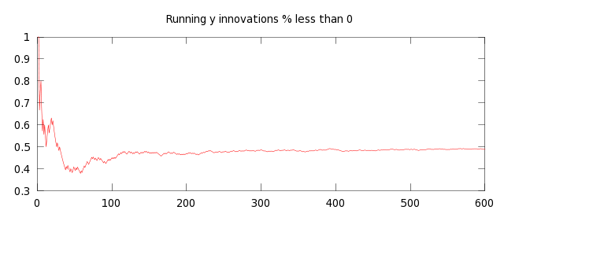
Target 2, without qconst

1. State of target at time of final observation:

x = -441.578532
y = 249.828067
vx = -.494970
vy = .279942

covariance:
[ .0013169, .000058996, .000062546, .000000094869;
.000058996, .00017696, .000000060835, .00000028643;
.0000015121, .000000060835, .000000071923, .000000000091606;
.000000094869, .00000028643, .000000000091606, .00000000055509], it is puzzling that the underlined values are different. They should be equivalent.

2. One hour prediction:

[-.001573; .099247; -.49597; .27994],
[.67742, .0011167, .00025335, .00000033789;
.0011167, .0056031, .00000030385, .000001759;
.00019231, .00000030385, .000000071923, .000000000091606;
.00000033788, .000001759, .000000000091606, .00000000055509], again the underlined values are inequivalent, when they should be equivalent.

3. Plot of normalized x innovations:

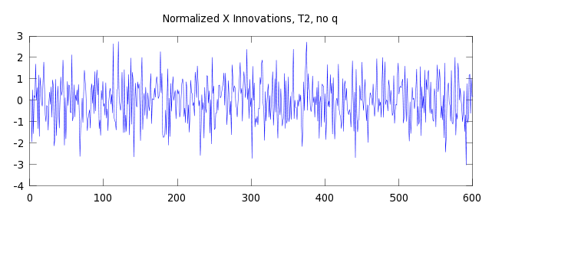
Plot of normalized y innovations:

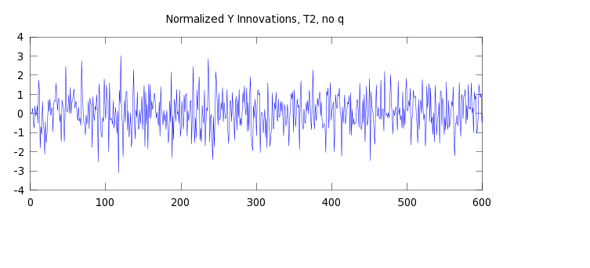
4. Percentage of x innovations less than 0: 50.833%
Plot of running x innovations % less than 0:

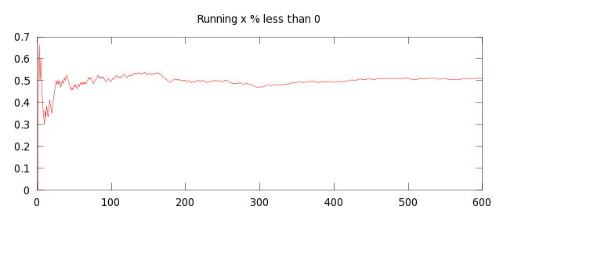
Percentage of y innovations less than 0: 48.8833%
Plot of running y innovations % less than 0:

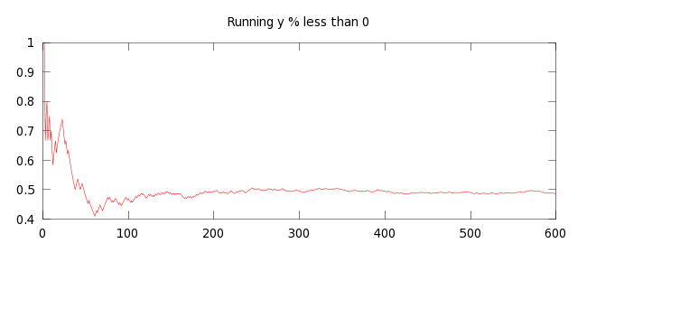

Appendix with Code

# Assignment 6: Implement routines necessary to estimate the state of a target moving with constant velocity in 2D.
# Seth Kurtenbach

data1 = textread("Target1.txt");
data2 = textread("Target2.txt");

function [x y vx vy P] = predict(dt, x, y, vx, vy, P, qconst)
F = [ 1, 0, dt, 0;
0, 1, 0, dt;
0, 0, 1, 0;
0, 0, 0, 1];
Q = qconst .* [1, 0, 0, 0;
0, 1, 0, 0;
0, 0, 0, 0;
0, 0, 0, 0];
#disp(x);
est = [x;
y;
vx;
vy];
est = F * est;
x = est(1,1);
y = est(2,1);
vx = est(3,1);
vy = est(4,1);
P = F*P*F' + Q; #When processing Target1, do not add Q.
endfunction

function [t x y R] = getObservation(data, i)
t = data(i);
x = data(i+1);
y = data(i+2);
m = [data(i+3), data(i+4); data(i+4), data(i+5)];
R = m * m';
endfunction

function [x y vx vy P v normx normy] = update(x, y, vx, vy, P, xnew, ynew, R, dt)
H = [1, 0, 0, 0;
0, 1, 0, 0];
est = [x;
y;
vx;
vy];

obs = [xnew;
ynew];
S = (H*P*H') + R;
W = (P*H'*inv(S));
v = [obs - (H*est)];
normx = v(1,1)/sqrt(S(1,1));
normy = v(2,1)/sqrt(S(2,2));
P = P - W*S*W';
est = est + W*(obs-(H*est));
x = est(1,1);
y = est(2,1);
vx = est(3,1);
vy = est(4,1);
endfunction

# Initializations
k = 1; # counts each round
i = 1; # tracks index in data
qconst = 0.5;
x = 0;
y = 0;
vx = 0;
vy = 0;
sizesx = [];
sizesy = [];
est = [x; y; vx; vy];
P = [10^10, 0, 0, 0; 0, 10^10, 0, 0; 0, 0, 10^10, 0; 0, 0, 0, 10^10];
oldt = 0;
while (i <= length(data2))
#Change data1 or data2 here for Target1 and Target2 resp. Target1 qconst = 0.
[t xnew ynew R] = getObservation(data2, i);
dt = t - oldt;
oldt = t;

[x y vx vy P] = predict(dt, x, y, vx, vy, P, qconst);
[x y vx vy P v normx normy] = update(x, y, vx, vy, P, xnew, ynew, R, dt);
xinnov(k) = v(1,1);
yinnov(k) = v(2,1);
xnorms(k) = normx;
ynorms(k) = normy;

if (v(1,1) <= 0)
sizesx(k) = 1;
else
sizesx(k) = 0;
endif

if (v(2,1) <= 0)
sizesy(k) = 1;
else
sizesy(k) = 0;
endif
runningPercX(k) = (sum(sizesx)/length(sizesx));
runningPercY(k) = (sum(sizesy)/length(sizesy));

k = k + 1;
i = i + 6;
end

xobs = (sum(sizesx)/600);
yobs = (sum(sizesy)/600);
printf("x = %f\n", x);
printf("y = %f\n", y);
printf("vx = %f\n", vx);
printf("vy = %f\n", vy);

#One Hour Prediction
[x1hr y1hr vx1hr vy1hr P1hr] = predict((3600-oldt), x, y, vx, vy, P, qconst);
OneHourEst = [x1hr; y1hr; vx1hr; vy1hr];

