SETTING UP UBUNTU VM :

Before this step I have alraedy downloaded iso for ubuntu 16.04 from site also install virtualbox :-
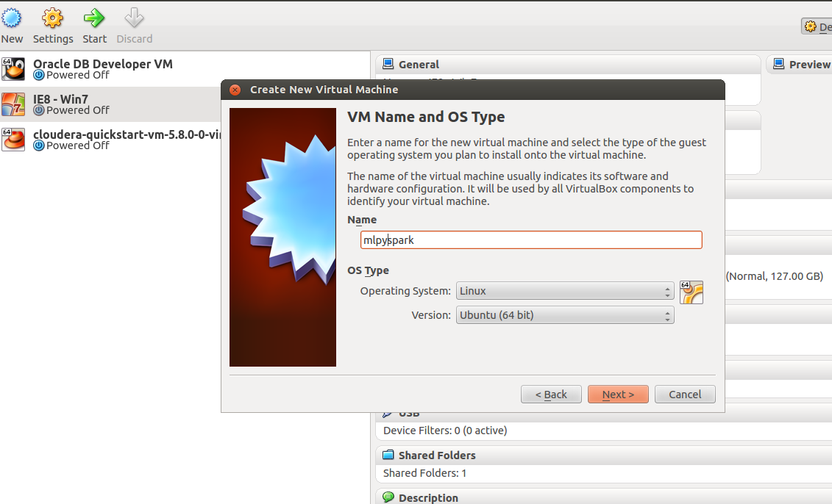
Next is below step: Click Next
Click Next, allocate 4GB Ram as shown below:
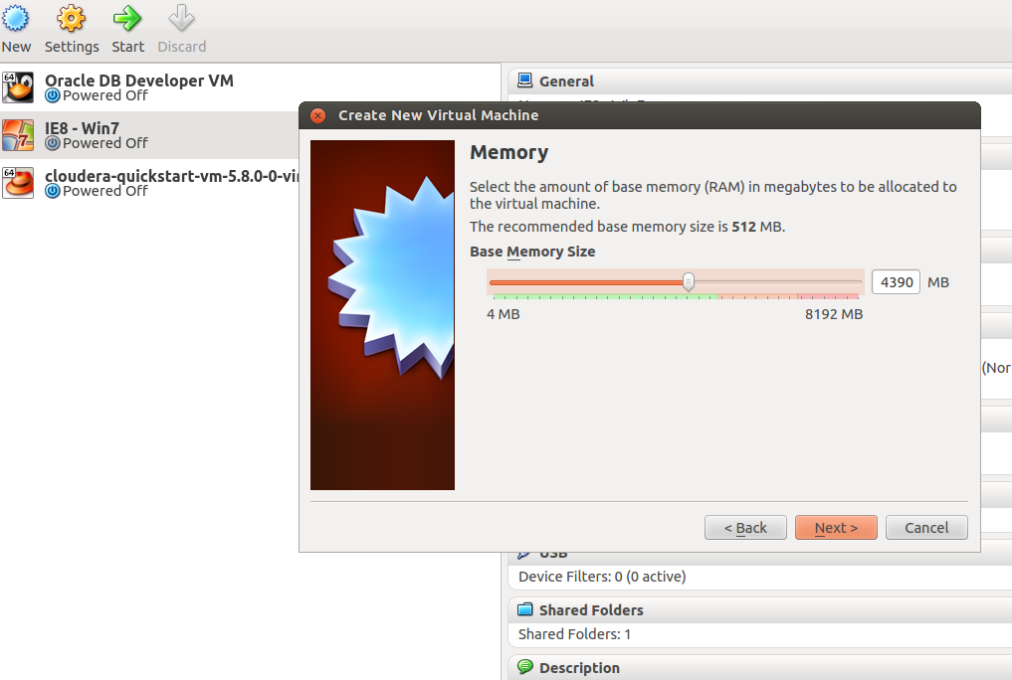
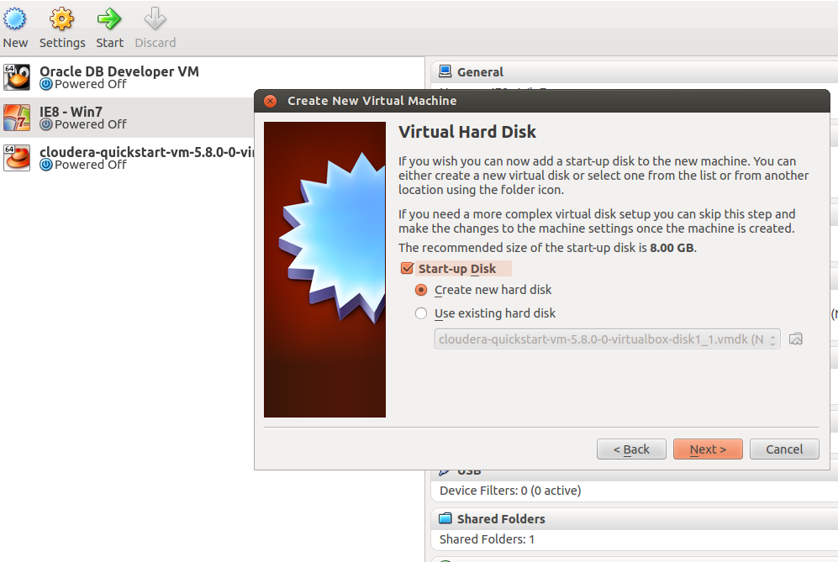

Click Next Allocate Memory 21GB
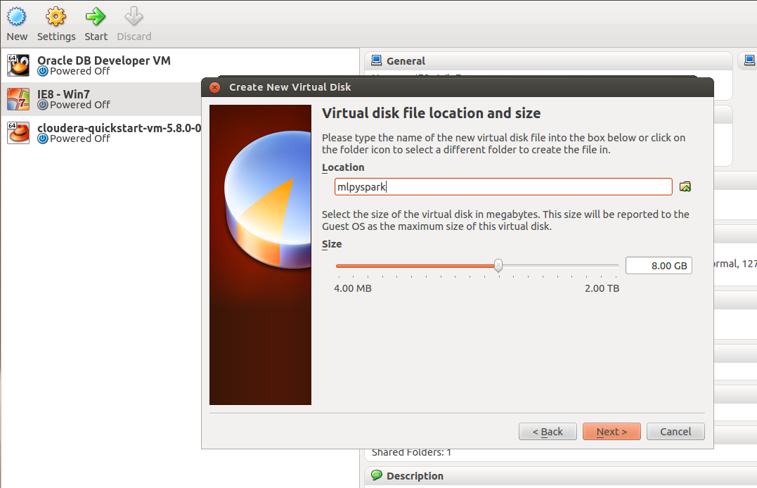

Click Next (select dynamic if not sure of storage size needed for vm)
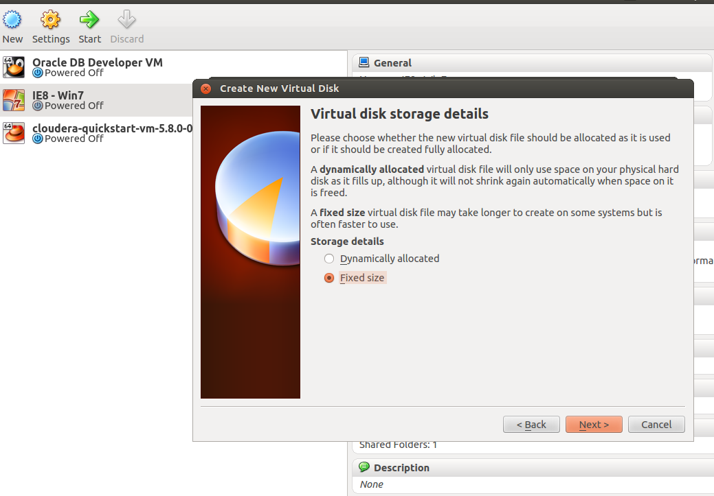

Click Next:-
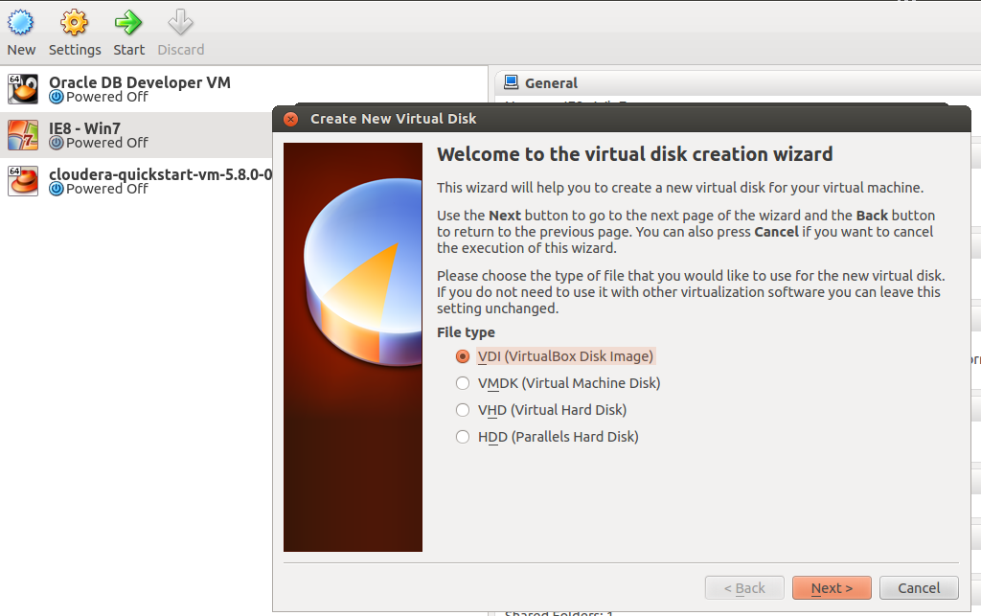

Below select path where ubuntu 16.04 is installed:-
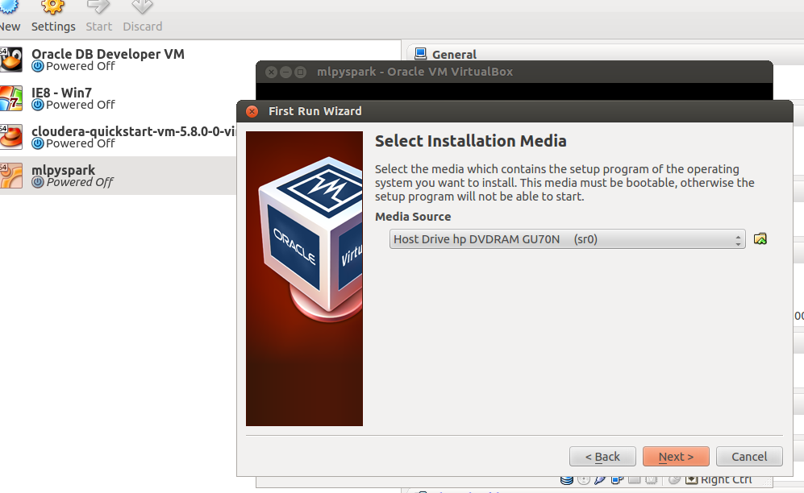

Below we select ubuntu 16.04 iso file:-
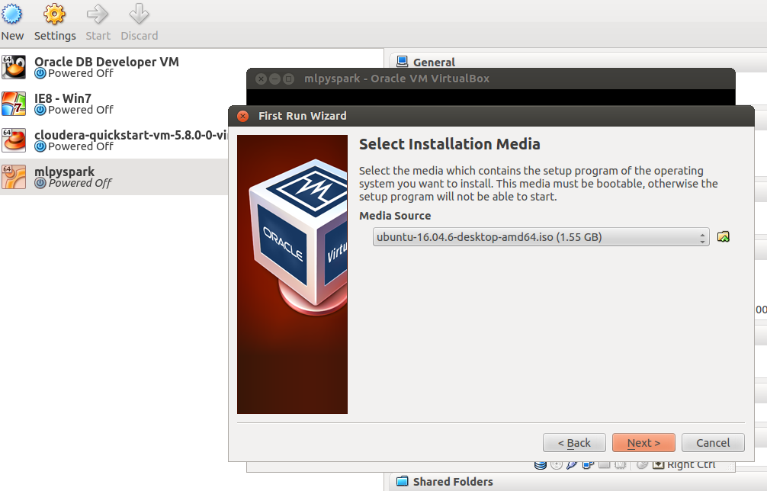

Click Start:

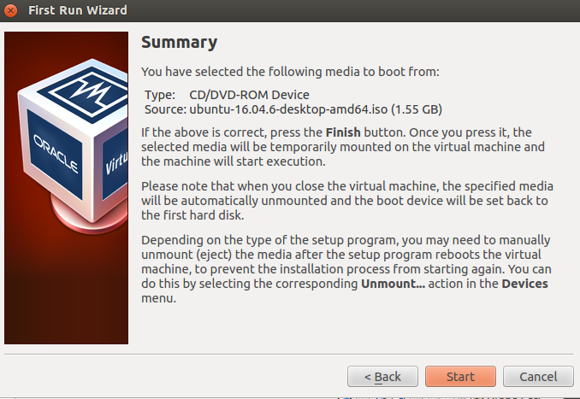

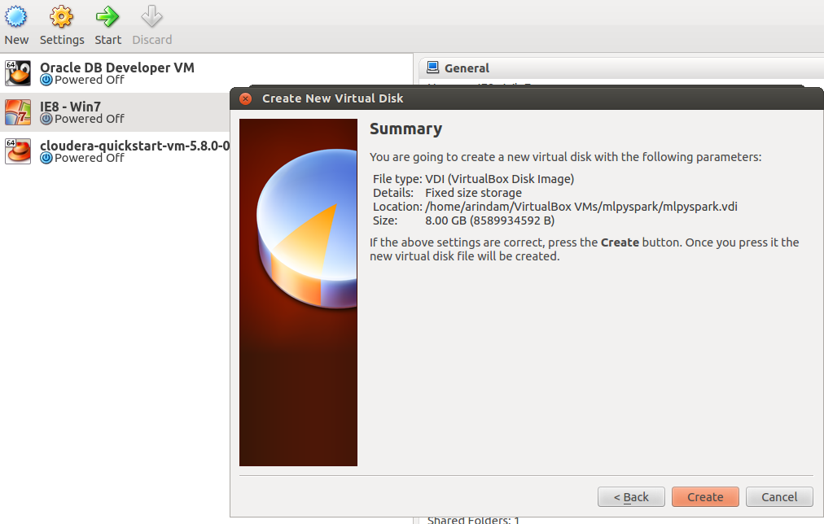

Click Create:-

Next select Install Ubuntu
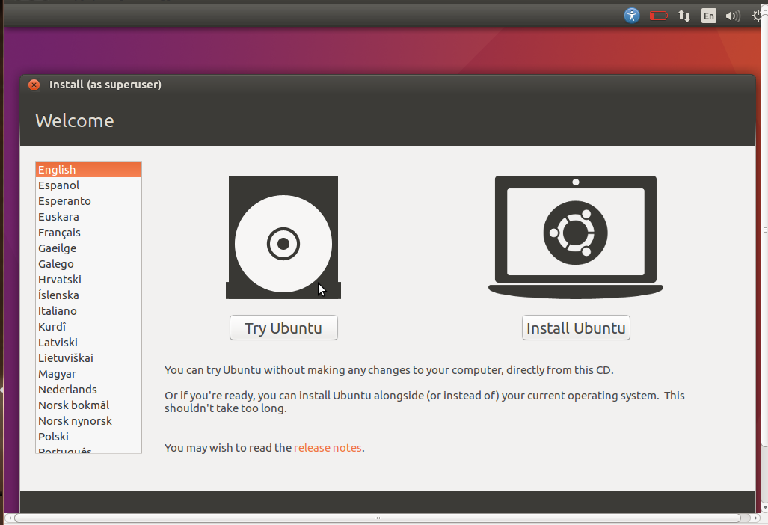
Next click Continue:-

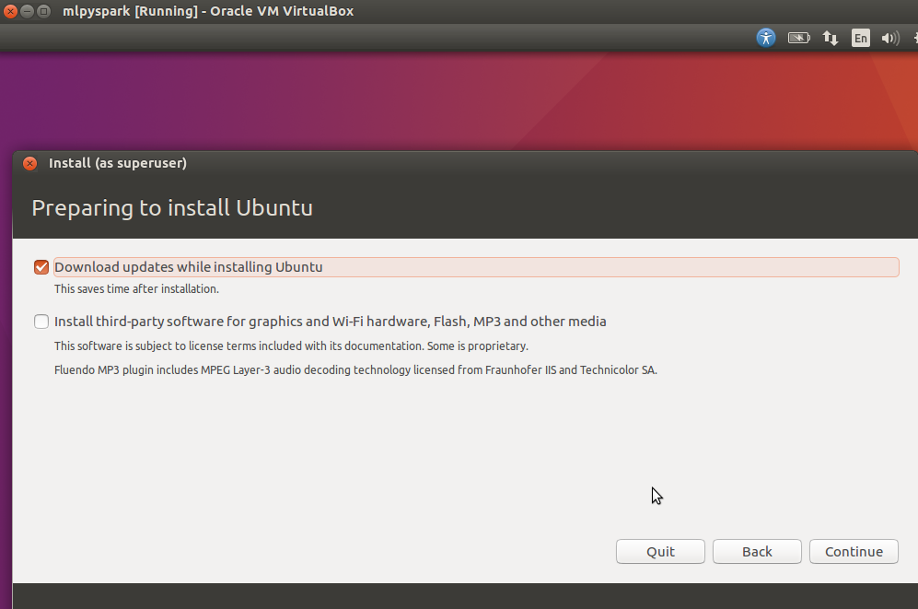

Next click “Install Now”
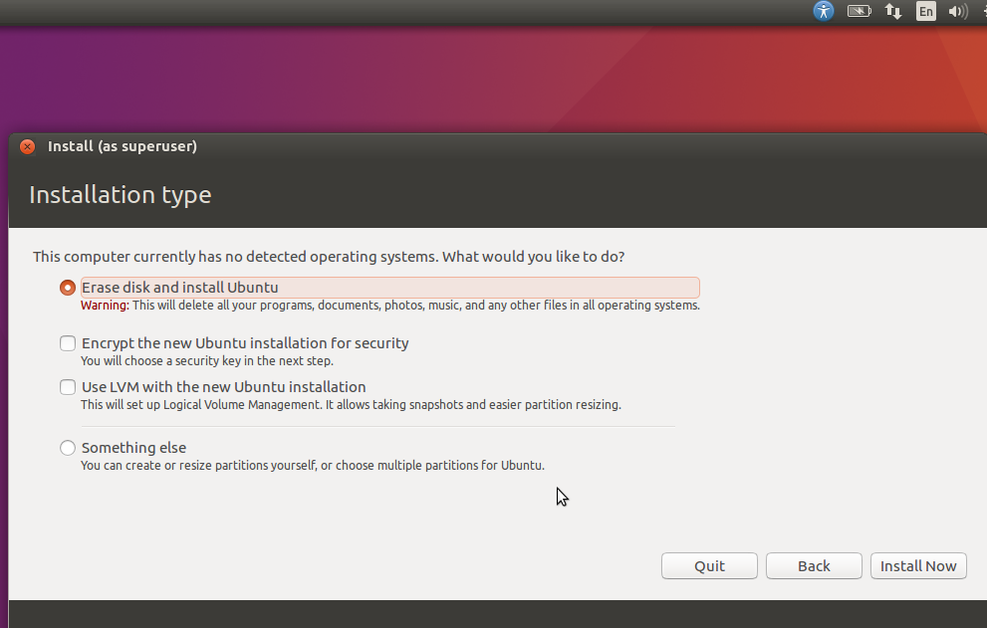
Click “Continue”
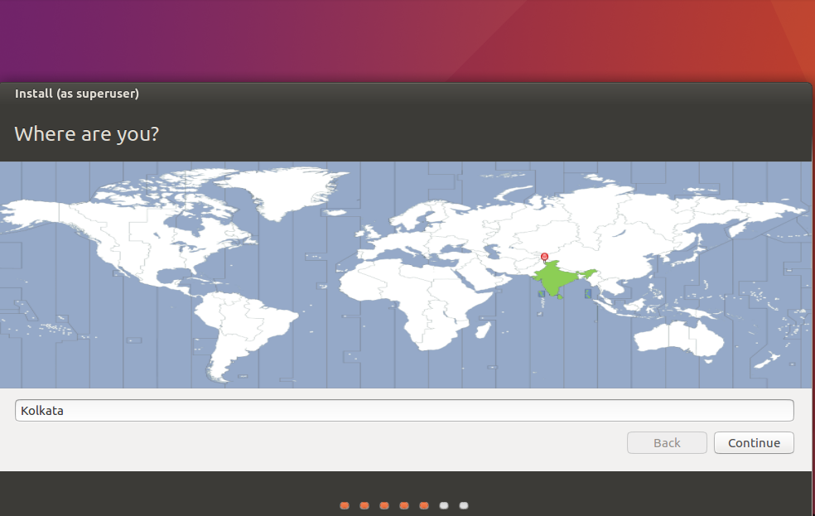

Click Continue:
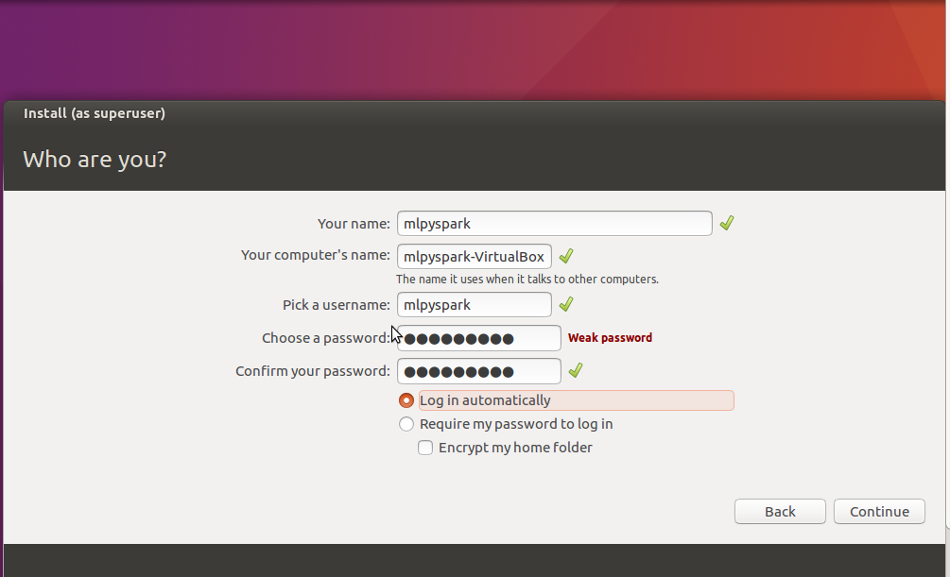
Next this screen comes:-
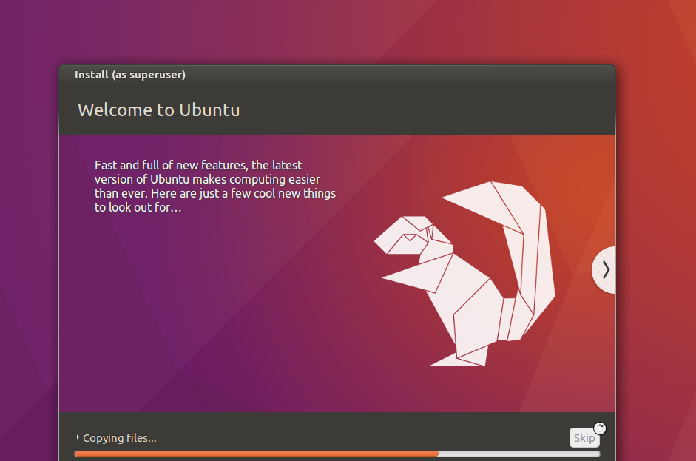

Next below screen:-
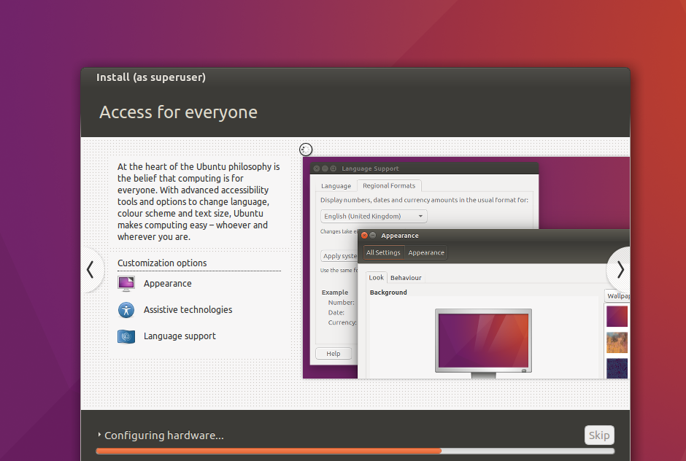
Net below screen comes:-
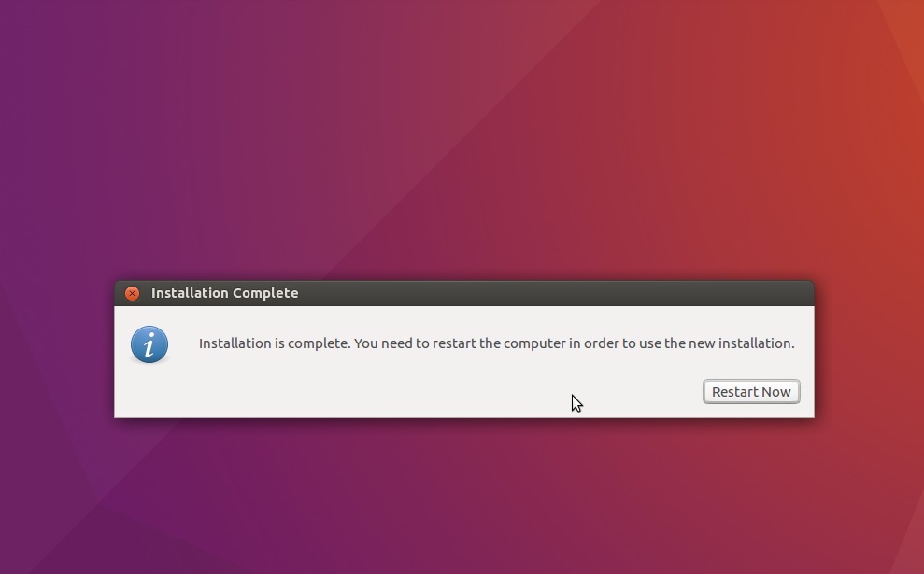

INSTALLING ANACONDA FOR PYTHON:-
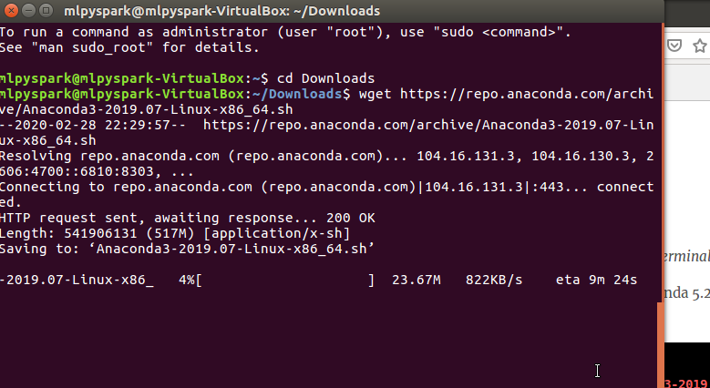
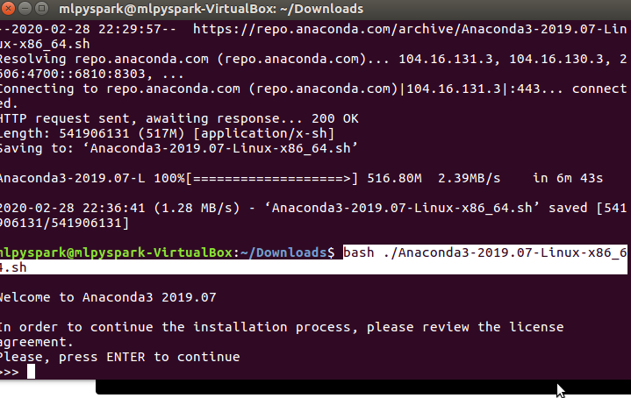
Next type below in terminal:-

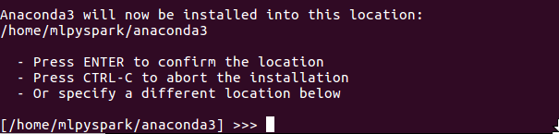
Next type below
export PATH=~/anaconda3/bin:$PATH

Next we start jupyter notebook:-
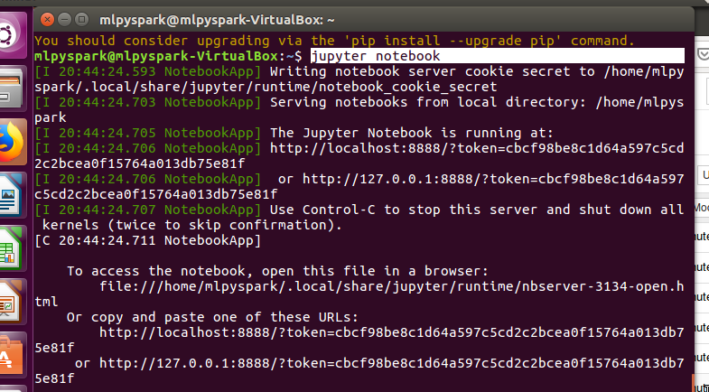
HURRAY JUPYTER NOTEBOOK STARTS:

Next we update the packages using sudo apt-get update:
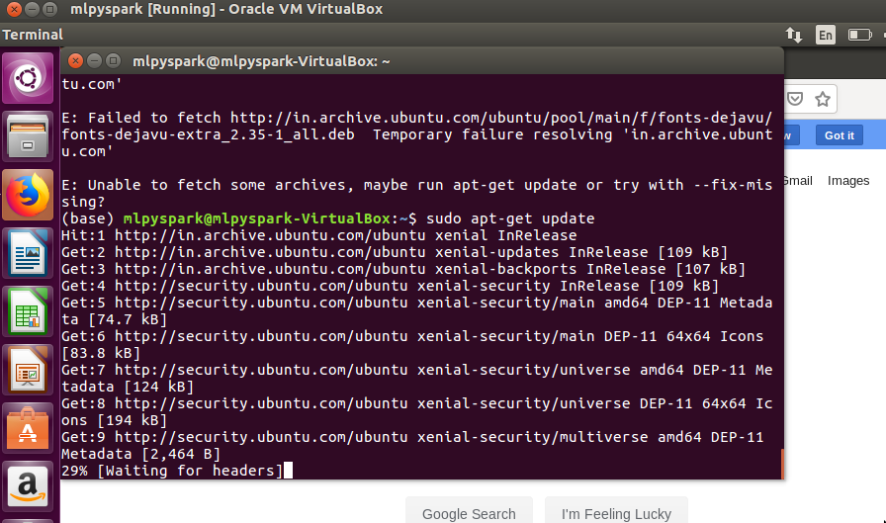

Next we install java:-
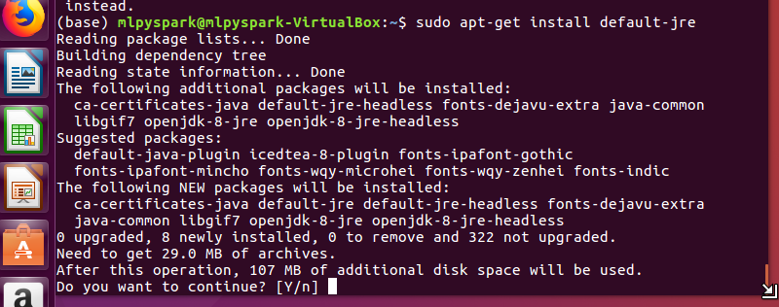
Next we install java:-

Next install scala:-

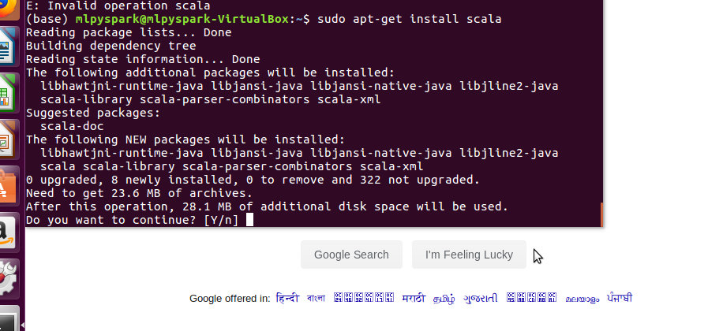
Next install p4j which will help in connecting jupyter notebook to spark:

conda install -c conda-forge py4j

Next download spark with hadoop:-
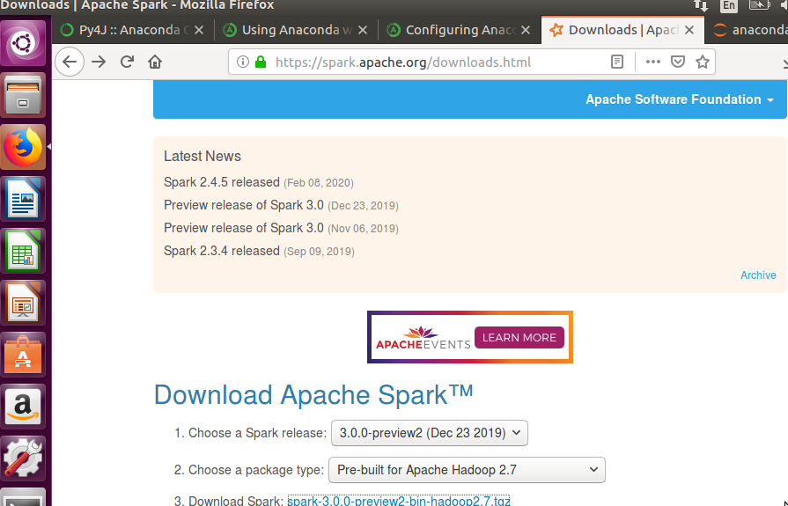

Next we unzip the tgz and keep it in Home:-
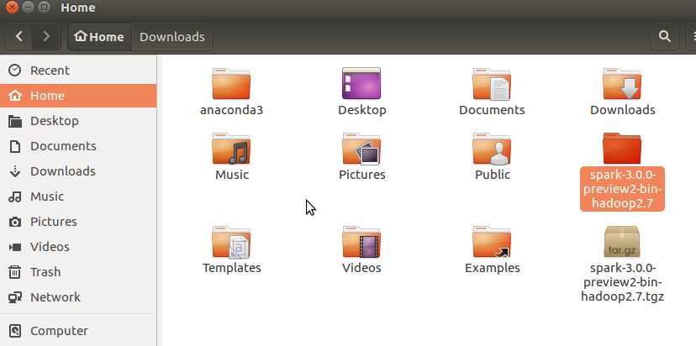
Next set all the environment variables:-
In the terminal type below:-

export SPARK_HOME='/home/mlpyspark/spark-3.0.0-preview2-bin-hadoop2.7'
export PATH=$SPARK_HOME:$PATH
export PYTHONPATH=$$SPARK_HOME/home:$PYTHONPATH
export PYSPARK_DRIVER_PYTHON="jupyter"
export PYSPARK_DRIVER_PYTHON_OPTS="notebook"
export PYSPARK_PYTHON="/home/mlpyspark/anaconda3/bin/python"
export PYLIB = “/home/mlpyspark/spark-3.0.0-preview2-bin-hadoop2.7/python/lib”

Next we also install pyspark with conda :-

conda install -c conda-forge pyspark

Now type pyspark in the terminal and the jupyter notebook opens in firefox:-

Then type below code and it gives output:-

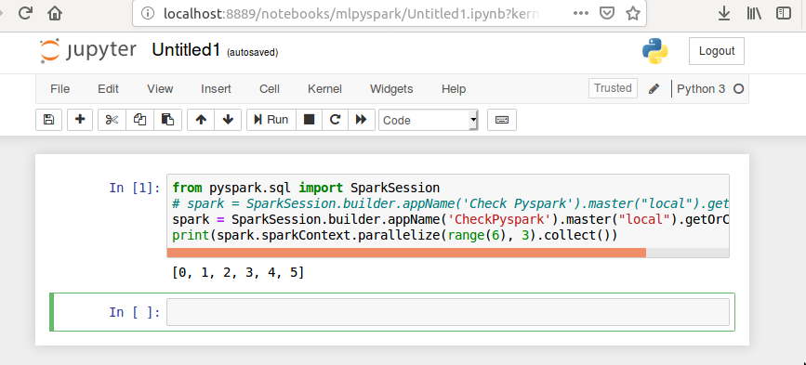
Next we check if ml is getting imported:-

