Seth Beckett

STAT 5550

**Bad Graph Proposal**

**Bad Graph:**

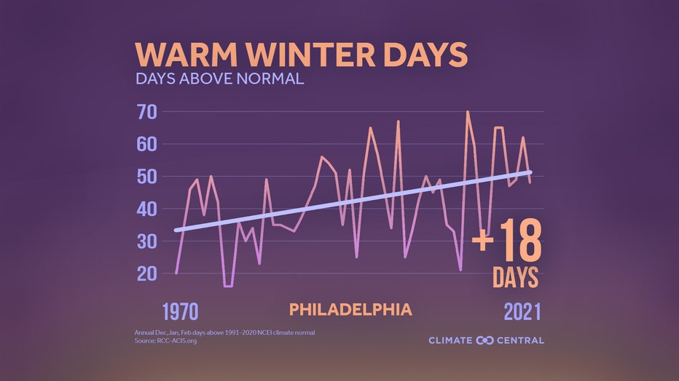

Found at <https://www.fox29.com/weather/studies-find-winter-is-fastest-warming-season-in-philadelphia-heres-why-thats-bad-news>

**Reasons Why:**

The reason that I chose this graph is because it labels ambiguously and incompletely, and also violates the ‘more is murkier’ rule. First off, the y axis isn’t clearly labeled, as the label appears as a subtitle. The x-axis only has two data points, and it’s unclear what the scale is like in between. This graph also adds a lot of info by adding what appears to be a linear regression line fitting the data, and then a big ‘+ 18 days’ towards the end of the graph.

**How to Fix:**

I will be fixing this graph by first obtaining the relevant data from the original source listed, NOAA/NCEI. I will use R to fill in the appropriate axis labels along with tick marks to clarify where the specific years are. I will also have to dig a little deeper to find out what is considered ‘normal’ in this context.