Crypto Academy
Crypto academy is an educational website that aims to educate people about cryptocurrencies and web3 technologies ranging from blockchain to defi to smart contract and investing.
Goals
- Education & awareness about cryptocurrencies
- Promote safe usage of crypto helping users avoid losing money
- Building trust in digital technologies and reduce fear of crypto and online finance
- Skill development in digital finance skills and basic investment knowledge
Target Audience
- Students (Junior school to university)
- Age:15-25
Technical aptitude
- Highest internet and computer usage group for social media such as you tube TikTok but have limited understanding of crypto.
- Most own smartphones and are heavy users also use mobile banking online services which is basic knowledge to understand crypto
  - Young Professionals (25-34)
Technical aptitude
    - Largest group of smartphone users
    - Most use mobile banking online services and have some exposure to crypto/investing
- Tech Enthusiasts/Developers (any age)
- Higher education levels
- Understand programming and blockchain basics and some may have interests web3 and smart contracts
- Rural Areas
We say in the crypto industry crypto is the bank for the unbanked

Technical aptitude
- Mostly use smartphones and free wi-fi spots in clinics and the kgotla

- Type of website
  - This is an educational website platform focused on cryptocurrency literacy providing financial information on crypto economics. It provides tutorial, information and content related to crypto.

- Information Design and Taxonomy
- Sitemap
    - Home
        - This is the first page the user interacts with when they visit the website it will contain the links to the curriculum, course quizzes, progress bar, and the feedback page.
    - Curriculum
        - This link will take the user to the curriculum page which has the learning pathways the user can take, showing beginner, intermediate and advanced learning pathways the user can select one to take and receive content a per the chosen pathways.
- Quizzes
  - This section will show quizzes to test the users progress and understanding looking at the learning pathway the user has chosen
- Progress
  - This section of the webpage will show the user how much they progressed
- Feedback
  - Feedback section will allow the user to rate the page and allow to suggest improvements to the page such as the type of information they would like to have

- Story Board flowchart
  - These is the visual representation of the site map

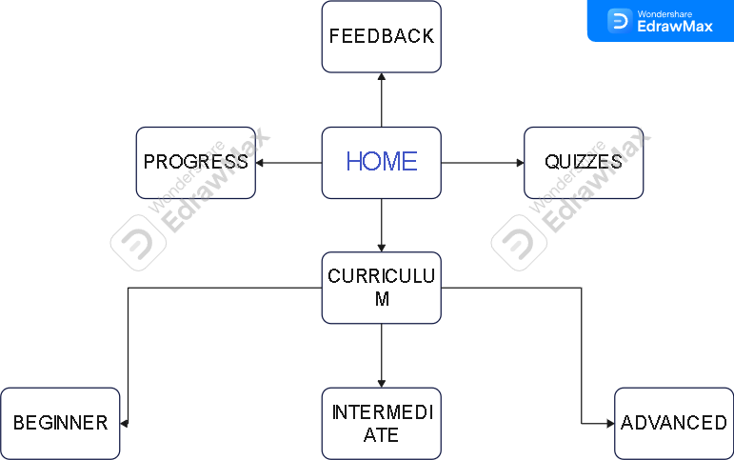

- Technical Brief
  - Planning
    - Microsoft word for documentation
    - Excali draw for wireframes
    - Edrawmax online for sitemaps
  - Construction and content development
    - Html for structure
    - CSS for styling
    - JavaScript for interactivenes
    - Bootstrap

