Timeline

1. Farming and Gardening

Years of farming and large summer gardens have provided the roots for our love of the land and appreciation of fresh food.

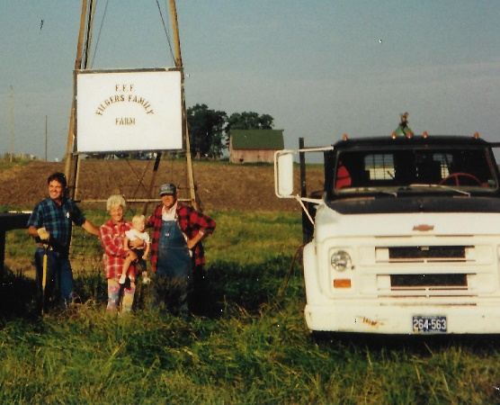

1. May 15, 1983 - Ed and Kathi opened a small 40-seat cafe that served breakfast and lunch, Monday through Friday.

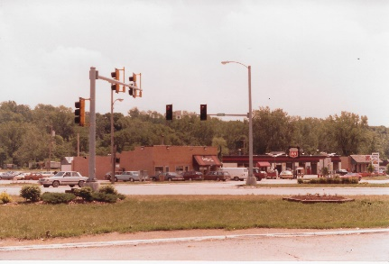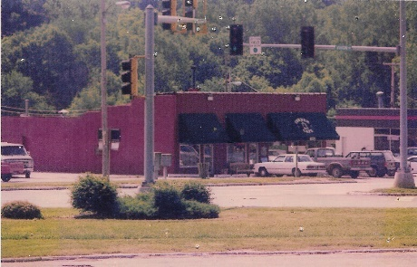 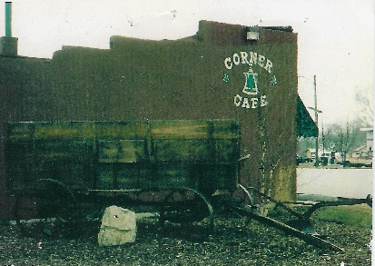

1. New items were introduced as daily specials written on the front windows and inside on the chalkboard.

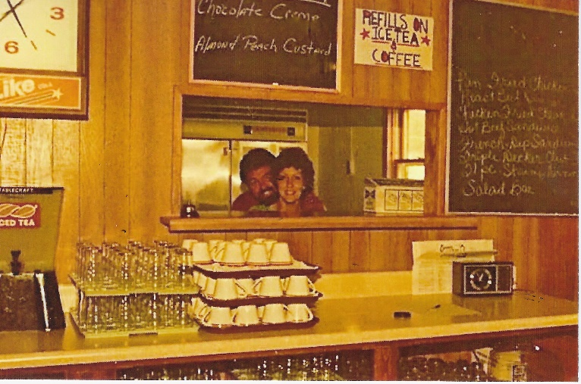

1. New Daily Specials – Kathi and Ed were always trying out new daily specials.

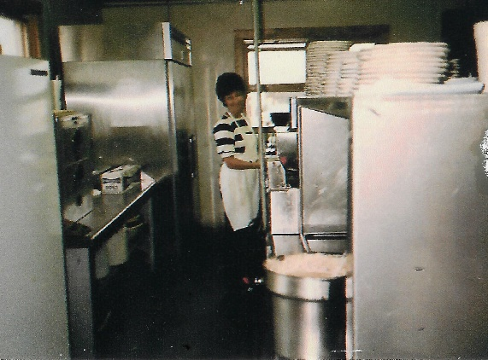

1. Chickens - One of the first specials at Corner Cafe was an “All U Can Eat Chicken Dinner.” Kathi has always enjoyed collecting chickens and in the early days of Corner Cafe began decorating with them.

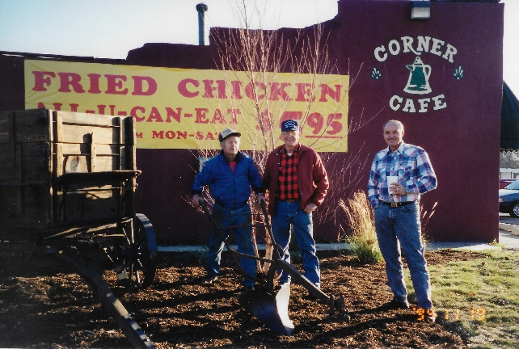 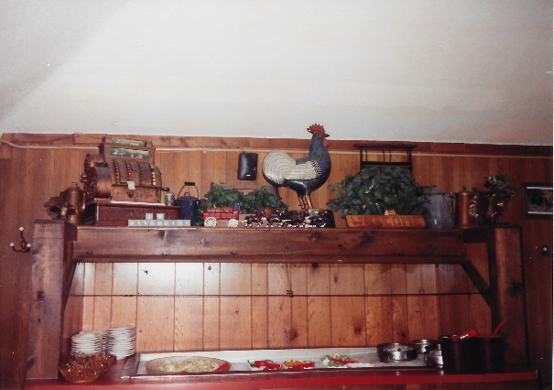

1. Early 1994 (2 pictures)

Selecting the fireplace stones from the foundation of the old family farmhouse.

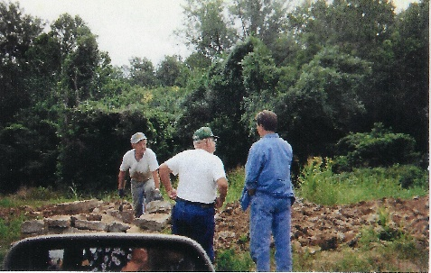 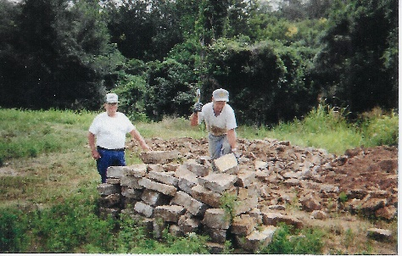

1. Mid 1994

A new Corner Cafe building is constructed on the traditions of the original. Look around the front porch to see where Jennifer kicked off construction by placing her name in the concrete.

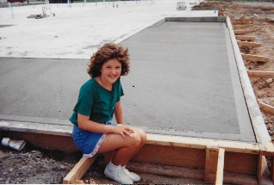

1. Late 1994
   1. For many years, a windmill stood on the farm of Kathi’s family. In 1994, that windmill was moved to the Riverside, Missouri location as a reminder of their farming roots. And when the Liberty location was built, one was included there also.
   2. Moving the windmill from the family farm to its current location at the Riverside restaurant was quite a challenge.

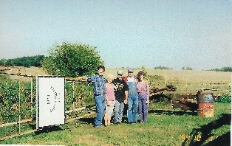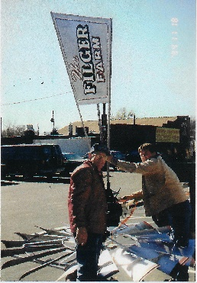 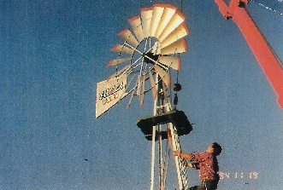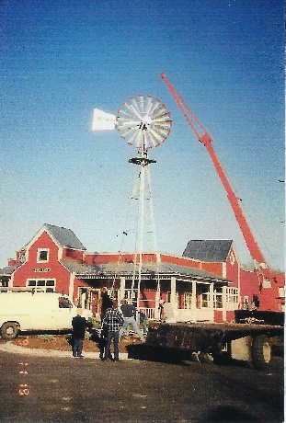 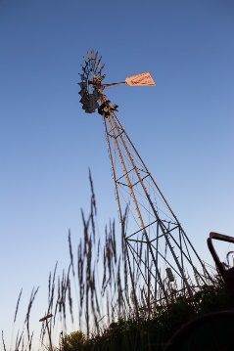

1. A rainbow gave us some assurance that the opening of a new Corner Cafe in December 1994 had promise.

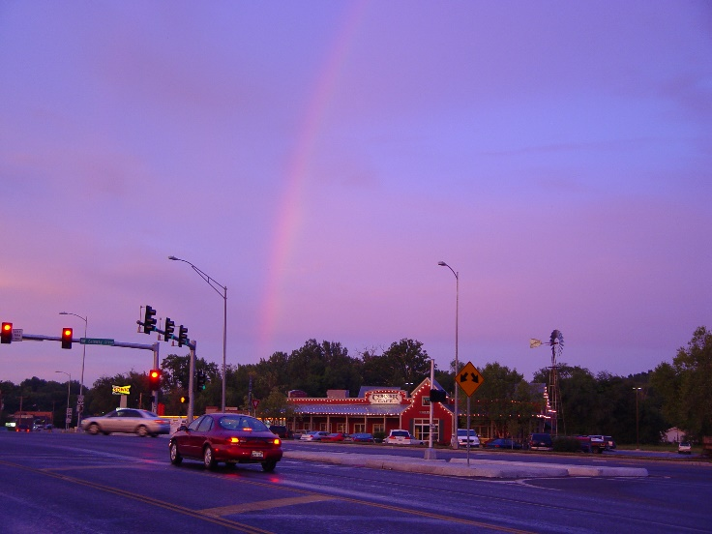

1. Saying goodbye to the old – Once the new Corner Cafe was opened in 1994, the original was torn down. The front door that welcomed customers over the years was one of the last sections to fall.

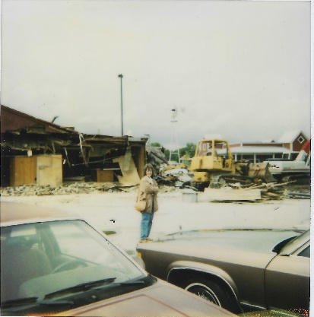 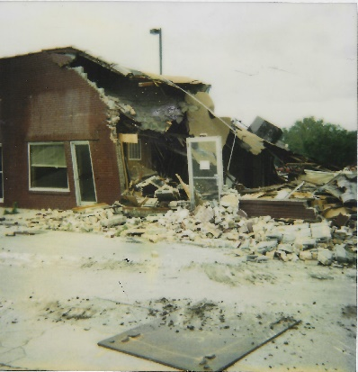

1. A new part of our family – On May 12, 2004, we built our location in Liberty.

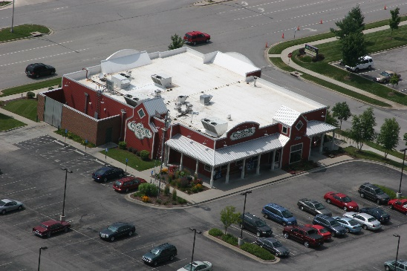 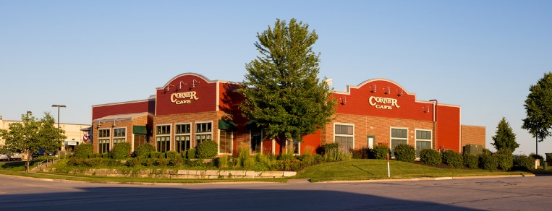

1. On December 17, 2008, we again expanded our family to include our Independence location.

