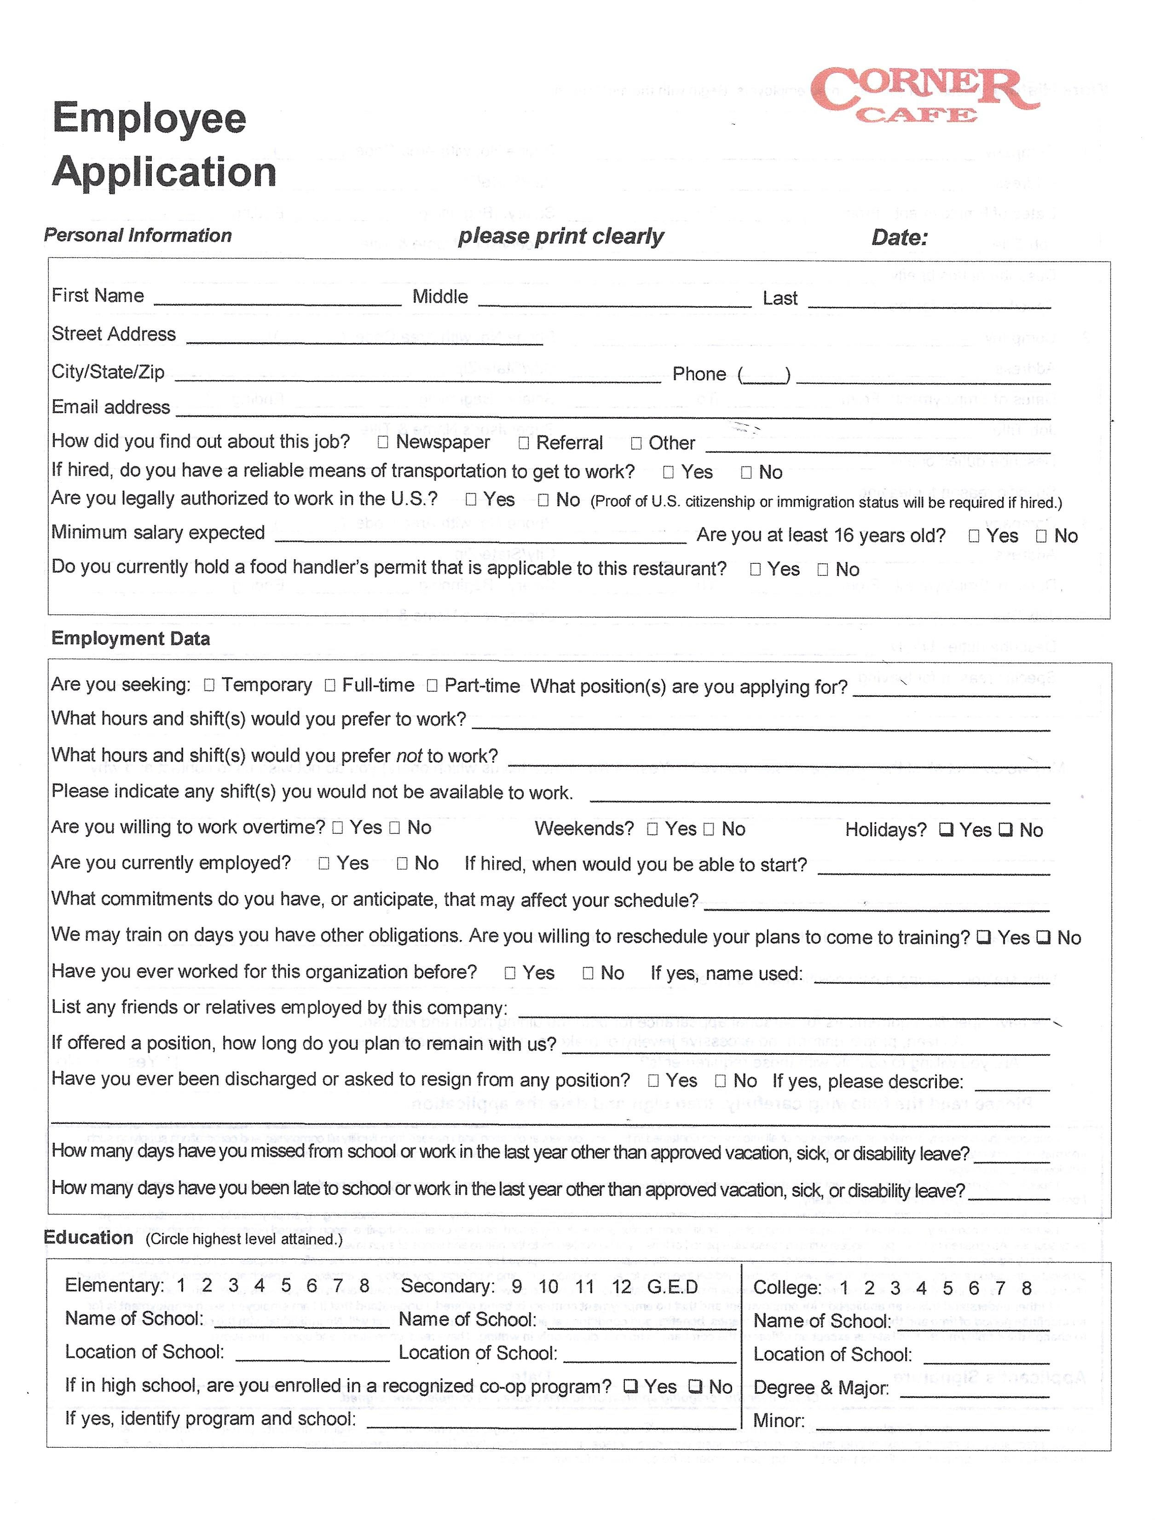

Ava



oceanbluerookie@gmail.com

(816) 522-2226

Independence, MO, 64055

4009 S Milton Dr

Alexandra

Nastasio

