925 S Wolfe Rd #117

Sunnyvale, CA 94086

(515) 631-0451

sethg13@gmail.com

200 Larkin St

San Francisco, CA 94102  
  
Dear Asian Art Museum,

I am writing to express my interest in your current opening for a Helpdesk Technician. As an experienced IT technician with 5+ years of experience, I am confident I can fulfill the duties of this position. I have recently graduated from Iowa State University with two Bachelor of Science degrees: Software Engineering and Psychology. During my studies, I worked as a help desk technician who routinely worked with faculty to troubleshoot hardware and software issues. I have also worked as an IT intern for Barilla America and was the sole on-site IT personnel for the entire pasta production plant. Currently, I am working for Proactive IT as an IT Technician deploying workstations for tech companies in the bay area, such as LinkedIn and Intuit. However, I am in looking of a position with a consistent work schedule.

Personally, working of a museum has always been interesting to me as I deeply enjoy learning things, hence the two degrees. I would like to learn as much as I can about the mythos of cultures other than Greek and Norse. I am very curious of the devatas of India or stories like Journey to the West, for example. When I was younger, I tried to teach myself Japanese, a goal I still would like to achieve, but failed because of a lack of people who I could talk with. Being surrounded by so much information and have people knowledgeable on these subjects with be very exciting to me. In my creative works, I want to be able to draw from these cultures. I want to make sure I understand the culture well enough not to offend, and know enough to teach.

If given the opportunity I would not only be able offer my experience, but my deep-seated interest in Asian culture. Thank you for taking the time to review my resume and consider me for the position.  Please contact me with any questions by emailing me at sethg13@gmail.com. I will follow up with you in the coming weeks, and look forward to discussing this opportunity with you.

*Warmest regards,*

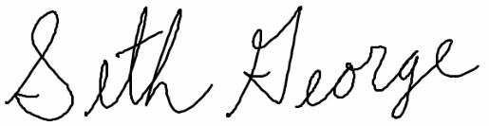

Seth J. George