Lab 1: Quartus II Tutorial

ECE 380

University of Alabama

Brandon Charles

Rebekah Flowers

Lab 1: Quartus II Tutorial

ECE 380

University of Alabama

Brandon Charles

Rebekah Flowers

**Lab 1: Quartus Prime Tutorial**

**ECE – 380**

**University of Alabama**

**PRIYANSHU SETHI**

**GAURAV SHRIVASTAVA**

**Introduction**

The purpose of the laboratory was to become familiar with Quartus II. Students created three

different design entries using schematic capture, VHDL, and Schematic Entry at the Top Level.

The purpose of the laboratory was to become familiar with Quartus II. Students created three

different design entries using schematic capture, VHDL, and Schematic Entry at the Top Level.

The Purpose of the laboratory was to become familiar with Quartus Prime. Students created three different design entries using Schematic capture, VHDL, and Schematic entry at the top level.

**Procedure**

1. We went through tutorials about quartus prime to make ourselves familiar with the software before getting into the lab.
2. We followed the lab #1 instruction manual using debugging techniques as posted by the Professor.
3. After each successful build we started compilation and showed the demo to the TA

**Results**

The first two test cases showed similar wavelengths, However the third one revealed a different wavelength.

Image 1:- example_schematic.bdf

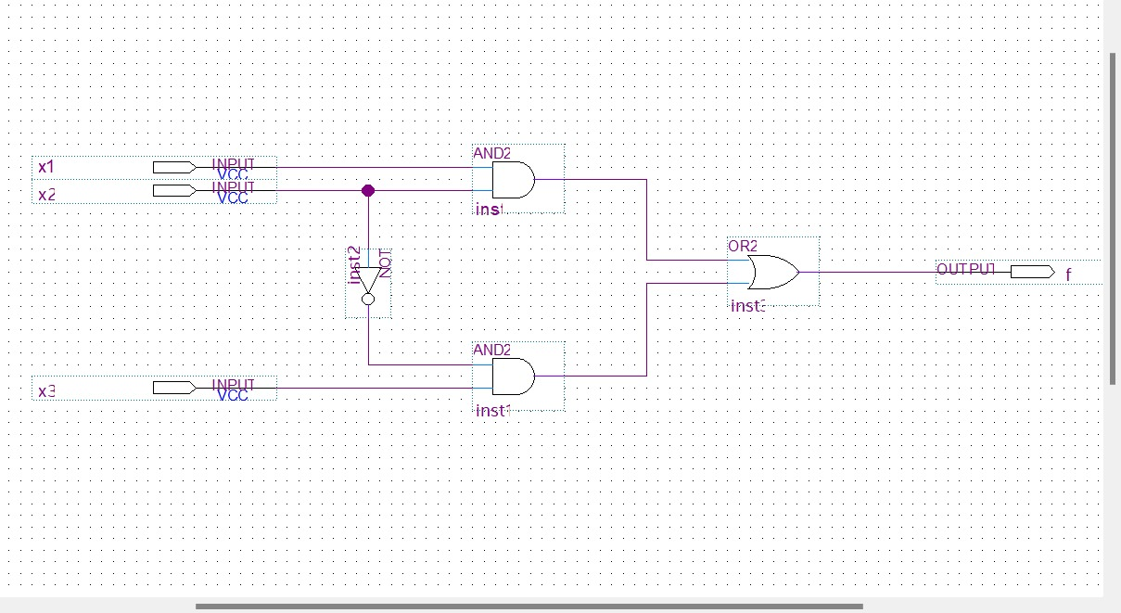

Image 2:- example_schematic.vwf

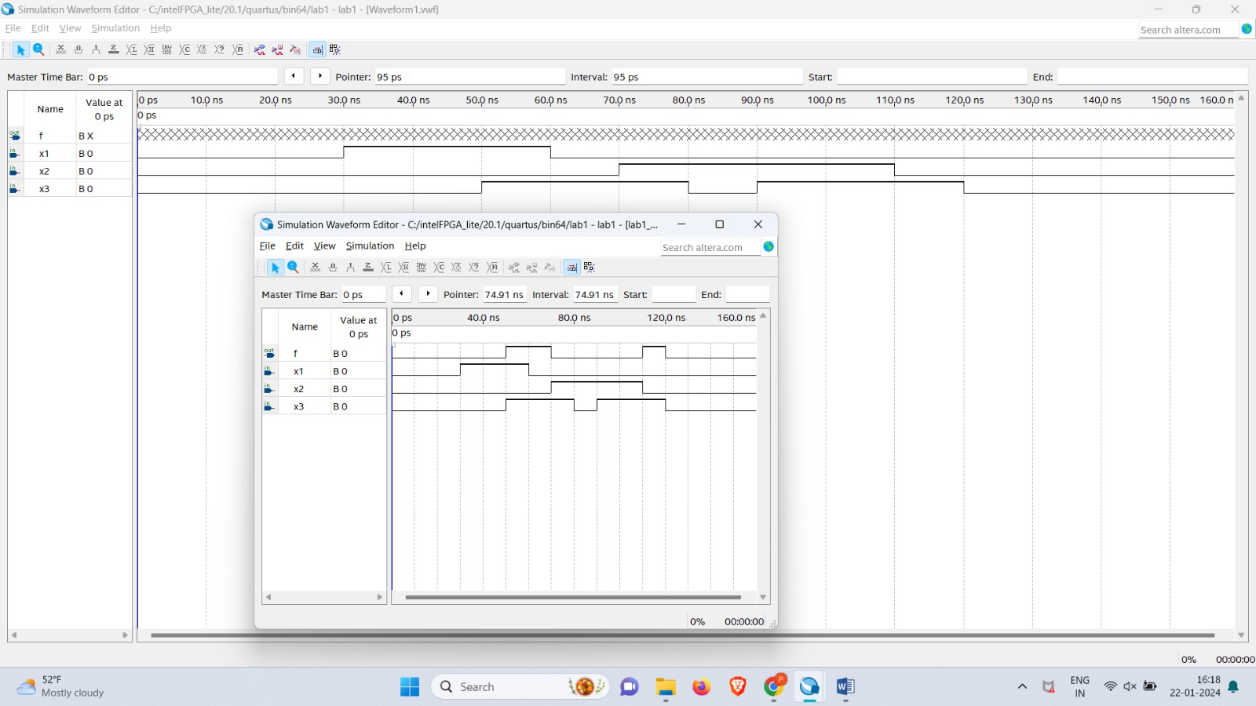

Image 3:- example_vhdl.vhd

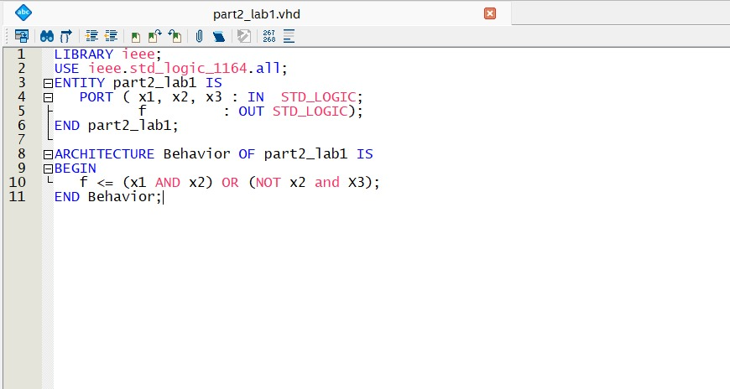

Image 4:- example_vhdl.vwf

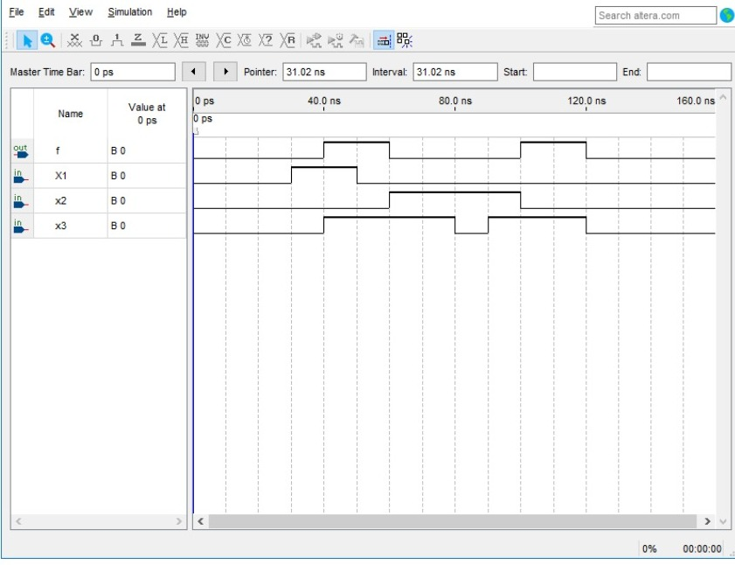

Image 5:- vhdlfunctions.vhd

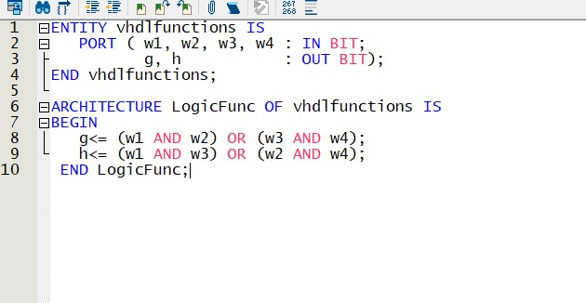

Image 6:- example_mixed1.bdf

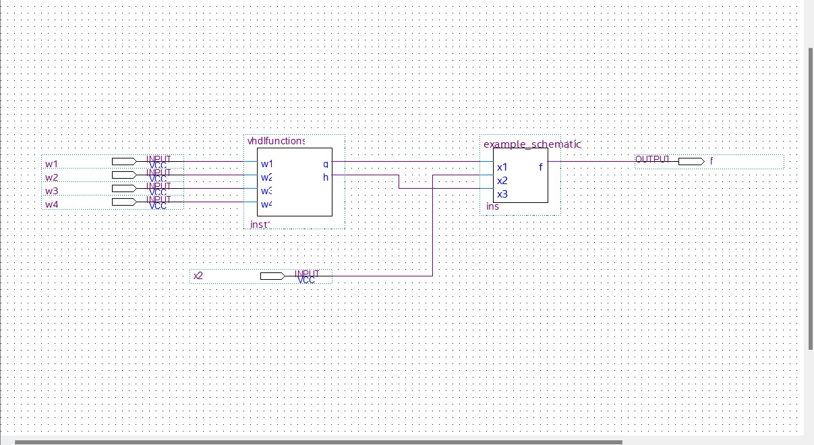

Image 7:- example_mixed1.vwf

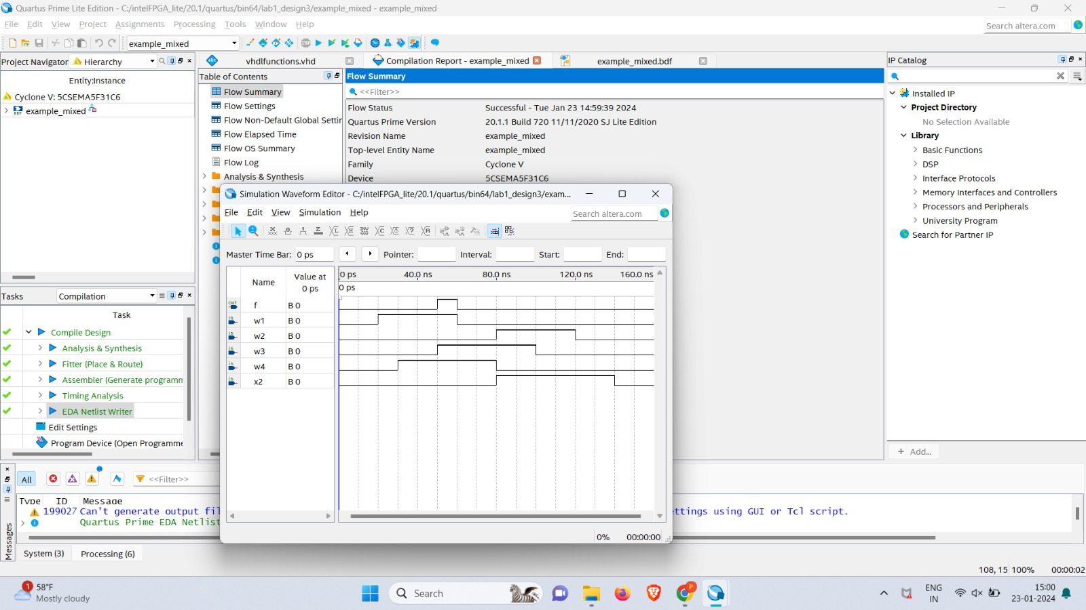

Image 8:- vhdlfunctions.bsf

