**Lab 02**

**ECE 380**

**The University of Alabama**

Priyanshu Sethi

Gaurav Shrivastava

Introduction

The objective of this lab was to become familiar with building circuits using a breadboard. We experimented with constructing different types of circuits to learn about basic guidelines for circuit construction that facilitate the testing and debugging process.

Procedure

1. Pre-laboratory

For the pre-lab, we went through the video links given in instructional manual to learn about intro to breadboards, number systems and logic gates. We then identified the components as listed in the table below, the polarity of the breadboard and the PIN-1s. We then looked up the appropriate pin assignments.

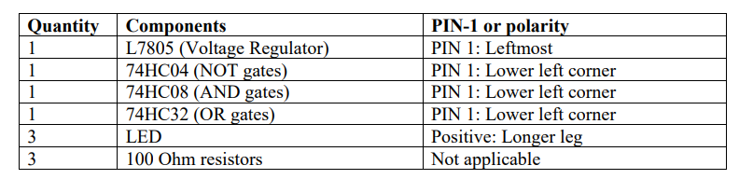

1. Part I

We built a simple power supply circuit to turn on an LED following the schematic built for the same.

1. Part II

We experimented with AND, OR and NOT gates on the breadboard and built a functional circuit for the OR gate using the given schematic.

1. Part III

We followed a similar process to analyse logic functions for NAND, NOR and XOR gates and followed the schematic to build a circuit for the NAND gate.

Image 1:- Simple circuit to light up an LED

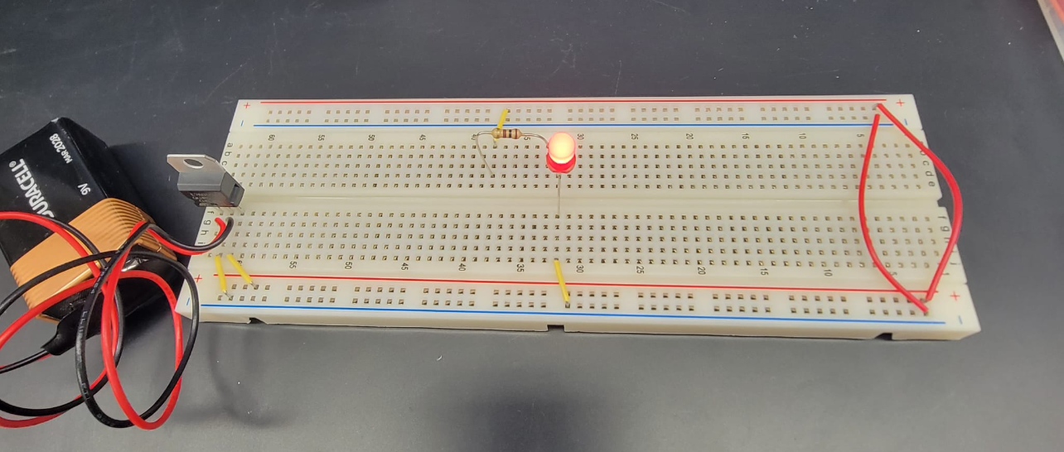

Image 2:- Schematic for simple circuit

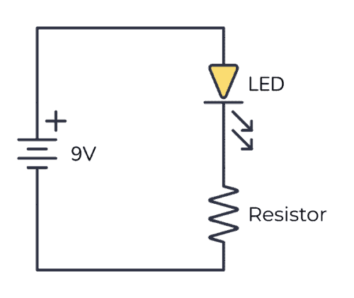

Image 3:- Schematic for OR Gate

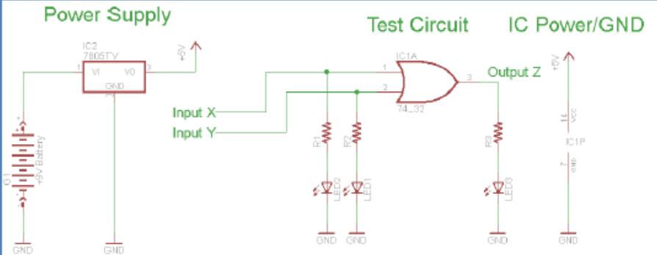

Image 4:- Breadboard implementation of OR Gate

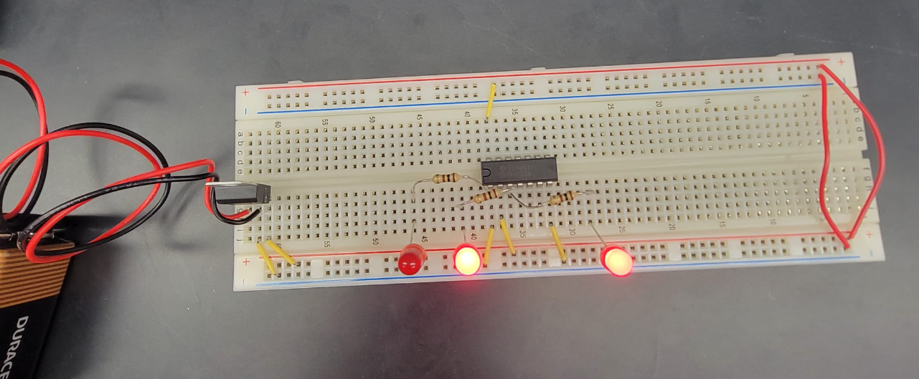

Image 5:- Breadboard implementation of NAND Gate

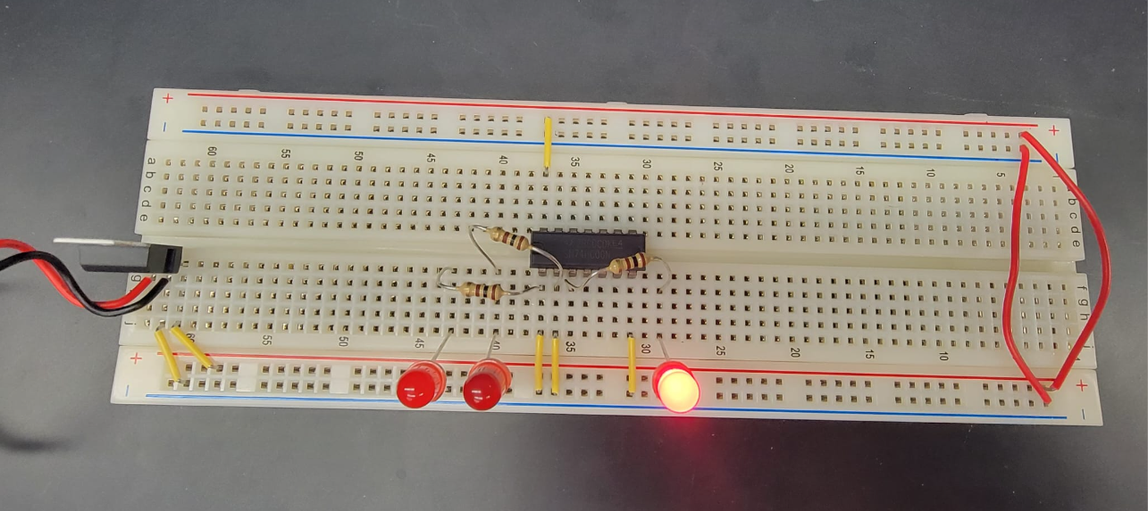

Image 6:- Schematic for NAND Gate