Selenium IDE Installation on Windows

**Download Firefox**

<https://www.mozilla.org/en-US/firefox/new/>

**Download Selenium IDE**

Open the below URL in Firefox browser

<http://www.seleniumhq.org/download/>

Click the link [from addons.mozilla.org](https://addons.mozilla.org/en-US/firefox/addon/selenium-ide/)

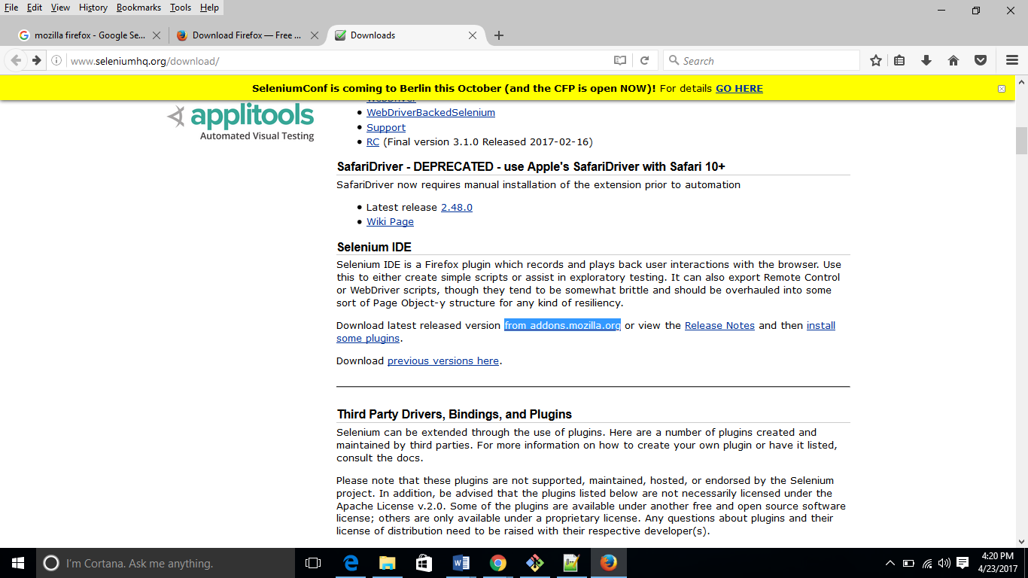

Click on “Add to Firefox”

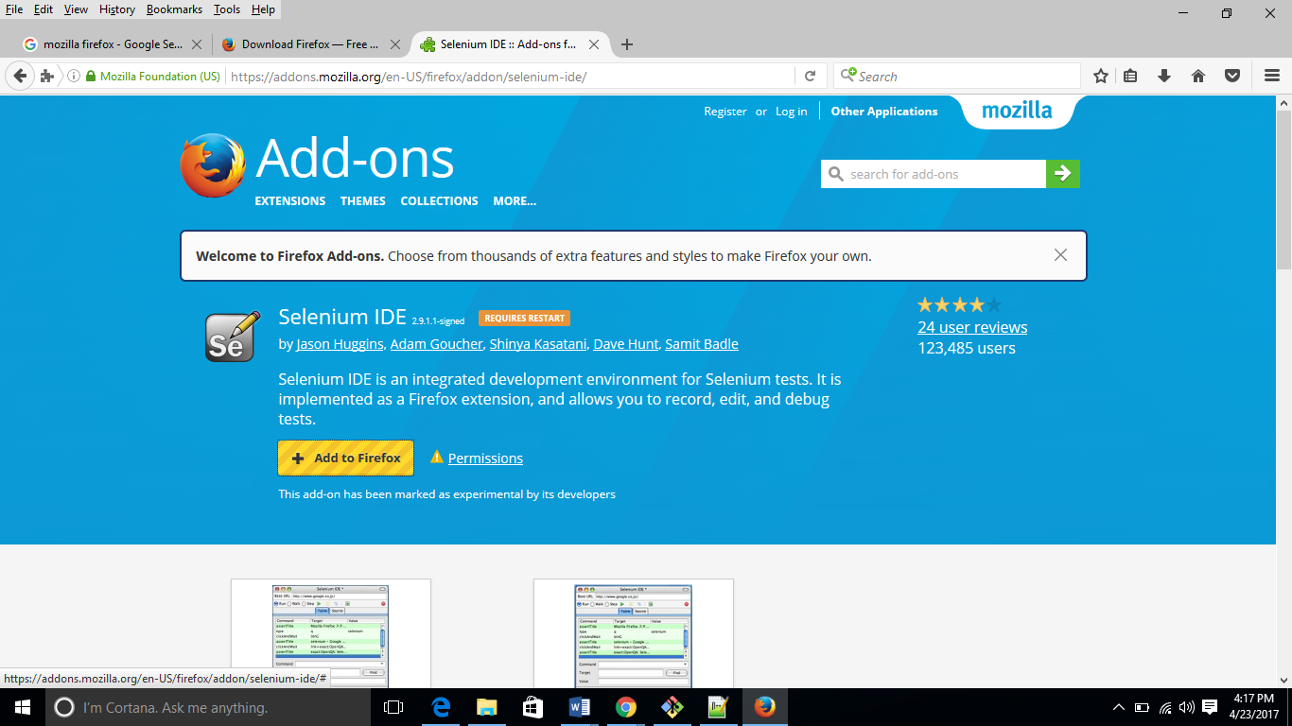

Install the plugin

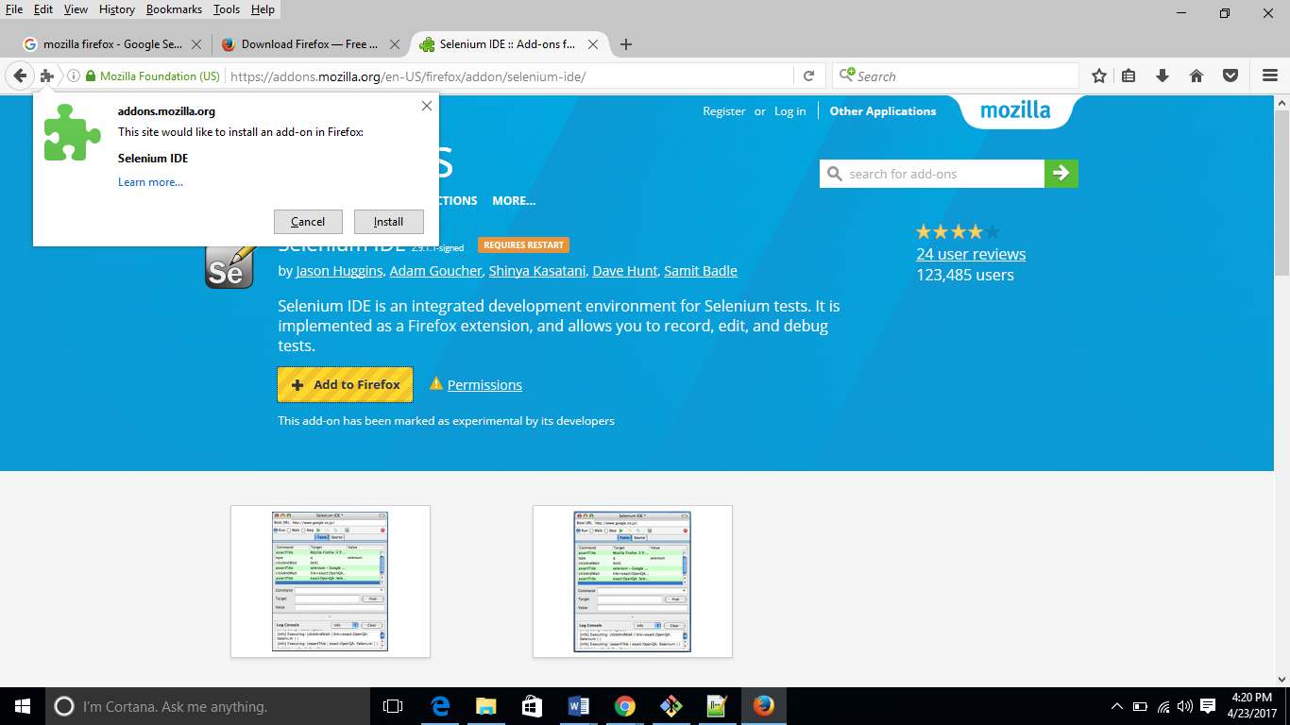

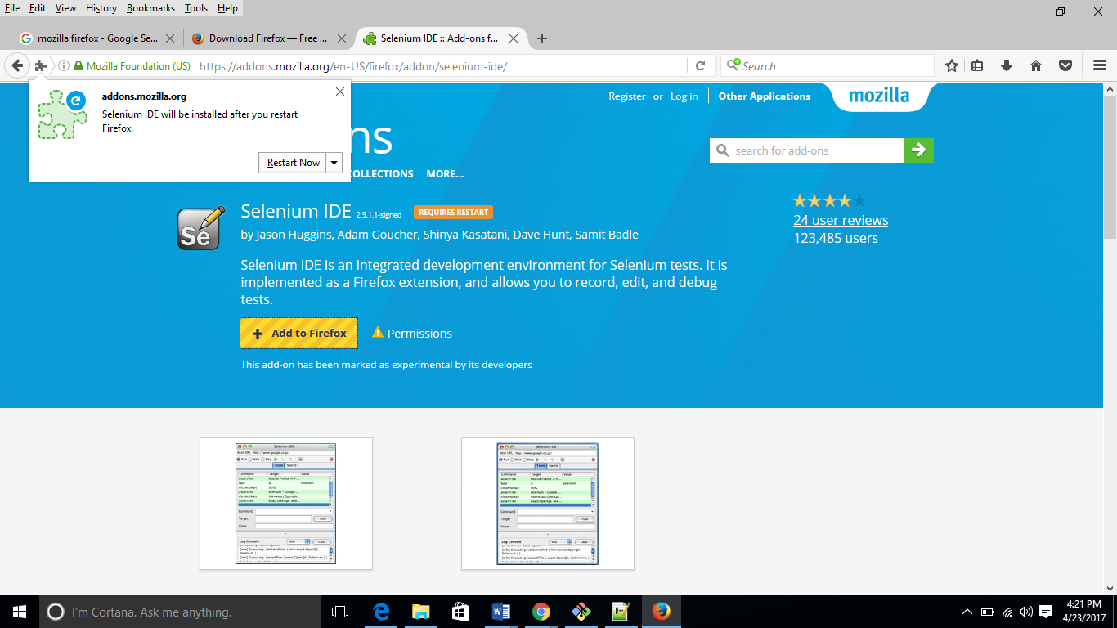

**Validate Selenium IDE in Firefox Browser**

