1.1

Robotics nowadays is becoming more popular due to diverse applications.The system implements Inverse Kinematics of a Robotic Arm and enhances its working using Artificial Intelligence, by means of object tracking. It will help to achieve the goal of picking and placing the desired object. The System On-Chip (SOC) technology is used for the system. Integrating System On-Chip (SOC) technology will allow complex hardware functionality on a single chip.

The aim is to design an algorithm and implement it on a robotic arm having an embedded processor. The detected image is then processed to track the object in real time. The information about the object and environment will be stored in the database, by applying the concept of Artificial Intelligence the various possibilities on the robotic arm movement will be calculated. The best solution from the set will be then decided and action will be taken as required.

Robotic arms are largely required in factories and labs. Using this concept, man power can be reduced by a great extent and causalities can be avoided in the applications where the jobs are dangerous. Accuracy can be achieved by the implementation of this system.

1.2

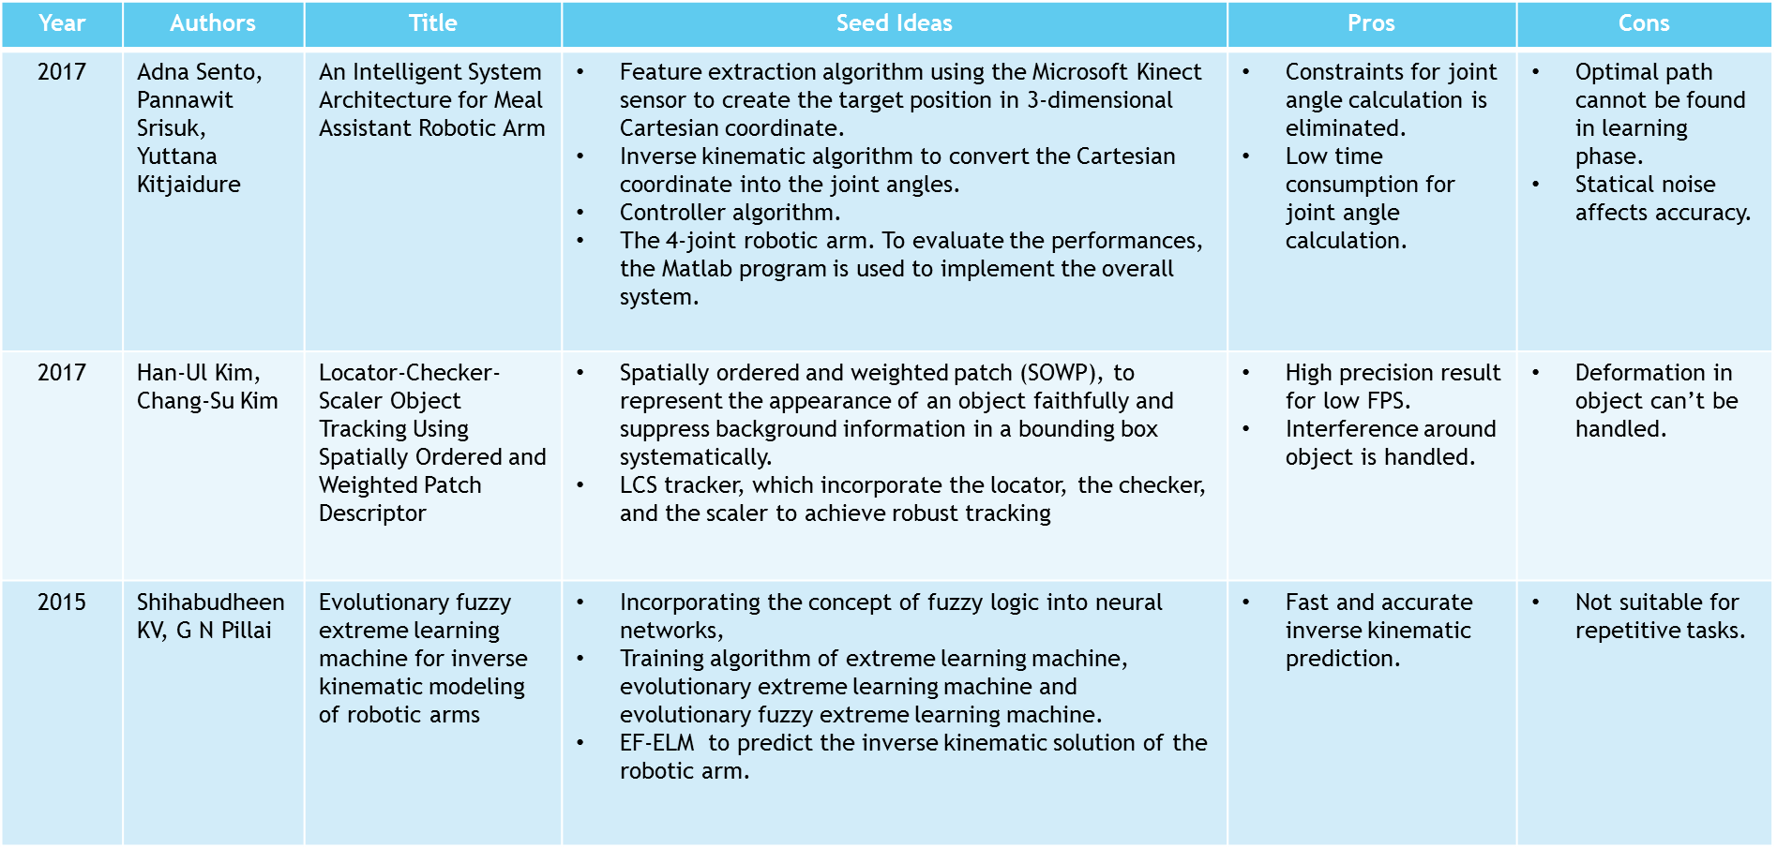

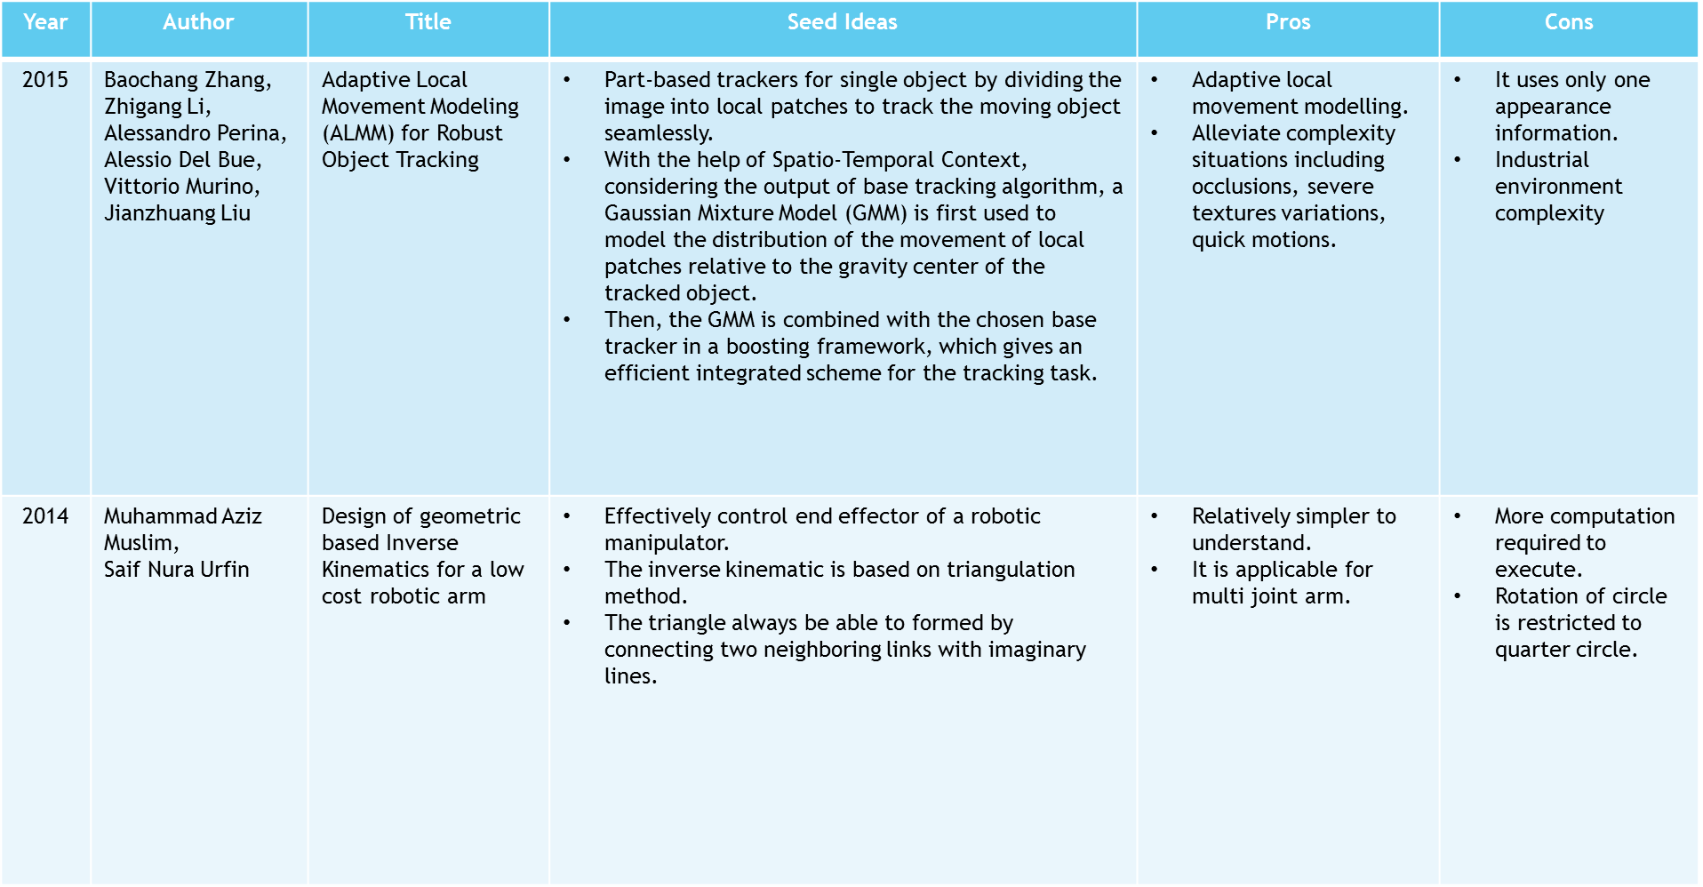

* 1. Project Undertaken
     1. Problem Definition

To implement a front end software to operate Robotic arm with a camera vision to identify target object, pick the target object and place the object at its destination intelligently. Motion of the Robotic arm should be optimized. Manufacturing defect should be identified and appropriate measures should be spaced apart.

* + 1. Scope Statement
* The machine will be of great use to preform repetitive task of picking and placing of target objects (up to 2kg) in an industrial production line.
* Camera vision of the robot will be used for tracking the target object.
* Controlling the movement of the robotic arm.

2.1.1 System Overview

The system is divided in two different modules namely mechanical arm and camera vision. In the mechanical arm module inverse kinematics will be implemented using FABRIK algorithm. The calculation of optimal path that is to be traversed by mechanical arm will be done using Cubature Kalman filter algorithm.

The another module will be camera vision in which two tasks will be done namely object detection and object tracking. The object detection will be done using SOWP Descriptor algorithm and the object tracking will be done by LCS tracker.

* Functional requirements

The system involves following features namely object locating and tracking, object detection and arm movement.

a)Object Detection

i) Description

Based on the current object in production line, the target object would be detected and verified that the detected object is the true target object.

ii) Stimulus/Response Sequences

Stimulus will be the master image from the database which contains details of the target object. According to the master image, the target object would be detected.

iii) Functional Requirements

The following are the requirements to detect the target object: -

* Master Image - This is the sample image of the target object and used to compare with sample images.
* OpenCV library - It contains the basic function set for object detection.

b) Object Locator and Tracker

i) Description

As soon as the object gets detected the location of the object in the image should be identified. And object should be tracked in order to control the movement of the robotic arm.

ii) Stimulus/Response Sequences

Stimulus to the locator and tracker is the detected object in the image which will give response by returning the location of the object in the image and tracking the movement of the object.

iii) Functional Requirements

The following are the requirements to locate and track the target object: -

* Detected Image - This is the image of the target object containing the descriptors used to locate the image
* OpenCV library - It contains the basic function set of LCS Tracker.

## c) Movement of Robotic Arm

i) Description

Based on the Location of the object obtained, the robotic arm will be moved at the object location and the object will be picked and placed at the appropriate location.

ii) Stimulus/Response Sequences

Stimulus to the robotic arm is the joint angles of the arm and the location of the target object which will give response by moving the arm at the required location.

iii) Functional Requirements

The following are the requirements to move the robotic arm: -

* Inverse Kinematics – It is used to convert 3D coordinates to joint angles.
* Joint angles - These are the angles between the arms of the robot.

**2.1.3: Non- Functional Requirements**

## 1) Performance Requirements

* Light Requirement

Sufficient light is required to be projected on the object for clear capture of the images. Eventually the amount of light projected will affect image processing.

* Weight of the object

For optimum movement of the robotic arm, the weight considered should be of 2 kilograms.

## Safety Requirements

* Human interference

While performing the given task, the automated system should be interfered by any human. Otherwise, the operation could get disturbed and may harm human.

* Maintenance of system

The robotic arm should be tested after a specific period of time to avoid any hazard to the system.

## Security Requirements

* Protection of software components

The algorithms which help perform the operations should not be manipulated by unauthorized personnel. Security measures should be taken to avoid such incidences.

* Undertaking for developers

An undertaking should be taken from developers to assure the confidentiality of the project components. The components provided should not be shared or discussed with anyone outside the interest of the project.

## Software Quality Attributes

* Interoperability

As the system progresses, it should learn optimum path using the previous information. Machine learning will help in this aspect.

* Adaptability

Regardless the position of object in given frame, size and weight of object in given range, the system should perform the given task correctly. System should be adaptable to different industrial environments and specified task.

* Correctness

As the system is automated, it will give more accurate output of the operation.

* Robustness

The system should be robust enough to handle the real-time tasks assigned.

* + 1. **Deployment Environment:**

## Hardware Interfaces

* Robotic Arm: Provided by Indus Robotics
* Camera (As provided by Indus Robotics)
* Embedded system: Beaglebone Black
  + AM335x 1GHz ARM® Cortex-A8
  + 512 MB DDR3 RAM
  + 4GB 8-bit eMMC on-board flash storage
  + 2x PRU 32-bit microcontrollers

## Software Interfaces

* Operating System: Linux (Debian)
* Programming Language: Python 3
* Database: MySQL
* Libraries: OpenCV 3.3

2.2 Project Process Modeling

Refer to below link

<http://istqbexamcertification.com/what-is-incremental-model-advantages-disadvantages-and-when-to-use-it/>

1. **ANALYSIS & DESIGN**
   1. IDEA Matrix

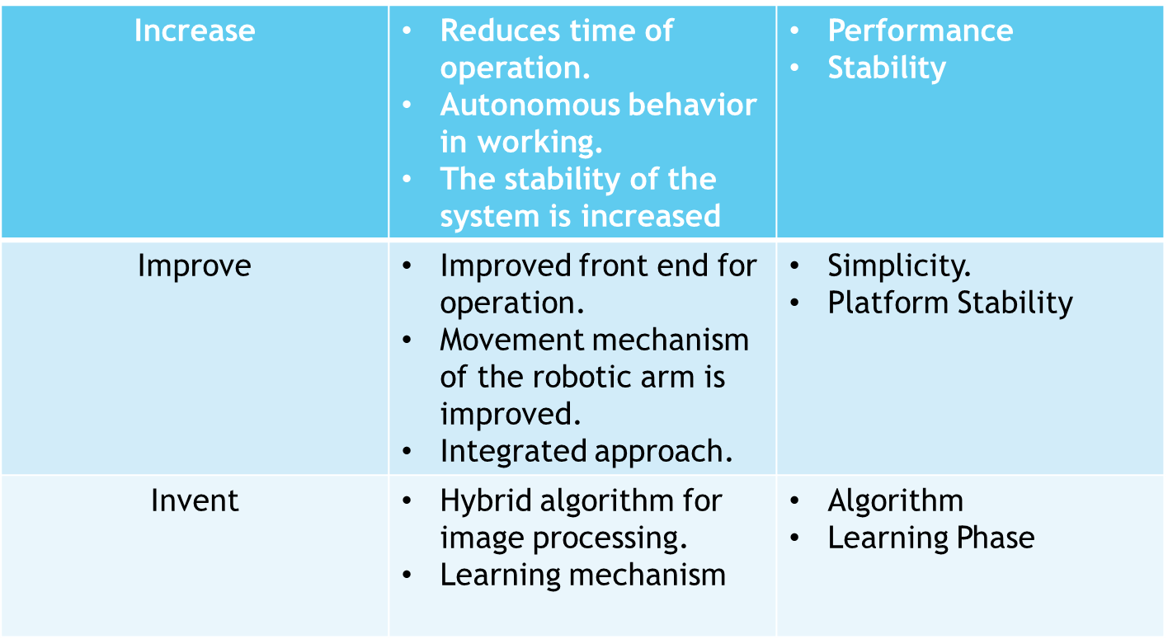

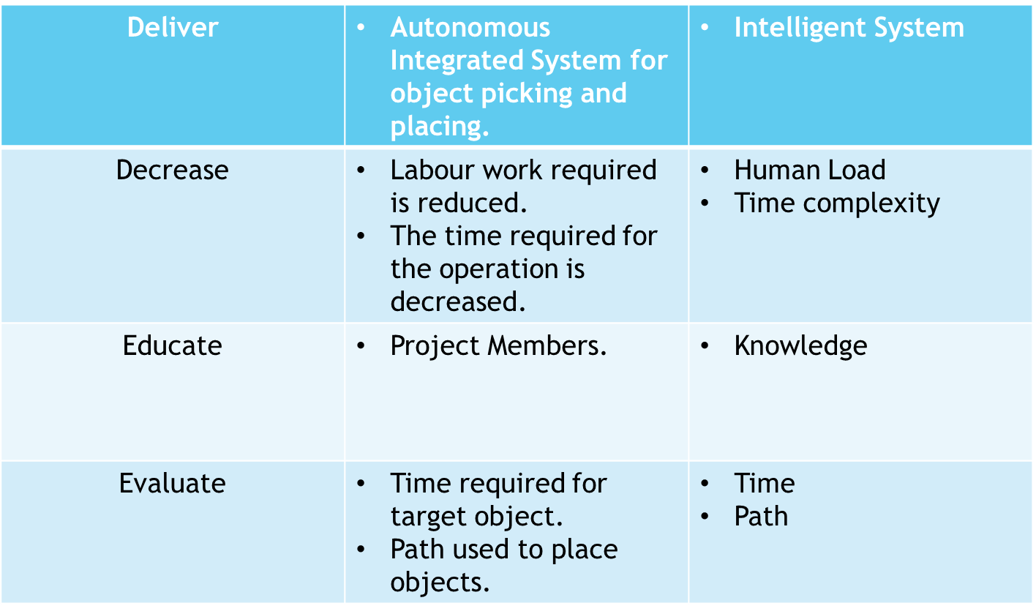

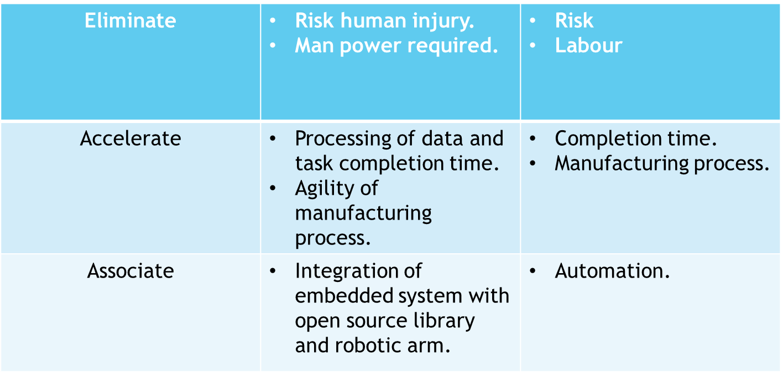

* 1. baaki sab copy paste hi hai, almost sab ready hai apna.

4th ye kal discuss kr k krte.