###Install ssh server
sudo apt-get install openssh-server
Enable the ssh service by typing sudo systemctl enable ssh
Start the ssh service by typing sudo systemctl start ssh
sudo ufw disable

----------------------------------------------------------------------------------------

####Change IP addres of a linux
Edit the /etc/hostname file and change the hostname.
Edit the /etc/hosts file and adjust the hostname there as well.
sudo nano /etc/network/interfaces (add next 4 lines till netmask)
auto enp0s8
iface enp0s8 inet static
address 192.168.56.10
netmask 255.255.255.0

#execute command to reflect the IP changes
sudo apt-get install ifupdown
sudo ifup enp0s8
https://code-maven.com/virtualbox-host-only-network-ssh-to-remote-machine
-----------------------------------------------------------------------------

###Share windows folder with linux OS
On Linux run below command. Reference - https://help.ubuntu.com/community/VirtualBox/GuestAdditions
sudo apt-get install virtualbox-guest-additions-iso

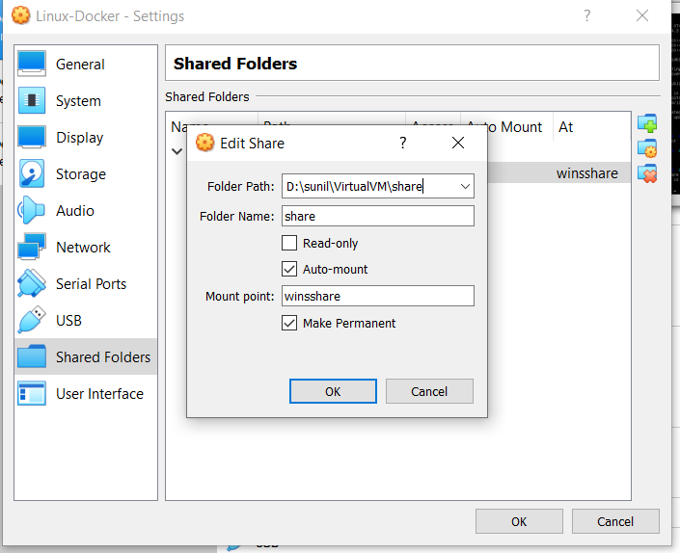
sudo usermod -G vboxsf -a sunil
ln -s /media/sf_share /home/sunil/share
chown sunil.sunil /home/sunil/share
chmod 777 ~/share

-----------------------------------------------------------------------
###Run registry on a node in swarm and push images from other nodes.

1. Add label to node on which you want to run registry container
docker node update --label-add region=registry <node id>

2. install certificates [put correct IP address]
Follow steps as per https://hackernoon.com/create-a-private-local-docker-registry-5c79ce912620

3. create stack
docker stack deploy -c deploy.stack.yml myregistry
Check myregistry container is up and running

4. copy certs from the node running registry to other nodes (e.g. docker1) so that they can connect. Here 192.168.56.20 is the node running registry container.
sunil@docker$ sudo scp -r sunil@192.168.56.20:/etc/docker/certs.d/* .

5.Push image to registry
sunil@docker$ docker image tag hello-world 192.168.56.20:5000/hello-world
sunil@docker$ docker image push 192.168.56.20:5000/hello-world

--------------------------------------------------------------------------

###run 3 nodes
Reference:https://devilbox.readthedocs.io/en/latest/howto/docker-toolbox/ssh-into-docker-toolbox.html
https://superuser.com/questions/1186576/installing-mysql-client-on-docker-php
###switch node
$eval $(docker-machine env node3)

$docker node update --role manager node1

