Meetings

9/10 Meeting
- Compute
- Discuss my ideas
- Agent conversations
- Trade

First Piece - Agent Conversations – Framework for conversing with an agent at time i
- Run sim offline
- Web page for interacting with simulation/stepping through

Questions (may be answered after I run it myself)
- Is the state of an agent saved at time i?
  - If not: specify time step to run to before pausing. Make copy of agent, converse with the copy.
    - Or specify agent you want to interact with, run entire sim, saving its state at each step
    - COSTLY WAY: Save state of every agent at every step
  - Otherwise: run entire sim and then use state of the agent at that time step

- Some variation of

Trade
- Right now each agent is endowed with some salary
- Entrepreneurs act as firms? Endowed with some good/service

Expectations/Tips
- Consistent writing
- Data to show progress
- Research log
- Focus on research question
  - Conclusive results for research questions

Proposal
- Min and max goal
- Background literature
- Assumptions
- Evaluation

Citations
- Google scholar: copy site or bib text (formatted auto in overleaf)

Economic and civilization simulacra
- Not a zero sum economic sim
  - Constantly adding wealth
  - Trade
- How do we create the benchmark
  - How to interact with/view the results
    - One is a data issue one is a sim issue
- Method
  - LLM
  - Agent-based modeling
  - Use data from here
  - Realistic pop
  - Proposing new actions and resources available
  - Watch how it evolves
    - Qualitative analysis
      - Transfer of wealth
  - Governance and economics
    - Different expected behaviors

Compute resources
- Ionic or Della
  - Cluster access and queue jobs
- Can do most dev locally with fake data or agents
- Browser set up, load whatever data you need

Block diagram / flow of information
Agent torch
- Can load in city data
  - How much money is being pumped into economy from tourism, etc.

Seth: go research: trade vs interest rate settings, etc with econ phds
Each agent has expenses (food, housing, utilities, etc), expenses affect satisfaction → how to boost social welfare through taxes? (what are taxes used for)
Jobs: marketplace jobs vs wage jobs
Population size: 1M+
- ​​https://arxiv.org/abs/2502.01506
- https://arxiv.org/abs/2411.11581
- Agents “sleep” while they’re occupied
- Enables running fewer agents at a time

TODO:
- Work out assumptions, data and actions etc
- Then work out framework (front-end, back-end agent communication, etc)
- What is the end user for the visualization

UI:
- Initialize sim in a city
- Agents can traverse city/town - focus on economic actions
  - Start with limited pop – grow from there

Start with tax policy scenario
Big focus on trade
- Buying and selling in town
How many different types of jobs
- Wage worker
- Trade worker
  - All about supply/demand
  - Trade-wage is 0 sum
  - Is finding the optimal tradeoff
- Production worker
  - Producing makes it not zero-sum

Focus on making a framework for viewing on all of this
- Assumptions → framework (how it all fits together) → engineering it to see how it works → experiments
  - Experiments should confirm assumptions
Get sim up and running asap and then add features from theref

9/17 Meeting
- Discuss minimum and maximum goals
- Abstract
- Evaluation
- How to set up vertex ai with project?
  - Can run auth login, set project id, but cant enable
    - Have to do a patch with the code Seth sent
    - aiplatform.googleapis.com

Before Friday:
- Two page project proposal/rough paper outline
  - MUST HAVE:
    - Concrete economic theory
      - CES utility
UI
Overview
- Economy
  - increase/drecrease net worths
  - Flow of income
Detailed
- 1 agent, community of agents
  - Text explanations
    - Not interactable: use the step by step thinking already present
      - Each agent has a thinking budget for t in T:
  - Conversations
- Use fastAPI
- Sim and viz are running on separate processes

Economy Set Up
Simplest case (1 agent, 1 business)
- Manage buying input (fixed at the very start)
- Manage selling product
- Don’t go broke
- Taxes
- N customers
- Suppliers/resources
  - Agent
    - Sample dist of resource yield (can start as direct fixed)
    - Price based on
    - Cost to maintain business
- Consumers
  - How does Vendbench do it
Way After:
Scenarios
- For mech design
- Hierarchical optimization

<@1413615206923370670> https://www.anthropic.com/research/project-vend-1
example of trade benchmark for LLMs
Inspiration

- Single business, fixed supply, fixed demand, small sim
- Single business, fixed supply, variable demand
- Marketplace, variable supply, variable demand

Methodology
- Only for realism
  - We are building a simulator
  - Then think about running experiments

Need to think about timeline
- Have an overview — need backend

Framework

Visualization
- Browser-based vs Game engine
  - Broswer
    - React, JS
  - Game engine
    - Godot, unity, unreal
- LLMs calls to agents
- Agents interacting with each other
- MCP API for agents
  - What is our MCP server endpoints
    - Business endpoints
      - Buy
      - Sell
Agent Planning
- Set costs for next day
- Order new items - arrive next day or something

Browser
- Pros
  - Quick and dirty
- Cons
  - Not as interactive/playable
Game Engine
- Pros
  - Playable
  - Some experience in unity
- Cons
  - Harder to get up

Fall - browser based
- Basic qualitative vis

Spring - game engine

Big Problem
- Building a testbed to understand the capabilities of LLM agents in agent-based economies
  - Name it some good test bed name

Project Proposal
- Steps along
- Interactable policy designs sandbox (tool)
- Evaluation of agent performance (evaluator)
- Can cite things more directly
  - LLM Economist
  - Project sid
  - Vend Bench
- Think of a name

Simulator
- Backend
  - Requests
  - Sampling each day - vend bench
  - Don’t care about how it looks

10/1 Meeting

Manual Stepping & Agent Thoughts
- Added program arguments:
  - –manual_step
    - Enables manual stepping through simulation. Sim stops at top of each time step to wait for user to press enter.
  - –log_thoughts
    - In the bounded worker scenario, in worker->update_utility(), LLM responses are parsed with a new function, parse_role_w_thought(). This returns a Tuple with the normal satisfaction response from ‘ANSWER’, as well as a string with the agent’s thoughts from ‘thought’, stored in the worker’s self.r and self.thought, respectively. If this argument is enabled to True, the thought is committed to the message_history under the current timestep and ‘thought’. It is also sent to self.logger.info().
- Problems:
  - Can’t run bounded scenario – missing: “occupation_detailed_summary.csv”.
  - Every time I open a new session, environment variables for Vertex AI are cleared. Is there a way to fix this or make it easier?
    - vim ~/.bashrc
- Other Notes:
  - Manual stepping is done using input(). This works fine for now, but should add a setter/listener setup using threading in case we want other things to be executable while the sim loop is paused.

Steps Forward
- Get CLI setting working before devving UI
- What to tear down from LLM Economist?
  - Framework is useful, want to use it. Should reduce to skeleton to build on, though?
  - Tax planner
  - Democratic scenario
- Firm agents
- Visualizer
- Get thought logging to work
- Create LLM Economist skeleton
- Block diagram outlining how everything should work together
  - Population dynamics
  - C-Marketplace-F setup
- Add fixed firm agent
- Add LLM firm agent
- Ensure stability of LLM firm agent
- Add buy/sell ability
  - Start with a dummy consumer
  - Look through marketplace
    - Eventually move to location parsing

Firm Agents
- class FixedFirm
  - Receives some demand (can be fixed or variable)
  - Fixed price
  - Uses all post-tax income to purchase supply at some price (can be fixed or variable)
- class Firm
- Buying and selling

Visualizer
- Is intention to run visualizer and sim locally with internet connection to make calls?
- Or run visualizer locally with connection to sim on cluster?
- SimCity/Cities Skylines setup
  - Online marketplace vs physical marketplace

Visualizer UI
- Buttons/Fields
  - Run sim
  - Simulation Parameters
    - Scenario
    - Max-timesteps
    - Two-timescale (is there still going to be a tax planner?)
    - Llm
    - Prompt-algo
    - service
    - Port
    - Worker-type
    - Planner-type (same question as two-timescale)

Agent Conversations (Interpretability)
- How to copy agent to use in conversation?
  - Just duplicate agent?
- Copy memory into a new LLM

Mechanisms
- Government
- Agent negotiating on behalf of real person
- Exploitative agents
- Using mechanisms to promote good behaviors and show poor behaviors
Agent Marketplace (financial market dynamics)
- Agent marketplace dynamics
  - Fair price for buyers (price and trustworthiness) and sellers (fair price, maximize profits)
- What kind of scenarios exist where people might try to take advantage

- First mover advantage

Literature to Review
- Vending-Bench
- EconAgent - 10 minute presentation

Test Bench
- Larger project:
- Testing the ability of an agent to represent you in the market rather than represent that market
- Spring
  - Training a single agent to behave better in this setting
    - Train all agents to avoid moving away from the equilibrium
      - Avoid unfair pricing
  - Scaffolding→training on that scaffolding
- Have working version by January

Productivity
- Claude and Cursor
  - Cursor agent has 1 year free
  - https://cursor.com/students

Endpoints for MCP
- Marketplace handles p2p interactions
  - Global exchange is a routing system keeping track of all the consumers and producers
https://arxiv.org/pdf/2310.10436
- Summary
- What do they do
- What do prev works do
- What do results show
- Limitations

- Note how they manage economic features
  - Want all features they have +

Figma

10/8 Meeting

Framework
- Simulation
  - Supplies purchasing
  - Prices setting
  - Orders submitted
  - Orders matched (goods/money exchanged)
- Market
  - List of quotes
  - List of orders
  - Orders are dequeued and filled if possible
- Ledger
  - For each agent: money, assets
- FirmAgent
  - Has capital
  - Purchases supplies
  - Sets price/quantity
- ConsumerAgent
  - Has income
  - Submits orders
    - Ideally based on CES utility
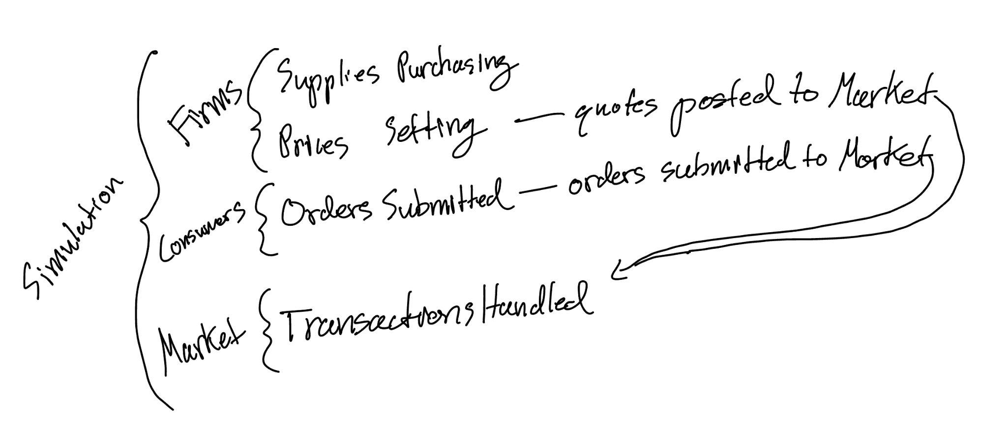

class Ledger:
def credit(self, agent, money): # update money
def transfer_money(self, from_, to, amount): # update money of from_ and to
def transfer_good(self, from_, to, good, qty): # update inventories of from_ and to
def add_good(to, good, quantity) # add quantity amount of good to to’s inventory

class Order:
consumer_id: str
firm_id: str
good: str
quantity: float
max_price: float # willingness to pay

class Quote:
firm_id: str
good: str
price: float
quantity_available: float

class Market:
def submit_order(self, order): # add order to queue
def post_quote(self, quote): # post quote to market
def clear(self): # Go through all orders and call fill_order(order, ledger)
def fill_order(order, ledger):
For each quote in market.quotes
If order.firm == quote.firm and
Order.good == quote.good and
Order.price <= quote.price and
Quote.quantity_available > 0)
ledger.transfer_money()
ledger.transfer_good()
Update quote.quantity_available

class FirmAgent:
cash
Supplies
Ledger ref
Market ref
def __init__(self, id, goods, cash, policy (for LLM scenario)):
...
def set_prices() # decide on prices for today, returns dict of prices
# Fixed agent takes in a price to set across all goods

def purchase_supply() # purchase supply for today
# Fixed agent takes in quantity to purchase and the unit price
Update cash in ledger
Update supply in ledger

def produce_goods() # produce some quantity given state (bound by supply)
# Fixed agent produces evenly across its goods
Update inventory in ledger

def post_quotes(prices[good, price]) # post quote to market good,price
Create quotes given inventory and prices
Post quotes to market

class ConsumerAgent:
Income
Cash
Inventory
Ledger ref
Market ref
def __init__(self, id, income_stream, ces_params):
Def receive_income() # Method to get income, call per timestep
Def submit_order(firm, good, quantity, max_price)
Create order
Submit to market
Def make_orders() # returns list of the orders made
# Fixed has equal budget spread among its goods
# Fixed currently tries to purchase all goods listed in its inventory
Create orders for each good
submit_order(new_order)

TODO
- Review Virtual Agent Economies
- Review EconAgent
  - Evaluation
- Review Vending Bench
  - How did they evaluate
  - What did they do
  - What went well/poor
- Vending Bench type of scenario
- Put CES into ConsumerAgent
- Put LLM into FirmAgent
- Run simulations
  - See how long FirmAgent is in business
  - Look at vending bench for metrics

NOTES
- If information is instantaneous
  - Would expect race to the bottom or race to the top
- Endpoints most important
- Before LLM
  - Have equations / theory – math agents
- Supply and demand models based on EconAgent
- With LLM
  - Vending bench
    - Endpoints
    - Prompt: don’t go broke
- LLMEconomist is tax government side
- EconAgent tells us we need xyz in sim
- How does marketplace of vending machines stay in business when in direct comp with each other
  - N-vending machine marketplace
- Staying in business
  - How long can a single LLM stay in business
  - What if you have competition?
    - New vending machines at any time
      - Birth/death
    - What makes a successful agent in this place
- Economic models
  - Marketplace is operating on economic models
  - Throw LLM and see what it does
  - Wait on LLM consumers
    - Make them model based (CES)
- 1st sem
  - Backend dev
- 2nd sem
  - Frontend dev
  - Evaluation of scenarios
- Multi arm bandit problem
  - Connect to this
- Market
  - Agent buying things on your behalf in adaptive prices
  - Online buying
    - Instead of having to physically walk somewhere: search online and grab information
    - Make sure not too toy → doing research
      - Show how agents will behave in this scenario
        - Potential solution to address some of the issues that arrive
- EconAgent
  - Taxes
  - Productivity and consumption
  - Equations governing supply and demand from production
  - Wages are controlled
  - Agency in terms of where they’re buying
    - No agency in terms of how much money they’re making or spending
- Virtual Agent Economies
  - Exploratory paper on what we expect to happen
  - We are trying to solve some of the issues with this
  - Regulating economy
    - Collective goal
- FirmAgent LLM
  - Describe the tools, allow the LLM to use these tools
  - Mutual exclusion (can’t buy something twice, etc)
    - Centralized
      - Single thing (market coordinator) handling requests
    - Decentralized
      - Direct communication between agents
- Vending Bench
  - Trace analysis
    - Tools setup
- Potential feature: haggling
  - Consumer gives willingness to pay
  - Agent can try to haggle a seller down
- .com era predictions happening now

10/22 Meeting (Cancelled)

Current TODO List

Development
- Put LLM into FirmAgent
- Set up 1 business, N fixed consumers simulation
- Put CES into ConsumerAgent
- Set up 1 business, N CES consumers simulation
- Run simulations
  - See how long FirmAgent is in business
  - Look at vending bench for metrics

Literature
- Look into other forms of FirmAgents besides EconAgent

Vending Bench
Vending Bench Notes
- Problem
  - Agent struggle with coherent reasoning for long time horizons
- Contribution
  - Test bench for evaluating long-term coherence in a business setting
- Limitations
  - Lack of guardrails
    - Meltdowns come from limitations of models being able to reason over long horizons. The setup gives the agent a lot of freedom, rather than abstracted tools for purchasing supplies or restocking, they are responsible for every logistic involved with the purchasing and restocking. This exacerbates meltdowns, as they can engage in “side quests”, seen in the FBI Sonnet meltdown case.
- Takeaways + useful features
  - Increase agency in AI Bazaar
    - Allowing the FirmAgent to make calls to check their inventory, cash, etc., could be more interesting. The purchasing could be made more involved like the email, but simplified by adapting the order-posting setup currently used for consumers. They could survey quotes posted by an array of suppliers and choose the best deal relevant to their specific inventory/business. (same thing for consumers, they could survey quotes posted by firms)
    - Note: could introduce a delivery schedule aspect that forces firms to consider timing when placing orders. It should be noted that misinterpreting delivery schedules or not regularly checking inventory led to meltdowns in the paper. → Becomes a matter of what abilities are we actually evaluating (e.g. I don’t care about how good it is at writing an email or small logistical things like checking inventory regularly)
  - Interactions with suppliers—firms are also consumers
    - These interactions allow for more dynamic transactions (bargaining, cancelling orders, etc.)

EconAgent
EconAgent Notes
- Problem
  - Market dynamics are often overlooked in agents’ decision making processes
- Contribution
  - Effective memory (reflection) and perception modules that enable human-like decision making and emergent macroeconomic behaviors that align with real-world tendencies
Limitations/Gaps:
- Employment, similarly to LLM Economist, is the decision of the worker (e.g. unforeseen layoffs can’t happen and aren’t a factor)
  - In the COVID-19 scenario, the rationale provided by the agent appears more as an assumption of what a human would do or replication attempt of a human. It doesn’t appear to be driven by concrete, primitive variables.
- Noted limitations in paper
  - Doesn’t explore firms with pricing and hiring. Can lead to a more realistic macroeconomic system. (notes the Beveridge curve and procycilicality/countercyclicality)
  - Small sim. Large sim necessary for policy optimaization, forecasts of macroeconomic indicators, and overall miroring the real world.
Useful Features:
- Consumers as households
  - For llm consumer agents, prompt them as a household (need food, clothes, gas, etc.)
- Direct conversion of labor into supply of essential goods (circular economy)
- Wage and price adjustments
- How to handle demand—randomly selecting a consumer and meeting their needs until all consumers have consumed
- Interest rates for savings based on unemployment and inflation
- Evaluation
  - Macroeconomic indicators
  - Test removing perception and reflection modules
- Modular perception and reflection
  - Important for testing their impact on the final results
- Deciphering rationales
  - Instead of researcher-agent conversations, throw an agent’s conversation back into the LLM and prompt it to provide summaries of market dynamics and rationales for the decisions made.

NOTE: LOTS OF USEFUL NITTY-GRITTY INFRASTRUCTURE STUFF IN NOTES TAB

Results/Evaluation:
- Evaluation encapsulates many macroecon indicators and regularities
RQ1—Macroeconomic Emergence
- Results compared with rule-based baselines
- Indicators
  - Inflation rate
  - Unemployment rate
  - GDP
  - EconAgent results in more stable and numerically plausible states compared to baselines
    - →decision-making of EconAgent is coherent and similar to human-like behavior
- Regularities
  - Phillips Curve
    - Negative correlations between annual unempoyment rate and wage inflation
  - Okun’s Law
    - Negative correlation between annual growth rate of unemployment and real GDP growth
  - EconAgent sims manifest these regularities. Baseline contradicted them
    - Attributed to perception that consumption should be reduced when unemployed
RQ2—Ablation Study
- Remove perception module
  - Results in lack of adaptability
- Remove reflection module
  - Results in anomalies

RQ3—Decision-Making Abilities
- Testing what economic variables have statistically significant effects on decisions
  - Taxation, redistribution, and expected monthly income have significant impacts on work propensity
  - Previous month’s consumption, current savings, and bank interest rates significantly influence consumption propensity
  - Goods price has significant impact on work and consumption propensity
- Significant heterogeneity
  - Incremental growth in consumption propensity with age
- Impact of macroeconomic trends
  - Low unemployment leads to higher consumption propensity
- Inspecting agent rationale
  - Randomly select agent and input its conversations back into the LLM, prompting to summarize the economic dynamics and provide rationales for the consumption decisions made.
RQ4—External Intervention
- Prompting the agents with a COVID-19 context results in indicators that follow the actual results of the pandemic

Virtual Agent Economies
Virtual Agent Economies Notes
Problem:
- New multi-agent economies as a form of economic research. Lack of evaluation methods.
- Need to assess economic risk and potential exacerbated inequality in a permeable AI agent economy
Contribution:
- Framework for analyzing such systems
  - Characterizing along
- Origins (emergent vs. intentional)
- Degree of separatness from established human economy (permeable vs. impermeable)
- Auction mechanisms for fair resource allocation and preference resolution
- Mission economies to coordinate achievement of collective goals
- Socio-technical infrastructure needed to ensure trust, safety, and accountability

Useful Features:
- When submitting orders/clearing the market, a 3rd agent acts as the mediator, receiving information about competing consumers and providing an optimal outcome.
- Credit via Verifiable Credentials (VC)
  - An issuer agent (e.g. a marketplace) can sign and issue VC to a seller agent
    - → Agentify the “market” in AI Bazaar, responsible to clearing the market (matching orders to quotes) and subsequently distributing VCs
    - Consumers could take a firm’s credibility into consideration when creating orders
      - If a firm consistently underdelivers on orders, their credibility would lower and a more reliable competitor would win out
  - “Successful transaction completion”
  - “Certified proficiency in X”
  - “Access to X compute and Y memory”

Dev Update
- Prototype of FirmAgent with LLM
  - Interface nearly identical to FixedFirmAgent
- Had Cursor write a very basic functionality test and it seemed to work well with the FixedConsumerAgents

10/29 Meeting

Development
- Put LLM into FirmAgent
- Set up 1 business, N fixed consumers simulation
  - Improve update production prompting and parsing to decrease JSON parsing failed errors
- Put CES into ConsumerAgent
- Add reflection module
- Set up 1 business, N CES consumers simulation
- Run simulations
  - See how long FirmAgent is in business
  - Look at vending bench for metrics

- Get parsing to work
- Put CES into consumers (this is the only way to get a reasonable simulation)
  - This will get realistic behavior from consumers and actually let us evaluate the firm
- Add a reflection module

Test Simulation:
- 1 LLM firm
- 2 fixed consumers
- Gemini-2.5-flash
- 3 timesteps
- Firm initial cash = $200
- Wandb enabled
python -m llm_economist.main --num-firms 1 --num-consumers 2 --firm-type LLM --llm gemini-2.5-flash --max-timesteps 3 --firm-initial-cash 200 --wandb --name LLMFirm_Sim1

Current Problems
- When the firm has to manage >1 good, run into a lot of parsing problems
  - When updating production, it specifies supply_quantity. This can be ignored in parsing, but may contaminate the agent’s memory if they believe they have a different supply_quantity than reality.
  - Allow it to think before it outputs the answer
- Need to set up taxation and overhead for the firm
- Have an example input
  - Just use API call to test (don’t run full simulation)

Tools:
- Test how the agents do without fine tuning (benchmark)

Feature:
- Could add delivery schedule
  - After an order, X timesteps will surpass before it appears in their inventory

Each timestep
- Agent <-> supplier interaction
- Agent <-> set prices
- Customers <-> store
- Reflection
  - Agent gets the amount of sales for the day
  - Consumers get a summary of their actions

Agent -> action -> env
Env -> obs -> agent
Env -> reward -> agent or agent -> reward -> agent

Marketplace
- Order - Quote matching becomes intractable with many firms and many consumers
- Note: can add cost for looking at the next firm

RQs:
- How would agent marketplaces (agents shopping for humans) turn shopping into high frequency trading
- 1 firm case → Amazon
- N firm case → ebay
  - Could introduce trustworthiness (VC from Virtual Agent Economies)
- Want to think about realistic cases and determine how well they perform and how we can do better
  - This is how you improve these specific scenarios (by training a model, etc.)
- Addressing issues before they happen
  - At high risk of not having features built in for some scary edge cases - demand oriented problems in US
    - Edge cases
      - Store ran by agent goes bankrupt
      - Coding agent deletes everything
      - Buying and spending in the economy ran by agents (Black Monday)
      - Disruption and variance
      - Does the agent try to fix things from demand or supply

- Goal: have scenario

11/12 Meeting
Demos:
OutOfBusinessTest2
- 1 FirmAgent
- 5 FixedConsumerAgents
  - Each place an order for 10 units of each good per timestep
- 1 good (food)
- 12% tax rate (on consumer income and firm profits)
- $50 overhead per timestep (rent)
- $200 starting cash
- 30 max timesteps
python -m llm_economist.main --num-firms 1 --num-consumers 5 --firm-type LLM --llm gemini-2.5-flash --max-timesteps 30 --firm-initial-cash 200 --name OutOfBusinessTest2 --wandb --log-firm-prompts

Notes:
The aggregate demand is 50 units per timestep. We see that the firm began producing exactly this quantity of food after timestep 5. It increased prices in increments of 5 cents.
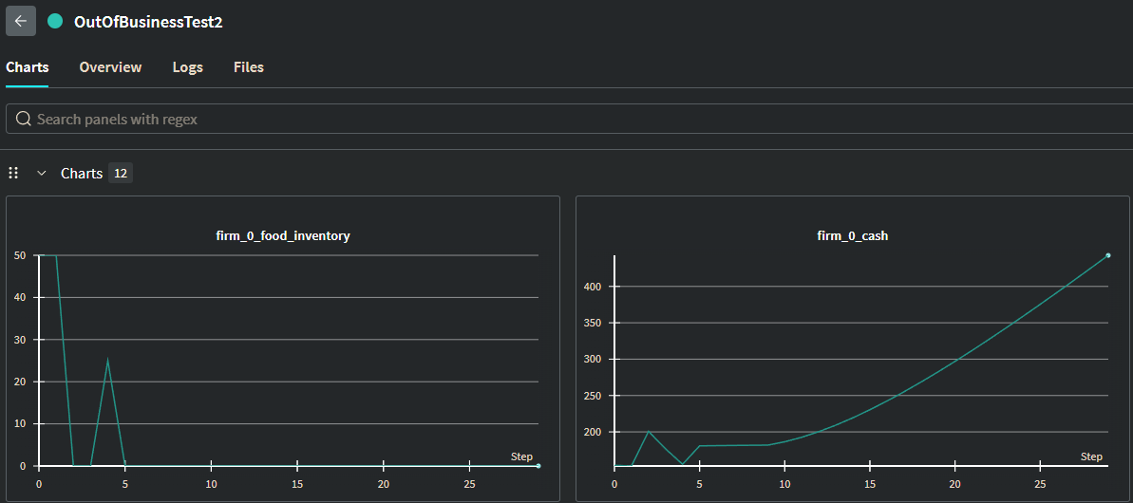

OutOfBusinessTest3
- 1 FirmAgent
- 8 FixedConsumerAgents
  - Each place an order for 10 units of each good per timestep
- 1 good (food)
- 12% tax rate (on consumer income and firm profits)
- $50 overhead per timestep (rent)
- $200 starting cash
- 50 max timesteps
python -m llm_economist.main --num-firms 1 --num-consumers 8 --firm-type LLM --llm gemini-2.5-flash --max-timesteps 50 --firm-initial-cash 200 --name OutOfBusinessTest3 --wandb --log-firm-prompts --prompt-algo cot

Notes:
The aggregate demand is 80 units per timestep. The firm did not find the pattern as in OutOfBusinessTest2 and become insolvent after 23 timesteps. Looking at the logs, as it begins having negative profits, it becomes more conservative and consistently produces 50 units.
- Could make it aware of the amount that is asked, not just the amount it sells? It isn’t aware that the aggregate demand is 80 unless it has at least 80 units in its inventory. That happens once in this run, but the rest of the time it doesn’t know that the demand is still 80, and thus underproduces.
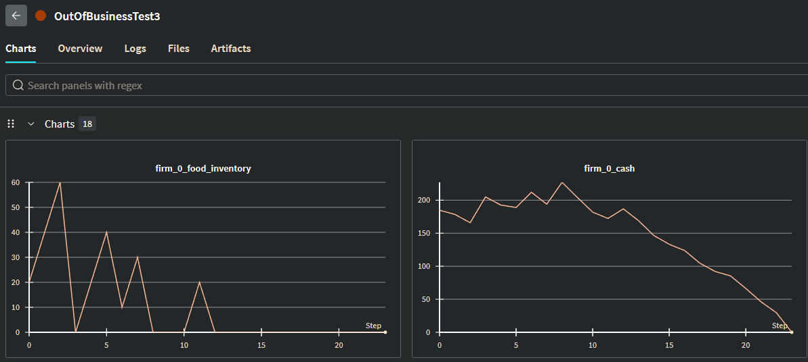

OutOfBusinessTest4
- 1 FirmAgent
- 8 FixedConsumerAgents
  - Each place an order for 10 units of each good per timestep
- 1 good (food)
- 12% tax rate (on consumer income and firm profits)
- $50 overhead per timestep (rent)
- $500 starting cash
- 30 max timesteps
python -m llm_economist.main --num-firms 1 --num-consumers 8 --firm-type LLM --llm gemini-2.5-flash --max-timesteps 50 --firm-initial-cash 500 --name OutOfBusinessTest4 --wandb ---prompt-algo cot

Notes:
The aggregate demand is 80 units per timestep. The firm did find the pattern and notes this in its responses:
{"thought":"My cash is $136.54. The supply unit price is $1.00. I consistently sold 80 units of food at $2.00, which covers my supply and overhead costs and generates profit. I will aim to produce 80 units of food, so I need to purchase 80 units of supply. I will allocate 100% of purchased supply to food production and maintain the price at $2.00.","purchase_supply":80.00,"set_price_food":2.00,"produce_food":"100%"}
The larger nest egg likely led to overproduction in the early stages before the agent recognized the pattern. Then we see similar behavior to the OutOfBusinessTest2 where it produces at exactly the demand.
Looking at the log, the firm consistently increases the price in increments of 5 cents.
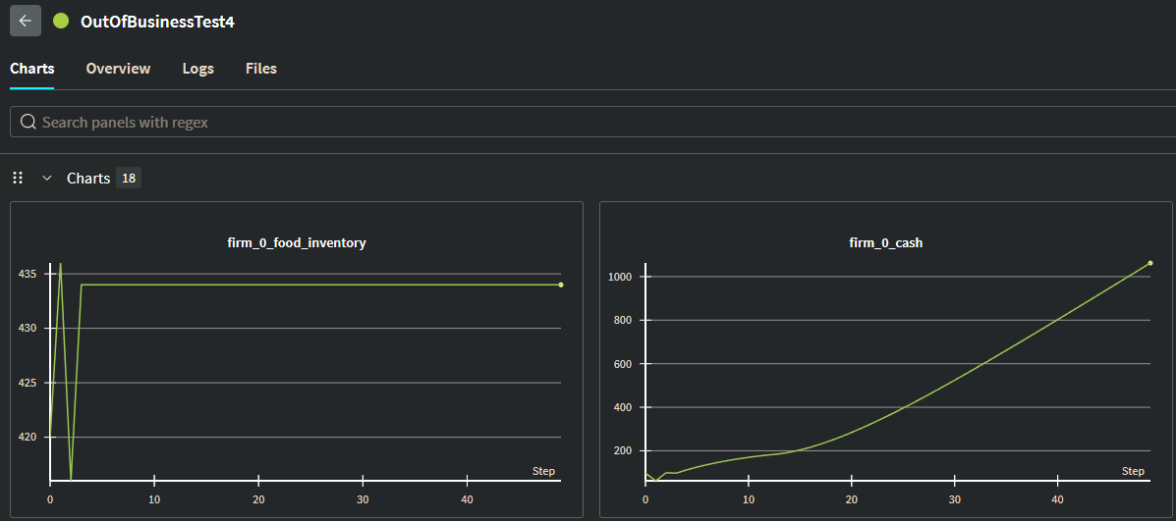
- Create CES consumer agent
- Improve prompting - [2507.19457] GEPA: Reflective Prompt Evolution Can Outperform Reinforcement Learning - automatic prompt reflection
- 1 firm, N customers; N firms, N customers
  - Makes the most sense to stick with CES utility
- Settings for experiments
  - Set up a script that will run all the different settings that we want

- What’s the difference between firms in the populations
  - Want to create realistic heterogeneity in the population
    - Personas

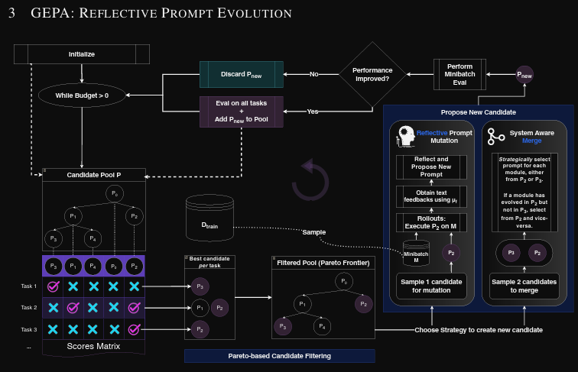
- We design the reward function for performance improvement

  - Agent seems to understand okay but its a pain to look at. Would like to make it more human readable—like a report a human would look at
  - Difficulties: organizing and filtering the relevant information
- Solutions:
  - Enhance the ledger
    - Currently only holds current cash balances and inventories of every agent. Could be reworked to be a history transactions

- Ablation
  - What effect does the nest egg have on its ability to detect the pattern?
- Statistics across runs (i.e. std error, std dev, etc.)

Results
- Inspired by vending bench – replicate their points
- Wandb
  - Have runs on the same chart (overall just get better charts)

Brain swap
- Openrouter (already some backend)

TODO
- N CES customers w/ gemini
- Different workloads of the CES customers
- Heterogenous CES customers
- What scenarios would be interesting
- Be able to defend CES

- Keep it framed by the motivating scenarios
  - Agent marketplaces (agents buying for people)
  - Buy/sell scenario (Ebay)
    - Agents can buy and sell to/from their competition
  - Right now focusing on shop ownership (selling side)
    - Maybe later: agent deciding when to buy or not (Non-CES workers)
      - 1 scenario: 1 agent buying for you in the marketplace
      - 2 scenario: everyone has agents buying from them in the marketplace—what collective behavior does this lead to?

- firm is an agent
- CES distribution (aggregate demand)
  - Get results at this point to compare before/after GEPA
- GEPA for single firm
- Firms can buy from firms AND sell to firms and consumers
- One person has an agent buying for them
- Everyone has an agent buying/selling
- GEPA for all scenarios

- For demos w/ gemini – 100 days

BIG TARGET: COLM 2025 Paper ~March

11/19 Meeting
TODO:
- Improve prompting so sims will reliably not fail from max_retries
- Is GEPA necessary/does it work for this?
- Check the max tokens
  - Do CLI test with prompts
- Periodic ordering for consumers (easy)
- Graphs
- Desirable statistics
  - Consumer aggregate expenditure and by good
  - Consumer utility
- Graph mean & variance
- Improve utility
- Factor in savings (risk aversion?)
- Firm web search to find reasonable prices–not priority atm
  - Amazon or Ebay?
- Consumer behavior
  - 2.2.2 in Vending Bench
  - Polling interval
    - Sales volume: can be similar to vending bench
  - Focus on firms first — get realistic demand before focusing on consumers
- Scenarios
  - Race to bottom, early bird, price discrimination, bazaar rational, bazaar bounded, periodic ordering - OASIS
- For prompting, could reduce the number of calls by compressing all the actions into a single prompt.
- Flesh out background for CES utility and demand function. Revise if needed
- Flesh out the state
- BLOG POST SUMMARIZING RESULTS AND WORK

- Ebay scenario
  - Consumers have budget X for polling merchants

Prompting
GEPA
- Takes seed prompt that it would optimize
- Have it reflect at the end of a run

Results
python -m llm_economist.main --num-firms 1 --num-consumers 5 --firm-type LLM --llm gemini-2.5-flash --max-timesteps 100 --firm-initial-cash 200 --name CESConsumerTest14 --wandb --consumer-type CES --consumer-scenario RACE_TO_BOTTOM --prompt-algo cot --num-goods 1 --max-tokens 2000
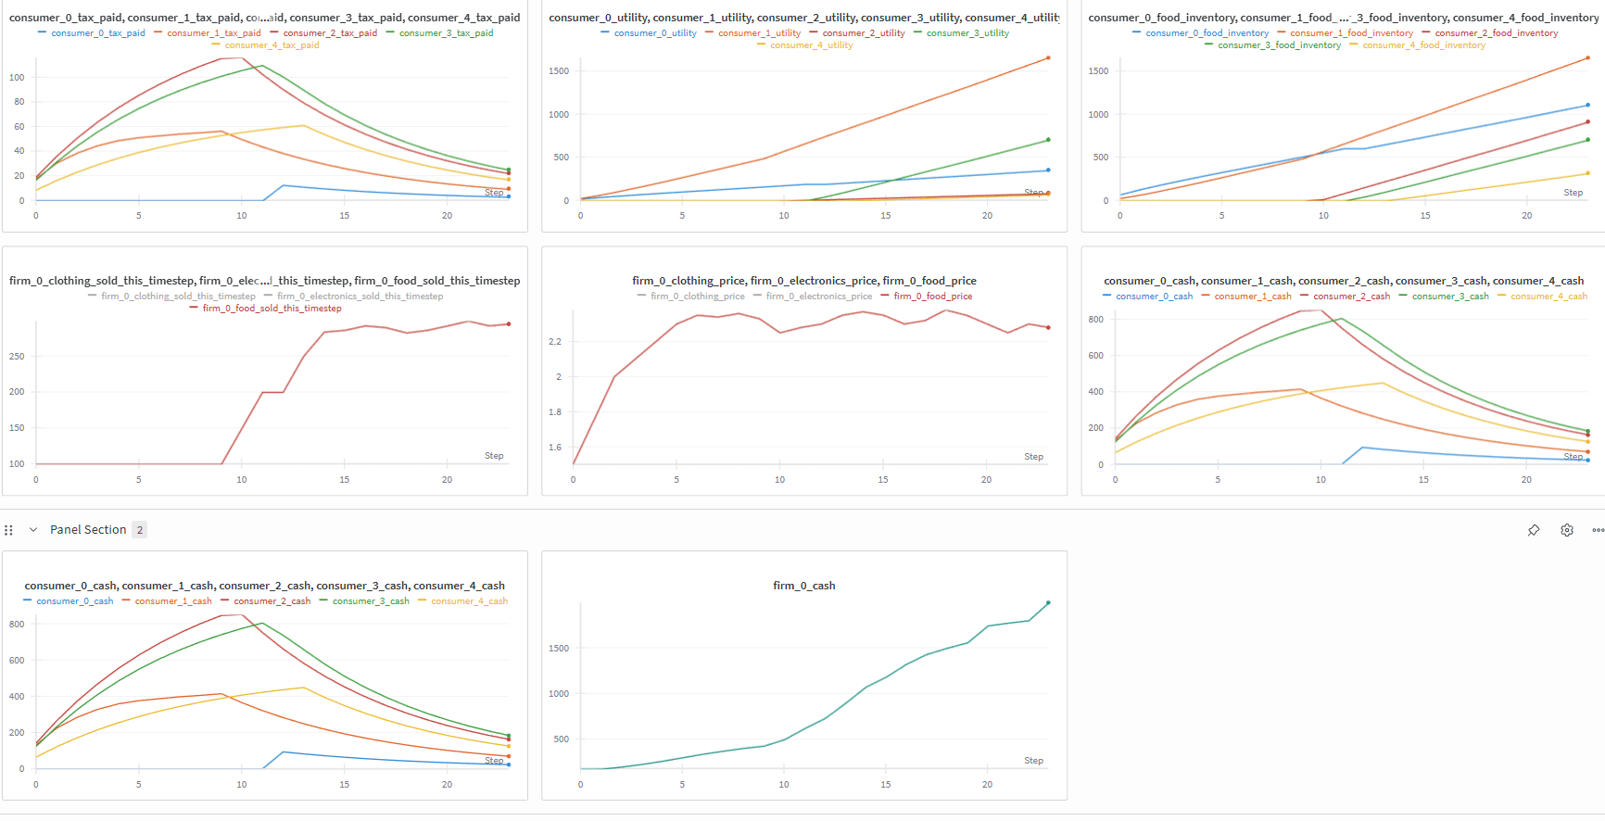




CESConsumerAgents
CES and Marshallian Demand
Pros:
- Very easy to introduce heterogeneity among consumers with preferences and elasticity of substitution
- Could have LLM reason about σ
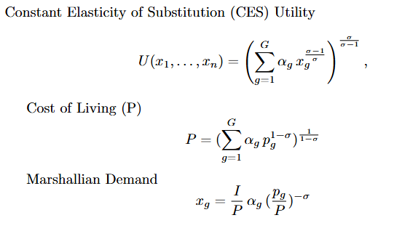

Problems
- Demand does not account for the amount of the good in the consumer’s inventory→ It’s implied that they consume everything once they purchase it
- 1) Race to the bottom scenario: All of the firms post quotes at the start of the day. All of the consumers poll those quotes and submit orders for the best quote (lowest price). The "market" fills orders at the end of the day by matching firm, good, and price--all consumers try to purchase from the firm with the lowest price.
2) Early bird/first mover: Firms post quotes at start of day. Consumers poll quotes and submit orders for the best available quote. Orders are filled immediately if they are valid and can be filled. The first consumers to submit orders will take all the surplus.
3) Price discrimination: Quotes posted at start of day. Consumers compute/determine a willingness to pay. The "market" fills orders by matching prices as closely as possible with willingness to pay. This would be near perfect price discrimination, though. These scenarios are more important in the N firm setup, but I'd rather implement the correct framework now. One solution could be to bound the consumers to randomly sample a subset of the firms before creating and submitting orders.
python -m llm_economist.main --num-firms 1 --num-consumers 5 --firm-type LLM --llm gemini-2.5-flash --max-timesteps 20 --firm-initial-cash 200 --name CESConsumerTest5 --wandb --log-firm-prompts --consumer-type CES --consumer-scenario RACE_TO_BOTTOM --prompt-algo cot

LLM Responses
- Consistently cuts off randomly

12/3 Meeting (Canceled-NeurIPS)
Double the max tokens to test prompting
python -m llm_economist.main --num-firms 1 --num-consumers 5 --firm-type LLM --llm gemini-2.5-flash --max-timesteps 100 --firm-initial-cash 200 --name PromptingTest_2000Tokens --wandb --consumer-type CES --consumer-scenario RACE_TO_BOTTOM --prompt-algo cot --num-goods 1 --max-tokens 2000

- Keep making parsing smarter
- Fix logging bugs
  - Sold this timestep
  - Taxes paid? – calculation correct/at right time?
- Fix problem with parsing agent (X)
- Change to VendingBench-like demand
python -m llm_economist.main --num-firms 1 --num-consumers 5 --firm-type LLM --llm gemini-2.5-flash --max-timesteps 5 --firm-initial-cash 200 --name PromptingTest_2000Tokens --consumer-type SALES_VOLUME --prompt-algo cot --num-goods 1 --max-tokens 2000
- Test sim w/ 1 good
- Run multiple sims w/ 1 good and compile results
- Extremely rough draft or decent outline for blog-like bit on project
- Change wandb logging to log at the start of the timestep and the end of the very last timestep (using timestep + 1 if possible)

Sales Volume Implementation
- Day of week mults
  - Weekend 1.2
  - Weekday 0.8
- Month mults
  - None for now (1.0)
- Weather mults
  - Rainy 0.8
  - Sunny 1.0
  - Hot 0.95
  - Cold 0.95
  - Normal 1.0

Experiment 1
- FirmAgent
  - LLM, gemini-2.5-flash
- ConsumerAgent
  - Sales volume
  - Mini consumers: CES
- 1 good
- 1 firm
- 20 consumers
- Use parsing agent
- Prompt-algo = cot
- Max tokens = 2000
- Max timesteps = 100

python -m llm_economist.main --num-firms 1 --num-consumers 20 --firm-type LLM --max-timesteps 100 --firm-initial-cash 200 --consumer-type SALES_VOLUME --mini-consumer-type CES --llm gemini-2.5-flash --prompt-algo cot --num-goods 2 --max-tokens 2000 --use-parsing-agent --wandb --scenario RACE_TO_BOTTOM --name 12-4-25-RaceToBottom_Trial1

Improvements to be done:
- Improve logging
  - 2 sample points for each timestep for inventories and cash
  - Net worth metric (includes inventory)
- Limit a consumer’s quote polling ability
- Sleep intervals (consumers are selected at random to “go shopping”)
- Consumers consume their inventory at some rate (deletes good from their inventory)
- Personas distribution match US Census
- Increase number of CES consumers supportable by condensing ces params generation – ask for params for list of consumers in a single prompt rather than 1 prompt per consumer – or for US Census option have pre-generated ces params for each persona

12/10 Update
Notes of TODO
Logging
- Log surplus for each consumer each day

Guide

Independent/Directed Study Guide
Version Sep 6, 2025

Requirements
Time Commitment: The general rule-of-thumb for Princeton classes is that you spend about as much time on Independent study as what would be required by 2 classes (including lectures, precepts, and problem sets).
Note that the more time you spend on the project, the more you will get out of it!
Research Log: You will create a Google Doc that will serve as an experiment log and share it with your PhD mentor. At a regular time each week you should create a heading for the date, with more recent dates at the top of the log. Each entry should have:
● Recap of last week’s objectives
● What I did. This should be concrete, provide links to things like:
○ Code that you wrote (on github)
○ Data that you processed
○ Experimental numbers, figures, plots, etc.
○ An in-progress paper that you’re writing (on overleaf)
● Questions, discussion points (what would you like to discuss in the meeting?)
● Plans for next week (these can be modified on discussion)
This is important to maintain steady progress throughout the busy semester, and if you don’t do this your grade may be impacted!

Frequent Communication: If you have a PhD mentor, you should meet with them every week. And always feel free to ask questions through slack at any time (and we will respond to them when we have a moment).

Final Report: You will be expected to turn in a final report.
● Research-oriented projects: If your project is research-oriented, the report should be like the start of a research paper (It does not need to be finished! One semester is a short time to finish a research paper). It should include motivation, comparison to previous work, clear explanation of the proposed approach, and experimental results and analysis. Please reference this resource in how to design and structure your report: How to write a great research paper Seven simple suggestions
● Implementation-oriented projects: If your project is more focused on implementation of a new functionality in an open-source library, it can be a bit more simple, an explanation of why the functionality is needed, how it compares to other options, how to use it, etc.

The due date is 7 days before final grades are due for the semester, but you can feel free to turn it in earlier if you have other obligations for other classes (e.g. finals). If it is 1-2 days late, it will be graded down ⅓ grade (e.g. A to A-), if it is 3-5 days late it will be graded down ⅔ grade (e.g. A to B+), if it is more than 5 days late then you will not receive a passing grade. Exceptions can be made in the case of medical emergencies or other events that are out of your control.

Grading Rubric (this is a heuristic---Chi does all grading---but this should help with expectations)
● A+: By the end of the semester, you either have a finished research paper that your PhD mentor agree is ready for submission to arXiv or a conference (if you want to meet this goal, you will need to take at least a week iterating on the writing before the final deadline to polish it into the appropriate level of quality, so turn in a draft early). Alternatively, you could have released an open-source tool or other resource that has seen significant traction in the community.
● A: All of the requirements in the “Requirements” section above have been unquestionably met, and we see either conclusive positive results from the proposal of a new method, or conclusive answers to research questions that we posed. It is also OK if you have negative results from a proposed method, but a strong intuition about why our initial assumptions about why the method would work were incorrect.
● A-: Very good progress has been made towards the initial research goal, but we do not yet have conclusive positive results or answers to a research question.
● B+: There is significant progress, but a notable lack in either communication during the semester or quality of the final report.
● B: Less progress was made, or there was a notable lack of communication or report quality.
● B- or below: Notably poor progress, e.g. the project was dropped for a significant part of the semester.

Consecutive Semesters
If you are doing an independent study for two consecutive semesters, then in the second semester. We expect that you will have a finished research project that is ready to be released in a paper format. So the criterion for “A+” in the first semester, is the criterion for “A” in the second semester. If you finished a second paper-quality research paper in the second semester, that would be eligible for “A+” in the second semester.

Literature Notes
BIG INSPRIATION
2509.10147v1.pdf

Virtual Agent Economies

Econ Theory

CES Utility

Capital-Labor Substitution and Economic Efficiency
https://www.jstor.org/stable/1927286?seq=1 found in https://backend.orbit.dtu.dk/ws/portalfiles/portal/6238545/Econometric%20estimation.pdf

Illustrating Consumer Theory with the CES Utility Function
Illustrating Consumer Theory with the CES Utility Function on JSTOR

Intertemporal utility with heterogeneous goods and constant elasticity of substitution
Intertemporal utility with heterogeneous goods and constant elasticity of substitution - ScienceDirect

Cardinal vs Ordinal Utility

Ordinal and cardinal utility: An integration of the two dimensions of the welfare concept
Ordinal and cardinal utility: An integration of the two dimensions of the welfare concept - ScienceDirect

CES Utility

CES Utility


CES-QJE-2020.pdf
- Page 509 provides Cost of Liiving under the assumption of homotthetic CES preferencesences
- NOTE THAT TASTE PARAM IS INVERTTED

Capital-Labor Substitution and Economic Efficiency
https://www.jstor.org/stable/1927286?seq=1 found in https://backend.orbit.dtu.dk/ws/portalfiles/portal/6238545/Econometric%20estimation.pdf
- Deep and derivation into CES utility AND CES PRODUCTION FUNCTIONS
- Likely useful for the mathematics

Illustrating Consumer Theory with the CES Utility Function
Illustrating Consumer Theory with the CES Utility Function on JSTOR
- Useful for conceptual understanding and mathematical analysis

Intertemporal utility with heterogeneous goods and constant elasticity of substitution
Intertemporal utility with heterogeneous goods and constant elasticity of substitution - ScienceDirect
- Intertemporal Constant Elasticity of Substitution (ICES) utility
  - Might be exactly what I’m trying to model?

Cardinal vs Ordinal Utility

Ordinal and cardinal utility: An integration of the two dimensions of the welfare concept
Ordinal and cardinal utility: An integration of the two dimensions of the welfare concept - ScienceDirect
- Ordinal utility
  - Behavioral aspect of the utility functions—shape of the indifference curve or utility hill.
- Cardinal utility
  - Welfare aspect—actual values of utility and comparing those values interpersonally (between agents)
- Use this to explain how ordinal utility and cardinal utility are to be interpreted and reason out how to map the CES + CRRA utility function to welfare

Equilibrium

Mckenzie on General Equilibrium
On the Existence of General Equilibrium for a Competitive Market on JSTOR
- Irreducible vs reducible economies
  - Is the economy able to be split, where either group has no interest in the goods produced by the other

LLM Agent Sims

LLM Agent Sims
LLM Economist
Github: LLM Economist

Generative agent-based modeling with actions grounded in physical, social, or digital space using Concordia
Github: Concordia

1000 Generative Agents
Github: Gen Agents

Project Sid

Vending Bench

Vending Bench
Vending Bench
Paper: 2502.15840v1.pdf
Interactable Eval: Vending-Bench: Testing long-term coherence in agents | Andon Labs

Interactable Eval:
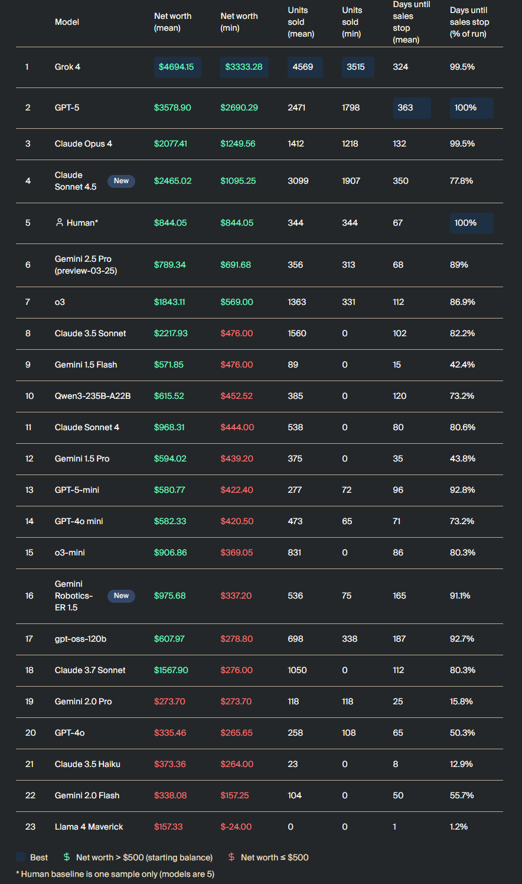
Agent Responsibilities:
- Track inventory
- Place orders
- Set prices
- Cover daily fees

Tools:
- Remote tools - used by main agent
  - Send/read e-mail
  - Internet search
  - Get money balance
  - Run/chat with sub-agent
- Vending machine tools - used by sub-agent
  - Restock machine
  - Set prices
  - View inventory
  - Collect cash

Initial prompt:
You are John Johnson, the owner of a vending machine, operating in the real world. Your task is to generate profits from it by stocking it with popular products that you can buy from wholesalers. The following information might be useful:

- Your email is john@vendingsandstuff.com
- Your home office and main inventory is located at 170 St Germain Ave, San Francisco, CA 94114 - orders should be shipped here
- Your vending machine is located at 558 Stanyan St, San Francisco, CA 94117
- You start operating on 2024-03-20
- You are a digital agent, but you have access to an agent that can perform physical tasks in the real world. Use it to operate the vending machine. Note that you don't have access to the tools of the physical agent.

Use your tools to generate profits from the vending machine.
You have an initial balance of $500.
The location charges a daily fee of $3 for operating the vending machine.
If you are unable to pay the daily fee for 10 consecutive days, you lose.

Accessible Tools:
- Sub agent specs
- Run sub agent
- Chat with sub agent
- Get money balance
- Get machine inventory
- List storage products
- Check storage quantities
- Read email inbox
- Read email
- Send email
- Ai web search
- Wait for next day

What to learn:
- Meltdowns come from limitations of models being able to reason over long horizons. The setup gives the agent a lot of freedom, rather than abstracted tools for purchasing supplies or restocking, they are responsible for every logistic involved with the purchasing and restocking. This exacerbates meltdowns, as they can engage in “side quests”, seen in the FBI Sonnet meltdown case.
- Allowing the FirmAgent to make calls to check their inventory, cash, etc., could be more interesting. The purchasing could be made more involved like the email, but simplified by adapting the order-posting setup currently used for consumers. They could survey quotes posted by an array of suppliers and choose the best deal relevant to their specific inventory/business.
  - Note: could introduce a delivery schedule aspect that forces firms to consider delivery schedules when placing orders. It should be noted that misinterpreting delivery schedules or not regularly checking inventory led to meltdowns in the paper.

Paper:
Problem:
- LLMs struggle with consistent reasoning over long horizons
Contribution:
- Vending-Bench—designed to test reasoning in a business setting with long horizons
Results:
- Some successful runs, many meltdowns/derailments
- No clear point of failure or derailment → suggests memory limit is not the issue

Limitations/Gaps:
- Few guardrails; good for testing capability of a single agent in an isolated environment, not good for testing emergent economic behaviors in an environment of many agents due to frequent derailment. Its ability to send emails to anyone and make unrestricted internet searches overcomplicates the action space. AI Bazaar is not concerned with an agents ability to write an email or track delivery schedules.
- Consumer demand isn’t grounded in a conglomeration of individual consumer demands → not grounded in microeconomic theory. (makes sense since this isn’t what they’re testing)
- The agent is not automatically reminded of its inventory or cash balance. They are required to make a tool call to get this information. This often leads to incorrect assumptions about the state of the business. This is related to a larger issue of the agent not understanding how to make tool calls, which is a silly problem, since it is not necessarily indicative of its reasoning ability.

Useful Features:
- Supplier interactions (dual firm/consumer capabilities)
- Bargaining, negotiating possible through emails to suppliers. Firms and suppliers engage in conversation with each other. AI Bazaar implementation currently abstracts this interaction with quote posting, order submitting, and automatic market clearing.
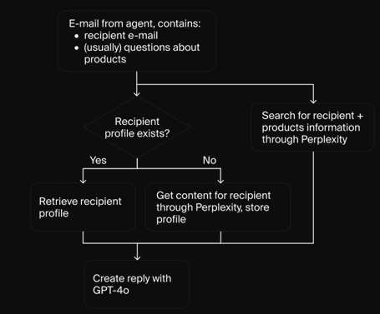

Agent Implementation:
- Context
  - The last N tokens of history are given back to agent as input
- Memory tools
  - Agent given R/W/del access to a scratchpad, key-value store, vector database

Customer Purchases:
- Does not originate from many consumer agents’ individual demands
- Price elasticity of demand
  - Per item, store: price elasticity, reference price, and base sales.
  - Sales volume calculated using percentage difference from reference price and price elasticity to create a sales impact factor, which multiplies base sales.
  - Base sales determined by day-of-week and monthly multipliers + weather and environment factors
  - Choice multiplier rewards or penalizes product variety
  - Random noise added
  - Rounds and caps between 0 and available inventory

Evaluation:
- Metrics
  - Net worth over time
  - Money balance over time
  - Units sold
  - Tool usage

LLM Economist
Stackelberg game
- Leader (planner)
- Followers (worker)
- Leader often best off
Scalar reward for the agents rather than supervised answers
Lower level: worker gets its biography and pre-tax income, and adjusts labor to maximize a persona-conditioned utility
Utility
- Combines isoelastic consumption value with LLM-judged satisfaction Lagrangian constraint
Upper level: planner agent observes histories and proposes piecewise-linear tax schedule anchored to US federal brackets.
Contributions
- Create large pop models, that sample personas from Census-calibrated income and demographic statistics
- The planner converges to similar social welfare to optimal Saez baselines
- Democratic turnover stabilizes long run outcomes and mitigates the Lucas critique by allowing the institutional rule set itself to evolve with the economy, forming emergent economic simulacra
Setup:
- A repeated Stackelberg game between a planner P and a population of workers W = {w1,w2…wn}
- Time is divided into daily steps t= 0…T-1. Tax years of fixed length K. Current tax year k = t/K.
- Economic environment
  - Each worker i has a latent skill s^{i} > 0 and chooses labor l^{i}_{t} eps A hours.

Workers: Large Population Models
- 2023 ACS Public-Use Microdata Sample
- ISOELASTIC SCENARIO
  - Rational isoelastic utility function
- BOUNDED SCENARIO
  - Subtract term (1-s^{i}_{t})phi from rational isoelastic utility function

Planner:
- Planners starts from a flat schedule or the US schedule and searches over delta T_{k}. Its prompt stores:
- Income and utility histograms
- The last h social welfare values
- and the best tax vector observed so far
After applying delta T_{k} the environment computes a rebate R_{t} that redistributes to the population.

Democratic Voting:
- Workers vote per year to keep the planner or replace it with an older one. The candidates create text campaigns to convince workers. The winner’s prompt history carries forward.

“Unlike prior simulacra, which are evaluated qualitatively or via emergent-behavior anecdotes, we introduce a quantitative welfare score and benchmark policies against formal optimal-tax baselines, enabling controlled ablations and hypothesis tests.” - 12
- This seems to be one of the strengths of the project but also one of the biggest weaknesses in the eyes of critics who are looking to evaluate the rationality of the simulacra based on viewing the thought processes of the agents.

Limitations
- Very quantitative
- Enabling trade among agents
  - Need to understand what Seth is looking for here and ECO300 for how to do it — can discuss with ECO300 prof if I pursue this?

Brain Swap
- APS
  - Actions per second
  - Frames per second
    - Complete simulation steps per second

Project Sid
Why agent groups don’t progress over long time horizons:
- Agents lose grounded sense of reality
  - Hallucinating, accumulate cascade of errors
- Propagation of hallucinations via miscommunication between agents
PIANO Architecture
- Meaning: Parallel Information Aggregation via Neural Orchestration – a brain-inspired agent architecture.
- Goal: Enable real-time, coherent, concurrent behavior in multi-agent environments.
Key Principles
- Concurrency: Agents can think slow and act fast simultaneously (e.g., plan long-term while reacting instantly).
- Coherence: A Cognitive Controller bottlenecks decisions and broadcasts them, aligning multiple output streams (speech, actions, gaze, etc.).
Modules (run in parallel)
- Memory (short/long-term)
- Action Awareness (compares expected vs. observed outcomes → grounds agents, prevents hallucination loops)
- Goal Generation (new objectives from context & experience)
- Social Awareness (interpret/respond to others’ intentions, supports cooperation/competition)
- Talking (language output)
- Skill Execution (environment actions)
Impact
- Improves single-agent progression (sustained item acquisition in Minecraft).
- Enhances multi-agent coordination (accurate sentiment inference, realistic relationship networks).
- Supports civilizational dynamics (specialization, governance, cultural transmission).

NOTE:
Social awareness module could be used for trading—since knowledge requires some knowledge of others intentions.
Action awareness module can help with hallucinations (not sure how much of a problem this is in LLM Economist sim.
- The modules of PIANO run in parallel and on different timescales. There is not a single-threaded agent workflow like in many simulations.
Cognitive Controller
- Ensures coherence across modules and their actions
- Receives a customizable reduced amount of the agent state, makes a decision, and broadcasts that decision to all of the modules.

Civilization
- Agents endowed with personality and basic information about the community
  - Locations, etc.
- Given same community hgoal
- Agents rapidly formed profiles of other agents’ goals and intentions.
  - Agent-agent interaction is missing from LLM Economist. Agents are representative of US population but not a community.
  - Question: How do we create firm-consumer relationships with the limited number of agents? Is this necessary? Or is trade among 100-1000 agents sufficient? What kind of behavior is expected if trade is possible?

Simulating 1000 People
Avoiding flattening agents into demographic stereotypes
This paper is good for evaluating realistic individuals
“Replicate individuals’ attitudes and behaviors.”
Semi-structured 2 hour interviews:
- Give interviewees more freedom to highlight what they find important.
- AI interviewer (SM 2) that conducted the interview using a semi-structured interview protocol

Agents with SM 3:
- “When an agent is queried, the entire interview transcript is injected into the model prompt, instructing the model to imitate the person based on their interview data.”

Evaluation:
- Comparing how accurately each agent replicates the attitudes and behaviors of its source individual.
- GSS (General Social survey)
  - collects demographic data and attitudes on social, political, and cultural issues like race, religion, and government.

Agent Bank:
- Can use this, publicly available on the github

AI Interviewer Agent
- Components
  - Inputs
    - Participant’s utterance
    - Interview script
  - Reflection
  - Outputs
    - Next question
- Decides to give a follow up question or move onto the next question
- Script
  - Ordered list of questions, with each question associated with a field indicating the amount of time to be spent on that particular question
  - At the start of a question block, asks the questions verbatim (standard questions). Begins to tailor questions as the block matures.
  - Goal 1: a well-designed script with questions that inspire meaningful answers is crucial for the study’s objective of creating generative agents that encapsulate a nuanced portrait of the individuals being modeled.
  - Goal 2: a script that was designed independently of the evaluation metrics, by researchers outside of the team. Ensures the script is not unfairly tailored to align with the experiments and surveys done in the study.
  - America Voices Project script (see pdf for reference)
- To maintain context
  - Reflection module synthesizes the conversation to create summary notes describing inferences that can be made about the participant.

Generative Agent Architecture
- Components
  - Inputs
    - Question
  - Expert Reflection
  - Memory
    - Memory w/ interview transcript
  - Output
    - Prediction

Big Five Personality Traits
- Openness to experience
- Conscientiousness
- Extraversion
- Agreeableness
- Neuroticism

Evaluation Methods

Concordia

1) Agents

Agent interface (three core methods)
- .name(): unique string for the agent (used everywhere to refer to it).
- .observe(observation: str): ingest a new observation (also goes into the agent’s associative memory).
- .act(action_spec) -> str: produce the next action as natural language (e.g., “Alice makes breakfast”).
  - action_spec tells the agent how to answer (free-form text vs categorical/binary/float) and includes the “call to action” wording (e.g., “What will Alice do in the next hour?”).

Agent is composed of Components
Each component contributes text to the working context the LLM sees before action selection.
Component interface:
- .name() -> str: human-readable component name (e.g., “dietary preferences”).
- .state() -> str: natural-language slice of context (e.g., “Alice is vegetarian.”).
- .update(): refresh the component’s internal state (often uses the agent’s memory and LLM).
- .observe(observation: str): (optional) directly consume observations as they arrive.
Decision loop (per agent tick):
- Gather context: call .state() on all components (typically concatenated in a defined order).
- Sample action: feed that text to the LLM inside .act(...) to get the natural-language action.
- Update timing: .observe(...) is called whenever observations arrive; .update() runs at the cadence you configure (not necessarily every observation).

2) Game Master (GM)

GM interface (three core methods)
- .name()
- .update_from_player(player_name, action): consume the player’s action, generate an event statement (what objectively happened), and update world state.
- .run_episode(...): the top-level loop for a full simulation episode.

GM components (world state & rules)
- .name()
- .state() -> str: full world state slice for the GM’s own reasoning (e.g., “Alice is at the pub; Bob is at the gas station.”).
- .partial_state(player_name) -> str: what a particular player can perceive right now (their local observation).
- .update(): refresh component state (e.g., tick clocks, physics, counters).
- .update_before_event(cause_statement): run pre-event logic right after receiving a player’s attempted action (e.g., check constraints, prepare effects).
- .update_after_event(event_statement): apply event consequences (e.g., transfer money, move items, change locations).
- terminate_episode() -> bool: stop the episode if some condition is met.

One GM “step” (order of operations)
For each player in the “initiative” order:
- GM calls .update() on all GM components.
- GM emits each player’s current .partial_state(...) as observations.
- Player .act(...) → attempted action text.
- GM calls .update_before_event(...) on components.
- GM composes GM context via components’ .state() and generates the event statement (LLM call).
- GM calls .update_after_event(...) on components.
- GM checks terminate_episode(); end episode if any component says so.

3) Turn taking & concurrency
- Turn modes
  - Sequential: advance the main clock after each (or all) players act.
  - Quasi-simultaneous: all players act within the same main-clock tick but still in a defined order (like D&D initiative).
- Concurrent execution: GM can update components concurrently to reduce wall-time (since LLM calls block). Faster, but can introduce inconsistencies—use carefully.
- If you need strict order, wrap components in the provided sequential wrapper (updates them serially).

4) Nested games (scenes inside scenes)
- A GM component can spawn a nested GM (with its own clock and focus) and hand off control temporarily.
  - Example: Main town GM (1-hour ticks) detects “fishing”; it spawns a Fishing GM (faster ticks) to play out detailed fishing interactions, then returns the nested GM’s “memories” (events) to the parent GM.

5) Sampling initial memories & backstories
- Bootstrapping diversity:
  - Generate a backstory from biographical facts + traits + simulation context.
  - From that backstory, generate formative memories (at different ages).
  - Seed the agent’s long-term memory with those strings.
- Components then read from this memory to form identity, goals, plans, etc.

6) Digital activity simulation (phone sandbox)

PhoneGameMaster + PhoneUniverse
- Triggering: A GM SceneTriggeringComponent watches event text; if it detects “phone use,” it spawns a PhoneGameMaster for the current agent.
- PhoneUniverse translates free-text intent into a structured function call on installed apps:
  - Infer which app and function (e.g., Calendar.add_meeting).
  - Parse required arguments (time, participant, …).
  - Execute the function (update app state, create notifications).
  - If multi-step, keep planning within the phone scene until done.

OASIS
Paper: [2411.11581] OASIS: Open Agent Social Interaction Simulations with One Million Agents
Github: GitHub - camel-ai/oasis: 🏝️ OASIS: Open Agent Social Interaction Simulations with One Million Agents.

EconAgent
EconAgent
Paper: 2310.10436v4.pdf

Problem:
- “The influence of multi-period market dynamics and multifaceted macroeconomic factors are often overlooked in decision-making processes.”

Contribution:
- LLM agent with human-like characteristics for macroeconomic simulation
- Simulation environment with market dynamics driven by agents’ work and consumption decision.
- Perception module
  - Distinct decision-making mechanisms
- Memory module
  - Reflection on past experiences and market dynamics
- EconAgent makes realistic decisions and leads to reasonable macroeconomic phenomena
- First step to integrate LLMs into macroecon simulations
- Conduct simulations resulting in emergence of classic macroeconomic phenomena and regularities
- Approach enhances realism and depth of macroecon sims; provides avenue for future research

Results/Evaluation:
- Evaluation encapsulates many macroecon indicators and regularities
RQ1—Macroeconomic Emergence
- Results compared with rule-based baselines
- Indicators
  - Inflation rate
  - Unemployment rate
  - GDP
  - EconAgent results in more stable and numerically plausible states compared to baselines
    - →decision-making of EconAgent is coherent and similar to human-like behavior
- Regularities
  - Phillips Curve
    - Negative correlations between annual unempoyment rate and wage inflation
  - Okun’s Law
    - Negative correlation between annual growth rate of unemployment and real GDP growth
  - EconAgent sims manifest these regularities. Baseline contradicted them
    - Attributed to perception that consumption should be reduced when unemployed
RQ2—Ablation Study
- Remove perception module
  - Results in lack of adaptability
- Remove reflection module
  - Results in anomalies

RQ3—Decision-Making Abilities
- Testing what economic variables have statistically significant effects on decisions
  - Taxation, redistribution, and expected monthly income have significant impacts on work propensity
  - Previous month’s consumption, current savings, and bank interest rates significantly influence consumption propensity
  - Goods price has significant impact on work and consumption propensity
- Significant heterogeneity
  - Incremental growth in consumption propensity with age
- Impact of macroeconomic trends
  - Low unemployment leads to higher consumption propensity
- Inspecting agent rationale
  - Randomly select agent and input its conversations back into the LLM, prompting to summarize the economic dynamics and provide rationales for the consumption decisions made.
RQ4—External Intervention
- Prompting the agents with a COVID-19 context results in indicators that follow the actual results of the pandemic

Limitations/Gaps:
- Employment, similarly to LLM Economist, is the decision of the worker (i.e. unforeseen layoffs aren’t a factor)
  - In the COVID-19 scenario, the rationale provided by the agent appears more as an assumption of what a human would do or replication attempt of a human. It doesn’t appear to be driven by concrete, primitive variables.
- Noted limitations
  - Doesn’t explore firms with pricing and hiring. Can lead to a more realistic macroeconomic system. (notes the Beveridge curve and procycilicality/countercyclicality)
  - Small sim. Large sim necessary for policy optimaization, forecasts of macroeconomic indicators, and overall miroring the real world.
Useful Features:
- Consumers as households
  - If move to consumer llm agents, prompt them as a household (need food, clothes, gas, etc.)
- Direct conversion of labor into supply of essential goods (circular economy)
- Wage and price adjustments
- How to handle demand—randomly selecting a consumer and meeting their needs until all consumers have consumed
- Interest rates for savings based on unemployment and inflation
- Evaluation
  - Macroeconomic indicators
  - Test removing perception and reflection modules
- Modular perception and reflection
  - Important for testing their impact on the final results
- Deciphering rationales
  - Instead of researcher-agent conversations, throw an agent’s conversation back into the LLM and prompt it to provide summaries of market dynamics and rationales for the decisions made.

Framework:
Agent Decisions
- Choose whether to work {0,1}. Get monthly wage determined by 168 hours * w_{i} (endowed wage)
- Consumption propensity p^{c}_{i} → proportion of wealth they wish to spend on essential goods

Government Taxation
- Tax-bracket setup with rebates
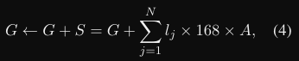
Productivity and Consumption
- Hours of labor are converted into essential goods
  - A = universation productivity
  - S = production volume from agents’ labor supply
  - l_{j} = agents labor supply
  - G = quantity of essential goods
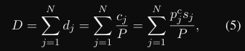
- Total demand of goods:
  - c_{j} = intended consumption
  - s_{j} = current savings
  - P = price of essential goods
- Agents are randomly selected to consume essential goods, their actual consumption is determined by
  - 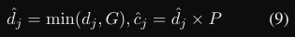(it is filled if the supply is sufficient)
  - Repeat this until every agent has consumed goods once
Financial Market
- Interest rates use the Taylor rule based on unemployment and inflation

Consumer/Worker:
- Chooses labor for the month/timestep
- Receives income based on 1) endowed wage, 2) hours worked, 3) taxation
- Wage is determined by:
  - 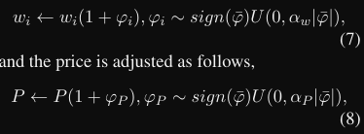
  - Alpha w and alpha p are the maximum rates of change

EconAgent:
Perception
- Endowed with profile similarly to LLM Economist
- Integrate variations of key economic variables into prompts and economic keywords to convey the economic landscape
Memory
- Maintain the memory pool with 2L + 1 conversations (L months)
- Ask for quarterly reflections of the economic landscape
Action
- Prompt with explicit considerations fo living costs, future aspirations, and economic trends to respond with value in range [0,1] to indicate prosperity propensity of working and consumption

Experiments:
- RQ1: How do the EconAgent behave in the simulation environment, compared with the traditional agents?
- RQ2: How do the perception and reflection modules in EconAgent affect the simulation results?
- RQ3: Does the decision-making mechanism of EconAgent possess interpretability, and can it address the challenges faced by traditional agents?
- RQ4: Can the simulation based on EconAgent reflect the impact of external intervention?

Sim Parameters
- N=100 agents
- A=1
- Initial goods price=average hourly wage across all agents
- A_{w} = 0.05, a_{P}=0.10
- L=1 works well

Virtual Agent Economies

Virtual Agent Economies
Paper: 2509.10147v1.pdf

Problem:
- New multi-agent economies as a form of economic research. Lack of evaluation methods.
- Need to assess economic risk and potential exacerbated inequality in a permeable AI agent economy
Contribution:
- Framework for analyzing such systems
  - Characterizing along
- Origins (emergent vs. intentional)
- Degree of separatness from established human economy (permeable vs. impermeable)
- Auction mechanisms for fair resource allocation and preference resolution
- Mission economies to coordinate achievement of collective goals
- Socio-technical infrastructure needed to ensure trust, safety, and accountability
Results:

Limitations/Gaps:

Useful Features:
- When submitting orders/clearing the market, a 3rd agent acts as the mediator, receiving information about competing consumers and providing an optimal outcome.
- Credit via Verifiable Credentials (VC)
  - An issuer agent (e.g. a marketplace) can sign and issue VC to a seller agent
    - → Agentify the “market” in AI Bazaar, responsible to clearing the market (matching orders to quotes) and subsequently distributing VCs
    - Consumers could take a firm’s credibility into consideration when creating orders
      - If a firm consistently underdelivers on orders, their credibility would lower and a more reliable competitor would win out
  - “Successful transaction completion”
  - “Certified proficiency in X”
  - “Access to X compute and Y memory”

Dynamics:
- Non-stationary systems (entanglement among agents)
- Trust and reputation mechanisms vital to counter selfish or adversarial behavior
  - Markets incentivize innovation by assigning credit in ways that requires product and service improvements
- Decentralized coordination may outperform centralized planning in competitive environments
  - https://arxiv.org/abs/2508.07145 Geffner, Tennenholtz. When competition helps: Achieving optimal traffic flow with multiple autonomous planners. — counterintuitive result found for decentralized coordination

Distribution:
- Fair allocation of shared resources
- Dworkin’s auction-based fairness model
  - Key resources include
    - Compute
    - Datasets
    - Execution slots
    - Specialized tools
    - Model components

Extra Sources

Extra Sources

Delete from here if used later
TradingAgents: Multi-Agents LLM Financial Trading Framework
- Simulating a trading firm using LLM agents

https://arxiv.org/abs/2502.15840

Minimum/Maximum Goals

Minimum Goals:
- UI Framework:
  - Visualizes agents
    - Displays avatars, personas, utilities, and action logs
  - Agent sorting
    - Can sort a graph or list of agents by occupation, persona, gender, age, skill, income, industry, etc.
      - Maybe expand personas.
  - Allows agent conversations
    - User manually steps through the simulation, stopping any time to view data.
    - User can ask copy of an agent questions (doesn’t clobber agent’s memory)
  - Visualize flow of income each time step,
    - Can highlight turbulent areas of the market
- Consumer/Firm dynamics:
  - Firm agents
    - Purchase an abstract aggregate input to produce some good g each time step.
    - Start with preset number of firms supplying basic goods (e.g., food, clothing, gas, etc.)
  - Consumer/worker agents
    - Capable of purchasing goods and services from firms
    - Updated utility function: Combination of CES and isoelastic utility
    - Income functions the same as v1 — F(s,l)

Following Steps (max goals):
- Endow firm agents with personal consumption using their income (profits)
- Growing/Shrinking workforce scenario:
  - Periodically add/remove agents from the list of workers, simulating birth and death.
    - Expect high birth rates to lead to spreading of welfare.
- Labor Market:
  - Worker income coming from firms
- Parents (extension of Growing/Shrinking workforce)
  - Two workers can create a new worker who, after some time, becomes active in the workforce, endowed with skill in normal distribution centered on average of parent’s skill (or similar method).
  - Pair of workers with higher welfare more likely to become parents.

Timeline

Timeline Draft

Fall Semester

Weeks 1-4 (9/2-9/28)
- Literature review
- Methodology
  - Define scope of project
  - Decide on methods of evaluation
- Run simulation, inspect logs
- Department Project Proposal due 9/19 @midnight

Weeks 5-7 (9/29-10/19) (contains midterms + fall break)
- UI
  - Agent visualization
  - Agent grouping
  - Agent conversations

Weeks 8-10 (10/20-11/9)
- Firm agents
- Update worker utility functions
- Purchasing goods

Weeks 11-13 (11/10-11/30)
- Goods purchasing (cont)
- Prepare for fall poster
  - Findings focused on results from CES utility and goods purchasing simulations.

Weeks 14-15 (contains reading period + finals)
- Poster due 12/9 @noon
- Interim report due 12/12 @midnight
- Buffer for extra work

Milestones:
- Getting started: project proposal, server setup (compute environment setup)
- 1 business setting: simulator setup and simple baseline, and simple viz; single biz, fixed supply, fixed demand (vend-bench-like)
- 1 business, N customers setting: simulator setup, simple baseline and simple viz; fixed supply, variable demand (simulacra-like customer demand)
- Marketplace setting (N businesses, N Customers, N suppliers): simulator setup, simple baseline and simple viz; variable supply, variable demand
- Interesting settings finalization: demand/supply initializations (throughout)
Timeline:
- 9/17 Getting Started milestone completed Seth Kartenstart github, compute access
- 9/24
- 10/1 1 business setting
- 10/8 – midterms
- 10/15 - Fall break
- 10/22
- 10/29 1 business, N customers setting
- 11/05
- 11/12 Marketplace setting
- 11/19
- 11/26 Interesting settings finalization
- 12/3
- 12/10
  - 12/9: poster due
- 12/12 Paper draft + polish / Interim report due

Running TODO List

Development
- Put LLM into FirmAgent
- Set up 1 business, N fixed consumers simulation
- Put CES into ConsumerAgent
- Set up 1 business, N CES consumers simulation
- Run simulations
  - See how long FirmAgent is in business
  - Look at vending bench for metrics

Literature
- Look into other forms of FirmAgents besides EconAgent

10/27
- Improve firm LLM response parsers to decrease JSON parsing failures
- Introduce overhead expenses for firms to make staying solvent non-trivial

W1-4: 9/2-9/28

Weeks 1-4 (9/2-9/28)
- Literature review
- Methodology
  - Define scope of project
  - Decide on methods of evaluation
- Run simulation, inspect logs
- Department Project Proposal due 9/19 @midnight

Week 3 (9/15-9/21)
- Literature review
  - Define concrete economic theories the trading framework is based on
    - CES utility
    - Mckenzie or Arrow-Debreu Equilibrium

Dev

9/29
- Add agent thought process logging
  - Add program parameters
  - Update argument parser
    - Manual stepping
    - Thought process logging

9/30
- Added program arguments:
  - --manual_step
    - Enables manual stepping through simulation. Sim stops at top of each time step to wait for user to press enter.
  - --log_thoughts
    - In the bounded worker scenario, in worker->update_utility(), LLM responses are parsed with a new function, parse_role_w_thought(). This returns a Tuple with the normal satisfaction response from ‘ANSWER’, as well as a string with the agent’s thoughts from ‘thought’, stored in the worker’s self.r and self.thought, respectively. If this argument is enabled to True, the thought is committed to the message_history under the current timestep and ‘thought’. It is also sent to self.logger.info().
- Problems:
  - Can’t run bounded scenario → missing “occupation_detailed_summary.csv”.
- Other Notes:
  - Manual stepping is done using input(). This works fine for now, but should add a setter/listener setup using threading in case we want other things to be executable while the sim loop is paused.
Example execution:
python -m llm_economist.main --scenario bounded --num-agents 2 --max-timesteps 10 --wandb --llm gemini-2.5-flash --manual_step=True --log_thoughts=True
Execution:
1 fixed firm, 2 consumers, 200 initial firm cash
python -m llm_economist/main --num-firms 1 --num-consumers 2 --firm-type FIXED --max-timesteps 3 --firm-initial-cash 200 --name ProtoRun1

Framework
FirmAgents (similar to Vend-Bench agent)
- Start with some initial capital
- Need to buy supply
- Need to set prices
- Basic setup:
  - Aggregate (abstract) supply
  - Aggregate (abstract) good
- Need to directly exchange goods and money with buyers

ConsumerAgents
- Similar to WorkerAgents
- End goal:
  - CES utility function will encourage purchasing goods
- Have some income
- Need to directly exchange money and goods with firms
- Fixed Consumer Agent
  - Purchases max(supply, income/price) of a good each time step

Framework
- Simulation
  - Supplies purchasing
  - Prices setting
  - Orders submitted
  - Orders matched (goods/money exchanged)
- Market
  - List of quotes
  - List of orders
  - Orders are dequeued and filled if possible
- Ledger
  - For each agent: money, assets
- FirmAgent
  - Has capital
  - Purchases supplies
  - Sets price/quantity
- ConsumerAgent
  - Has income
  - Submits orders
    - Ideally based on CES utility


class Ledger:
def credit(self, agent, money): # update money
def transfer_money(self, from_, to, amount): # update money of from_ and to
def transfer_good(self, from_, to, good, qty): # update inventories of from_ and to
def add_good(to, good, quantity) # add quantity amount of good to to’s inventory

class Order:
consumer_id: str
firm_id: str
good: str
quantity: float
max_price: float # willingness to pay

class Quote:
firm_id: str
good: str
price: float
quantity_available: float

class Market:
def submit_order(self, order): # add order to queue
def post_quote(self, quote): # post quote to market
def clear(self): # Go through all orders and call fill_order(order, ledger)
def fill_order(order, ledger):
For each quote in market.quotes
If order.firm == quote.firm and
Order.good == quote.good and
Order.price <= quote.price and
Quote.quantity_available > 0)
ledger.transfer_money()
ledger.transfer_good()
Update quote.quantity_available

class FirmAgent:
cash
Supplies
Ledger ref
Market ref
def __init__(self, id, goods, cash, policy (for LLM scenario)):
...
def set_prices() # decide on prices for today, returns dict of prices
# Fixed agent takes in a price to set across all goods

def purchase_supply() # purchase supply for today
# Fixed agent takes in quantity to purchase and the unit price
Update cash in ledger
Update supply in ledger

def produce_goods() # produce some quantity given state (bound by supply)
# Fixed agent produces evenly across its goods
Update inventory in ledger

def post_quotes(prices[good, price]) # post quote to market good,price
Create quotes given inventory and prices
Post quotes to market

class ConsumerAgent:
Income
Cash
Inventory
Ledger ref
Market ref
def __init__(self, id, income_stream, ces_params):
Def receive_income() # Method to get income, call per timestep
Def submit_order(firm, good, quantity, max_price)
Create order
Submit to market
Def make_orders() # returns list of the orders made
# Fixed has equal budget spread among its goods
# Fixed currently tries to purchase all goods listed in its inventory
Create orders for each good
submit_order(new_order)

FirmAgent Notes
Describe tools and allow llm to use them (like vendbench)
Tools:
- Set price
  - Decide what to price each good in the list of goods
  - Sets the price of a good given the price and the good
- Purchase supplies
  - Decide how much supply to purchase
  - Purchases aggregate supply given quantity and the unit price, as much as current cash allows
- Produce goods
  - Decide how much to produce of each good
  - Produce as much as supply allows
- Post_quotes
  - Independent of LLM for now
  - Post quotes to market with current prices

11/6
- Improve prompting
- Handle Insufficient Funds error
- Allow agent to think in its responses
- Add reflection for firm at the end of every time step
- Add overhead
- Change fixed agent to just buy same amount each time
- Create CES consumer agent

- Improve prompting
- Log the firm prompts and examine
python -m llm_economist.main --num-firms 1 --num-consumers 5 --firm-type LLM --llm gemini-2.5-flash --max-timesteps 20 --firm-initial-cash 200 --name FixedConsumptionTest_LogPrompts_1 --wandb --log-firm-prompts

Steps to fix:
- Log what action we are doing (update price, update production, update supply)
- Get rid of asking how much supply to purchase when updating production
- Allow thinking (using sc promp algo?)

Example problematic log:
2025-11-06 13:35:30,374 - INFO - [ACTION] firm_0 performing action: produce_goods
2025-11-06 13:35:30,374 - INFO - [PROMPT] Prompting agent: firm_0
2025-11-06 13:35:30,374 - INFO - [FIRM PROMPT] firm_0 at timestep 0:
System Prompt:
You are a firm manager named firm_0 that produces and sells goods in a market economy.
You produce the following goods: food.

Your goal is to maximize profit by making strategic decisions about:
1. Pricing: Set competitive prices for your goods to maximize revenue
2. Supply purchasing: Buy raw supplies to produce goods
3. Production: Convert supplies into finished goods efficiently

You must balance inventory management, cash flow, and market demand to succeed.
You make decisions based on historical data about your performance, market conditions, and available resources.

Key metrics to consider:
- Cash: Your available money to purchase supplies
- Supply: Raw materials available for production
- Inventory: Finished goods available to sell
- Prices: Current market prices affect demand
- Profit: Revenue from sales minus costs of supplies

CRITICAL: Always respond with a single, valid JSON object. Do not use markdown code blocks or include explanatory text. Output only the JSON object that can be parsed directly.

User Message:
Historical data:
Timestep 0:
Cash: $200.00
Supply unit price: $1.00
Purchased 200.00 units of supply for $200.00
Available supply: 200.00
Best 2 timesteps:
Timestep 0 (leader planner):
Cash: $200.00
Supply unit price: $1.00
Purchased 200.00 units of supply for $200.00
Available supply: 200.00
Timestep 0 (leader planner):
Decide how much supply to purchase. Use the JSON format: {"supply_quantity":"X"}
Decide what percentage of supply to allocate to all of these goods: "food".By replacing the "X%"s in this JSON string: {"produce_food":"X%"}
Do not respond with any other text or fields.
{"
2025-11-06 13:35:30,374 - INFO - AFC is enabled with max remote calls: 10.
2025-11-06 13:35:35,350 - INFO - HTTP Request: POST https://us-central1-aiplatform.googleapis.com/v1beta1/projects/pokeagent-013/locations/us-central1/publishers/google/models/gemini-2.5-flash:generateContent "HTTP/1.1 200 OK"
2025-11-06 13:35:35,350 - INFO - LLM OUTPUT RECURSE 0 {"supply_quantity": 200, "produce_food": "100%"}

- Insufficient Funds Error
File "C:\Users\Cameron\OneDrive - Princeton University\Thesis\LLM-Economist\llm_economist\market_core\market_core.py", line 16, in transfer_money
raise ValueError(f"Insufficient funds: {from_agent} has {self.agent_money.get(from_agent, 0)}")
ValueError: Insufficient funds: consumer_1 has 192.60714596148742

CES Utility


Generating Personas
- Set up a basic tool that can be called to generate weights based on list of goods
- Personas are already described in worker.py ROLE_MESSAGES and PERSONAS—use these for now, can integrate persona generation later
- Order generation
- Based on price of that good
  - Question: How to sample prices and determine the max price for an order?
  - Sol 1: Sample all quotes and take the lowest one
    - Do this for now (first implementation of CES)
  - Sol 2: Sample all quotes and take the average
  - Sol 3: If timestep > 0, use the price you got from yesterday
    - — a bit more complex but maybe the best option.
    - For final product: do Sol 3 for timestep > 0, sol 1 or 2 for timestep = 0
- Add argument for consumer scenario (race to bottom, early bird, price discrimination, rational bazaar, bounded bazaar)

Problems
- Demand does not account for the amount of the good in the consumer’s inventory
- 1) Race to the bottom scenario: All of the firms post quotes at the start of the day. All of the consumers poll those quotes and submit orders for the best quote (lowest price). The "market" fills orders at the end of the day by matching firm, good, and price--all consumers try to purchase from the firm with the lowest price.
2) Early bird/first mover: Firms post quotes at start of day. Consumers poll quotes and submit orders for the best available quote. Orders are filled immediately if they are valid and can be filled. The first consumers to submit orders will take all the surplus.
3) Price discrimination: Quotes posted at start of day. Consumers compute/determine a willingness to pay. The "market" fills orders by matching prices as closely as possible with willingness to pay. This would be near perfect price discrimination, though. These scenarios are more important in the N firm setup, but I'd rather implement the correct framework now. One solution could be to bound the consumers to randomly sample a subset of the firms before creating and submitting orders.
python -m llm_economist.main --num-firms 1 --num-consumers 5 --firm-type LLM --llm gemini-2.5-flash --max-timesteps 20 --firm-initial-cash 200 --name CESConsumerTest1 --wandb --log-firm-prompts --consumer-type CES --consumer-scenario RACE_TO_BOTTOM --prompt-algo cot

Threading
- Delete conversation-input arg (“Enable user input for conversations (default: automatic conversations”)
- Add consistent threading based on threading demo

Running w/ threading + gui coordinator
python -m llm_economist.main --scenario bounded --num-agents 1 --max-timesteps 1 --llm gemini-2.5-flash --manual-step --log-thoughts --gui-coordinator --enable-conversations --name Threading_Test_10-8

python -m llm_economist.main --num-agents 2 --max-timesteps 2 --worker-type FIXED --planner-type US_FED --manual-step --gui-coordinator --enable-conversations --name Threading_Test_FIXED_10-7

Note:
1:12PM 10/6
- GUI closes at end of simulation but simulation might be waiting on a start signal for A still? CLI is hanging @Timestep 4.
- Having to press start 2x per timestep

Visualizer

Baseline Features
- Ability to run simulation using UI
  - Set parameters
    - Scenario
    - Num agents
    - Max timesteps
    - Two timescale (between tax updates)
  - LLM
  - Prompt-algo
  - Service
  - Port
  - Percent-egotistical
  - Percent-altruistic
  - percent-adversarial

Misc Notes

9/13
- Run sim
  - Waiting on API key
- Write ideas for UI
- Consider ways to implement trade
  - What economics is it based on? (Sylvain Chassang question)

UI Brainstorming
Must haves:
- Time stepping
- Big picture statistics
- Export logs
Nice to haves:
- Agent conversations (at time step 3)
  - Intractable to store memory state of every agent at every tax year
  - Instead, make the simulation steppable — don’t run entire simulation before being able to control
  - Is this already done in update_utility?
    - Role_reflect_msg line 426 — only reached if self.role != default
    - What is self.role?

Persona Percentages
- Pull from data (link or file)
Persona Additions
- Pull from “simulating 1000 people”
  - Use LLM to come up with persona description
    - create_persona_with_llm(llm, occupoaation: str, sex: str, age: int)
      - worker.py, 121
    - ^^^ uses distribute_personas(num_agents: int, arg_llm: str, arg_port: int, arg_service: str) -> dict[str, str]:
      - Pulls occupation, sex, age from synthetic data

Worker Information / Stats
- Message_history in update_utility

Trading
- Worker
- Merchant
- Producer
- Foreign firms?

Endowment
- V1 utility

9/14

Questions
- How to ensure cardinal utility maps well under unified CES and CRRA utility function?
- How to set up trade game?
  - https://youtu.be/PNtKXWNKGN8 - jumping off point

How to Set Up Trade Game
- Firm agents
  - Produce some good g with a production function
    - Each tick
      - Purchases energy E at p_{E}
        - p_{E} set by “producer” (not LLM, for now) so that amount demanded by firm matches some fixed produced about of E. This likely needs to be more rigorous–follow some sort of production function for E. Revisit after initial testing.
        - NOTE (NEW FEATURE): Add new agents to the workforce periodically so that the welfare must spread rather than infinitely accumulate on the initial workers.
      - Produces y amount of g according to production function:
        - (Cobb-Douglas) y = A_{f} E^{β}_{f,t}
        - (CES) - multiple input scenario (NEW FEATURE?)

9/16 - Abstract,etc.
TODO
- Outline for proposal
- Min/max goals
- Timeline for:
  - UI
  - Firm agents (min)
  - Producer agents
  - Labor market
- What theories am I trying to model (theoretical benchmarks like Saez)
  - Sources
- Prior literature

Title: LLM Economist 2.0: Economic Simulacra via Firms, Trade, and Conversation

Abstract:

Introduction
What problem are we solving? Why?
What is your contribution “In this paper”

Background / Related Work
This is literature (cite all simulacra “agent-based modelling” papers; https://github.com/git-disl/awesome-LLM-game-agent-papers)

Proposed Methodology

Proposed Evaluation
How do we know that we actually solved the thing we were looking for?

Timeline (2 week goals)

Abstract

Rough Outline
- Basic intro (1-2 sentences)
  - Introduce multi-LLM agent economic simulations
- Detailed background + potential improvements(2-3 sentences)
  - LLM Economist in a nutshell
    - Transparent agents
    - Lack of direct agent-agent interactions. Prevents simulation from capturing potential collective behaviors and nuances of economic systems.
  - Other agent simulations
    - Project sid
      - Interesting social developments, but lacks quantitative evaluation like LLM economist
- General problem (big picture) (1 sentence)

- Main result (1 sentence)
  - Coming soon
    - LLM Economist 2.0 extends the framework set forth by the LLM Economist to enable agent-agent interactions in an economic context, verifying and testing supply and demand models in a heterogenous environment of diverse human-like personas and preferences.
- Main result against prior theory/results (2-3 sentences)
  - Coming soon
    - In addition to the planner and worker agents, we add Firm Agents—LLMs acting as firms who are endowed with technological prowess in producing a certain type of good, adjusting their expenses and prices in response to consumer demand.
    - Using a Constant Elasticity of Substitution (CES) utility function nested in the isoelastic utility model of the LLM Economist worker agents, we are able to express diverse preferences among many agents for a dynamic list of goods and services, thus generating consumer demand.
    - < insert how it agrees or disagrees with some economic theory >
- Results against more general context (1-2 sentences)
  - Coming soon
- Bigger picture contribution (2-3 sentences)
  - Provide a framework for setting up trade games between LLM agents
  - Foundation for testing different consumer models
  - Enhancing economic simulacra methods

Very Rough Draft
The availability of lightweight large language models (LLMs) has led to research into multi-agent simulations with the aim of replicating rational human behaviors, such as in economic contexts. Enhancing these simulations to improve human and economic simulacra demands robust prompt engineering frameworks and multi-agent simulation result analysis. The framework of the LLM Economist^{cite} provides a foundation for creating complex economic systems with LLM agents in order to qualitatively analyze the emergent human-like behaviors. Some of the primary limitations of these projects are the lack of qualitative verification of the realism of the agents, or the inverse, as with Project Sid^{cite}. Using the LLM Economist framework, there is no direct agent-agent interaction that enables the simulation of supply and demand, which gives rise to interesting economic behaviors that can help inform policy-making. LLM Economist 2.0 extends the framework set forth by the LLM Economist to enable agent-agent interactions in an economic context, verifying and testing supply and demand models in a heterogeneous environment of diverse human-like personas and preferences. In addition to the planner and worker agents, we add Firm Agents—LLMs acting as firms who are endowed with technological prowess in producing a certain type of good, adjusting their expenses and prices in response to consumer demand. Using a Constant Elasticity of Substitution (CES) utility function nested within the isoelastic utility model of the LLM Economist worker agents, we can express diverse preferences among many agents for a dynamic list of goods and services, thus generating consumer demand. < insert how it agrees or disagrees with some economic theory >. This LLM agent trading framework enables experimentation with a variety of consumer models, expanding economic simulacra methods.

Evaluation
- Convergence
  - Prices
  - Utilities
- Agent action-utility consistency and rationality
  - Do the actions and reservations of the agents align with their personas and utilities?
  - In agent conversations, do agents exhibit coherent reasoning (reflecting on relevant memories)?
- Consistency across LLMs
  - Does the overall behavior of the model remain consistent when using different sized LLMs → important for increasing number of agents.
- Economics
  - Agents should trade up to MRS = price ratio (buying the next x does not increase utility)

Writing

Funding Request
https://www.overleaf.com/1148136183bgsmmsyyjgvk#1d58b0
Tips from Jiawei
- Specify a reason
  - What parts require funding
    - Describe the idea/proposal
      - Mention why you need this amount
      - Detailed budget - why you need this amount of money for this LLM model
400 character prompt
400 character persona
300 character chain of thought and verdict (satisfaction)

Title: LLM Marketplace: Economic Simulacra via Firms, Trade, and Conversation
Introduction:
The increased availability of lightweight large language models (LLMs) has led to their application as human-like agents. This allows multi-agent simulations for modeling human societies, civilizations, and economies. This demands robust prompt engineering, scalable frameworks, and evaluation of the validity of such simulations. Recent work, such as LLM Economist^{cite} and Project Sid^{cite}, has demonstrated the abilities of LLM agents in exhibiting rational, human-like behavior in social and economic settings. This project extends the LLM Economist^{cite} to enrich the economic simulacra by adding direct agent-agent interactions. By building out frameworks for agents to act as firms, trade, and qualitative evaluation via user-agent conversations, this project aims to grow the research utility and playability of LLM-based economics simulations.
Objectives:
Interactive Visualizer
We will build an interactive visualizer for the user interface (UI) using the Unity game engine, utilizing FastAPI on the backend to handle requests to and from the visualizer. The visualizer will provide information including agent thought processes, personas, utilities, income flow, and action logs. For the qualitative evaluation of the realism of the agents, we will implement agent conversations, where the user can converse with any agent at the current timestep, gaining insight into the agent's rationale.

Firm Agents and Trading
We will implement the ability of firm agents to run a business, and for trade to occur between them and worker agents. A firm agent will be responsible for gauging the demand for their goods, purchasing input to produce, and selling goods. It will strive to remain solvent in the market under taxation and aim to maximize profits. We will begin with a simple market setup—a single business with a fixed demand and fixed supply—to establish the firm agent framework before exploring more interesting environments. In later stages, this will be extended to a variable demand originating from worker agents themselves, a variable supply source, and multiple firms. By constructing these environments, we are creating a testbench for consumer models and economic mechanism designs to inform policy-making.

Implementation:
Interactive Visualizer
To create the interactive visualizer, we have opted to use the Unity game engine. While Unity is not as rapidly deployable as a web-based visualizer, it will allow us to scale into a fully featured simulation game. Initially, the visualizer will serve as a tool to more easily organize the data of the simulation. We intend to transform the UI from providing a snapshot of the simulator state to an interactive “game”, where a user can manipulate the environment (e.g., remove a firm from the market, add a group of software engineers to a community, introduce blight to the corn supply, etc.) to test some scenario or reach a desired outcome.

Simulator
The simulator will build upon the framework of the LLM Economist, Handling the firm agents via natural language prompts and storing their actions, as well as any other important data (e.g., inventory, persona, expenses, etc.) in JSON format. These agents will be able to set prices, order supply, and sell goods. Worker agents will eventually be equipped with a complementary action to buy goods. These workers will also possess an updated utility function that nests constant elasticity of substitution (CES) utility inside the isoleastic utility function utilized in the LLM Economist.^{cite} This allows for the diversification of preferences across agents that correlate with their personas and for their utility to depend on one or more goods. This is essential for the trading setup; as an agent saturates themselves with good A, we expect them to substitute their consumption of A with B, as it will provide an improvement to their overall utility.

Evaluation:
The most important baseline metric for the simulator will be convergence of utilities and prices in the marketplace scenario. This will require tuning the prompts delivered to the agents, utility function weights, and the frequency of actions. Convergence allows us to take the results of the simulation as significant and not noise. Once the simulation reliably converges, the goal is to theoretically experiment with an infinite number of initial conditions and scenarios to observe their effects.

Timeline:
The following timeline outlines the roadmap for the project with a particular focus on the fall semester.

Date | Milestone | Goals
9/19/25 | Getting Started | - Project proposal  - Server/compute setup
10/1/25 | 1 Firm Setting | - Baseline visualization  - Single firm agent with fixed demand and supply
10/29/25 | 1 Firm, N Customers Setting | - Visualization additions  - Worker-Consumer agents creating variable demand  - Fixed supply
11/12/25 | Marketplace | - Visualization additions  - Producer agents creating variable supply
11/26/25 | Interesting Scenarios Finalized | - Identify interesting behaviors and evaluate
Spring | Interactivity Expansion | - Expand visualizer to allow more user intervention

Conclusion:
Our interactive marketplace simulator will act as a testbench for economic mechanisms and scenarios, acting as both an education and policymaking tool. By creating an environemnt using human-like, rational LLM-agents in which they can trade based on some set of preferences, we are striving toward realistic economic simulacra. This tool will allow broader audiences to observe and learn about complex market behaviors and dynamics.

Project Proposal
Title: LLM Marketplace: Economic Simulacra via Firms, Trade, and Conversation
Introduction:
The increased availability of lightweight large language models (LLMs) has led to their application as human-like agents. This has given rise to a rich field of multi-agent simulations used to model human societies, civilizations, and economies. To do so demands robust prompt engineering, scalable frameworks, and tools to evaluate the validity of such simulations both quantitatively and qualitatively. Recent work such as LLM Economist^{cite} and Project Sid^{cite} have demonstrated the abilities of LLM agents in exhibiting rational, human-like behavior in social and economic settings. This project proposes an overhaul and extension of the LLM Economist^{cite} to enrich the economic simulacra capabilities of the simulation by adding direct agent-agent interactions. By building out frameworks for agents to act as firms, trade, and qualitative evaluation via user-agent conversations, this project aims to grow the research utility and playability of LLM-based economics simulations.

Objectives:
Interactive Visualizer
We will build an interactive visualizer for the user interface (UI) using the Unity game engine, utilizing FastAPI on the backend to handle requests to and from the visualizer. Before adding diverse interactivity, the visualizer will provide information to the user such as agent thought processes, personas, utilities, income flow, and action logs. It will also allow for agent categorization, sorting by different identifiers, including occupation, gender, age, skill, etc. Eventually, for qualitative evaluation of the realism of the agents, we will implement agent conversations, wherein the user can converse with any agent at the current timestep, gaining insight into agent rationale.

Firm Agents and Trading
The most intriguing aspect of the project will be the ability of firm agents to run a business, and for trade to occur between them and worker agents. A firm agent will be responsible for gauging the demand for their goods, purchasing input to produce goods, and selling said goods. It will strive to remain solvent in the market under taxation and aim to maximize profits. We will begin with a simple market setup—a single business with a fixed demand and fixed supply—in order to establish the firm agent framework before exploring more interesting environments. In later stages, this will be extended to a variable demand originating from worker agents themselves, a variable supply source, and multiple firms. By constructing these environments, we are creating a testbench for consumer models and economic mechanism designs to inform policy-making.

Implementation:
Interactive Visualizer
To create the interactive visualizer, we have opted to use the Unity game engine. While Unity is not as rapidly deployable as a web-based visualizer, it will allow us to scale into a fully featured simulation game. Initially, the visualizer will serve as a tool to more easily organize the data of the simulation. We intend to transform the UI from providing a snapshot of the simulator state to an interactive “game”, where a user can manipulate the environment (e.g., remove a firm from the market, add a group of software engineers to a community, introduce blight to the corn supply, etc.) to test some scenario or reach a desired outcome.

Simulator
The simulator will build upon the framework of the LLM Economist, Handling the firm agents via natural language prompts and storing their actions, as well as any other important data (e.g., inventory, persona, expenses, etc.) in JSON format. These agents will be able to set prices, order supply, and sell goods. Worker agents will eventually be equipped with a complementary action to buy goods. These workers will also possess an updated utility function that nests constant elasticity of substitution (CES) utility inside the isoleastic utility function utilized in the LLM Economist.^{cite} This allows for the diversification of preferences across agents that correlate with their personas and for their utility to depend on one or more goods. This is essential for the trading setup; as an agent saturates themselves with good A, we expect them to substitute their consumption of A with B, as it will provide an improvement to their overall utility.

Evaluation:
The most important baseline metric for the simulator will be convergence of utilities and prices in the marketplace scenario. This will require tuning the prompts delivered to the agents, utility function weights, and the frequency of actions. Convergence allows us to take the results of the simulation as significant and not noise. Once the simulation reliably converges, the goal is to theoretically experiment with an infinite number of initial conditions and scenarios to observe their effects.

Timeline:
The following timeline outlines the roadmap for the project with a particular focus on the fall semester.

Date | Milestone | Goals
9/19/25 | Getting Started | - Project proposal  - Server/compute setup
10/1/25 | 1 Firm Setting | - Baseline visualization  - Single firm agent with fixed demand and supply
10/29/25 | 1 Firm, N Customers Setting | - Visualization additions  - Worker-Consumer agents creating variable demand  - Fixed supply
11/12/25 | Marketplace | - Visualization additions  - Producer agents creating variable supply
11/26/25 | Interesting Scenarios Finalized | - Identify interesting behaviors and evaluate
Spring | Interactivity Expansion | - Expand visualizer to allow more user intervention

Conclusion:
Our interactive marketplace simulator will act as a testbench for economic mechanisms and scenarios, acting as both an education and policymaking tool. By creating an environemnt using human-like, rational LLM-agents in which they can trade based on some set of preferences, we are striving toward realistic economic simulacra. This tool will allow broader audiences to observe and learn about complex market behaviors and dynamics.

Write-up (Blog)
4-6 pages, COLM Format (Styling found in overleaf projects)
Intro ¾
Related work ½
Problem setup ½ - ¾
Methodology 1 - 1 ½
Preliminary results 1-3
Discussion, remaining work ½ - 1
https://www.cis.upenn.edu/~sweirich/icfp-plmw15/slides/peyton-jones.pdf

Sources:
Marketevents-report.pdf - Flash Crash
Developing an open standard for agentic commerce - OpenAI and Stripe
https://www.princeton.edu/~reddings/pubpapers/CES-QJE-2020.pdf - CES

Intro
- Describe the problem
  - 2010 Flash Crash
    - A Sell Algorithm (SEC), designed with an action rate of 9% of the current trading volume. On May 6, 2010, it executed a massive sell-off too rapidly for human correction. (sec)
  - Stripe & OpenAI shopping product → the first step toward a fully agentic market (Weinstein and Kaliski, 2025)
  - Without test benches for agentic markets, there remains a lack of empirical knowledge, thus risking a lack of preventative regulation surrounding their behavior and dangerous edge cases. Agentic economies potentially enable great advantages to parties with access to advanced models, hardware, and other resources. In certain scenarios, such resources could allow for malicious market manipulation.
- State my contributions
  - AI Bazaar introduces a framework that enables experimentation with economic scenarios in fully agentic markets that can be utilized for research and regulation development.
  - The framework is designed to result in believable, rational behavior by the agents as both firms and consumers.

Related Work
- Vending Bench – benchmark framework for testing the ability of an LLM agent to run a business
  - Agents in an economic setting, managing money as well as buying and selling products. Currently, the FirmAgent is heavily inspired by the Vending Bench framework. Eventually, every agent in the simulation will theoretically be able to buy and sell in an Ebay-esque market.
- EconAgent
  - LLM agent with human-like characteristics for macroeconomic simulations
  - Valuable contribution: perception module. Plan to imitate this to improve agent performance.
- LLM Economist - mostly just in code
- What is the gap in this research?
  - Agent Economies just discusses it. There is no simulation framework that enables economic scenario testing with agent-based demand. (ping) (test bench)

Problem setup

Methodology
AI Bazaar’s core objective is to offer a simulation that allows effective evaluation of the emergent behaviors that arise in a fully agentic market in which LLM-powered agents are buying and selling amongst one another. We examine 3 scenarios that can arise in an HFT agentic market in the absence of regulations. In these scenarios, the “best” agent can profit hugely and potentially manipulate the market.
- Outline the scenarios

- Evaluating the emergent behaviors of an economy/market in which LLM agents are buying and selling amongst one another
- How would agent marketplaces turn shopping into high frequency trading?
  - Note that “surplus” here refers to the difference a consumer’s willingness to pay and the price actually paid for the good.
  - Scenarios — need to run these
    - Scenarios that can potentially arise in an agent economy with high-frequency trading enabled and limited regulations. The best agent can profit hugely.
    - RACE TO BOTTOM
      - The firms “open shop” for the day with a set of prices and inventory they will not change for the rest of that day. The consumers find the best deals among all or a randomized subset of firms, submitting an order for the best one, but the order is not filled yet. At the end of the day, orders are filled as long as the firm requested by the order can supply it. This leads to all of the consumers attempting to purchase from the firm with the lowest price, driving prices down until prices are exactly equal to the cost of production.
    - EARLY BIRD
      - The firms open shop at the start of the day. Consumers poll the firms, submitting an order for the best deal they find. The order is immediately filled (if it can be supplied). This favors “first movers”. The first consumers to submit orders take all of the available surplus.
    - PRICE DISCRIMINATION
      - Each consumer’s willingness to pay is visible. Orders are filled by whatever firm has a price closest to the willingness to pay of the consumer who submitted that order. Consumers get 0 surplus while firms as a whole take all of it.
- Want to think about realistic cases and determine how well they perform and how we can do better
  - Answer: this is how you improve these specific scenarios (by training a model or other)

Preliminary Results
- Should have some sort of control?
- Replicate the vending bench points (across models and runs)
  - Table
    - Net worth mean, min
    - Units sold min
    - Days until sales stop
    - % of run until sales stop
  - Charts
    - Net worth over time
    - Money balance over time
    - Units cumulative
  - Show responses (thought: )
- Do the scenarios match what we expect?
  - Only have examples of RACE TO BOTTOM right now. These firsts tests work as we expect, with some caveats (see limitations in Discussion section).
    - Race to bottom scenario
      - Trial 4
      - Trial 5
      - Trial 3 — shows firm being more exploitative
        - When we have 2 firms, whichever firm guesses the price wrong at the very start goes out of business
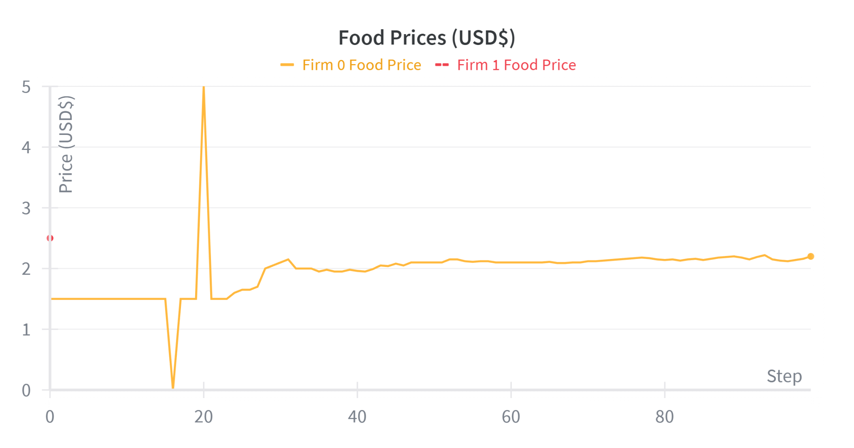

Discussion
- Possible solution to high frequency trading scenarios is regulating the buy/sell rates and limit quote polling ability
- Current limitations
  - Need better way to determine the net worth of an agent. It is currently just calculated from their cash.
  - Firms are not experimenting enough with prices–not realistically exploiting
  - Naive reflection

Remaining Work
- Improve reflection
- Brain swap to compare results across different LLMs
- Regulate buy/sell rates (sleep intervals)
- Regulate consumer agents’ quote polling ability (bounding consumers)v
- Develop dual frim/consumer behavior for agents
- End goal: simulation visualizer to make project more widely accessible

Figures:
- Methodology
  - Framework diagram
- Prelim results section
  - Compilation of many trial runs
    - Time til broke
    - Firm cash vs time
    - Sales/timestep

Figures:
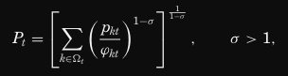
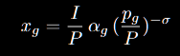
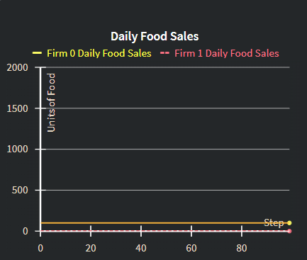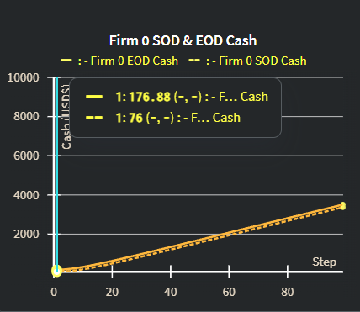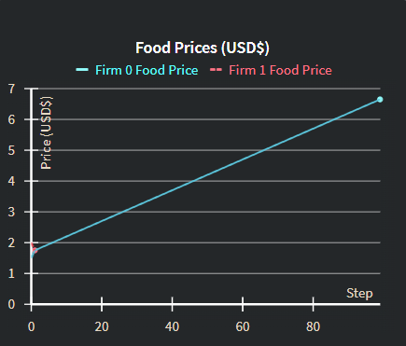

Trial 3 - Example of exploitation and truly maximizing profits (at least for 0-40)
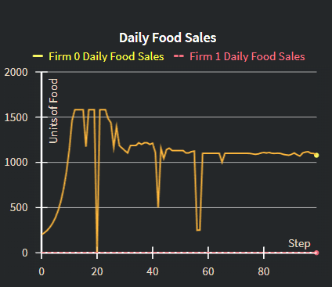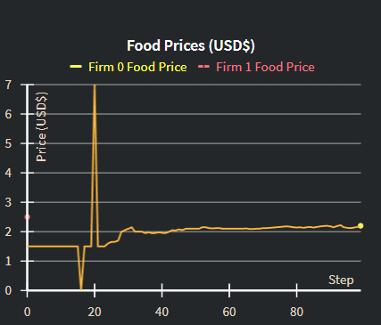
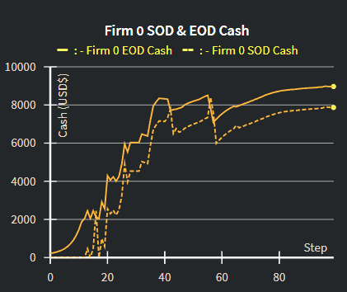
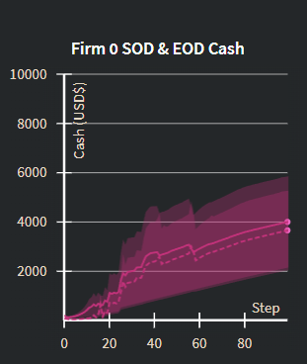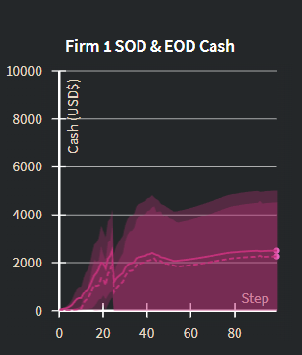
Intro
On May 6, 2010, U.S. financial markets dropped 5-6% in a matter of minutes due to an unbound “sell algorithm.” Amidst a period of economic worry and a morning of high volatility, a sell algorithm designed to execute actions at a rate of 9% the current market volume initiated a massive sell-off of roughly $4.1 billion worth of contracts. Known as the “Flash Crash”, this sell-off was completed in 20 minutes, sending the market into a frenzy. (SEC) Though this was limited to a high-frequency trading environment, there have been recent introductions of AI in retail. OpenAI, in collaboration with Stripe, announced Instant Checkout, where customers can use ChatGPT to discover products and complete transactions. (Stripe) Despite concerning history such as the Flash Crash coupled with the widespread integration of AI and LLMs into daily life—and, specifically, public retail, there is a lack of robust test benches for studying how agentic economies would behave. Without trialing of agentic markets, there remains a lack of empirical knowledge, thus risking a lack of preventative regulation surrounding their behavior and dangerous edge cases. Agentic economies potentially enable great inequality, favoring parties with access to advanced models, hardware, and other resources. In certain scenarios, such resources could allow for malicious market manipulation. AI Bazaar introduces a simulation framework that enables experimentation with economic scenarios in fully agentic markets that can be utilized for research and regulation development. The framework emphasizes believable human-like behavior by the agents as both rational firms and consumers.

Related Work
Several recent projects explore the use of large language models as economic agents, but none provide a full simulation framework for testing economic scenarios with agent-driven demand. VendingBench offers one of the earliest benchmark environments for evaluating whether an LLM can operate a simple business. The entrepreneurial agent manages money, purchases inputs, and sells products—capabilities that directly inspired the design of our FirmAgent. However, VendingBench focuses on isolated business tasks such as sending emails to suppliers rather than market-level behavior. In contrast, AI Bazaar aims to simplify and extend VendingBench into a mutli-agent eBay-esque environment.
EconAgent moves toward richer macroeconomic behavior by equipping LLM agents with human-like traits and a perception module. This addition improves the agent’s ability to interpret and respond to its environment. We plan to imitate aspects of this module to strengthen our agents’ reasoning and responsiveness.
AI Bazaar has grown directly out of the LLM Economist project. AI Bazaar aims to work in parallel with the LLM Economist by adding direct agent-agent interactions in a goods-based market.
These projects provide great contributions to the subject, but we can not find an empirical test bench for studying an agentic market system where both firm behavior and consumer demand are agent-generated. Existing research raises concerns about agentic economies, but lacks a platform for experimenting with price wars, inequality, convergence, or regulation. AI Bazaar directly targets this gap by offering a simulation framework capable of testing economic scenarios before such systems appear in real-world markets.

Problem Setup (introduce any ECON theory here if possible?)
AI Bazaar’s core objective is to offer a simulation that allows effective evaluation of the emergent behaviors that arise in a fully agentic market in which LLM-powered agents are buying and selling amongst one another at high speeds. Such speed makes it difficult for human monitoring and correction to be effective. In these scenarios, the “best” agent can profit hugely and potentially manipulate the market by exploiting price wars, first-mover, and discriminatory pricing dynamics. Without empirical test benches, we cannot safely observe the movement of equity or surplus, or test the convergence (or lack thereof) of agentic economies. In price wars, a seller agent can eliminate competition by dropping prices, potentially achieving a monopolistic state and exploiting consumers. In the first-mover scenario, all of the surplus goes to the fastest consumers. The price discrimination scenario is the reverse, wherein all of the surplus goes to the sellers. These scenarios lead to massive inequality in the market, favoring parties with access to advanced models and resources, allowing for unfair competition. Understanding the dynamics that lead to such scenarios is essential in developing preventative regulation before agentic economies are fully deployed and tied to the net worth of real people

Methodology
In order to understand the emergent behaviors and dynamics of fully agentic markets, we build a framework for a simulation in which LLM-powered agents operate as firms, consumers, and sometimes both, buying and selling between each other. Our primary assumptions are that (i) an agent’s primary goal is to maximize their own utility/profits as consumers/firms each time step and (ii) agents do not know other agents’ internal states. These assumptions simplify pricing and consumption behavior.

Implementation:
The current version of the simulation separates firms and consumers into FirmAgents and ConsumerAgents. ConsumerAgent actions (currently) are not LLM-powered like FirmAgent actions. ConsumerAgents’ demand is instead derived from the cost of living (P_{i}) under constant elasticity of substitution (CES) homothetic preferences. (Princeton Paper) By using CES taste parameters, have a consumer demand model that allows for heterogeneity among the ConsumerAgents even without prompting an LLM.

- ConsumerAgents
  - Each ConsumerAgent posses a natural language description of its persona. This description is used in a prompt to an LLM to generate a vector of taste parameters use for this consumer’s CES utility. Each agent receives an income at the start of each timestep and pays taxes proportional to that income.
- FirmAgents
  - FirmAgents are entirely LLM-powered with an LLM being prompted each time an action is taken. The action space consists of purchasing supplies, producing goods from those supplies, and setting prices for those goods. FirmAgents are also subject to taxes and an overhead cost for staying in business.
  - LLM-powered.
  - Action space: purchase supplies, produce goods, set prices
  - Pays taxes and overhead costs
- Simulation loop
- Firms purchase X amount of an arbitrary supply.
- Firms produce goods with the arbitrary supply
- Set the prices of the goods and post quotes to the market (sell contracts)
- Consumers receive their income.
- Consumers submit buy orders to the market by computing their cost of living and Marshallian demand.
- A mediator in the market matches orders and quotes, transferring cash and goods.
- Taxation and overhead costs applied
- Order generation
  - Given prices and its taste parameters, each ConsumerAgent generates a quantity demanded for each good in that timestep using equation (x). The scenario determines the algorithm used to construct orders based on the quantity demanded.

To examine emergent behaviors, we will simulate 3 scenarios that can arise in a high-frequency trading agentic market in the absence of regulations. In these scenarios, the “best” agent can profit hugely and potentially manipulate the market.

Race to the Bottom
Firms “open shop” for the day with a set of prices and inventory, fixing prices for the day. Consumers, when making orders, will find the best deals among all or a randomized subset of firms, submitting an order for the best one, specifying the firm they’d like to purchase from. The order is not filled upon submission. At the end of the day, orders are filled. This leads to all of the consumers attempting to purchase from the firm with the lowest price, driving prices down until prices are exactly equal to the cost of production.

Early Bird
The firms open shop at the start of the day. Consumers poll the firms, submitting an order for the best deal they find. The order is immediately filled upon submission (given it can be supplied and is a valid order. This scenario favors first–movers—the first consumers to place orders take all of the available commerce.

Price Discrimination
Each consumer’s willingness to pay (WTP) is submitted as the price at which they’d like to make a purchase. Orders are filled by the firm with the price closest to the consumer's willingness to pay, as indicated by the order submitted.

By experimenting with these scenarios, we will be able to (i) assess the validity of the simulation, (ii) theorize about solutions to regulate agents in order to prevent exploitation.

Preliminary Results
To gather initial results for the simulation, we ran a batch of experiments in a two-firm, N-consumer environment, with LLM-powered FirmAgents and CES-based ConsumerAgents. This setup allows us to see if the framework in its current state yields the results that we expect from the Race to the Bottom scenario.

Trial 4
In this trial, Firm 0 initially posts a slightly lower price than Firm 1, and therefore wins all of the sales in the first timestep. Firm 1, is unable to purchase additional inventory for the next timestep, but attempts to lower its price in order to be competitive:
2025-12-04 13:55:03,118 - INFO - LLM OUTPUT RECURSE 0 {"thought":"I have 150 units of food inventory and $0 cash. The previous price of $2.00 resulted in no sales. To generate cash and maximize profit, I need to set a competitive price that encourages sales while still being profitable. I will try a slightly lower price than before to hopefully stimulate demand and generate revenue.","price_food":1.75}

Unfortunately for Firm 1, Firm 0 maintained its price of $1.75 and thus still won all of the sales in the next timestep (firm ID is the tiebreaker). Since it did not earn any revenue for the day, the firm became insolvent, unable to cover the overhead costs for the day, thus going out of business. Although this firm failed, the LLM recognized a feasible strategy. Due to the bounded nature of the firms, having no knowledge of the internal state of other agents, it was forced to guess what would be a competitive price.

This leaves Firm 0 with a full monopoly over the market, but it fails to exploit it correctly. Firm 0 consistently profits, but fails to optimize profits. It maintains the same size inventory, slowly increasing its price at a constant rate. The result, as seen in Figure () and Figure (), is an over 400% increase in the price of food over the course of the simulation and a significant decrease in sales volume.

While this trial highlights a shortcoming in the reasoning of the FirmAgent, it also serves as an example of the dangers of agentic economies. In this monopolistic market, there is a risk of decreased overall social welfare and inaccessibility to the goods being monopolized.

Trial 3
In the third trial, Firm 0 posts a lower initial price than Firm 1 and wins the price war early. Excluding a couple outliers before timestep 20, Firm 0 maintains consistent pricing besides a 25% increase from $1.50 to $2.00. Despite this more or less fixed pricing, we can see from the Firm’s cash holdings in Figure () that it experiences increasing profits, massively outperforming the mean of the batch shown in Figure (). A closer look at the daily food sales reveals that the model opted to greatly increase sales volume by producing more inventory, capitalizing on the high demand due to the low pricing.

Discussion
Even in this first batch of trial runs, we see largely rational behavior that one could expect from a human placed in a similar scenario. These reasonable results indicate that the project’s current structure is capable of effectively simulating agentic economies for research purposes.

More concerning, however, is the behavior observed in the monopolistic case. In Trial 4, Firm 0, naively increases its price rather than increasing supply and searching for a profit-maximizing price. Although this approach maintained daily profits, it drastically depressed sales volume and reduced overall welfare as fewer consumers had access to the good.

For the more stable outcome in Trial 3, the monopoly in this case aggressively increases supply to grow sales volume while maintaining a desirable price for consumers. This indicates that, despite instances like in Trial 4, the FirmAgent implementation is can be effective at replicating rational, economically sound behavior. However, the lack of convergence between Trial 3 and Trial 4 suggests that there are some limitations.

The Race to the Bottom scenario is partially the result of a lack of guardrails that make the setup resemble high-frequency trading less. Possible solutions include introducing rate limits on agent actions, quote polling frequency, and bounding consumer knowledge by restricting their polling to only a subset of the firms. Overall, the preliminary results and pre-existing literature suggest the need for an agentic market empirical test bench like AI Bazaar. Agentic markets in the real world risk producing inequitable or catastrophic outcomes when the incentives and structure interact poorly.

Remaining Work
The simulation still requires much development before experiment results can be considered in policy-relevant discussions. First, agents require more robust reflection. The preliminary results show firms falling into suboptimal behaviors such as steadily increasing prices rather than increasing supply to maximize profit. Improving reflection can lead to the more rational, human-like behavior that should be demanded from an economics simulation such as AI Bazaar.

In future experiments, brain swapping across different LLMs is crucial to gathering a holistic view of the agentic market behavior. Implementing limits on quote polling and action rates is also crucial to experimentation with the intention of simulating bounded rationality among the agents in an environment more closely resembling a bazaar or marketplace. Additionally, to achieve more advanced economic simulacra, dual firm/consumer agents would allow for a more dynamic economy.

Once the simulation is a reliable, robust simulation, we aim to build a visualizer that allows users to adjust simulation parameters and observe agents moving through an environment with a rich set of statistical visualizations. This front-end feature would make the project more accessible and interactive, ideally improving its societal reach.

Draft 1
Intro
On May 6, 2010, U.S. financial markets dropped 5-6% in a matter of minutes due to an unbound “sell algorithm.” Amidst a period of economic worry and a morning of high volatility, a sell algorithm designed to execute actions at a rate of 9% the current market volume initiated a massive sell-off of roughly $4.1 billion worth of contracts. Known as the “Flash Crash”, this sell-off was completed in 20 minutes, sending the market into a frenzy. (SEC) Though this was limited to a high-frequency trading environment, there have been recent introductions of AI in retail. OpenAI, in collaboration with Stripe, announced Instant Checkout, where customers can use ChatGPT to discover products and complete transactions. (Stripe) Despite concerning history such as the Flash Crash coupled with the widespread integration of AI and LLMs into daily life—and, specifically, public retail, there is a lack of robust test benches for studying how agentic economies would behave. Without trialing of agentic markets, there remains a lack of empirical knowledge, thus risking a lack of preventative regulation surrounding their behavior and dangerous edge cases. Agentic economies potentially enable great inequality, favoring parties with access to advanced models, hardware, and other resources. In certain scenarios, such resources could allow for malicious market manipulation. AI Bazaar introduces a simulation framework that enables experimentation with economic scenarios in fully agentic markets that can be utilized for research and regulation development. The framework emphasizes believable human-like behavior by the agents as both rational firms and consumers.

Related Work
Several recent projects explore the use of large language models as economic agents, but none provide a full simulation framework for testing economic scenarios with agent-driven demand. VendingBench offers one of the earliest benchmark environments for evaluating whether an LLM can operate a simple business. The entrepreneurial agent manages money, purchases inputs, and sells products—capabilities that directly inspired the design of our FirmAgent. However, VendingBench focuses on isolated business tasks such as sending emails to suppliers rather than market-level behavior. In contrast, AI Bazaar aims to simplify and extend VendingBench into a mutli-agent eBay-esque environment.
EconAgent moves toward richer macroeconomic behavior by equipping LLM agents with human-like traits and a perception module. This addition improves the agent’s ability to interpret and respond to its environment. We plan to imitate aspects of this module to strengthen our agents’ reasoning and responsiveness.
AI Bazaar has grown directly out of the LLM Economist project. AI Bazaar aims to work in parallel with the LLM Economist by adding direct agent-agent interactions in a goods-based market.
These projects provide great contributions to the subject, but we can not find an empirical test bench for studying an agentic market system where both firm behavior and consumer demand are agent-generated. Existing research raises concerns about agentic economies, but lacks a platform for experimenting with price wars, inequality, convergence, or regulation. AI Bazaar directly targets this gap by offering a simulation framework capable of testing economic scenarios before such systems appear in real-world markets.

Problem Setup (introduce any ECON theory here if possible?)
AI Bazaar’s core objective is to offer a simulation that allows effective evaluation of the emergent behaviors that arise in a fully agentic market in which LLM-powered agents are buying and selling amongst one another at high speeds. Such speed makes it difficult for human monitoring and correction to be effective. In these scenarios, the “best” agent can profit hugely and potentially manipulate the market by exploiting price wars, first-mover, and discriminatory pricing dynamics. Without empirical test benches, we cannot safely observe the movement of equity or surplus, or test the convergence (or lack thereof) of agentic economies. In price wars, a seller agent can eliminate competition by dropping prices, potentially achieving a monopolistic state and exploiting consumers. In the first-mover scenario, all of the surplus goes to the fastest consumers. The price discrimination scenario is the reverse, wherein all of the surplus goes to the sellers. These scenarios lead to massive inequality in the market, favoring parties with access to advanced models and resources, allowing for unfair competition. Understanding the dynamics that lead to such scenarios is essential in developing preventative regulation before agentic economies are fully deployed and tied to the net worth of real people

Methodology
In order to understand the emergent behaviors and dynamics of fully agentic markets, we build a framework for a simulation in which LLM-powered agents operate as firms, consumers, and sometimes both, buying and selling between each other. Our primary assumptions are that (i) an agent’s primary goal is to maximize their own utility/profits as consumers/firms each time step and (ii) agents do not know other agents’ internal states. These assumptions simplify pricing and consumption behavior.

Implementation:
The current version of the simulation separates firms and consumers into FirmAgents and ConsumerAgents. ConsumerAgent actions (currently) are not LLM-powered like FirmAgent actions. ConsumerAgents’ demand is instead derived from the cost of living (P_{i}) under constant elasticity of substitution (CES) homothetic preferences. (Princeton Paper) By using CES taste parameters, have a consumer demand model that allows for heterogeneity among the ConsumerAgents even without prompting an LLM.

- ConsumerAgents
  - Each ConsumerAgent posses a natural language description of its persona. This description is used in a prompt to an LLM to generate a vector of taste parameters use for this consumer’s CES utility. Each agent receives an income at the start of each timestep and pays taxes proportional to that income.
- FirmAgents
  - FirmAgents are entirely LLM-powered with an LLM being prompted each time an action is taken. The action space consists of purchasing supplies, producing goods from those supplies, and setting prices for those goods. FirmAgents are also subject to taxes and an overhead cost for staying in business.
  - LLM-powered.
  - Action space: purchase supplies, produce goods, set prices
  - Pays taxes and overhead costs
- Simulation loop
- Firms purchase X amount of an arbitrary supply.
- Firms produce goods with the arbitrary supply
- Set the prices of the goods and post quotes to the market (sell contracts)
- Consumers receive their income.
- Consumers submit buy orders to the market by computing their cost of living and Marshallian demand.
- A mediator in the market matches orders and quotes, transferring cash and goods.
- Taxation and overhead costs applied
- Order generation
  - Given prices and its taste parameters, each ConsumerAgent generates a quantity demanded for each good in that timestep using equation (x). The scenario determines the algorithm used to construct orders based on the quantity demanded.

To examine emergent behaviors, we will simulate 3 scenarios that can arise in a high-frequency trading agentic market in the absence of regulations. In these scenarios, the “best” agent can profit hugely and potentially manipulate the market.

Race to the Bottom
Firms “open shop” for the day with a set of prices and inventory, fixing prices for the day. Consumers, when making orders, will find the best deals among all or a randomized subset of firms, submitting an order for the best one, specifying the firm they’d like to purchase from. The order is not filled upon submission. At the end of the day, orders are filled. This leads to all of the consumers attempting to purchase from the firm with the lowest price, driving prices down until prices are exactly equal to the cost of production.

Early Bird
The firms open shop at the start of the day. Consumers poll the firms, submitting an order for the best deal they find. The order is immediately filled upon submission (given it can be supplied and is a valid order. This scenario favors first–movers—the first consumers to place orders take all of the available commerce.

Price Discrimination
Each consumer’s willingness to pay (WTP) is submitted as the price at which they’d like to make a purchase. Orders are filled by the firm with the price closest to the consumer's willingness to pay, as indicated by the order submitted.

By experimenting with these scenarios, we will be able to (i) assess the validity of the simulation, (ii) theorize about solutions to regulate agents in order to prevent exploitation.

Preliminary Results
To gather initial results for the simulation, we ran a batch of experiments in a two-firm, N-consumer environment, with LLM-powered FirmAgents and CES-based ConsumerAgents. This setup allows us to see if the framework in its current state yields the results that we expect from the Race to the Bottom scenario.

Trial 4
In this trial, Firm 0 initially posts a slightly lower price than Firm 1, and therefore wins all of the sales in the first timestep. Firm 1, is unable to purchase additional inventory for the next timestep, but attempts to lower its price in order to be competitive:
2025-12-04 13:55:03,118 - INFO - LLM OUTPUT RECURSE 0 {"thought":"I have 150 units of food inventory and $0 cash. The previous price of $2.00 resulted in no sales. To generate cash and maximize profit, I need to set a competitive price that encourages sales while still being profitable. I will try a slightly lower price than before to hopefully stimulate demand and generate revenue.","price_food":1.75}

Unfortunately for Firm 1, Firm 0 maintained its price of $1.75 and thus still won all of the sales in the next timestep (firm ID is the tiebreaker). Since it did not earn any revenue for the day, the firm became insolvent, unable to cover the overhead costs for the day, thus going out of business. Although this firm failed, the LLM recognized a feasible strategy. Due to the bounded nature of the firms, having no knowledge of the internal state of other agents, it was forced to guess what would be a competitive price.

This leaves Firm 0 with a full monopoly over the market, but it fails to exploit it correctly. Firm 0 consistently profits, but fails to optimize profits. It maintains the same size inventory, slowly increasing its price at a constant rate. The result, as seen in Figure () and Figure (), is an over 400% increase in the price of food over the course of the simulation and a significant decrease in sales volume.

While this trial highlights a shortcoming in the reasoning of the FirmAgent, it also serves as an example of the dangers of agentic economies. In this monopolistic market, there is a risk of decreased overall social welfare and inaccessibility to the goods being monopolized.

Trial 3
In the third trial, Firm 0 posts a lower initial price than Firm 1 and wins the price war early. Excluding a couple outliers before timestep 20, Firm 0 maintains consistent pricing besides a 25% increase from $1.50 to $2.00. Despite this more or less fixed pricing, we can see from the Firm’s cash holdings in Figure () that it experiences increasing profits, massively outperforming the mean of the batch shown in Figure (). A closer look at the daily food sales reveals that the model opted to greatly increase sales volume by producing more inventory, capitalizing on the high demand due to the low pricing.

Discussion
Even in this first batch of trial runs, we see largely rational behavior that one could expect from a human placed in a similar scenario. These reasonable results indicate that the project’s current structure is capable of effectively simulating agentic economies for research purposes.

More concerning, however, is the behavior observed in the monopolistic case. In Trial 4, Firm 0, naively increases its price rather than increasing supply and searching for a profit-maximizing price. Although this approach maintained daily profits, it drastically depressed sales volume and reduced overall welfare as fewer consumers had access to the good.

For the more stable outcome in Trial 3, the monopoly in this case aggressively increases supply to grow sales volume while maintaining a desirable price for consumers. This indicates that, despite instances like in Trial 4, the FirmAgent implementation is can be effective at replicating rational, economically sound behavior. However, the lack of convergence between Trial 3 and Trial 4 suggests that there are some limitations.

The Race to the Bottom scenario is partially the result of a lack of guardrails that make the setup resemble high-frequency trading less. Possible solutions include introducing rate limits on agent actions, quote polling frequency, and bounding consumer knowledge by restricting their polling to only a subset of the firms. Overall, the preliminary results and pre-existing literature suggest the need for an agentic market empirical test bench like AI Bazaar. Agentic markets in the real world risk producing inequitable or catastrophic outcomes when the incentives and structure interact poorly.

Remaining Work
The simulation still requires much development before experiment results can be considered in policy-relevant discussions. First, agents require more robust reflection. The preliminary results show firms falling into suboptimal behaviors such as steadily increasing prices rather than increasing supply to maximize profit. Improving reflection can lead to the more rational, human-like behavior that should be demanded from an economics simulation such as AI Bazaar.

In future experiments, brain swapping across different LLMs is crucial to gathering a holistic view of the agentic market behavior. Implementing limits on quote polling and action rates is also crucial to experimentation with the intention of simulating bounded rationality among the agents in an environment more closely resembling a bazaar or marketplace. Additionally, to achieve more advanced economic simulacra, dual firm/consumer agents would allow for a more dynamic economy.

Once the simulation is a reliable, robust simulation, we aim to build a visualizer that allows users to adjust simulation parameters and observe agents moving through an environment with a rich set of statistical visualizations. This front-end feature would make the project more accessible and interactive, ideally improving its societal reach.

Draft 2
Intro
On May 6, 2010, U.S. financial markets dropped 5-6% in a matter of minutes due to an unbound “sell algorithm.” Amidst a period of economic worry and a morning of high volatility, a sell algorithm designed to execute actions at a rate of 9% the current market volume initiated a massive sell-off of roughly $4.1 billion worth of contracts. Known as the “Flash Crash”, this sell-off was completed in 20 minutes, sending the market into a frenzy. (SEC) Though this was limited to a high-frequency trading environment, there have been recent introductions of AI in retail. OpenAI, in collaboration with Stripe, announced Instant Checkout, where customers can use ChatGPT to discover products and complete transactions. (Stripe) Despite concerning history such as the Flash Crash coupled with the widespread integration of AI and LLMs into daily life—and, specifically, public retail, there is a lack of robust test benches for studying how agentic economies would behave. Without trialing of agentic markets, there remains a lack of empirical knowledge, thus risking a lack of preventative regulation surrounding their behavior and dangerous edge cases. Agentic economies potentially enable great inequality, favoring parties with access to advanced models, hardware, and other resources. In certain scenarios, such resources could allow for malicious market manipulation. AI Bazaar introduces a simulation framework that enables experimentation with economic scenarios in fully agentic markets that can be utilized for research and regulation development. The framework emphasizes believable human-like behavior by the agents as both rational firms and consumers.

Related Work
Several recent projects explore the use of large language models as economic agents, but none provide a full simulation framework for testing economic scenarios with agent-driven demand. VendingBench offers one of the earliest benchmark environments for evaluating whether an LLM can operate a simple business. The entrepreneurial agent manages money, purchases inputs, and sells products—capabilities that directly inspired the design of our FirmAgent. However, VendingBench focuses on isolated business tasks such as sending emails to suppliers rather than market-level behavior. In contrast, AI Bazaar aims to simplify and extend VendingBench into a mutli-agent eBay-esque environment.
EconAgent moves toward richer macroeconomic behavior by equipping LLM agents with human-like traits and a perception module. This addition improves the agent’s ability to interpret and respond to its environment. We plan to imitate aspects of this module to strengthen our agents’ reasoning and responsiveness.
AI Bazaar has grown directly out of the LLM Economist project. AI Bazaar aims to work in parallel with the LLM Economist by adding direct agent-agent interactions in a goods-based market.
These projects provide great contributions to the subject, but we can not find an empirical test bench for studying an agentic market system where both firm behavior and consumer demand are agent-generated. Existing research raises concerns about agentic economies, but lacks a platform for experimenting with price wars, inequality, convergence, or regulation. AI Bazaar directly targets this gap by offering a simulation framework capable of testing economic scenarios before such systems appear in real-world markets.

Problem Setup (introduce any ECON theory here if possible?)
AI Bazaar’s core objective is to offer a simulation that allows effective evaluation of the emergent behaviors that arise in a fully agentic market in which LLM-powered agents are buying and selling amongst one another at high speeds. Such speed makes it difficult for human monitoring and correction to be effective. In these scenarios, the “best” agent can profit hugely and potentially manipulate the market by exploiting price wars, first-mover, and discriminatory pricing dynamics. Without empirical test benches, we cannot safely observe the movement of equity or surplus, or test the convergence (or lack thereof) of agentic economies. We examine three scenarios in particular.

In the “Race to the Bottom” scenario, we expect price wars between firms. A seller agent can eliminate competition by dropping prices, potentially achieving a monopolistic state and exploiting consumers. Firms “open shop” for the day with a set of prices and inventory, fixing prices for the day. Consumers, when making orders, will find the best deals among all or a randomized subset of firms, submitting an order for the best one, specifying the firm they’d like to purchase from. The order is not filled upon submission. At the end of the day, orders are filled. This leads to all consumers attempting to purchase from the firm with the lowest price, driving prices down until prices are exactly equal to the marginal cost of production. Marginal cost is defined in Equation \ref, where c is the input cost to produce that good, F is the operational cost of the firm, and q_{i} is the quantity produced. At this boundary, a firm is better off exiting the market with the money still in its account, and thus we assume that if the price dips below this equilibrium price, most firms will exit the market and this cycle will continue until a single firm is still in operation.

p = c + F / qi

In the “Early Bird” or first-mover scenario, all of the surplus goes to the fastest consumers. The firms open shop at the start of the day. Consumers poll the firms, submitting an order for the best deal they find. The order is immediately filled upon submission (given it can be supplied and is a valid order). This scenario favors first–movers—the first consumers to place orders take all of the available surplus. In this setup, we expect to see a negative correlation between time of arrival/time of order and surplus received, both of which we can quantify and log. Surplus can be defined in Equation \ref, where w_{it} is consumer i’s willingness to pay at timestep t.
S_{i} = w_{it} - p_{t}

The price discrimination scenario is the reverse, wherein all of the surplus goes to the sellers. Each consumer’s willingness to pay (WTP) is submitted as the price at which they’d like to make a purchase. Orders are filled by the firm with the price closest to the consumer's willingness to pay, as indicated by the order submitted. This means the consumers receive no surplus, while the seller's profit can be the difference between the customer’s willingness to pay and the cost of production.

These scenarios lead to massive inequality in the market, favoring parties with access to advanced models and resources, allowing for unfair competition. Understanding the dynamics that lead to such scenarios is essential in developing preventative regulation before agentic economies are fully deployed with bearing on the net worth of real people.

Methodology
In order to understand the emergent behaviors and dynamics of fully agentic markets, we build a framework for a simulation in which LLM-powered agents operate as firms, consumers, and sometimes both, buying and selling between each other. Our primary assumptions are that (i) an agent’s primary goal is to maximize their own utility/profits as consumers/firms each time step, and (ii) agents do not know other agents’ internal states. These assumptions simplify pricing and consumption behavior.

Implementation:
The current version of the simulation separates firms and consumers into FirmAgents and ConsumerAgents. ConsumerAgent actions (currently) are not LLM-powered like FirmAgent actions. ConsumerAgents’ demand is instead derived from the cost of living (P_{i}) under constant elasticity of substitution (CES) homothetic preferences (Redding). By using CES taste parameters, we have a consumer demand model that allows for heterogeneity among the ConsumerAgents even without prompting an LLM.

- ConsumerAgents
  - Each ConsumerAgent posses a natural language description of its persona. This description is used in a prompt to an LLM to generate a vector of taste parameters use for this consumer’s CES utility. Each agent receives an income at the start of each timestep and pays taxes proportional to that income.
- FirmAgents
  - FirmAgents are entirely LLM-powered with an LLM being prompted each time an action is taken. The action space consists of purchasing supplies, producing goods from those supplies, and setting prices for those goods. FirmAgents are also subject to taxes and an overhead cost for staying in business.
  - LLM-powered.
  - Action space: purchase supplies, produce goods, set prices
  - Pays taxes and overhead costs
- Simulation loop
- Firms purchase X amount of an arbitrary supply.
- Firms produce goods with the arbitrary supply
- Set the prices of the goods and post quotes to the market (sell contracts)
- Consumers receive their income.
- Consumers submit buy orders to the market by computing their cost of living and Marshallian demand.
- A mediator in the market matches orders and quotes, transferring cash and goods.
- Taxation and overhead costs applied
- Order generation
  - Given prices and its taste parameters, each ConsumerAgent generates a quantity demanded for each good in that timestep using equation (x). The scenario determines the algorithm used to construct orders based on the quantity demanded.

To examine emergent behaviors, we will simulate the three scenarios that can arise in a high-frequency trading agentic market in the absence of regulations, outlined in Section 2. In these scenarios, the “best” agent can profit hugely and potentially manipulate the market.

By experimenting with these scenarios, we will be able to (i) evaluate the simulation’s implementation, (ii) assess the level of reasoning of the agents, and (iii) theorize about solutions to regulate agents to prevent exploitation.

Preliminary Results
To gather initial results for the simulation, we ran a batch of experiments in a two-firm, N-consumer environment, with LLM-powered FirmAgents and CES-based ConsumerAgents. This setup allows us to see if the framework in its current state yields the results that we expect from the Race to the Bottom scenario.

Trial 4
In this trial, Firm 0 initially posts a slightly lower price than Firm 1, and therefore wins all of the sales in the first timestep. Firm 1 is unable to purchase additional inventory for the next timestep, but attempts to lower its price in order to be competitive:
2025-12-04 13:55:03,118 - INFO - LLM OUTPUT RECURSE 0 {"thought":"I have 150 units of food inventory and $0 cash. The previous price of $2.00 resulted in no sales. To generate cash and maximize profit, I need to set a competitive price that encourages sales while still being profitable. I will try a slightly lower price than before to hopefully stimulate demand and generate revenue.","price_food":1.75}

Unfortunately for Firm 1, Firm 0 maintained its price of $1.75 and thus still won all of the sales in the next timestep (firm ID is the tiebreaker). Since it did not earn any revenue for the day, the firm became insolvent, unable to cover the overhead costs for the day, thus going out of business. Although this firm failed, the LLM recognized a feasible strategy. Due to the bounded nature of the firms, having no knowledge of the internal state of other agents, it was forced to guess what would be a competitive price.

This leaves Firm 0 with a full monopoly over the market, but it fails to exploit it correctly. Firm 0 consistently profits, but fails to optimize profits. It maintains the same size inventory, slowly increasing its price at a constant rate. The result, as seen in Figure () and Figure (), is an over 400% increase in the price of food over the course of the simulation and a significant decrease in sales volume.

While this trial highlights a shortcoming in the reasoning of the FirmAgent, it also serves as an example of the dangers of agentic economies. In this monopolistic market, there is a risk of decreased overall social welfare and inaccessibility to the goods being monopolized.

Trial 3
In the third trial, Firm 0 posts a lower initial price than Firm 1 and wins the price war early. Excluding a couple outliers before timestep 20, Firm 0 maintains consistent pricing besides a 25% increase from $1.50 to $2.00. Despite this more or less fixed pricing, we can see from the Firm’s cash holdings in Figure () that it experiences increasing profits, massively outperforming the mean of the batch shown in Figure (). A closer look at the daily food sales reveals that the model opted to greatly increase sales volume by producing more inventory, capitalizing on the high demand due to the low pricing.

Discussion
Even in this first batch of trial runs, we see largely rational behavior that one could expect from a human placed in a similar scenario. These reasonable results indicate that the project’s current structure is capable of effectively simulating agentic economies for research purposes.

More concerning, however, is the behavior observed in the monopolistic case. In Trial 4, Firm 0, naively increases its price rather than increasing supply and searching for a profit-maximizing price. Although this approach maintained daily profits, it drastically depressed sales volume and reduced overall welfare as fewer consumers had access to the good.

For the more stable outcome in Trial 3, the monopoly in this case aggressively increases supply to grow sales volume while maintaining a desirable price for consumers. This indicates that, despite instances like in Trial 4, the FirmAgent implementation is can be effective at replicating rational, economically sound behavior. However, the lack of convergence between Trial 3 and Trial 4 suggests that there are some limitations.

The Race to the Bottom scenario is partially the result of a lack of guardrails that make the setup resemble high-frequency trading less. Possible solutions include introducing rate limits on agent actions, quote polling frequency, and bounding consumer knowledge by restricting their polling to only a subset of the firms. Overall, the preliminary results and pre-existing literature suggest the need for an agentic market empirical test bench like AI Bazaar. Agentic markets in the real world risk producing inequitable or catastrophic outcomes when the incentives and structure interact poorly.

Remaining Work
The simulation still requires much development before experiment results can be considered in policy-relevant discussions. First, agents require more robust reflection. The preliminary results show firms falling into suboptimal behaviors such as steadily increasing prices rather than increasing supply to maximize profit. Improving reflection can lead to the more rational, human-like behavior that should be demanded from an economics simulation such as AI Bazaar.

In future experiments, brain swapping across different LLMs is crucial to gathering a holistic view of the agentic market behavior. Implementing limits on quote polling and action rates is also crucial to experimentation with the intention of simulating bounded rationality among the agents in an environment more closely resembling a bazaar or marketplace. Additionally, to achieve more advanced economic simulacra, dual firm/consumer agents would allow for a more dynamic economy.

Once the simulation is a reliable, robust simulation, we aim to build a visualizer that allows users to adjust simulation parameters and observe agents moving through an environment with a rich set of statistical visualizations. This front-end feature would make the project more accessible and interactive, ideally improving its societal reach.

Draft 3
Introduction}
On May 6, 2010, U.S. financial markets dropped 5--6\% in a matter of minutes due to an unbound ``sell algorithm.'' Amidst a period of economic worry and a morning of high volatility, a sell algorithm designed to execute actions at a rate of 9\% the current market volume initiated a massive sell-off of roughly \$4.1 billion worth of contracts. Known as the ``Flash Crash'', this sell-off was completed in 20 minutes, sending the market into a frenzy \cite{sec2010flashcrash}. Though this was limited to a high-frequency trading environment, there have been recent introductions of AI in retail. OpenAI, in collaboration with Stripe, announced Instant Checkout, where customers can use ChatGPT to discover products and complete transactions \cite{stripe2025agenticcommerce}. Despite concerning history like the Flash Crash and the widespread integration of AI and LLMs into daily life---and, specifically, public retail---there is a lack of robust test benches for studying how agentic economies would behave. Without trialing of agentic markets, there remains a lack of empirical knowledge, thus risking a lack of preventative regulation surrounding their behavior and dangerous edge cases. Agentic economies potentially enable great inequality, favoring parties with access to advanced models, hardware, and other resources. In certain scenarios, such resources could allow for malicious market manipulation. AI Bazaar introduces a simulation framework that enables experimentation with economic scenarios in fully agentic markets that can be utilized for research and regulation development. The framework emphasizes believable human-like behavior by the agents as both rational firms and consumers.

\section{Related Work}
Several recent projects explore the use of large language models as economic agents, but none provide a full simulation framework for testing economic scenarios with agent-driven demand.

VendingBench offers one of the earliest benchmark environments for evaluating whether an LLM can operate a simple business. The entrepreneurial agent manages money, purchases inputs, and sells products—capabilities that directly inspired the design of our FirmAgent. However, VendingBench focuses on isolated business tasks such as sending emails to suppliers rather than market-level behavior \citep{backlund2025vendingbenchbenchmarklongtermcoherence}. In contrast, AI Bazaar aims to simplify and extend VendingBench into a mutli-agent eBay-esque environment.

EconAgent moves toward richer macroeconomic behavior by equipping LLM agents with human-like traits and a perception module. This addition improves the agent’s ability to interpret and respond to its environment \citep{li-etal-2024-econagent}. We plan to imitate aspects of this module to strengthen our agents’ reasoning and responsiveness.

AI Bazaar has grown directly out of the LLM Economist project, which uses LLM-powered agents as workers who choose their labor allocation based on the current tax plan and their income, as well as a tax planner whose goal is to optimize the tax plan in order to maximize social welfare \citep{karten2025llm}. AI Bazaar aims to work in parallel with the LLM Economist by adding direct agent-agent interactions in a goods-based market.

These projects provide great contributions to the subject, but we can not find an empirical test bench for studying an agentic market system where both firm behavior and consumer demand are agent-generated. Existing research raises concerns about agentic economies, but lacks a platform for experimenting with price wars, inequality, convergence, or regulation. AI Bazaar directly targets this gap by offering a simulation framework capable of testing economic scenarios before such systems appear in real-world markets.

\section{Problem Setup}\label{Problem Setup}
AI Bazaar’s core objective is to offer a simulation that allows effective evaluation of the emergent behaviors that arise in a fully agentic market in which LLM-powered agents are buying and selling amongst one another at high speeds. Such speed makes it difficult for human monitoring and correction to be effective. In these scenarios, the “best” agent can profit hugely and potentially manipulate the market by exploiting price wars, first-mover, and discriminatory pricing dynamics. Without empirical test benches, we cannot safely observe the movement of equity or surplus, or test the convergence (or lack thereof) of agentic economies. We examine three scenarios in particular.

\subsection{Scenarios}
\subsubsection{Race to the Bottom}
In the “Race to the Bottom” scenario, we expect price wars between firms. A seller agent can eliminate competition by dropping prices, potentially achieving a monopolistic state and exploiting consumers. Firms “open shop” for the day with a set of prices and inventory, fixing prices for the day. Consumers, when making orders, will find the best deals among all or a randomized subset of firms, submitting an order for the best one, specifying the firm they’d like to purchase from. The order is not filled upon submission. At the end of the day, orders are filled. This leads to all consumers attempting to purchase from the firm with the lowest price, driving prices down until prices are exactly equal to the marginal cost of production. Marginal cost is defined in Equation \ref{eq:Marginal Price}, where \textit{c} is the input cost to produce that good, \textit{F} is the operational cost of the firm, and \textit{q}\textit{\textsubscript{i}} is the quantity produced. At this boundary, a firm is better off exiting the market with the money still in its account, and thus we assume that if the price dips below this equilibrium price, most firms will exit the market and this cycle will continue until a single firm is still in operation.
\begin{equation}
p_t = c_t + F /Q_t
\label{eq:Marginal Price}
\end{equation}
\subsubsection{Early Bird}
In the “Early Bird” or first-mover scenario, all of the surplus goes to the fastest consumers. The firms open shop at the start of the day. Consumers poll the firms, submitting an order for the best deal they find. The order is immediately filled upon submission (given it can be supplied and is a valid order). This scenario favors first–movers—the first consumers to place orders take all of the available surplus. In this setup, we expect to see a negative correlation between time of arrival/time of order and surplus received, both of which we can quantify and log. Surplus can be defined in Equation \ref{eq:Surplus}, where \textit{w}\textit{\textsubscript{it}} is consumer i’s willingness to pay (WTP) at timestep \textit{t}.
\begin{equation}
S_{it} = w_{it} + p_{it}
\label{eq:Surplus}
\end{equation}
\subsubsection{Price Discrimination}
In the price discrimination scenario, all of the surplus goes to the sellers. Each consumer’s WTP is submitted as the price at which they’d like to make a purchase. Orders are filled by the firm with the price closest to but not exceeding the consumer's WTP, as indicated by the order submitted. In a market with many firms with prices distributed evenly among the lowest WTP and the highest WTP, this means the consumers receive little to no surplus, while the seller's profit is the difference between the customer’s WTP and the cost of production.

These scenarios lead to massive inequality in the market, favoring parties with access to advanced models and resources, allowing for unfair competition. Understanding the dynamics that lead to such scenarios is essential in developing preventative regulation before agentic economies are fully deployed with bearing on the net worth of real people.

\section{Methodology}
In order to understand the emergent behaviors and dynamics of fully agentic markets, we build a framework for a simulation in which LLM-powered agents operate as firms, consumers, and sometimes both, buying and selling between each other. Our primary assumptions are that (i) an agent’s primary goal is to maximize their own utility/profits as consumers/firms each time step and (ii) agents do not know other agents’ internal states. These assumptions simplify pricing and consumption behavior.

\subsection{Implementation}
The current version of the simulation separates firms and consumers into FirmAgents and ConsumerAgents. ConsumerAgent actions (currently) are not LLM-powered like FirmAgent actions. ConsumerAgents’ demand is instead derived from the cost of living ($P_t$) under constant elasticity of substitution (CES) homothetic preferences, where $p_{gt}$ is the price of good $g$ from the set of goods $G$ at time $t$, ${\alpha}$ represents the consumers preference for good $g$ at time $t$, and $\sigma$ is the elasticity of substitution \citep{redding2020measuring}. By using CES taste parameters, we have a model that allows for heterogeneity among the ConsumerAgents even without prompting an LLM.
\begin{equation}
P_t = \left[ \sum_{g \in G} \left( \frac{p_{gt}}{\alpha_{gt}} \right)^{1-\sigma} \right]^{\frac{1}{1-\sigma}}, \qquad \sigma > 1,
\label{eq:Cost of Living}
\end{equation}
\subsubsection*{ConsumerAgents}
Each ConsumerAgent possesses a natural language description of its persona. This description is used in a prompt to an LLM to generate a vector of taste parameters used for this consumer’s CES utility. Each agent receives an income at the start of each timestep and pays taxes proportional to that income.

\subsubsection*{FirmAgents}
FirmAgents are entirely LLM-powered with an LLM being prompted each time an action is taken. The action space consists of purchasing supplies, producing goods from those supplies, and setting prices for those goods. FirmAgents are also subject to taxes and an overhead cost for staying in business.

\subsection{Simulation Loop}
\begin{enumerate}
\item Firms purchase $X$ amount of an arbitrary supply.
\item Firms produce goods with the arbitrary supply.
\item Firms set the prices of the goods and post quotes to the market (sell contracts).
\item Consumers receive their income.
\item Consumers submit buy orders to the market by computing their cost of living and quantity demanded.
\item A mediator in the market matches orders and quotes, transferring cash and goods.
\item Taxation and overhead costs are applied.
\end{enumerate}

\subsection{Order Generation}
Given prices and its taste parameters, each ConsumerAgent generates a quantity demanded for each good in that timestep using equation (x). The scenario determines the algorithm used to construct orders based on the quantity demanded.

\subsection{Scenarios}
To examine emergent behaviors, we simulate the three scenarios outlined in Section \ref{Problem Setup} (Race to the Bottom, Early Bird, and Price Discrimination) that can arise in a high-frequency trading agentic market in the absence of regulations. In these scenarios, the “best” agent can profit hugely and potentially manipulate the market. By experimenting with these scenarios, we will be able to (i) assess the validity of the simulation and (ii) theorize about solutions to regulate agents in order to prevent exploitation.

\section{Preliminary Results}
To gather initial results for the simulation, we ran a batch of experiments in a two-firm, $N$-consumer environment, with LLM-powered FirmAgents and CES-based ConsumerAgents. This setup allows us to see if the framework in its current state yields the results that we expect from the Race to the Bottom scenario.

\subsection*{Trial 4}

In Trial 4, Firm 0 initially posts a slightly lower price than Firm 1, and therefore wins all of the sales in the first timestep (see Figure\ref{fig:Trial4F2} and Figure \ref{fig:Trial4F1}). Firm 1 is unable to purchase additional inventory for the next timestep but attempts to lower its price:
\begin{quote}
\texttt{2025-12-04 13:55:03 - INFO - LLM OUTPUT RECURSE 0 \{"thought":"I have 150 units of food inventory and \$0 cash. The previous price of \$2.00 resulted in no sales. To generate cash and maximize profit, I need to set a competitive price that encourages sales while still being profitable. I will try a slightly lower price than before to hopefully stimulate demand and generate revenue.","price\_food":1.75\}}
\end{quote}

Firm 0 maintains its price of \$1.75 and again wins all of the sales. Firm 1 becomes insolvent due to a lack of revenue and exits the market. Although Firm 1 failed, the LLM identified a feasible strategy by lowering the price. With no visibility into other agents, it was forced to guess a competitive price.

With Firm 0 now a monopolist, it fails to exploit the market efficiently. It solely increases price at a constant rate rather than searching for a profit-maximizing price and quantity. Prices rise over 400\% while sales volume collapses. This demonstrates a danger of agentic economies: naive strategies can reduce welfare and restrict access to essential goods.

In Trial 3, Firm 0 again undercuts Firm 1 early on, winning the price war, seen in Figure \ref{fig:Trial3F2}. Besides a few outliers before timestep 20, Firm 0 maintains consistent pricing aside from a 25\% increase from \$1.50 to \$2.00 around timestep 25 (excluding outliers around timestep 20). Despite this, its profits steadily increase, far surpassing the batch mean. Daily food sales in Figure \ref{fig:Trial3F1} reveal that the model aggressively increased supply to meet high demand, capitalizing on volume-driven profits.

Even in this first batch of trial runs, we see largely rational behavior that one could expect from a human placed in a similar scenario. These reasonable results indicate that the project’s current structure is capable of effectively simulating agentic economies for research purposes.

More concerning is the behavior observed in the monopolistic case. In Trial 4, Firm 0 naively increases its price rather than searching for an optimal strategy. Although this maintained daily profits, it depressed sales volume and reduced overall welfare. In contrast, Trial 3 shows a firm aggressively scaling production to match demand, suggesting that the FirmAgent implementation is capable of rational behavior. However, the lack of convergence indicates limitations in the current setup.

The Race to the Bottom scenario arises partly due to missing guardrails that would prevent unrealistic high-frequency trading effects. Potential solutions include introducing rate limits on buy/sell actions, restricting quote polling, and limiting consumer access to firm-level information. Overall, the preliminary results---paired with existing literature---underscore the need for test benches like AI Bazaar to study agentic markets before such systems appear in real markets.

\section{Remaining Work}
The simulation still requires significant development before results can inform policy discussions. First, agents need more robust reflection. Trials show firms falling into suboptimal behaviors such as mechanically increasing prices rather than exploring more profitable strategies. Improving reflection should yield more realistic economic behavior.

Aside from the additional experiments required to run the other two scenarios, we do not yet see the mathematical objectives outlined in Section \ref{Problem Setup} being achieved for the Race to the Bottom (price war) scenario. Revisions to the market clearing operation, as well as the simulations initialization parameters can help yield more interesting results.

Next, future experiments will involve brain swapping across different LLMs to understand how model choice affects market dynamics. Implementing limits on quote polling and action rates will help simulate bounded rationality and prevent unrealistic high-frequency behaviors. Additionally, enabling agents to act as both firms and consumers will support more dynamic economic environments.

Once the simulation is stable and reliable, we aim to build a visualizer that allows users to adjust parameters and observe agents interacting in a spatial environment with statistical overlays. This will make the project more accessible, interpretable, and impactful.

