**Index**

**Project Details –**

**Page 2**

**ESXI OS Install –**

**Page 3**

**Adding ISOs to Datastore (Adding OS to use) –**

**Page 4**

**Creating Virtual Machines –**

**Page 5**

**Details**

**ESXI –**

**The operating system used on the server, to deploy virtual machines. Version used on this project is ESXI 7.0**

**Panel –**

**A graphical interface, used to interact with individual instances on a server**

**PUTTY –**

**Remote SSH tool used to connect into server, or individual virtual machines located on the server**

**Remote Desktop –**

**Remote connection tool, paired with Windows Professional edition, allowing users to remotely connect into machines, including a graphical user interface.**

**ISO –**

**File type containing information structured identically to an optical disk, in our case, used to install ESXI OS.**

**ESXI OS Installation**

**If ESXI isn’t installed -**

1. **Locate the USB Drive labeled “TMiller”**
2. **Insert Drive into USB port on server**
3. **Boot up server & make sure the flash drive is selected as the Boot Drive**
4. **Create a root password and username**
   1. **Password must contain one capital, one number & one unique character**
5. **Once installed & completed making user account, locate the IP on screen**
6. **Log into your lab computer**
7. **Open your web browser & enter the IP address associated with the ESXI server**
8. **Login with the root credentials**
9. **Done!**

**If ESXI is installed –**

1. **Make sure server is powered on and has output showing an IP address**
2. **Log into your lab computer**
3. **Open web browser of choice & enter IP address associated with the ESXI Server**
4. **Enter the root credentials to sign in**
5. **Done!**

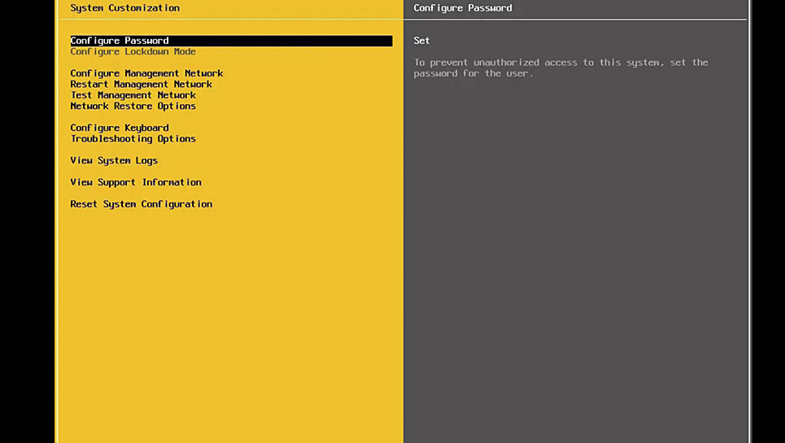

**Adding ISOs**

1. **Download an ISO, or locate one on a flash drive**
   1. [**Windows Operating Systems**](https://www.microsoft.com/en-us/software-download/)
   2. [**Linux Distributions**](https://www.linux.org/pages/download/)
2. **Locate and click the storage tab**
3. **Enter into the datastore file directory**
4. **Navigate to the isos folder, if it is not present, create one**
5. **Click the upload file icon**
6. **Select the operating system you’d like to use**
7. **Let the server upload the file fully, and do not shut off either system in the process**
8. Qr code

   Description automatically generated**Qr code

   Description automatically generatedDone!**

**Windows Operating Systems**

**Linux Distributions**

**Creating Virtual Machines**

1. **Ensure you have the OS you’d like to use installed prior to creating a VM (page 4)**
2. **Navigate to the Virtual Machines Tab**
3. **Click on “Create / Register VM”**
4. **Select the correct OS**
5. **Select the datastore**
6. **Enter the specifications necessary, and allocate ram according to the purpose of the VM**
7. **Allocate storage needed for the VM**
8. **Ensure the “CD/DVD Drive 1” is set to the file path locating the ISO you’re trying to use on the datastore**
9. **Check to ensure that all the settings provided on the summary page are correct**
10. **Click “Finish”**
11. **Run the machine**

**Remote Connection (VM)**

1. **Navigate to the Virtual Machine page, & note the IP shown under the virtual machine you want to connect into.**
2. **Open PUTTY and enter in the IP**
3. **Connect!**