id',

'psu',

'country',

'wave',

'q1',

'wt',

'stratum',

Q1001. [PROGRAMMER: ALL] In what year were you born?

Q1002. [PROGRAMMER: ALL] Gender [INTERVIEWER: DO NOT ASK, RECORD] 1. Male 2. Female

Q1003. [PROGRAMMER: ALL] What is your highest level of education? 1. No formal education 2. Elementary 3. Preparatory/Basic 4. Secondary 5. Mid-level diploma/professional or technical 6. BA 7. MA and above 98. Don’t know [INTERVIEWER: DO NOT READ] 99. Refused to answer [INTERVIEWER: DO NOT READ]

Q1005. [PROGRAMMER: ALL] Are you… 1. Employed 2. Self-Employed 3. Retired 4. A housewife 5. A student 6. Unemployed or looking for work 7. Other, specify: ___________ 98. Don’t know [INTERVIEWER: DO NOT READ] 99. Refused to answer [INTERVIEWER: DO NOT READ]

**Economy and Governance:**

Q100. [PROGRAMMER: ALL] In general, do you think that things in [COUNTRY] are going in the right or wrong direction?

1. Going in the right direction

2. In between

3. Going in the wrong direction

98. Don’t know

99. Refused to answer

Q101. [PROGRAMMER: ALL] How would you evaluate the current economic situation in your country?

1. Very good

2. Good

3. Bad

4. Very bad

Q102. [PROGRAMMER: ALL] What do you think will be the economic situation in your country during the next few years (2-3 years) compared to the current situation?

1. Much better

2. Somewhat better

3. Almost the same

4. Somewhat worse

5. Much worse

98. Don’t know [INTERVIEWER: DO NOT READ]

99. Refused to answer [INTERVIEWER: DO NOT READ]

**Government Satisfaction:**

Q204a. How satisfied are you with the following?

1 The educational system in our country

2 The healthcare system in our country

1. Completely satisfied

2. Satisfied

3. Dissatisfied

4. Completely dissatisfied

98. Don’t know [INTERVIEWER: DO NOT READ]

99. Refused to answer [INTERVIEWER: DO NOT READ]

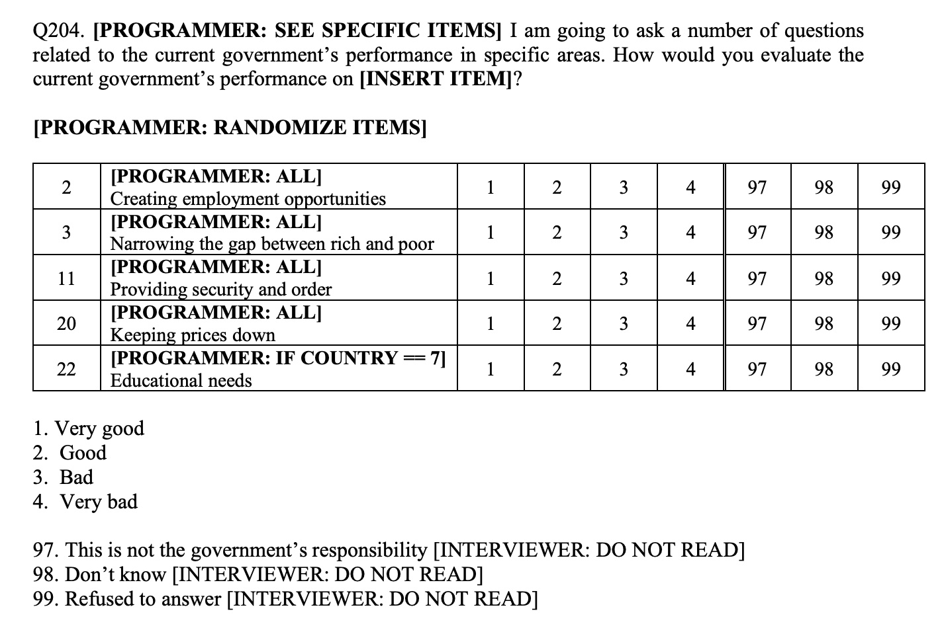

**Participation/Charity:**

Q209b. [PROGRAMMER: ALL] To what extent do you agree with this statement: “Existing charitable and social organizations do everything they can to help provide our country’s citizens with necessary services.”

1. Strongly agree

2. Agree

3. Disagree

4. Strongly disagree

98. Don’t know [INTERVIEWER: DO NOT READ]

99. Refused to answer [INTERVIEWER: DO NOT READ]

Q501a. [PROGRAMMER: ALL] Have you volunteered for any local group / organization regardless of your status of membership?

1. Yes

2. No

98. Don’t know [INTERVIEWER: DO NOT READ]

99. Refused to answer [INTERVIEWER: DO NOT READ]

Q266. [PROGRAMMER: ALL] In a typical month, do you donate money to a charity or those in need?

1. Yes

2. No

98. Don’t know [INTERVIEWER: DO NOT READ] 99. Refused to answer [INTERVIEWER: DO NOT READ]

Q263. [PROGRAMMER: ALL] Which of the following statements best describes you?

1. I prefer helping the poor, even at a large personal cost

2. I prefer helping the poor, even at a small personal cost

3. I prefer helping the poor, but if this costs nothing to me

4. I prefer not helping the poor

98. Don’t know [INTERVIEWER: DO NOT READ]

99. Refused to answer [INTERVIEWER: DO NOT READ]

**Values:**

Q516a. [PROGRAMMER: ALL] In the next few questions, I am interested how you think about the core values underlying any society. Which of these three statements is closest to your own opinion:

1. For people like me, it doesn't matter what kind of government we have

2. Under some circumstances, a non-democratic government can be preferable

3. Democracy is always preferable to any other kind of government

98. Don’t know [INTERVIEWER: DO NOT READ]

99. Refuse to answer [INTERVIEWER: DO NOT READ]

Q512. [PROGRAMMER: ALL] Now measuring the extent to which your democracy is suitable for your country, on a scale from 0-10 with 0 meaning that democracy is completely inappropriate for your country and 10 meaning that democracy is completely appropriate for your country. To what extent do you think democracy is suitable for your country?

Q515a2. [PROGRAMMER: ALL] If you have to choose only one of the statements below, which one would you choose as the most essential characteristics of a democracy?

1. Government ensures law and order.

2. Media is free to criticize the things government does.

3. Government ensures job opportunities for all.

4. Multiple parties compete fairly in the election.

98. Don’t know [INTERVIEWER: DO NOT READ] 99. Refused to answer [INTERVIEWER: DO NOT READ]

Q511. [PROGRAMMER: ALL] Measuring the extent to which your country is democratic, on a scale from 0-10 with 0 meaning there is no democracy whatsoever and 10 meaning that it is democratic to the greatest extent possible. In your opinion, to what extent is your country democratic?