ECEn 631 Camera Calibration & Distortion Correction – HW 3
Seth Nielsen

Task 1

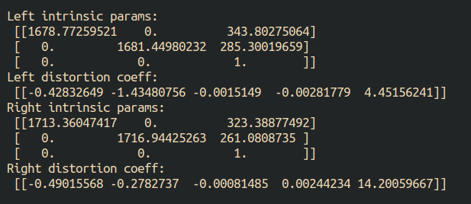
Task 2

Extrinsic parameters (R and T), essential matrix (E), and fundamental matrix (F) between the two cameras:

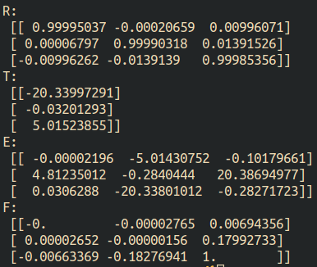
Task 3

Epipolar lines:
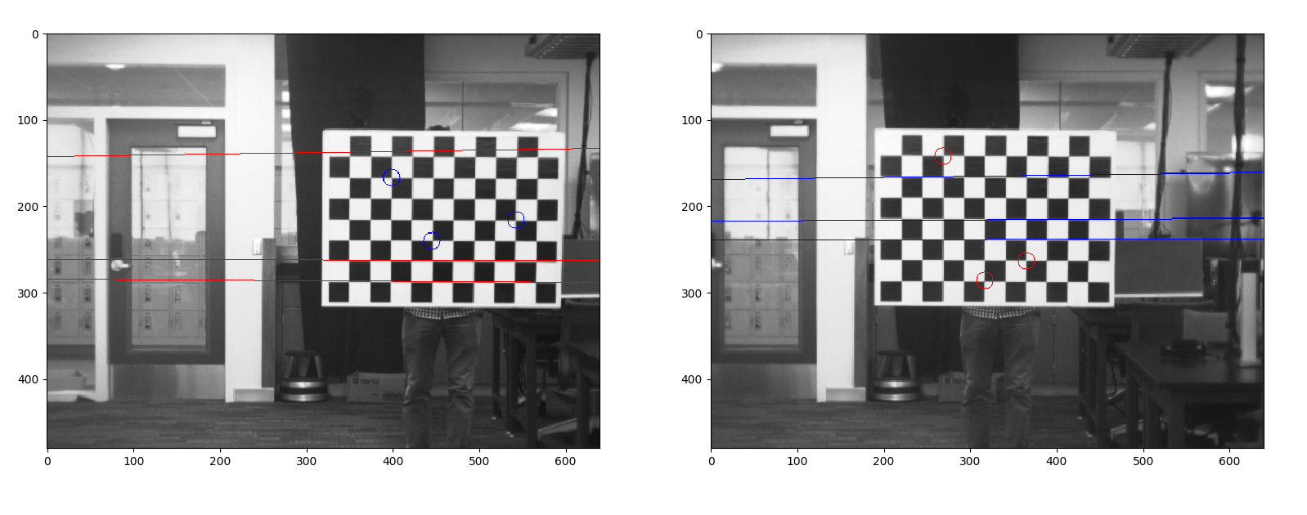

Task 4

Left Image (Original, Rectified):
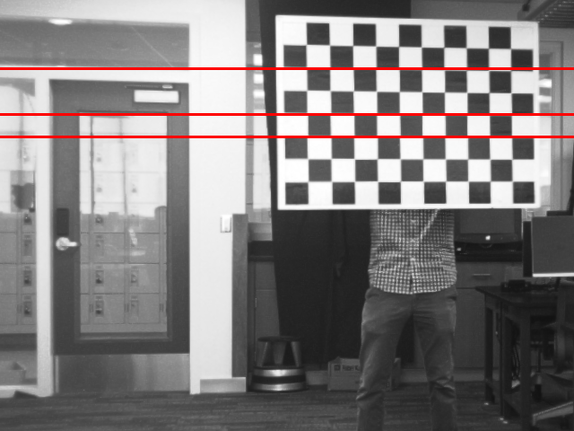
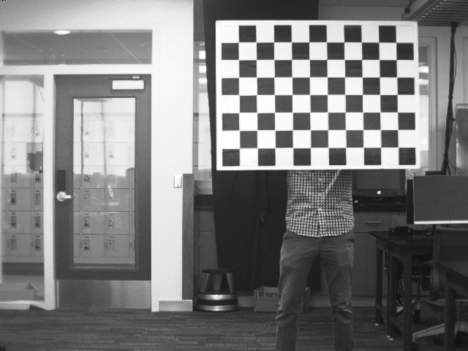

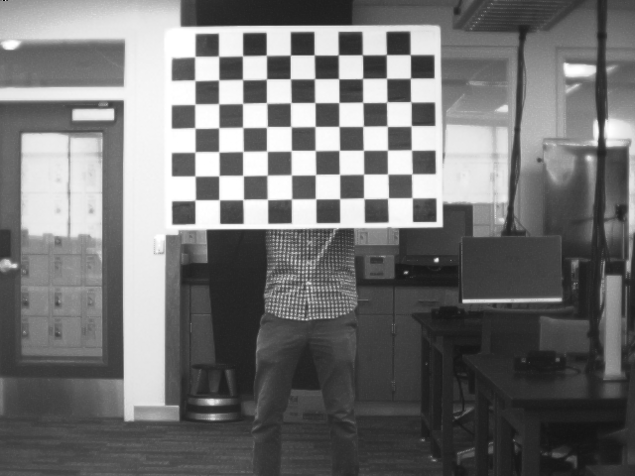
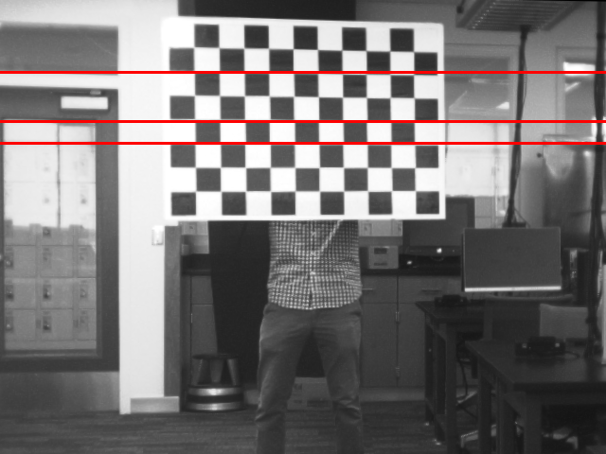

Right Image (Original, Rectified):
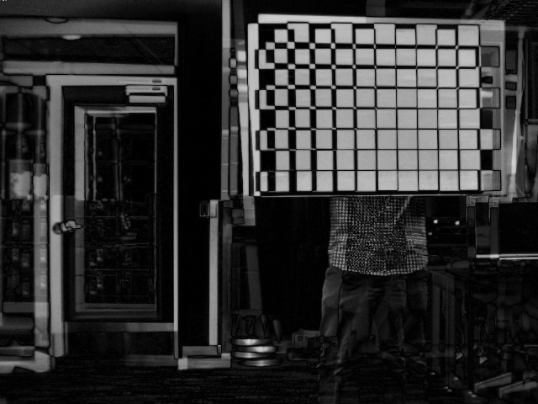
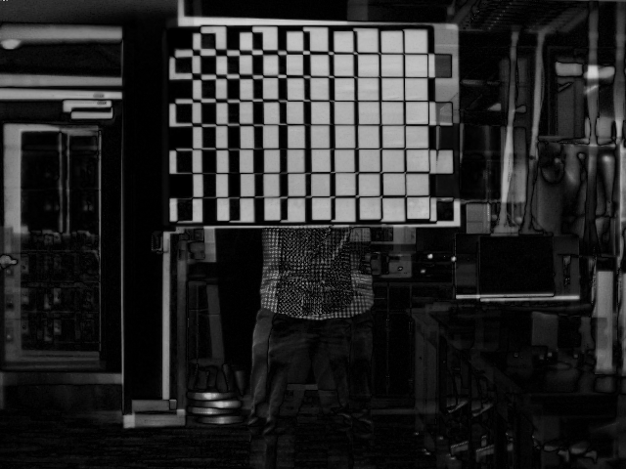
Left absolute difference image:

Right absolute difference image:

