ECEn 631 Camera Calibration & Distortion Correction – HW 3
Seth Nielsen

Task 1

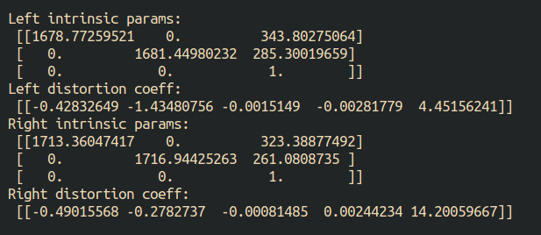
Task 2

Extrinsic parameters (R and T), essential matrix (E), and fundamental matrix (F) between the two cameras:

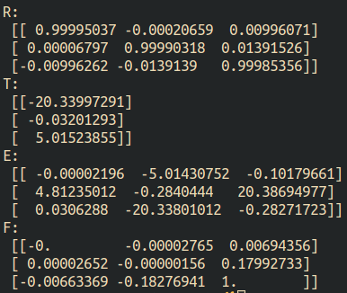

The values for the T vector were accurate in x and y, but had a discrepancy of 5 inches in z for some reason. I ran my code on practice images and it output the same extrinsic parameters as the given ones, and I also ran another student’s code on my dataset and his code also output 5 inches in z. So it appears that my dataset was not ideal.
Task 3

Epipolar lines:
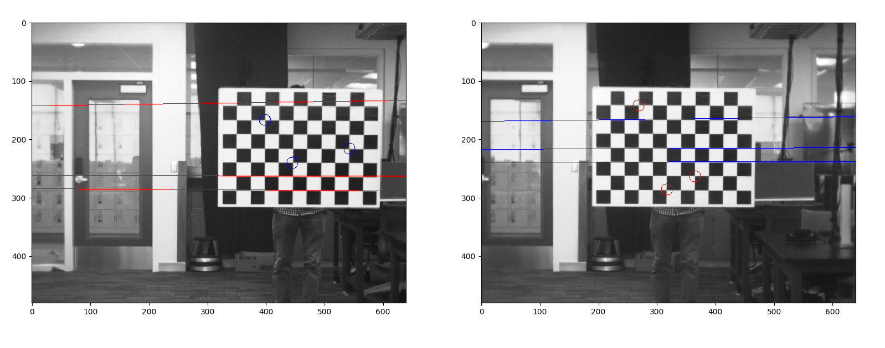

The epipolar lines closely matched the points selected on the opposing images.
Task 4

Left Image (Original, Rectified):
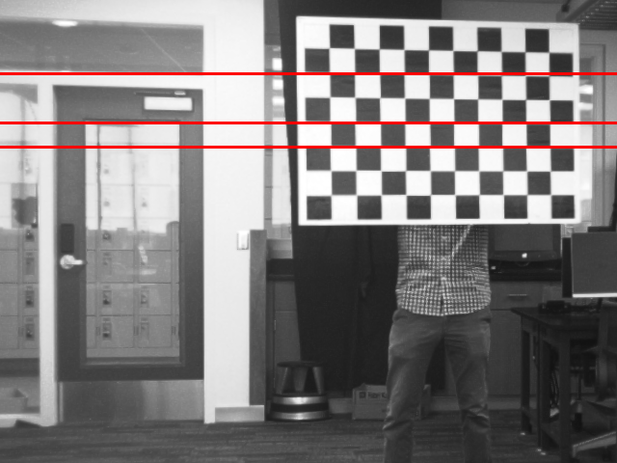
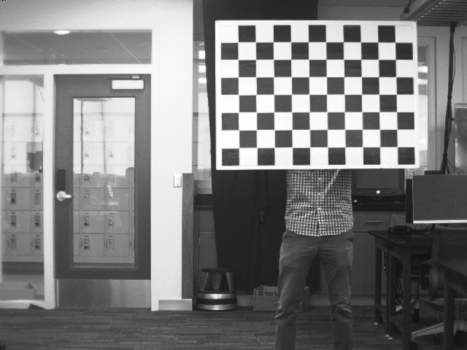

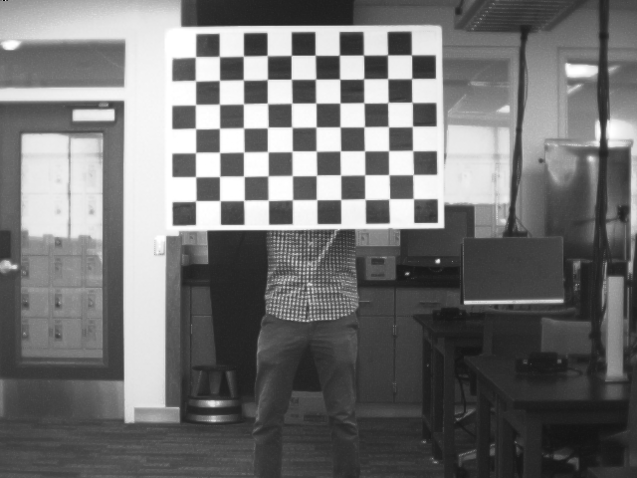
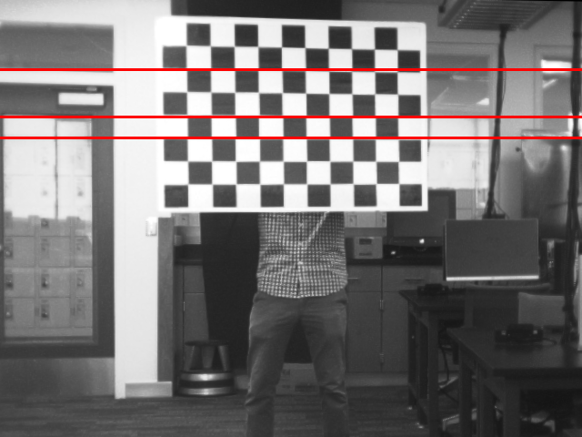

Right Image (Original, Rectified):

It appears that the image rows are indeed aligned.
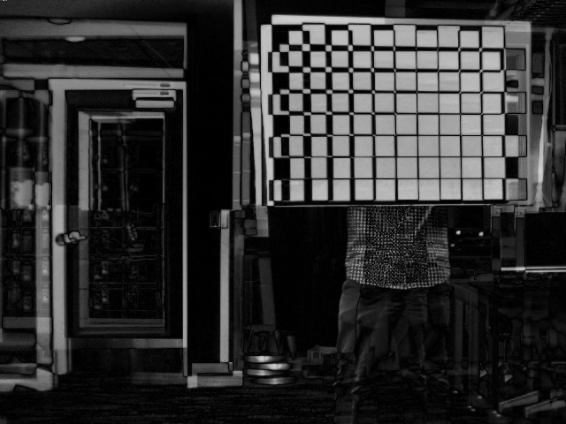
Left absolute difference image:

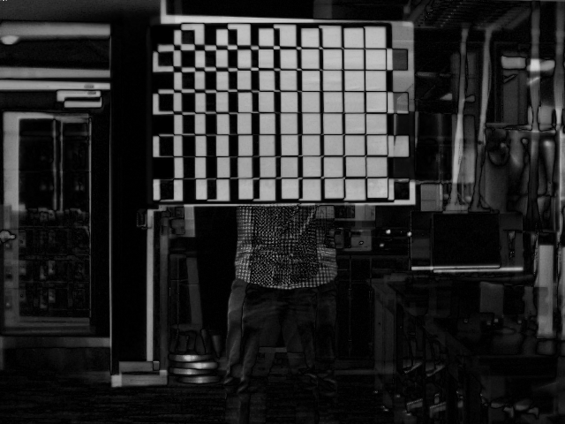
Right absolute difference image:

Once again, it seems that this large absolute difference was caused by the large discrepancy in the extrinsic z translation parameter, which in turn was due to the fairly poor image dataset.

