ECEn 631 3D Trajectory Estimation – HW 4
Seth Nielsen

Task 1

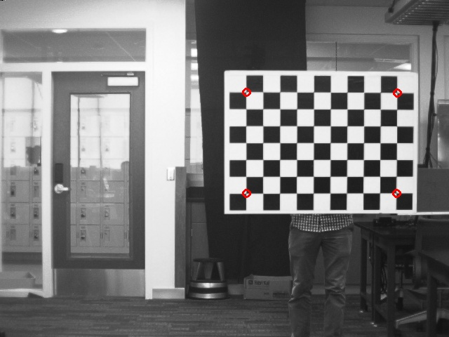
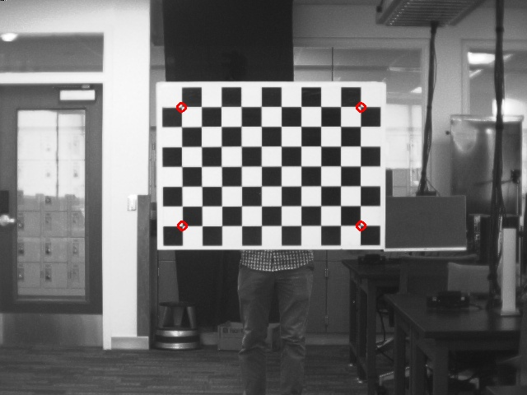
Left:

Left pts:
[38.5474, 5.67971, 277.41]
[3.51612, 5.91889, 277.296]
[38.3723, -17.5588, 275.304]
[3.37155, -17.3091, 274.585]

Right:

Right pts:
[18.2687, 5.5991, 277.41]
[-16.7626, 5.8765, 277.296]
[18.0936, -17.6365, 275.304]
[-16.9072, -17.3983, 274.585]
Task 2

