Ocean Simulation Environment - Seth Nielsen

As there are no testing locations at BYU that could visually resemble a ship at sea, it was desired to create a simulation that could be a viable alternative for developing and testing our visual algorithms. This research project’s immediate goal is to create such a simulation with highly accurate dynamics for an ocean, a ship, and a UAV agent, as well as photorealistic models of each. This will greatly aid development of better and novel visual pose estimation algorithms for future research done on this project, and potentially including the other BYU research projects outlined in this report.
Work began on the simulation in September and has seen much progress since that time. Several routes were explored, including creating a simulation nearly from the ground up using the Unity game engine, then using Unreal Engine. It quickly became apparent that this approach would be too large of a time investment for this project, and so was abandoned in favor of exploring tools that already exist. An attempt was made to utilize Microsoft AirSim for the task, but issues with Linux compatibility (our sole development platform) and the lack of any pre-built binaries of an ocean world caused this option to be abandoned as well.
Finally, a decision was reached to combine two separate tools together into one unique simulation package. The first is Holodeck - a simulator built on Unreal Engine being developed by the BYU Perception, Control and Cognition Lab - which allows users to control a multirotor UAV agent throughout various pre-built worlds. Holodeck’s main advantage is its highly realistic visuals, as well as a local BYU dev team that has created a configurable ocean world with a ship at sea for this project. A major disadvantage is that any control or polling of virtual sensors (i.e. camera, IMU, gyros) can only occur once per rendered frame at the rate of 30 frames per second; far too slow for control of a multirotor. The second tool is one developed by the BYU MAGICC Lab, called ROSflight: a modular autopilot system that contains packages for control of a UAV in hardware as well as some software-in-the-loop (SIL) functionality. It can stream simulated high-rate sensor data and simulate the dynamics of a multirotor UAV. As ROSflight is regularly flown in hardware, the simulated dynamics model has been thoroughly tested and proven to have a high degree of fidelity.
The combined simulator being developed for this project uses Holodeck as a camera simulator and to take care of the complicated physics of collisions (such as when the UAV lands on the boat), while ROSflight’s SIL capabilities are used to simulate the remaining sensors and to propagate the dynamics between each rendered Holodeck frame, allowing streaming of sensor data at upwards of 1 kHz. The state of the UAV within the Holodeck world is overwritten by ROSflight’s simulated dynamics each frame, until a collision occurs, in which case the UAV’s state within ROSflight is overwritten by the state computed by Holodeck.
At this point in time, a basic working system has been implemented where a quadcopter UAV agent can be flown around the ocean environment using an RC transmitter, including manually landing the UAV on the boat agent, correctly working between ROSflight and Holodeck to allow high-rate sensor streaming and control while also correctly entering in and out of a “collision” state, thus offering a unique simulation package that combines the major advantages of both systems. Currently work is being done to implement autonomous waypoint following and improving stability and robustness of the simulation.

Semantic Image Segmentation - Seth Nielsen

This project is developing a semantic image segmentation approach to the problem of autonomously landing a multirotor UAV on a ship at sea. A photo-realistic, 3D simulated world containing a boat on moving waves with a flying UAV was created for this project. The ship has a flat area that serves as a landing pad for the multirotor. The multirotor is equipped with a simulated sensor suite of a monocular camera, IMU, and GPS. A pre-trained deep convolutional neural network was used to perform semantic image segmentation on the camera’s video feed in order to distinguish the boat from the ocean, followed by distinguishing the landing pad from the other parts of the boat. The neural network has shown promising performance in the task of identifying the boat.
The simulator developed for this project combines two tools: Holodeck (created by the BYU Perception, Control and Cognition Lab) as a camera simulator, and ROSflight (developed by the BYU MAGICC Lab) is used to simulate the other sensors and to propagate the dynamics between each rendered Holodeck frame, allowing control and streaming of sensor data at upwards of 1 kHz between rendered images. The state of the UAV within the Holodeck world is overwritten by ROSflight’s simulated dynamics each frame, until a collision occurs, in which case the UAV’s state within ROSflight is overwritten by the state computed by Holodeck.
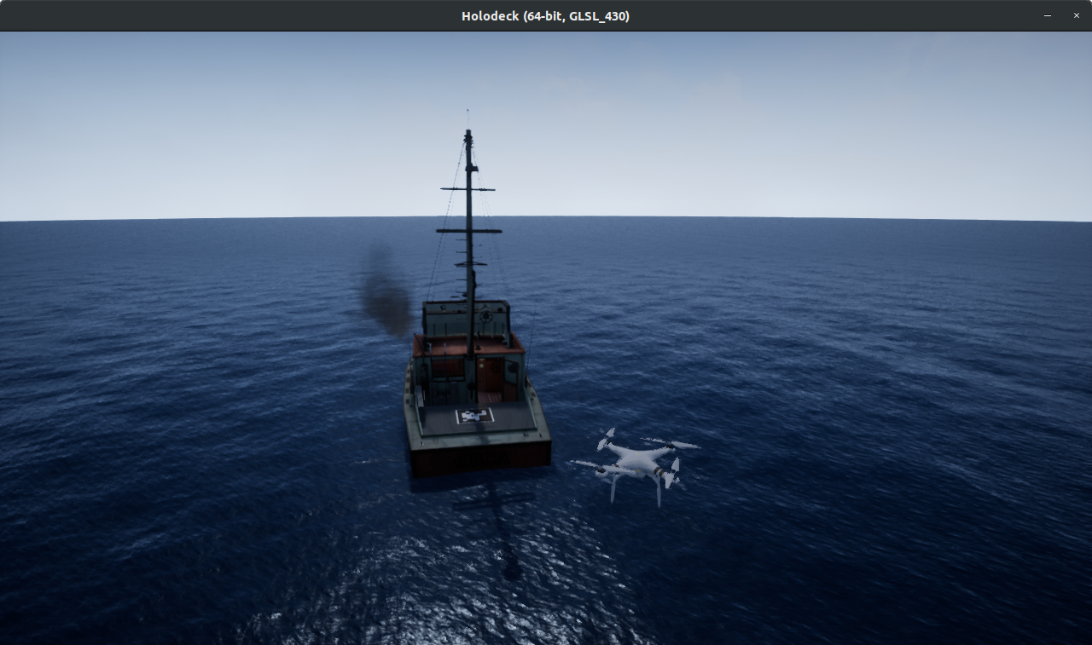
Holodeck Ocean World

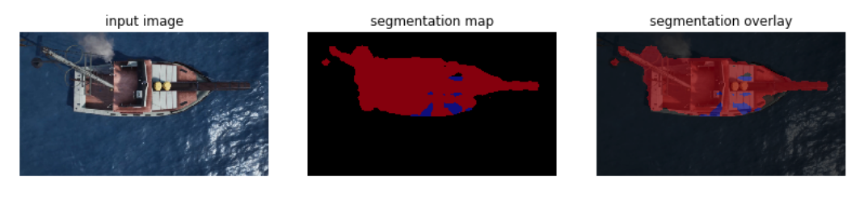
Semantic image segmentation results on image of rendered boat and ocean water

Model Predictive Control - Mathew Haskell

The main research objective of this project is to explore how model predictive control (MPC) can improve performance of shipboard landings in highly uncertain environments. One area of interest is handling communication delays when complicated computation for feedback control occurs on a ground station rather than on the UAV. This includes measurement delay and control delay, depicted in the figure below. Moving computation to a ground station would reduce the amount of hardware required on the payload, which would reduce weight and power consumption. Other benefits include the potential for a universal controller independent of the vehicle platform and the possibility of a more powerful computer to use for calculations.
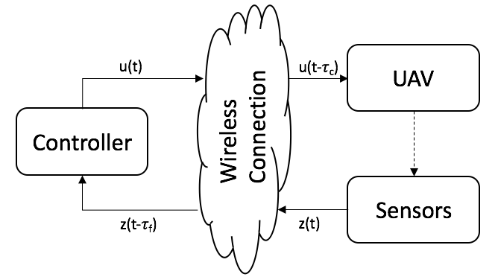
To test if the predictive nature of MPC would be capable of accounting for time delays, an initial simulation framework was constructed in MATLAB and Simulink. In this framework, a dynamic model was used with MPC to generate thrust and body torque commands while receiving full-state feedback. The first step was to fly waypoint trajectories. After that, MPC was used to land the multirotor on a platform moving sinusoidally in height. Finally, time delays were added. A maximum amount of 0.9 seconds of delay was simulated, with 0.6 seconds on the downlink and 0.3 seconds on the uplink. The delayed feedback information was propagated forward in time, using the MPC model along with a history of sent commands that have yet to be received by the multirotor, to the point in time where the vehicle was expected to receive the control commands. This provided a state prediction at the current time (in the vehicle’s frame of reference). This predicted state was used as the initial condition for the MPC optimization, which ran as if there weren’t any time delays. With this setup, the multirotor was successfully able to fly waypoint trajectories
Previously, an attempt was made to modify the MPC model to output attitude commands rather than body torques in order to be more compatible with generic flight controllers. This was done by including a simple, fitted model of the inner loop dynamics of the flight controller. Fitting the model is not trivial, so the current model has been changed to use full dynamics for translation and only kinematics for rotation. A kinematic model allows for MPC to generate angular rate commands by assuming that the torques required to achieve the commanded angular rates are achieved instantaneously. This is a similar assumption to that of successive loop closure with PID controllers. The kinematic model has been used by other students in the MAGICC Lab for LQR controllers that flew in hardware. Going forward, this kinematic model will be used since it does not require system identification of the flight controller dynamics.
Another ongoing change involves the optimization library and the framework of MPC. It is theorised that the time window used with MPC should look 2 to 3 times further ahead than the amount of time delay in the communication. The solver for the initial MPC was CVXGEN, which only allowed for a 10 step look ahead. This required a large discretization time step of 0.3 seconds in order to have a look ahead of 3 seconds. This crude discretization of a linearized model did not perform as well as hoped. There were significant drops in height whenever the multirotor tilted. Currently, a change to use OSQP rather than CVXGEN is being made. OSQP allows for larger problems and has been shown to solve faster than CVXGEN. Also, the MPC framework is being changed by parameterizing the input trajectory over the time horizon with fewer free control variables than the number of time steps in the prediction horizon. As few as 3 or 4 points can be chosen to parameterize the input space, which is the search space of the optimization, with simple linear interpolation between the points to calculate all of the inputs in between. Also, this input space parameterization has been shown to have little, if any, performance reduction (see this paper). This means the length of the time horizon no longer scales the search space of the optimization. So a 100 step time horizon can be used without increasing the amount of time it takes to solve the optimization. With these extended time horizons, a more reasonable discretization time step can be used on the model, allowing for control inputs to change more frequently.
In addition to changes in solver and controller parameterization, which we think will improve performance, we have also improved our method of linearizing and discretizing our dynamic model for MPC. We derived a method to perform an exact discretization of a linearized system about a desired trajectory. As far as we are aware, there is no literature that does this. This is only an issue when linearizing about a non-equilibrium point, because there are terms in the Taylor Series linearization that do not go away which need to be integrated properly. I have forward propagated a model using manual inputs with this new discretization method and compared it to the model of the initial simulation. The new method follows RK4 integration better (where doing RK4 integration during control is not feasible, but is feasible for benchmarking). I hypothesize that this new model will reduce the negative coupling effects on height when the vehicle tilts, although it has yet to be simulated in a controller. Current work involves organizing a code base in C++ that will allow for the theoretical changes described above to be easily utilized in simulation and hardware.

