ECEn 631 3D Structure From Motion – HW 6
Seth Nielsen

Task 1

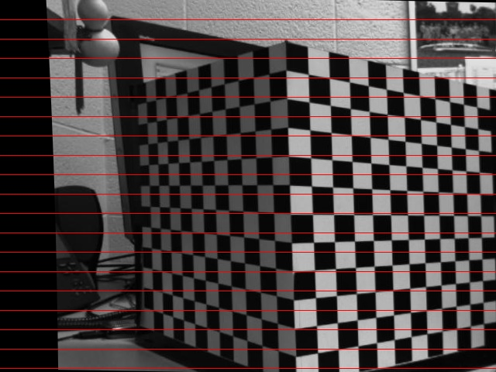
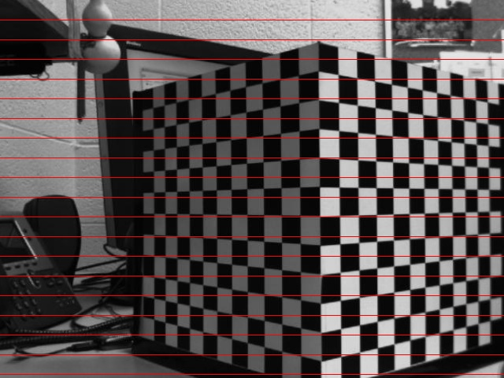
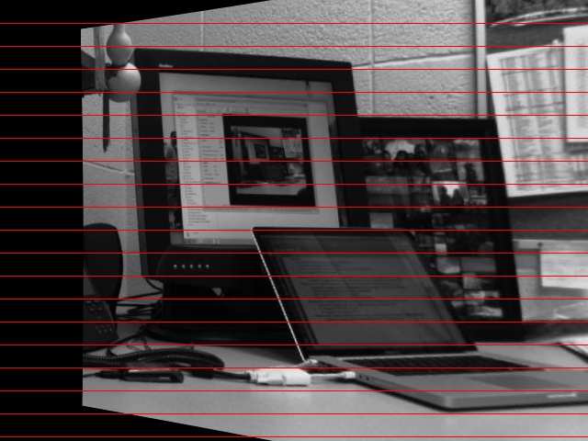
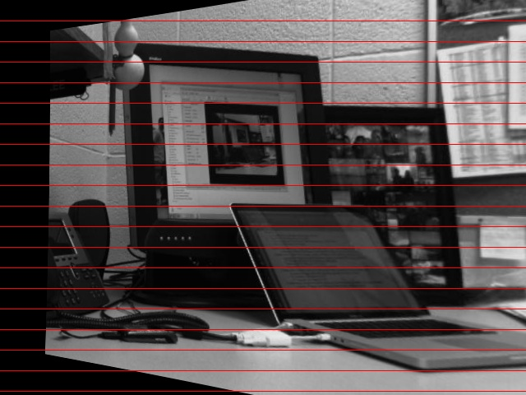
Parallel sequences

First Last
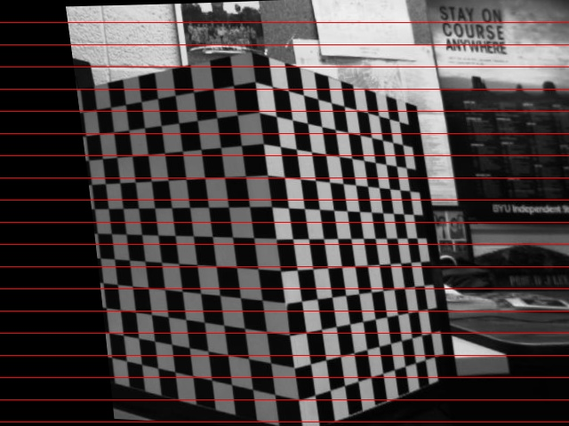
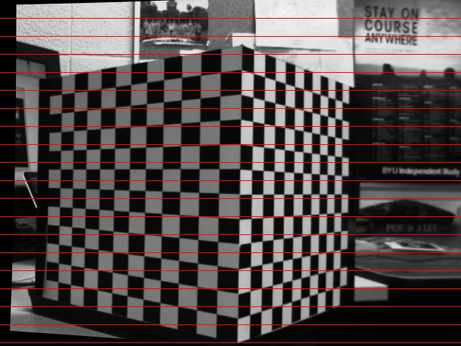
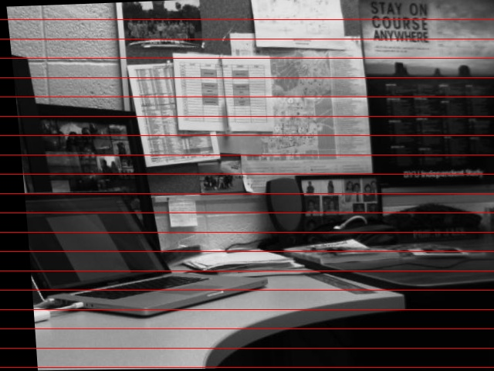
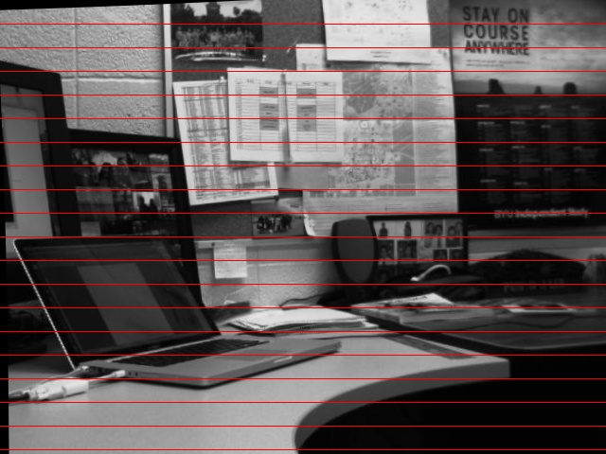
Real sequences

It appears that rectifying the images was somewhat successful in that sequences 1, 2, and 4 line up fairly well. However, sequence TurnCube was not successfully rectified. I believe this is due to error in the guess for the instrinsic parameters.
Task 2

Parallel Cube

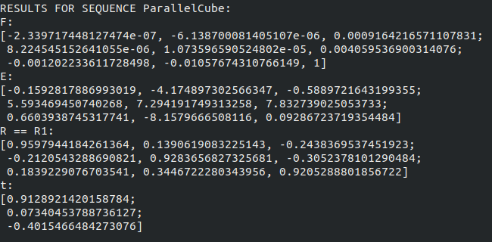
Motion: very little rotation, high displacement in -x, some displacement in +z

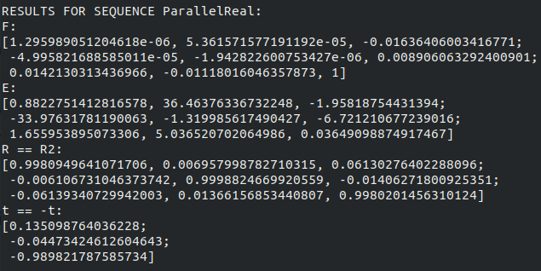
Parallel Real

Motion: zero rotation, high displacement in +z
Turn Cube
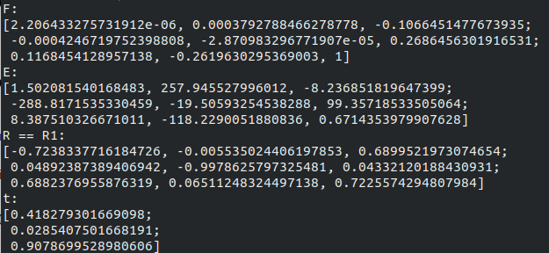

Motion: +rotation about y-axis, high movement in -z, some movement in -x

Turn Real
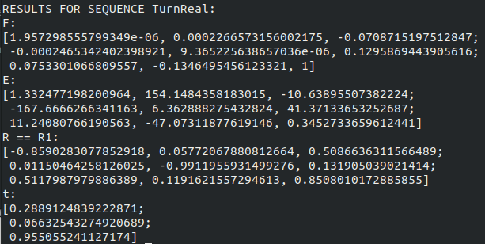
Motion: +rotation about y-axis, high movement in -z, small movement in -x
Task 3

For the Parallel images, the scale factor was 2.7

Parallel Cube

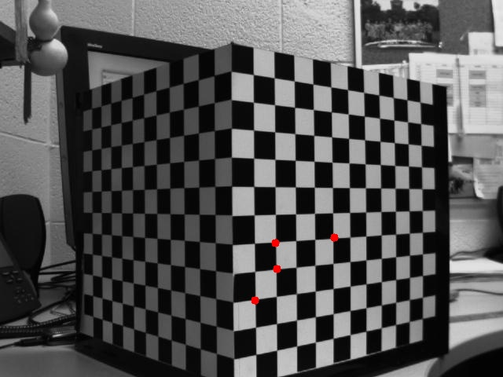

T =
[2.673458914606298;
-0.2094803564206801;
0.3142219155087391]

-2.67” in x
0.21” in y
-0.31” in z

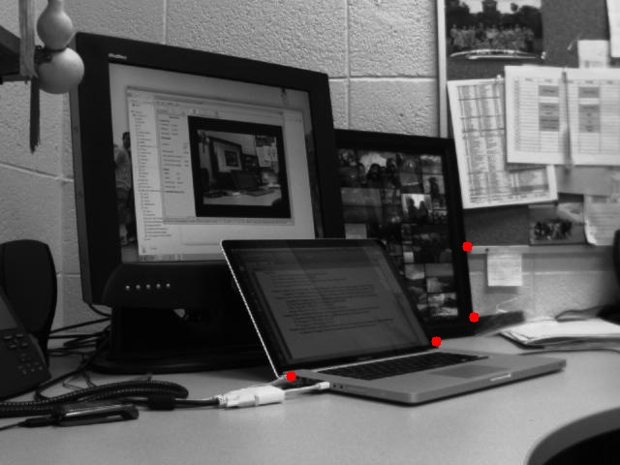
Parallel Real

T =
[0.4740132860188657;
-0.2489938960104165;
-2.646377419119796]

-0.47” in x
0.25” in y
2.65” in z
For the Turn images, the scale factor was 2.3

Turn Cube

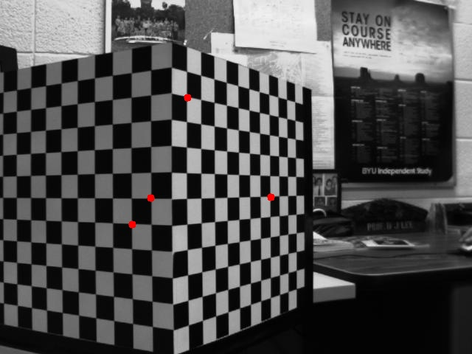

T =
[1.554422843193451;
0.09549055537012778;
1.692528043606218]

-1.55” in x
-0.095” in y
-1.69” in z

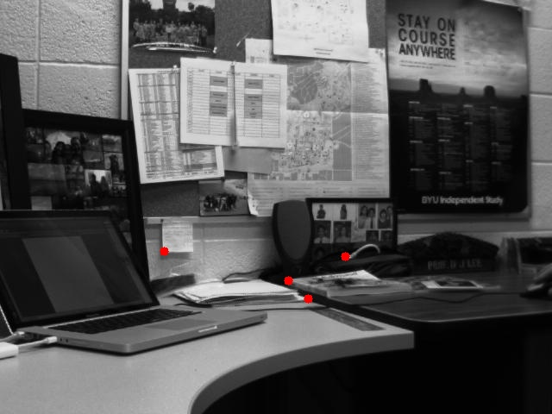
Turn Real

T =
[0.3701657375194454;
-0.1100497790400233;
-2.267347872052263]

-0.37” in x
0.11” in y
2.27” in z

