Problem 1: A lot of 100 semiconductor chips contain 20 that are defective.

(a) Two are selected, at random, without replacement, from the lot. Determine the probability that the second chip selected is defective.

P(*D) = P(ND) + P(DD) = 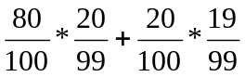 = 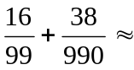.2

(b) Three are selected, at random, without replacement, from the lot. Determine the probability that all are defective.

P(DDD) = 20/100 * 19/99 * 18/98 = 0.00705
Problem 2. Samples of a cast aluminum part are classified on the basis of surface finish (in microinches) and length measurements. The results of 100 parts are summarized as follows:

 |  | Length
 |  | excellent | good
Surface  Finish | excellent | 80 | 2
Surface  Finish | good | 10 | 8

Let A denote the event that a sample has excellent surface finish, and let B denote the event that a sample has excellent length. Are events A and B independent? Explain your answer.

P(A ∩ B) = 80/100 = .8
P(B)*P(A) = .82*.90 = 0.738

P(A ∩ B) ≠ P(B)*P(A) ∴ events A and B are not independent, because the outcome of one influences the probability of the other greater than chance alone would.

Problem 3. The following circuit operates if and only if there is a path of functional devices from left to right. The probability that each device functions is as shown. Assume that the probability that a device is functional does not depend on whether or not other devices are functional. What is the probability that the circuit operates?

0.90
0.95
0.80
0.95
0.70
0.95

Φ(x) = x₁ * x₂ * x₃
= (.90 U .95) * (.80 U .95) * (.70 U .95)
= (1- (1-.90)(1-.95)) * (1- (1-.80)(1-.95)) * (1-(1-.70)(1-.95))
= (.90+.95-(.90*.95)) * (.80+.95-(.95*.80)) * (.70+.95-(.70*.95))
= .9703

Problem 4: A particular test for the presence of illegal steroids is to be used after a professional track meet.
- If steroids are present, then the test will give a positive result 95% of the time (in the other 5% of these cases the test will give a negative result).
- If steroids are not present, the test will give a negative result 90% of the time (so, it is wrong in 10% of these cases and falsely gives a positive result).
- Based on past data, it is believed that 2% of the athletes in the track meet use steroids.
- Suppose that the test is given to a randomly selected athlete at the track meet.
  - Let A be the event that the athlete is guilty of using illegal steroid
  - Let B be the event that the test is positive for steroids.
- What is the probability of event A?

P(A) = .02

- What is the probability of event B?

P(B) = P(positive)
= P(pos | S)*P(S) + P(pos | !S)*P(!S)
= (.95 * .02) + (.10 * .98)
= .117

- Suppose that the test is negative, what is the probability that the athlete is guilty of using illegal steroids?

P(negative) = !P(positive) = 1 - .117
= P(neg | S)*P(S) + P(neg | !S)*P(!S)
= (.05 * .02) + (.90 * .98)
= .883

P(S | negative) = 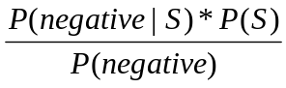= 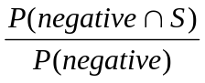
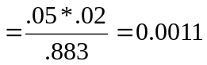

- Suppose that the test is positive, what is the probability that the athlete is guilty of using illegal steroids?

P(S | positive) = 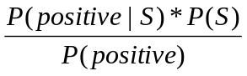=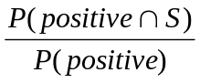
= 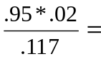0.162

