Problem 1. A company that tracks the use of its website determined that the more pages a visitor views, the more likely the visitor is to provide contact information. Use the following tables to answer the questions:

Number of pages viewed | 1 | 2 | 3 | 4 or more
Percentage of visitors | 40 | 30 | 20 | 10

Number of pages viewed | 1 | 2 | 3 | 4 or more
Percentage of visitors in each page-view category that provide contact information | 10 | 10 | 20 | 40

- What is the probability that a visitor to the website provides contact information?

P(contact) = P(V=1)*.10 + P(V=2)*.10 + P(V=3)*.20 + P(V≥4)*.40
= (.40*.10) + (.30*.10) + (.20*.20) + (.10*.40)
= .15

- If a visitor provides contact information, what is the probability that the visitor viewed four or more pages

P(V≥4 | contact) =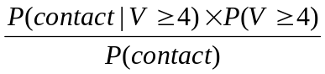=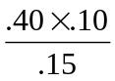=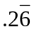
Problem 2. In a semiconductor manufacturing process, three wafers from a lot are tested. Each wafer is classified as pass or fail. Assume that the probability that a wafer passes the test is 0.8 and that wafers are independent. Determine the probability mass function of the number of wafers from a lot that pass the test.
P(X=0) = 1 * .8⁰ * .2³ = .008  P(X=1) = 3 * .8¹ * .2² = .096  P(X=2) = 3 * .8² * .2¹ = .384  P(X=3) = 1 * .8³ * .2⁰ = .512  P(X=x) = 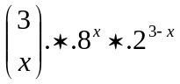 for x = {0,1,2,3} | 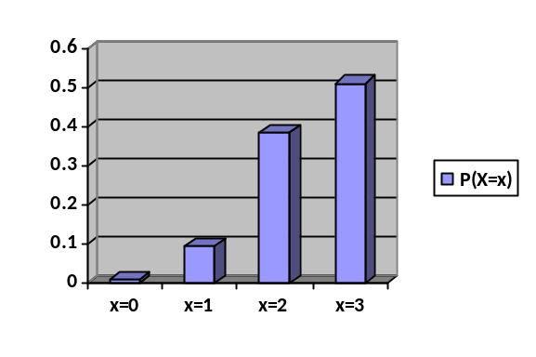

Problem 3. Determine the cumulative distribution function for the random variable, the number of wafers that past the test, in problem 2 above.

CDF(P(X=x)) = P(X≤x)  F_{x}(X=0) = .008  F_{x}(X=1) = .104  F_{x}(X=2) = .488  F_{x}(X=3) = 1  CDF(X=x) = 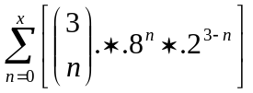 for x={0,1,2,3,4} | 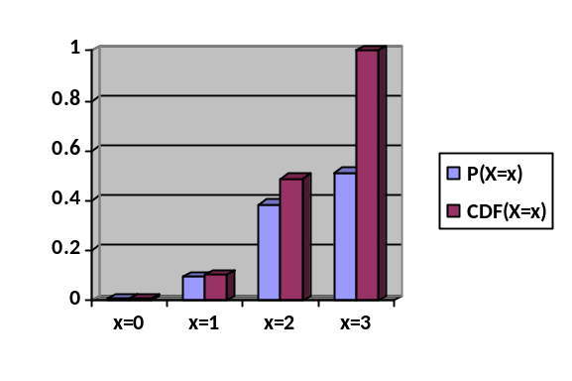

Problem 4. An assembly consists of two mechanical components. Suppose that the probabilities that the first and second components meet specifications are 0.95 and 0.98. Assume that the components are independent. Determine the probability mass function of the number of components in the assembly that meet specifications.

P(X=0) = F₁ * F₂ = .05 * .02 = .001
P(X=1) = F₁ * M₂ + M₁ * F₂ = .05 * .98 + .95 * .02 = .068
P(X=2) = M₁ * M₂ = .98 * .95 = .931
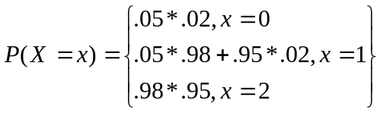 for x = {0,1,2}

