EMIS 7300 Homework Assignment 4

Problem 1
A particularly long traffic light on your morning commute is green 20% of the time that you approach it. Assume that each morning represents an independent trial.
- Over five mornings, what is the probability that the light is green on exactly one day?
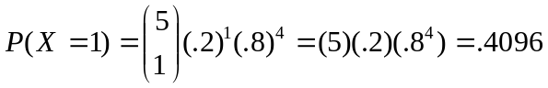
- Over 20 mornings, what is the probability that the light is green on exactly four days?
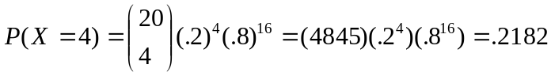
- Over 20 mornings, what is the probability that the light is green on more than four days?
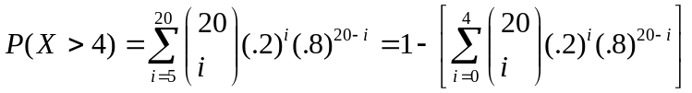
= 1- [ (1)(.2^0)(.8^20)
+(20)(.2^1)(.8^19)
+(190)(.2^2)(.8^18)
+(1140)(.2^3)(.8^17)
+(4845)(.2^4)(.8^16) ] = 1 - .6296 = .3704

Problem 2
The probability is 0.6 that a calibration of a transducer in an electronic instrument conforms to specifications for the measurement system. Assume that the calibration attempts are independent. What is the probability that at most three calibration attempts are required to meet the specifications for the measurement system?

C = Calibrated trial; N = Not Calibrated trial; X = number of trials

P(X < 4) = 1 – P(NNN) = 1 - .4³ = .936

Problem 3
A fault-tolerant system that processes transactions for a financial services firm uses three separate computers. If the operating computer fails, one of the two spares can be immediately switched online. After the second computer fails, the last computer can be immediately switched online. Assume that the probability of a failure during any transaction is 10⁻⁸ and that the transactions can be considered to be independent events.

- What is the mean number of transactions before all computers have failed?

E(x | r=3) = 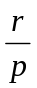 = 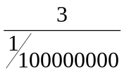 = 3*10⁸

- What is the variance of the number of transactions before all three computers have failed?

V(x | r=3) = 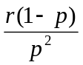 = 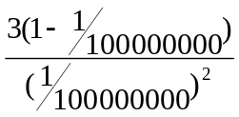=3*10¹⁶

Problem 4 - Hypergeometric
A lot of 75 washers contains 5 in which the variability in thickness around the circumference of the washer is unacceptable. A sample of 10 washers is selected at random, without replacement.

- What is the probability that none of the unacceptable washers is in the sample?

A = Acceptable; N = Unacceptable

P(AAAAAAAAAA) =
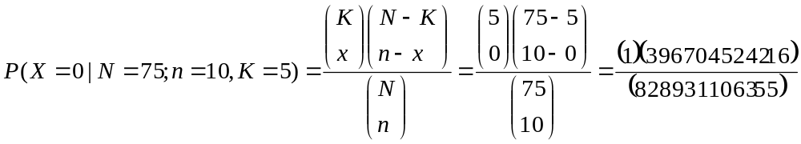=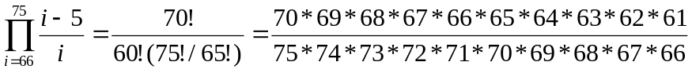=.4786

- What is the probability that at least one unacceptable washer is in the sample?

P(N>0) = 1–P(N=0) = 1 – P(AAAAAAAAAA) = 1-.4786 = .5214

- What is the probability that exactly one unacceptable washer is in the sample?

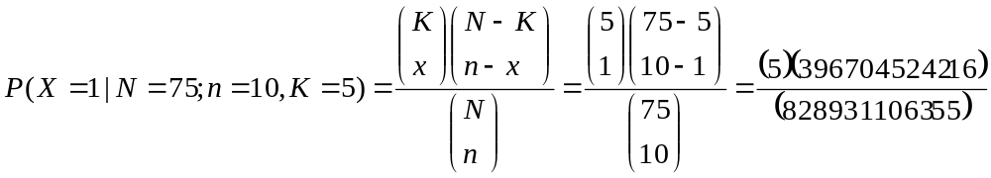=0.07845

d) What is the mean number of unacceptable washers in the sample?

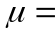E(x) = np = (10)(5/75) = 2/3

