Tracking Filters:

     Continuous, Uni-modal: Kalman and Particle

     Discrete, Muli-modal: Monte Carlo/Localization

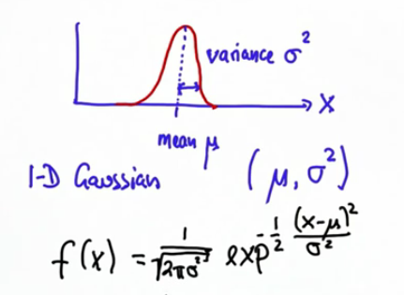

f(x) = .... * exp(-.5 * .... )

Update = Sense

Predict = Move

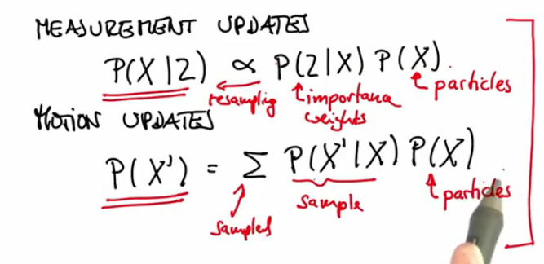

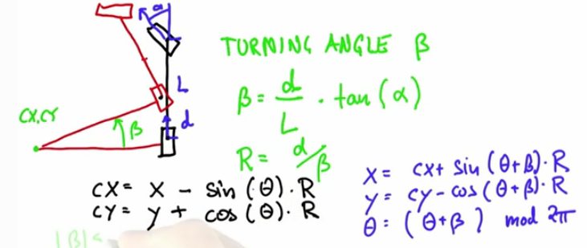

There are special rules with small Betas, to prevent division by zero:

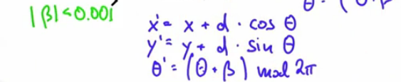

Inline image 3

arctan2 gives the angular orientation to a position give a change in x/y

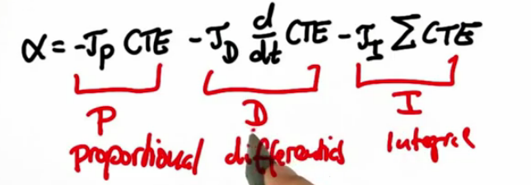

tau_d is a "smoothing" term

