C:\Users\gaineys.FWT2HS1\Documents\3758d36c-786a-48ca-b863-ec55cdedecf5.png

C:\Users\gaineys.FWT2HS1\Documents\02fbe93c-5b87-420e-9318-9ba20b4c5060.png

    ex:  7c5 = (7\*6)/(2\*1)

P(A|B) = P(A and B)/P(B)

Two sample Z test: 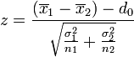 ; ignore d-0.

Compare the z-value 1.96 or other value. If it's greater, then the difference is significant.

1-Sample Confidence Interval  = 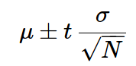 =  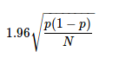

Bayes calculations, assuming you observe a positive test result:

p(cancer) = .1  
p(positive|c) = .9  
p(negative|!c) = .8  
p(positive|!c) = .2  
#joint probabilities  
p(c,pos) = p(c) \* p(pos|c) = .09  
p(!c, pos) = p(!c) \* p(pos|!c) = .18  
normalizer-> 3.703703704  
p(c|pos) = .09 \* normalizer = 0.333

St dev can be multiplied by a multiple. Variances can be added for multiple measures of some uncertainty. I.e., you can sum variances, and scale standard deviations.