INTRODUCTION:

Predicting stock market prices is a challenging and essential task in the world of finance. Accurate predictions can help investors make informed decisions and maximize their returns in an increasingly dynamic and complex market. This introduction sets the stage for exploring innovative methodologies and approaches to enhance stock market prediction, addressing the challenges and opportunities in this field, and highlighting its relevance in shaping the future of financial markets.

INNOVATION:

* News Sentiment Analysis: Incorporate sentiment analysis of news articles and social media posts to gauge public sentiment and its impact on stock prices.
* Natural Language Processing (NLP): Develop advanced NLP models to extract insights from financial news, earnings reports, and other textual data sources.
* Alternative Data Sources: Explore unconventional data sources such as satellite imagery, consumer foot traffic, or social media trends to gain unique insights into market movements.
* Social Network Analysis: Analyze the social networks of influential investors and traders to identify trends and predict market sentiment.
* Quantum Computing: Investigate the potential of quantum computing for more complex and faster data analysis, which can lead to more accurate predictions.
* Blockchain Technology: Utilize blockchain to enhance transparency in stock market data and transaction records, reducing fraud and manipulation.
* Intermarket Analysis: Incorporate data and insights from related markets, such as commodities, currencies, and bond markets, to provide a holistic view of market dynamics.

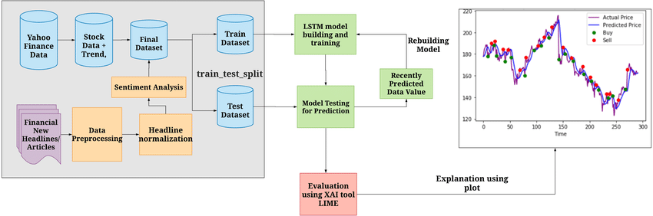

STEPS TO INVOLVE :

1. Data Collection: Gather historical stock market data, including price, volume, and other relevant indicators.

2. Data Preprocessing: Clean and preprocess the stock market data to handle missing values, outliers, and ensure data consistency.

3. Feature Engineering: Create meaningful features and indicators from the stock market data, such as moving averages, relative strength index (RSI), and trading volume.

4. Data Splitting: Divide the dataset into training and testing sets to facilitate model development and evaluation.

5. Model Selection: Choose an appropriate prediction model for stock market analysis, such as time series forecasting, machine learning, or deep learning models.

6. Model Training: Train the selected model using the training dataset to capture historical patterns and relationships.

7. Model Evaluation: Assess the model's performance on the test dataset using metrics like accuracy, precision, recall, and F1-score.

8. Hyperparameter Tuning: Optimize the model's hyperparameters, such as learning rate, batch size, and hidden layers, to improve its predictive accuracy.

9. Final Model Selection: Select the best-performing model based on evaluation results and hyperparameter tuning.

10. Prediction: Utilize the final model to make predictions for stock prices or market trends, providing insights for investors and traders.

CONCLUSION:

stock market prediction, driven by advanced technologies and data analytics, remains an indispensable tool for informed investment decisions in an ever-evolving financial landscape. Investors should embrace these innovations while emphasizing the importance of sound financial strategies and risk management.