**1.TABLE CODE**

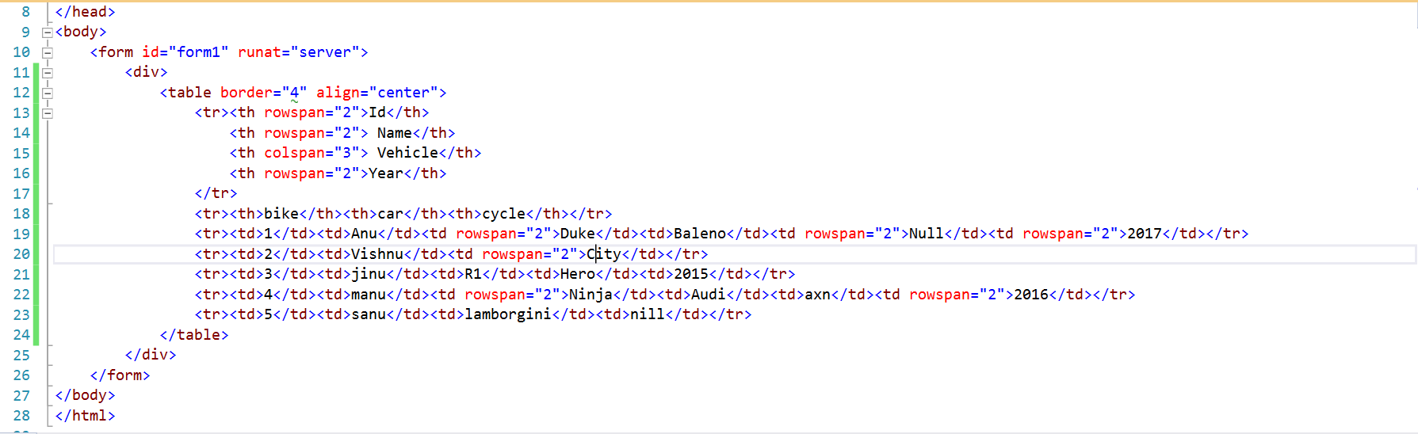

**OUTPUT**

**2.STUDENT LOGIN FORM CODE**

**OUTPUT**

