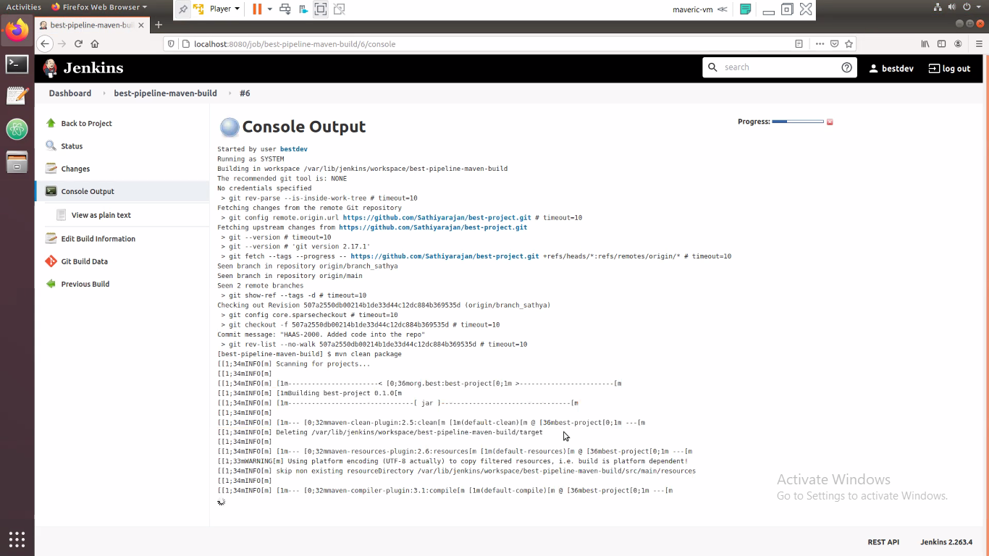

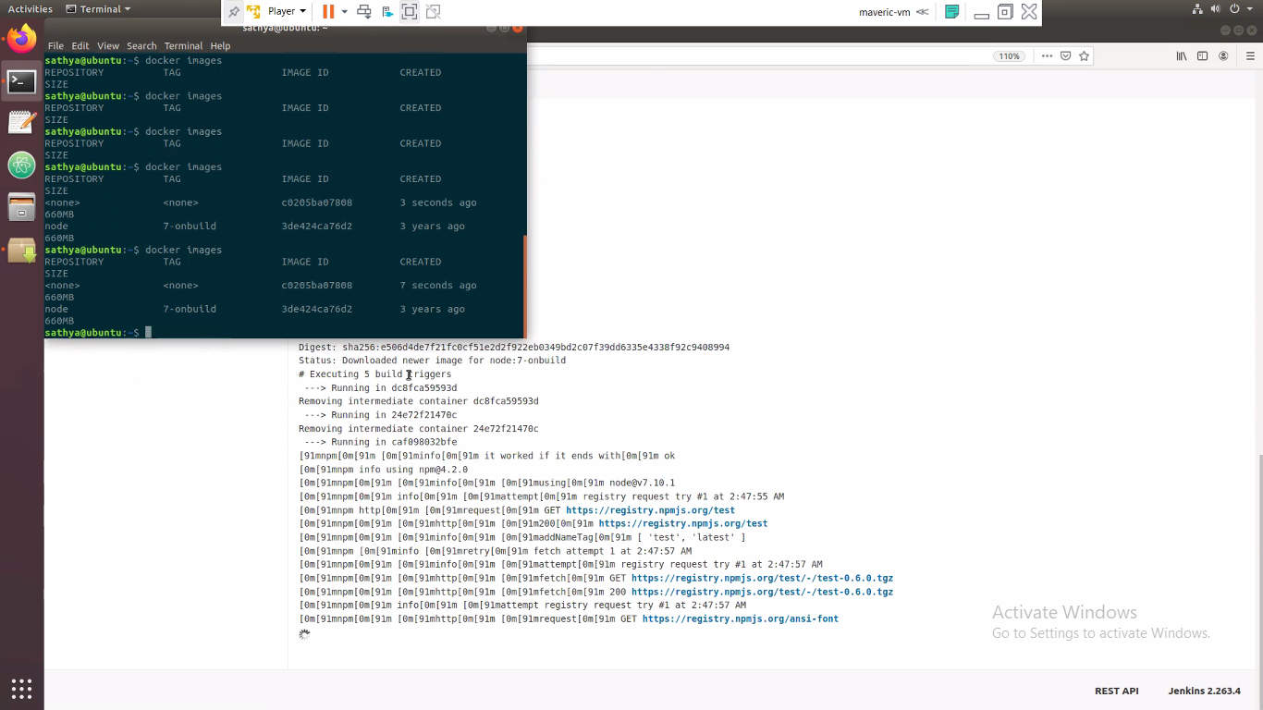

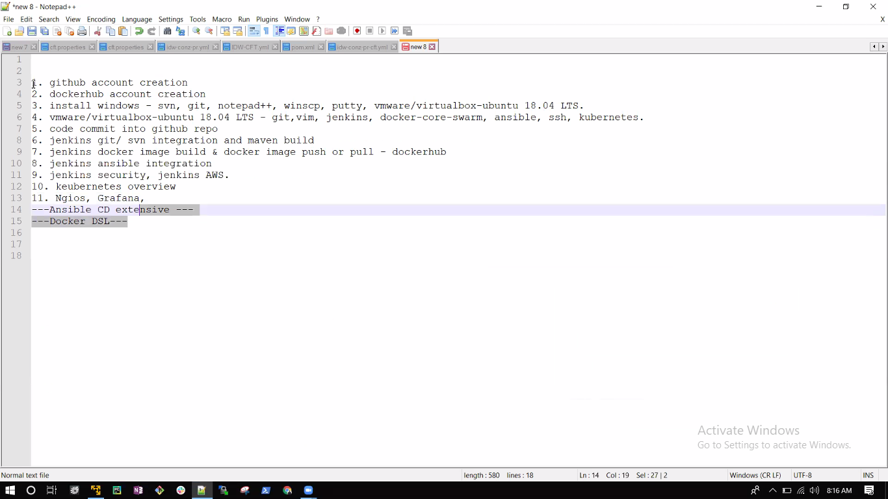

From sathiyarajanm to Everyone: 07:10 AM

able to hear me?

GitHub.com

dockerhub.com

Amazonpwd123$

From sathiyarajanm to Everyone: 07:24 AM

changing the classroom

From sathiyarajanm to Everyone: 08:19 AM

1. github account creation

2. dockerhub account creation

3. install windows - svn, git, notepad++, winscp, putty, vmware/virtualbox-ubuntu 18.04 LTS.

4. vmware/virtualbox-ubuntu 18.04 LTS - git,vim, jenkins, docker-core-swarm, ansible, ssh, kubernetes.

5. code commit into github repo

6. jenkins git/ svn integration and maven build

7. jenkins docker image build & docker image push or pull - dockerhub

8. jenkins ansible integration

9. jenkins security, jenkins AWS.

10. keubernetes overview

11. Ngios, Grafana,

---Ansible CD extensive ---

---Docker DSL---

1. github account creation

2. dockerhub account creation

3. install windows - svn, git, notepad++, winscp, putty, vmware/virtualbox-ubuntu 18.04 LTS.

AWS - 4. vmware/virtualbox-ubuntu 18.04 LTS - git,vim, jenkins, docker-core-swarm, ansible, ssh, kubernetes.

5. code commit into github repo

6. jenkins git/ svn integration and maven build

7. jenkins docker image build & docker image push or pull - dockerhub

8. jenkins ansible integration

9. jenkins security, jenkins AWS.

10. keubernetes overview

11. Ngios, Grafana,

---Ansible CD extensive ---

---Docker DSL---

sudo apt install default-jre -y

sudo apt install default-jdk -y

sudo wget -q -O - https://pkg.jenkins.io/debian-stable/jenkins.io.key | sudo apt-key add -

sudo sh -c 'echo deb https://pkg.jenkins.io/debian-stable binary/ > /etc/apt/sources.list.d/jenkins.list'

sudo apt-get update

sudo apt-get install jenkins -y

sudo systemctl status jenkins

sudo ufw allow 8080

sudo ufw status

sudo ufw enable

sudo systemctl start jenkins

====================================

git clone <https://github.com/Sathiyarajan/best-project.git> - Checkout to local

to create a branch

git checkout -b besant_sathya

git status

add files

git add .

git commit -m "commit message"

git push origin besant_sathya

==============================================

sudo systemctl status jenkins - To start Jenkins

Jenkins Password - 5d4ca5a3899f4ae6a6f06e28ba9e5292

<http://ec2-15-206-128-240.ap-south-1.compute.amazonaws.com:8080/>

git commands:to download a repo:git clone https://github.com/Sathiyarajan/best-project.gitto create a branchgit checkout -b besant_sathyacheck the files addedgit statuscheck the difference between local files & remote git repo filesgit diffto add files to a local repogit add .commit a fies to local repogit commit -m "commit message"push the code to remove git repogit push origin besant_sathya