**SCANIA TRUCK FAILURE PREDICTION**

Wireframe Document

Home Page

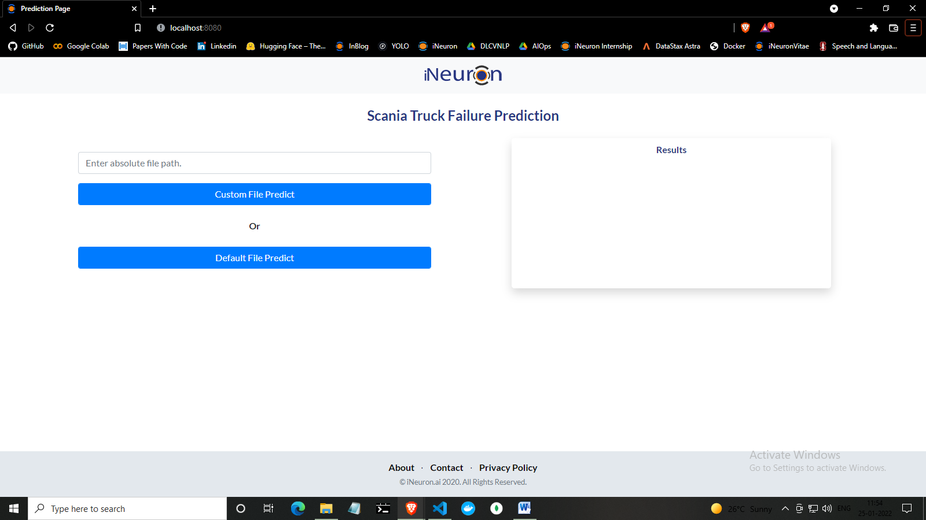

Here we will change the route to train or predict depending upon the need. After passing the route, the raw data bucket name will be picked up automatically for training and prediction, the results will be saved into csv file and stored in S3 buckets which can be picked up for actual verification.