Dreamscape

A report

## Description

The full rules have been provided in the same folder as this document. In summary: three “Invader” players had to manipulate the “Dreamscape” board, while avoiding the “Dreamer” player, in order to escape with a “Bottle of Secrets”.

Pictured below is the fully set-up game board. Each of the twenty-five “tiles” can be rotated at 90-degree angles. Each player starts in a separate corner, with the Secrets in the center. There’s a total of four “corners”, four “halls”, three “crossroads”, two “dead-ends”, and twelve “tees”. Not pictured are the 6-sided and 12-sided dice used.

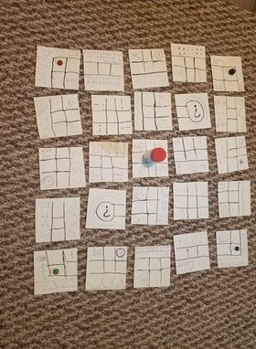

## Observations

Gameplay took approximately 15 minutes to complete; the Dreamer lost handily to the “action economy” principle (The invaders, by dint of being able to do more on their turn, were able to easily overwhelm the Dreamer). One rule - in which the Dreamer could not pass the Invaders or Secrets, was found to be too cumbersome and was quickly discarded. Otherwise, the general mechanics seem sound. There was some confusion expressed at the existence of the two “dead-end” tiles, and in fairness I don’t rightly know why I made them to begin with. However, they may present some interesting opportunities in a more refined iteration.

## Suggested Changes

1. The Dreamer needs to have an equal amount of actions to the players in addition to the more “impactful” abilities available to the Dreamer to begin with.
2. The rotating tiles mechanic felt fun to the point of almost under-utilized: it is inarguably the selling point of the game, and can do a lot more work than it does in the first iteration.
3. The “dead-ends” need a reward element attached to them: otherwise they’re nothing more than an uninteresting nuisance. My favorite suggestion was the idea of a “power up” being placed in them for whomever gets to them first.
4. It was suggested that, rather than all being equal, the three Invaders might be given different actions that they can each utilize. This would lower the learning curve for the Invaders slightly (Since each player need only understand one particular ability), while increasing the strategy requirement (Since the players must coordinate their respective abilities more, and feeling the loss of a team member more keenly as they no longer have access to that ability).
5. A larger overall gameboard could assist in making games last longer, if desired. Additionally, it was suggested that the pieces themselves could have more complex effects attached to them.

## Overall Conclusion

I am pleasantly surprised by how well Dreamscape turned out, and I may very well end up fleshing it out more to pass around to various friend circles, at minimum.