**Nama : Yayang Setiyawan  
NIM : 18090045  
Kelas : 5D**

1. **Source Code**

Latihan1.php : application/controllers

Latihan2.php : application/controllers

latihan2.php : view-application/views

Model1.php : application/models

1. **URL**

[http://localhost/pustakabooking/Latihan1](http://localhost/pustaka_booking/index.php/Latihan1)

http://localhost/pustakabooking/Latihan1/Penjumlahan/4/8

1. **Capture Hasil**

**Latihan 1**

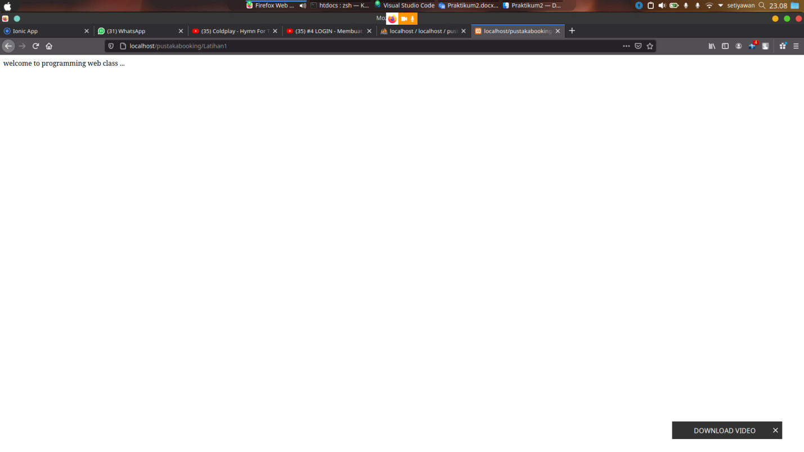

**Latihan 2**

