Using OpenMP with Jacobi Heat – a HPC case study

In this document, we will be discussing and analyzing an implementation of the jacobi heat algorithm, using OpenMP.

The first two questions we always ask when trying to parallize an algorithm are:
1) Is the problem complex/big/computationally hard enough for its parallelization to be worthwhile?
2) Are the steps of the algorithm that we want to parallelize linked together? Is each next step of the algorithm dependent on the previous one?

Obviously, the first question is true for us. Jacobi heat is a complex and computationally hard problem. But in order to understand how we can parallelize it, we first need to learn how it works under the hood.

We need a matrix size N. This will be the size of the 2D NxN array with the temperatures we want to observe. The code provided initializes each temperature to 20 degrees celcius. We also need a number of iterations. This will be the amount of times the algorithm is going to perform its calculations in order to conclude to a result. We CANNOT parallelize this part, since EACH iteration is dependent on the state of the previous one. We can, though, parallelize the temperature matrix.
Let’s take a look:
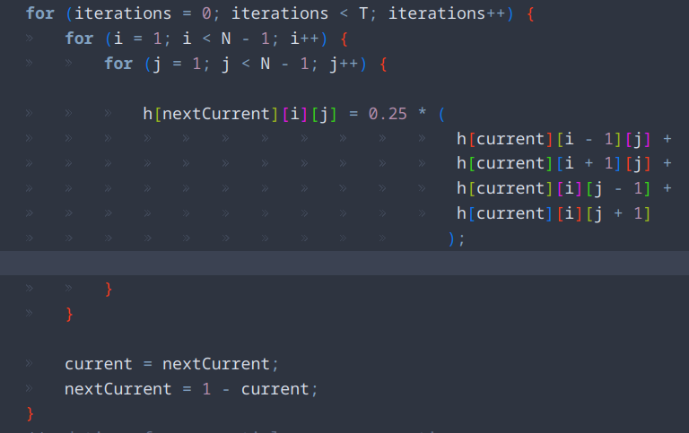

We can parallelize the first loop since it is independent. Maybe though, some improvements could be made. The h[nextCurrent][i] address is shared among all threads. Possible improvements using padding could be made to make the parallelization even faster.

Linked Files: ./jacobi_heat.c
Credits: May Moftah, GitHub code link

