Creating a new Ionic app in Netbeans:

1. Open git Bash
2. Navigate through to your new project and create a new ionic app:
   1. Instructions here: <http://ionicframework.com/getting-started/>
   2. 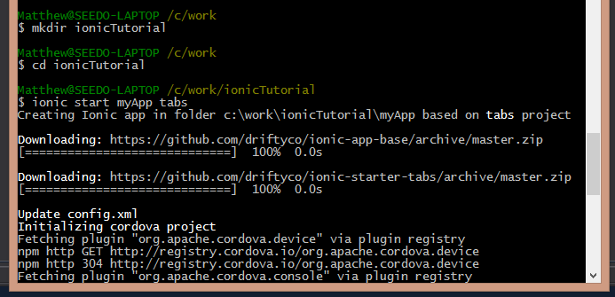
      1. The ionic app will be created in that folder
3. Open Netbeans
4. New – Project – HTML5 – HTML 5 Application with Existing sources
   1. 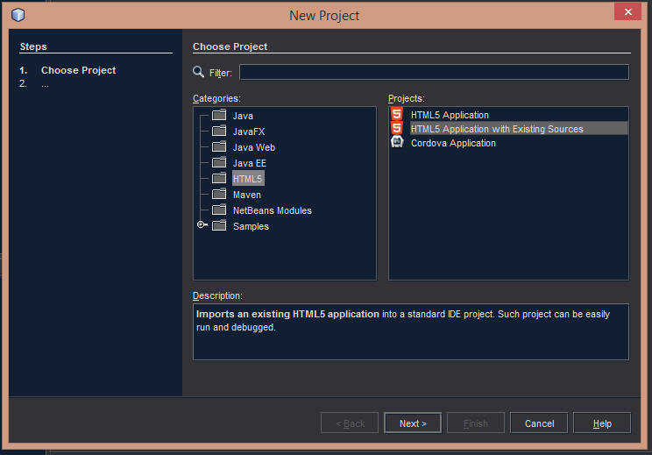
   2. Next
   3. Navigate through and set the Site Root to your new app folder (in this case we called it myApp when we created it in GitBash)
   4. 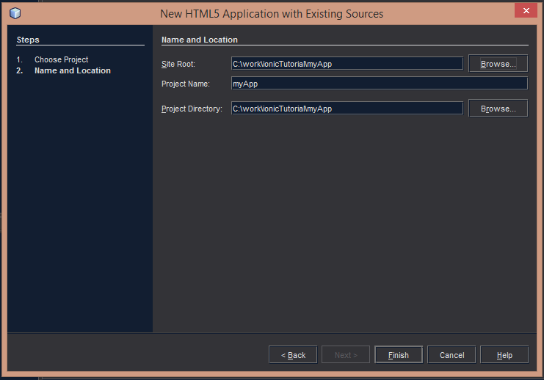
   5. The rest of the fields should auto populate
5. The project should be populated in the navigation window
   1. Hint: you can set the projects window to active through Window-Projects
   2. 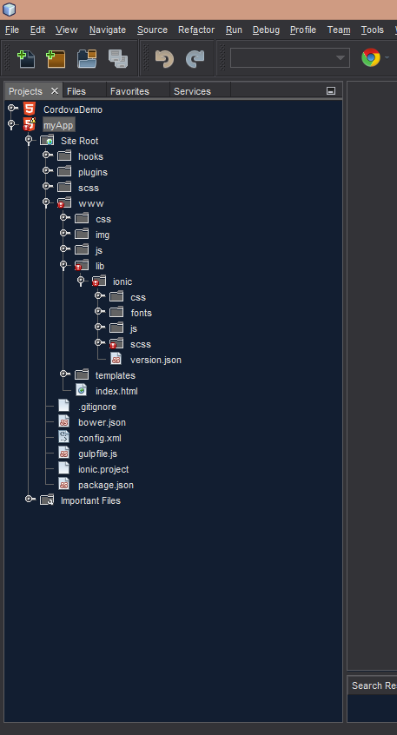
6. Congrats, we just made a new app!