Sam Trapp
Genetic Racers

Description
I opted to create 'racecars' that could find their way through an arbitrary track. This seemed like an interesting problem for a genetic algorithm to solve, and given the time span of the project, I thought I could get more out creatures that did not rely on physicality. These cars could be used to measure a difficulty metric of a given track, find high-use segments of a track, and determine optimal stats for a track. Their use in actual racing, however, is minimal, at best, because they maintain a specific list of moves, so even with the perfect fitness function, they could not deal with car-to-car collisions.

Fitness
Fitness is determined by three measurements, a distance metric, a time metric, and a constant scale.
Fitness = distanceMetric * timeMetric * scale
The distance metric incentivizes maximizing distance on the track and minimizing distance off the track.
distanceMetric = distOnTrack * (distOnTrack - (distTotal - distOnTrack))
Cars travel slower off the track than they do on it, so the time metric also incentivizes staying on the track, while also encouraging moving above half speed.
timeMetric = (durationOnTrack + durationAboveHalfSpeed) / totalDuration
During testing, a constant scale was added to keep small fitness distinguishable on the integer level and large fitness below the maximum integer value. Due to the current metrics and the duration of each generation, fitness has potential of reaching large integer values.
scale = 0.1
At the end of a generation members are given reproduction weights directly proportional to their fitness. The best performers are chosen as elites to continue to the next generation. The rest of the next population is created by mating two members of this generation to create two children. Mates are chose randomly based on reproduction weights.

Population Generation
Part of a car's genome is its stats. Each car is given stat points in top speed, acceleration, and handling, with the sum of the three adding up to exactly 100. In the first generation, stat points are distributed randomly, and tweaked to stay withing allotted stat pool and not fall below set minimum. In new generations parent genomes are crossed over by determining the highest stat between the parents, giving the child the higher of the two parents' stats in each stat, and tweaking the stats to stay with in proper range. Here the highest stat is preserved from being modified by tweaks. After crossover, a car's stats may be mutated in one of the following ways: two stats get swapped, half of one stat gets moved to another stat, new stats get chosen at random. After being mutated, or ignoring the mutation step, stats are re-tweaked once more to ensure the sum is exactly 100 and that no stat falls below the minimum. Unlike during crossover, the highest stat may be tweaked here.
The other part of a car's genome is its move list. At the start of the program, the generation time duration and the number of moves per second are chosen. These numbers are shared between all cars to avoid confusion. Based on the time allotted to each generation and the number of moves per second, a time step is determined at which to read a new move from the list. Once a move is read, it will be continued on every update cycle until a new move is read and replaces it. Each move consists of choice to change speed, either accelerating or decelerating, and the choice to change direction, turning either left or right. Changing speed and changing direction can be done in the same move, but a move cannot both accelerate and decelerate, or turn both left and right. In the first generation, each car generates a list of random moves. In later later generations, two parents' move lists are crossed-over by choosing a random parent to copy for each move. The first parent is given a slight bias to be copied at each move to lower noise between generations. To avoid unfairly favoring one parent over the other, the second child of the pair reverses the parent order. After crossover, a car's move list may be mutated. Unlike the mutation of stats, moves may have multiple types of mutation applied across parts of the list. The rate of mutation in moves is higher than that of stats to help cars discover new paths. The following move mutation may be applied to groups of moves: Moves get swapped between time steps, moves get flipped to opposite directions (eg. turn left instead of right), moves get one type of choice enabled or disabled, a new random list of moves gets generated, moves get copied across the following moves to increase coherency.

Extras
I focused most of my effort on the actual genetic algorithm but there is other functionality exists outside of it. At the start of the program, I provide a check-boxes to allow for different options. The user can generate a new population, read from a previously created generation, read from a provided demo population, write population to a file, and choose to run the drag strip track that was used for trivial testing. Every 100 generations a screen capture is take to record the progress of the cars.
While generations are running the track, info about the population is also provided. Each car displays number indicating its id.
ID = originalGeneration.memberNumber
Most cars share the same generation number, but the elites indicate the number of their original generation. Cars also display their stats in the form of bars on top of them. If a car was turned to be directed down the negative x-axis, the stat bars from top to bottom would be top speed, acceleration, handling. The car with the highest fitness of the generation, is colored in red and moved towards the camera to always be visible. Finally, information about the time remaining for the current generation, the current generation number, the winning ID, and the winning fitness is written in a corner of the screen.

Problems
The worst problem I ran into was shallow copying moves between parents and children. This caused mutation on one child to permeate through the new generation and destroy advances made in previous generations. This became very apparent when I was attempting to save elites between generations. Similar to this issue, I realized that my encoding of the move list genome required that the timestep between moves be kept exactly the same. Variation in timestep led to children attempting to mimic parents but finding themselves in a different location. These problems were not difficult to fix once they were found, but they only became apparent when running more than a few cars beyond the simple test of the drag strip.
The final problem, which has proven much more difficult to overcome, is the fitness function. Keeping the cars moving fast and keeping them on the track are two opposed goals that are not easy to balance. If a car is unable to stay on the track, then the distance it travels is meaningless, but encouraging cars to stay on the track incentivizes the to stop when turning to avoid leaving the track.

Improvements
I've thought two improvements that might make this generator more useful. First is the addition of checkpoint. Tracking only distance traveled and distance traveled on track limits tracks from having multiple routes and laps, because no direction is implied. By adding checkpoints, laps could be tracked, and shortcuts, both intentional and unintentional, could be tested for effectiveness and difficulty. Second, rather than encoding specific moves, the genome could encode steering behavior weights and stats. This would allow cars to be more dynamic and potentially be used for actual races. Approaching racecar behavior this way as opposed to relying on path following may produce more interesting result.
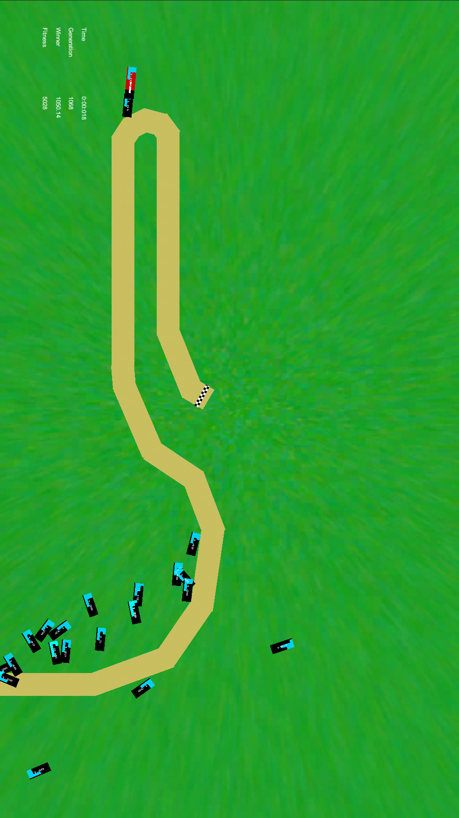
Screen Captures can be found in the Captures directory

