**Different techniques of customizing x-path**

**1) Basic XPath:**

XPath expression select nodes or list of nodes on the basis of attributes like **ID , Name, Classname**, etc. from the XML/HTML document as illustrated below.

Xpath=//input[@name='uid']

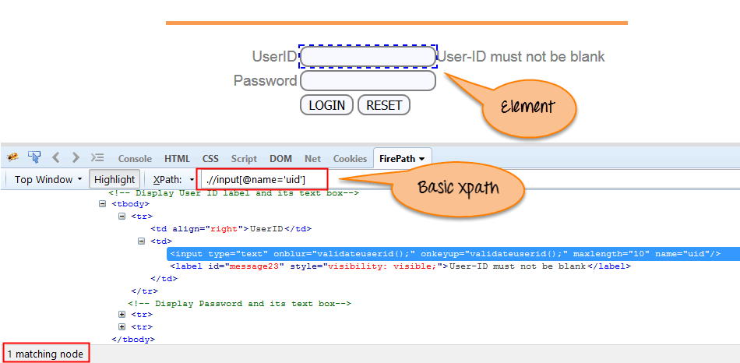

Xpath=//input[@type='text']

Xpath= //label[@id='message23']

Xpath= //input[@value='RESET']

Xpath=//*[@class='barone']

Xpath=//a[@href='http://demo.guru99.com/']

Xpath= //img[@src='//cdn.guru99.com/images/home/java.png']

### 2) Contains():

Contains() is a method used in XPath expression. It is used when the value of any attribute changes dynamically.

The contain feature has an ability to find the element with partial text as shown in below example.

Complete value of 'Type' is 'submit' but using only partial value 'sub'.

Xpath=//*[contains(@type,'sub')]

Complete value of 'name' is 'btnLogin' but using only partial value 'btn'.

Xpath=//*[contains(@name,'btn')]

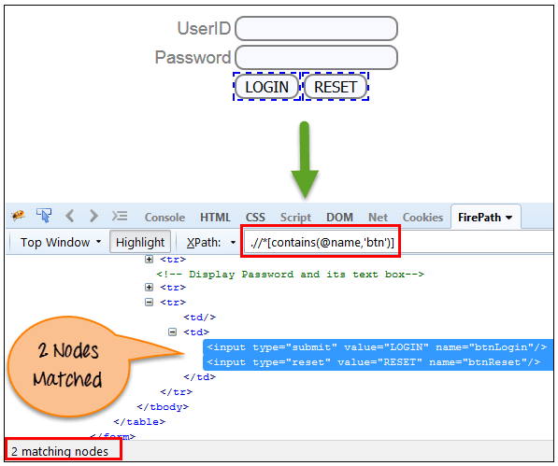

### 3) Using OR & AND:

In OR expression, two conditions are used, whether 1st condition OR 2nd condition should be true. It is also applicable if any one condition is true or maybe both. Means any one condition should be true to find the element.

In the below XPath expression, it identifies the elements who’s single or both conditions are true.

Xpath=//*[@type='submit' or @name='btnReset']

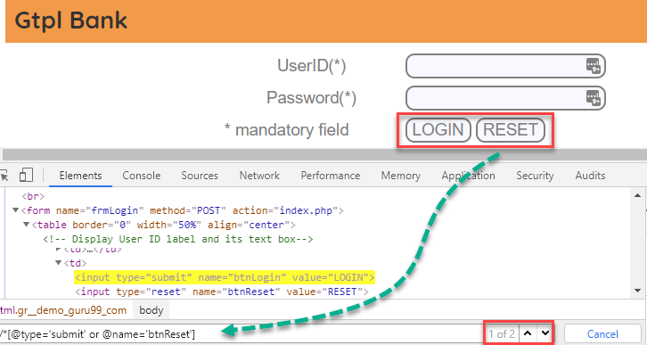

n AND expression, two conditions are used, both conditions should be true to find the element. It fails to find element if any one condition is false.

Xpath=//input[@type='submit' and @name='btnLogin']

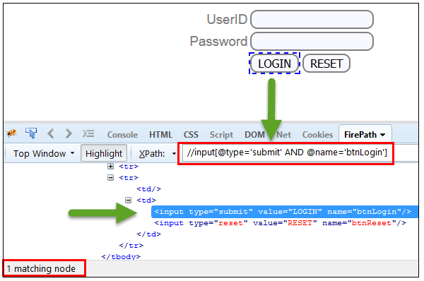

### 4) Xpath Starts-with

**XPath starts-with()** is a function used for finding the web element whose attribute value gets changed on refresh or by other dynamic operations on the webpage. In this method, the starting text of the attribute is matched to find the element whose attribute value changes dynamically. You can also find elements whose attribute value is static (not changes).

For example -: Suppose the ID of particular element changes dynamically like:

Id=" message12"

Id=" message345"

Id=" message8769"

and so on.. but the initial text is same. In this case, we use Start-with expression.

In the below expression, there are two elements with an id starting "message"(i.e., 'User-ID must not be blank' & 'Password must not be blank'). In below example, XPath finds those element whose 'ID' starting with 'message'.

Xpath=//label[starts-with(@id,'message')]

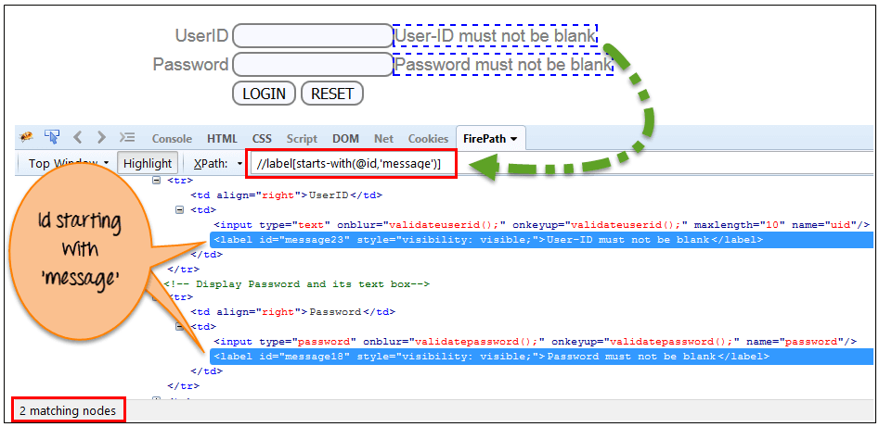

### 5) XPath Text() Function

The **XPath text() function** is a built-in function of selenium webdriver which is used to locate elements based on text of a web element. It helps to find the exact text elements and it locates the elements within the set of text nodes. The elements to be located should be in string form.

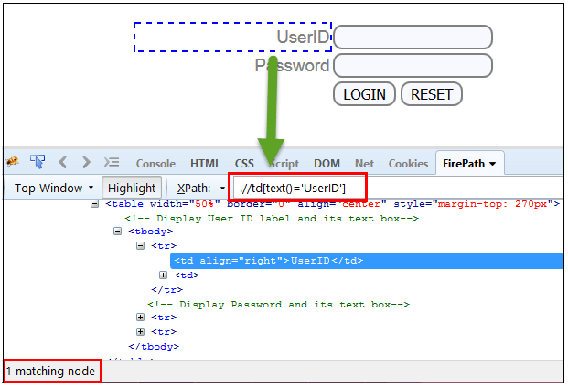

### 6) XPath axes methods:

These XPath axes methods are used to find the complex or dynamic elements. Below we will see some of these methods.

### a) Following:

Selects all elements in the document of the current node( ) [ UserID input box is the current node] as shown in the below screen.

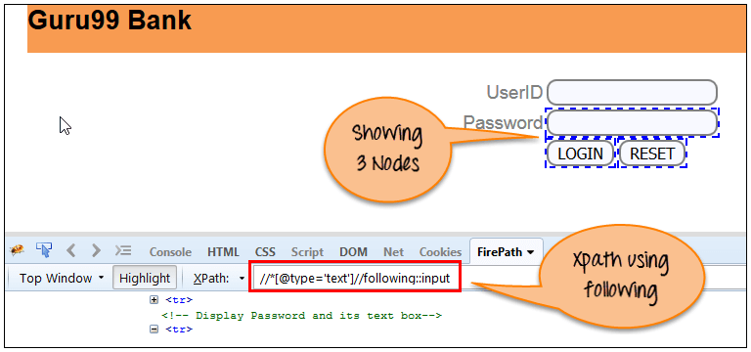

There are 3 "input" nodes matching by using "following" axis- password, login and reset button. If you want to focus on any particular element then you can use the below XPath method:

Xpath=//*[@type='text']//following::input[1]

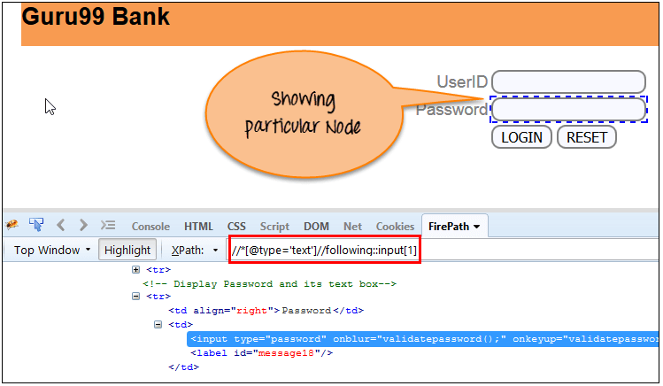

### b) Ancestor:

The ancestor axis selects all ancestors element (grandparent, parent, etc.) of the current node as shown in the below screen.

Xpath=//*[text()='Enterprise Testing']//ancestor::div

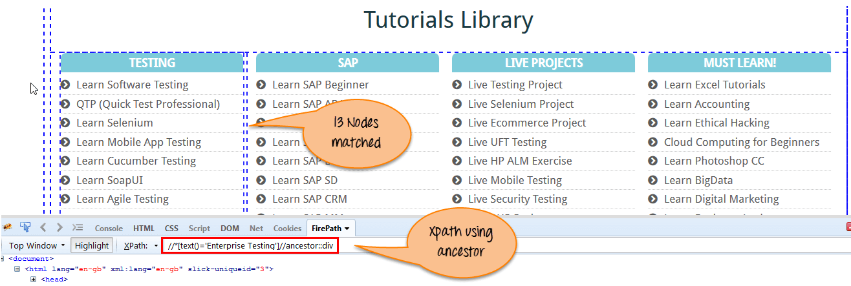

There are 13 "div" nodes matching by using "ancestor" axis. If you want to focus on any particular element then you can use the below XPath, where you change the number 1, 2 as per your requirement:

Xpath=//*[text()='Enterprise Testing']//ancestor::div[1]

### c) Child:

Selects all children elements of the current node (Java) as shown in the below screen.

Xpath=//*[@id='java_technologies']//child::li

[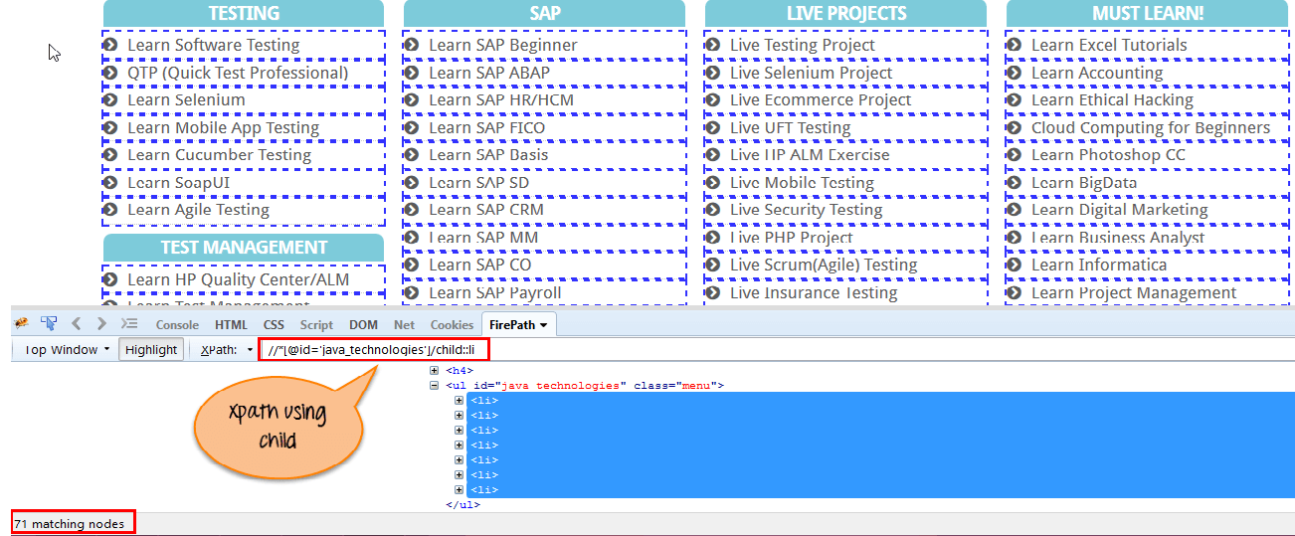](https://www.guru99.com/images/3-2016/032816_0758_XPathinSele15.png)

There are 71 "li" nodes matching by using "child" axis. If you want to focus on any particular element then you can use the below xpath:

Xpath=//*[@id='java_technologies']/child::li[1]