Pushdown Automaton (PDA)

Definition:
In computer science, a pushdown automaton (PDA) is a type of automaton that employs a stack. Pushdown automata are used in theories about what can be computed by machines. They are more capable than finite-state machines but less capable than Turing machines.
Pushdown Automata is finite automata with extra memory called stack which helps Pushdown automata to recognize context free languages. A Pushdown Automata (PDA) can be defined as: Q is the set of states. ∑is the set of input symbols. Γ is the set of pushdown symbols (which can be pushed and popped from stack)
A pushdown automaton is a 6-tuple (Q, Σ, Γ, δ, q0, F), where Q, Σ, Γ, and F are all finite sets, and
1. Q is the set of states,
2. Σ is the input alphabet,
3. Γ is the stack alphabet,
4. δ : Q × Σε × Γε→P(Q × Γε) is the transition function,
5. q0 ∈ Q is the start state, and
6. F ⊆ Q is the set of accept states.
- Alphabets Σε=∑ U {ε} and Γε=Γ U {ε}
- P( ) accounts for the non-determinism
A Pushdown Automata has three components:
- An Input Tape
- A Finite Control Unit
- A Stack with Infinite Size
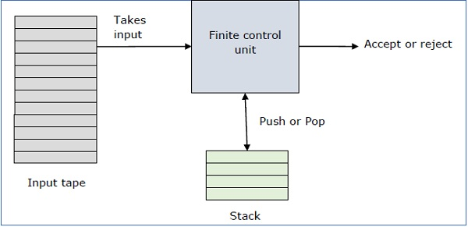

State Diagram

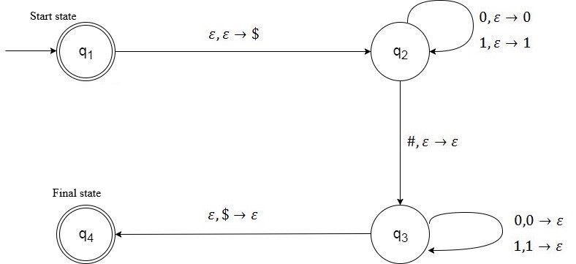

The Graph of the PDA

Fig:1

Here,

P = (Q, Σ, Γ, δ, q0, F), where
- Set of states, Q = {q1, q2, q3, q4},
- Alphabet, ∑ = {0, 1, #}, [Input alphabet Σ]
- The stack alphabet, Γ= {0, 1, $},
- Start state, qs= q1
- Set of final states, F = {q1, q4},
δ is given by the following transition table, cell entries are new state and TOS symbol pair, blank entries are ∅.
Inputs are current state, input string and TOS symbols. Cell entries are new state and TOS symbol pair. Blank entries are ∅.

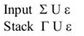

Transitions,
δ(q1, ε ,ε)= {q2,$}
δ(q2, 0, ε)= {q2,0}
δ(q2, 1, ε)= {q2,1}
δ(q2, #, ε)= {q3, ε}
δ(q3,0, 0)= {q3, ε}
δ(q3,1, 1)= {q3, ε}
δ(q3, ε, $)= {q4, ε}

Transition Table:

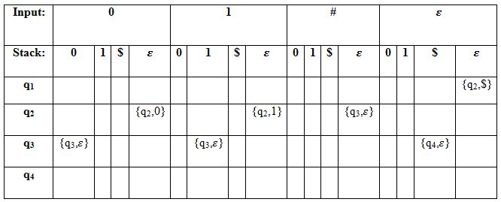

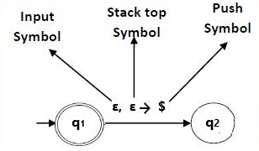

Program

Implementation using C program:
Source Code:

// Setu Barman CS 457 May 2019
#include<stdio.h>
#define EOS '\0'
#define SIZE 101

char Stck[SIZE];
int top=-1;

void push(char symb)
{
Stck[++top]= symb;
}

char pop(void)
{
return Stck[top--];
}

int main()
{
char c,inpstr[SIZE]; //c is Alphabet Charcters(0, 1, #)
int q,i;
printf("Enter String: ");
scanf("%s",inpstr);
printf("\n");
printf("%s ",inpstr);
q=1;
i=0;
c=inpstr[i];
while(1)
{
if(q==1) //Transitions, δ(q1, ε ,ε)= {q2,$}
{
q=2;
push('$');
}
if(q==2) //Transitions, δ(q2, 0, ε)= {q2,0}
{
if(c=='0')
{
q=2;
push(c);
}
else if(c=='1') //Transitions, δ(q2, 1, ε)= {q2,1}
{
q=2;
push(c);
}
else if(c=='#') //Transitions, δ(q2, #, ε)= {q3, ε}
{
q=3;
}
else
{
q=5;
break;
}
}
else if(q==3) //Transitions, δ(q3,0, 0)= {q3, ε}
{
if(c=='0' && Stck[top]=='0')
{
q=3;
pop();
}
else if(c=='1' && Stck[top]=='1') //Transitions, δ(q3,1, 1)= {q3, ε}
{
q=3;
pop();
}
else if(c==EOS && Stck[top]=='$') //Transitions, δ(q3, ε, $)= {q4, ε}
{
q=4;
break;
}
else
{
q=5;
break;
}
}
else
{
q=5;
break;
}
i++;
c=inpstr[i];
}

if(q==5)
printf(" Rejected");
if(q==4)
printf(" Accepted");

printf("\n");

return 0;
}

I/O:

Input: 101011#110101
Output: Accepted
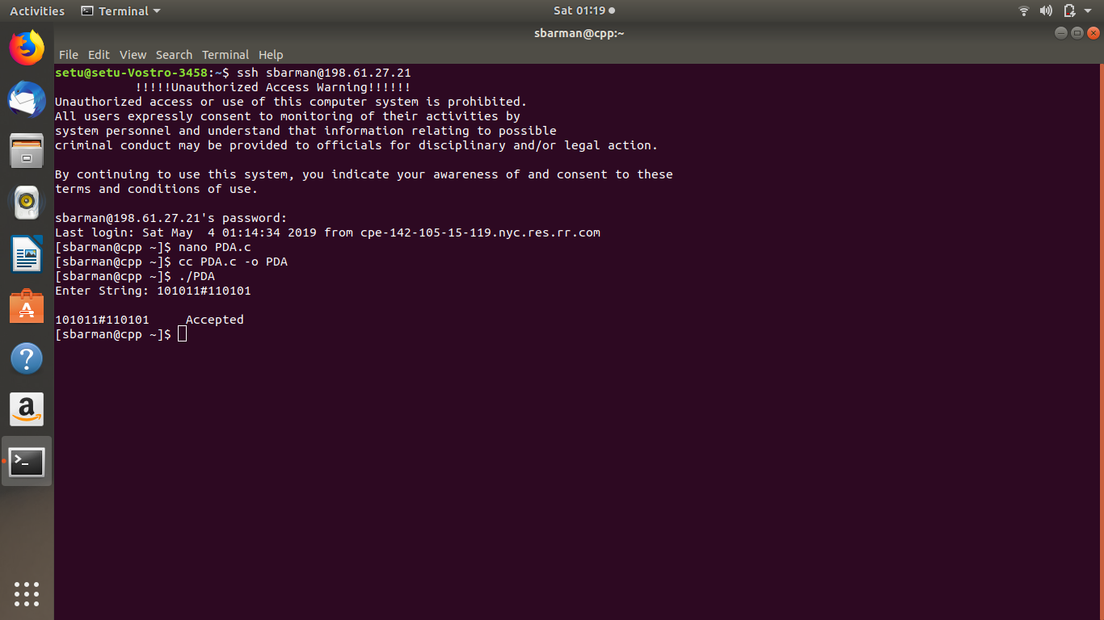

Input: 1010#1010
Output: Rejected
Input: 11#00
Output: Rejected

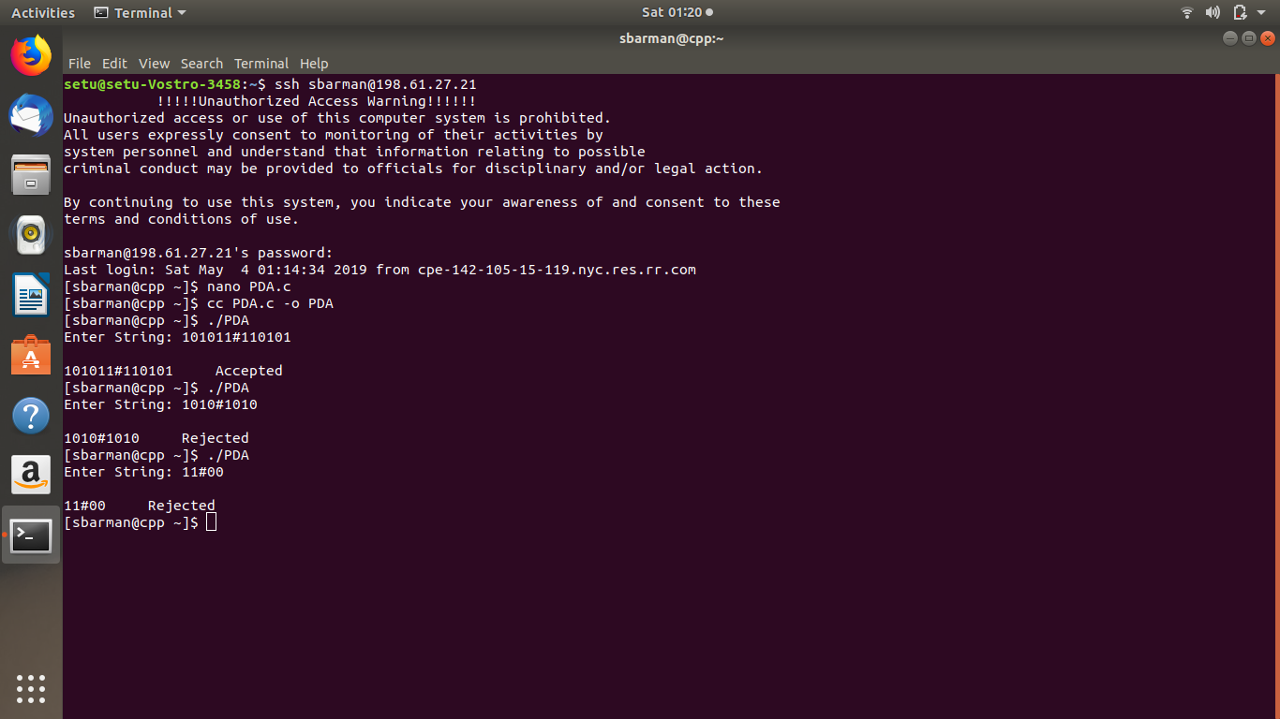

How can you check if the stack is empty:
- What we usually do is to place a special symbol (for example a $) at the bottom of the stack.
- Whenever we find the $again we know that we reached the end of the stack.
- In order to accept a string there is no need for the stack to be empty.

PDA Accept – Reject Status
The PDA accepts when there exists a computation path such that:
- The computation path ends in an accept state
- All the input is consumed (no requirement for the stack)
The PDA rejects when all the paths:
- Either end in a non-accepting state
- Or are incomplete (meaning that at some point there is no possible transition under the current input and stack symbols)
How to compile the program:
cc PDA.c -o PDA or, gcc PDA.c -o PDA
This will generate the executable main and you can run it using
./ PDA

