Slack Workshop – 1 hour

Profile
Update your profile (click the photo/image top right)
- Photo
- Display Name
- Title
- Name Recording ***
- Name Pronunciation

SideBar

Channels +
Browse Channels

- #general
- #watercooler
- #connections
- #induction-workshop

Public / private

EXERCISE: If you haven’t done so already, browse for the #connections channel, read at least one introduction, then Write your own introduction.

Direct Messages (DMs) +
type their name
EXERCISE: Find out the person’s name next to you, and send them a DM of “Hi”
EXERCISE: Reply to the DM you receive
EXERCISE: Exchange a photo each
EXERCISE: Take a Screenshot and upload it/post it. (Not sure how? Ask by typing on the #induction-workshop) If you know how please reply.

(TIP: Screenshotting:
- PrintScrn
- Windows Sniping Tool
- Windows key + shift + s)
- Mac - Shift + Cmd + 3 (or 4 or 5).
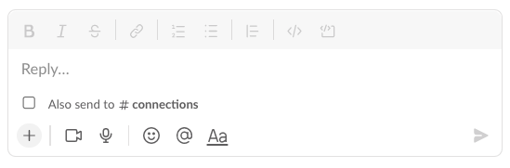
Reactions

EXERCISE: Respond with a suitable reaction to a DM you have received

Give me thumbs up if you are still here!

Give me smiley face if you are happy!

What country were you born in? (use an emoji reaction)

What is your background? (use an emoji reaction)

PRACTICAL EXERCISE:

Colm – Post Question on the #induction-workshop (e.g. Favourite Band?)

Everyone is to respond

Now get them to reply to delete their answers, select the question and reply to the thread instead using the floating toolbar (wait for everyone)

Review the answers in the thread and add a love emoji/reaction to the best answer you see (besides your own). Save 3 other replies that you like (add to save items from the floating toolbar)

What county are you residing in now?

Use this information to create a GROUP DM – 4 people…

Select Direct Messages and type @the-persons-name @next-persons-name, etc

DEMO:
One group only, convert to a group call / huddle

CALLS / Zoom / Huddles

DEMO:

Call
- with audio
- with video

Huddle
- with audio
- with video
- share screen
- closed captions

Zoom Call – (BETTER QUALITY)
- with audio
- with video
- share screen
- closed captions

So now you know how to create remote study groups

MISCELLANEOUS

 BACK / FORWARD / HISTORY

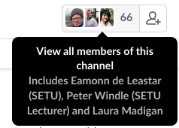
Clicking this gives you a list of everyone on the course (that has joined Slack)

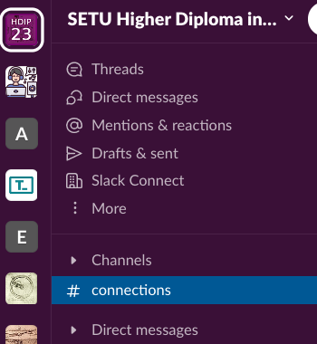

Expand Channels. right click on your favourite channels (#general, #programming-fundamentals, #web-development) and select STAR channel

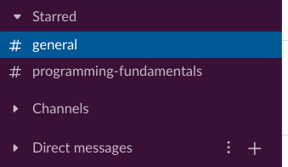

The options below allow you filter your feed to show different things…

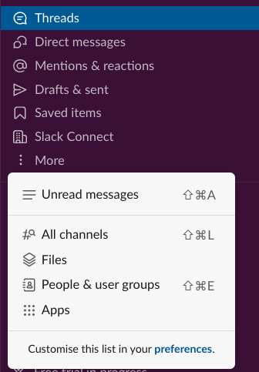

Finally a Socrative Quiz
https://api.socrative.com/rc/RhLWnD

