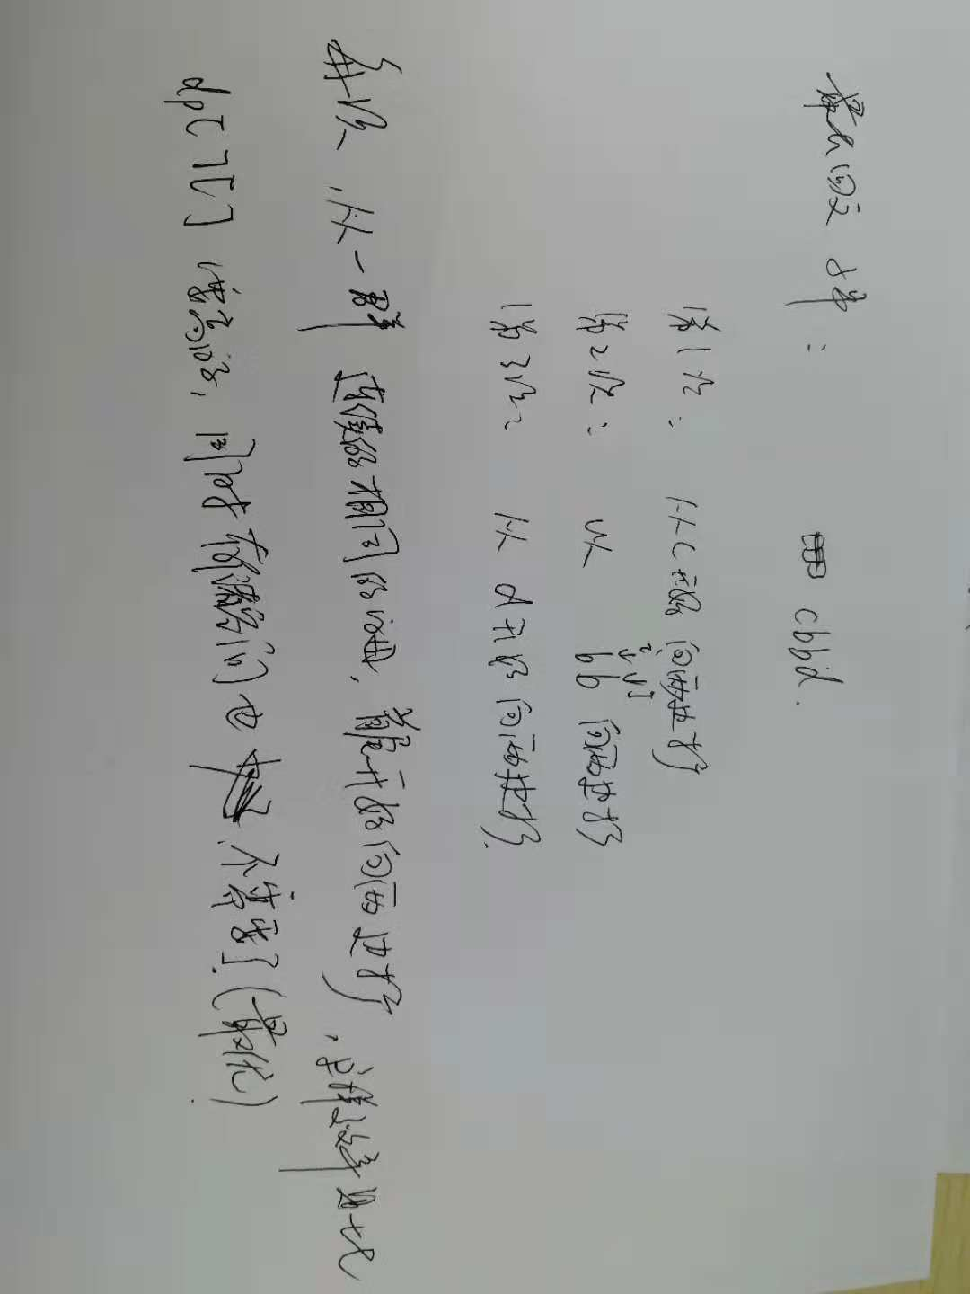

class Solution {
public:
std::string longestPalindrome(std::string s) {
if (s.size() < 2)
return s;
int len = s.size(), max_left = 0, max_len = 1, left, right;
for (int start = 0; start < len && len - start > max_len / 2;) {
left = right = start;
while (right < len - 1 && s[right + 1] == s[right])
++right;
start = right + 1;
while (right < len - 1 && left > 0 && s[right + 1] == s[left - 1]) {
++right;
--left;
}
if (max_len < right - left + 1) {
max_left = left;
max_len = right - left + 1;
}
}
return s.substr(max_left, max_len);
}
};

