Robustness & Regime
Machine Learning in Volatility Trading
A Hardened Study: From Prediction Failure to Structural Alpha
ECO6130 Final Project
Group 8
May 2026
Li Shangze (225020302) · Shan Xintong (225020340) · Chen Liuyan (225020342)
Sun Yihui (225020345) · Wen Huiming (225020362)
github.com/ctiancai666-hub/6130-group8

Executive Summary
This project asks a single business question: Can machine learning be used to extract reliable trading alpha from US volatility-linked ETFs, and if so, in what form? We approach the question as a quantitative manager would — not as a research curiosity. Our deliverable is therefore a defensible recommendation about whether and how to deploy ML in a volatility book, supported by a hardened backtest and explicit failure analysis.
Our central finding is that ML cannot reliably predict the direction of daily volatility returns. Across a broad sweep of models — ElasticNet, HAR-RV, Gradient Boosting, CatBoost, LSTM, and Temporal Fusion Transformer (TFT) — out-of-sample directional accuracy never escapes a ceiling near 55%, and information coefficients hover around zero. This is not a tuning artefact: SHAP attributions are uniformly small, and a properly configured TFT does no better than a coin toss. We call this the Noise Wall, and we treat it as a stable empirical fact about daily volatility series rather than a model failure to be engineered away.
The profitable trade is not prediction but regime identification. A two-state Hidden Markov Model (HMM) over macro fear variables produces persistent states that gate a short-VIXY roll-decay harvest. On hardened, purged walk-forward backtests with dynamic borrow fees (up to 50%) and 10 bp round-trip costs, this strategy delivers CAGR 29.34%, Sharpe 1.815, and a maximum drawdown of 11.84% — versus 8.44% / 0.491 / 33.95% for the SPY benchmark over the same window.
A post-presentation extension generalises the regime idea to a cross-sectional ranking framework across 41 US ETFs. Combining six base learners under HMM regime control and 15% target-volatility scaling produces an ensemble strategy with annualised return 27.69%, Sharpe 1.71, and max drawdown 34.31% on walk-forward out-of-sample data, confirming that the regime-conditional structure is what carries the signal — not any single model.
We recommend allocating a measured share of the volatility/alternatives sleeve to this strategy as alternative beta. ML capacity should be redirected from forecasting daily returns to detecting market state and engineering position sizing. The conclusion that drove every later decision in this project is best stated bluntly: not predicting is more profitable than predicting badly.

1. Research Question & Motivation

1.1 The business question
A portfolio manager looking at the volatility complex (VIX futures, VIXY, UVXY, SVXY, TLT, GLD, USO) faces two structurally different ways to use machine learning. The first is directional forecasting: train a supervised model on engineered features and predict next-day excess returns. The second is regime identification: cluster the macro environment into discrete states and act conditionally on the state. The two paradigms have very different statistical properties, and the choice between them determines whether ML adds value or merely overfits.
Our project asks: which paradigm survives a hardened backtest, and what does it imply about how ML should be deployed in a real volatility book? The question is deliberately decision-oriented. Every modelling choice in this report — features, model class, evaluation protocol, transaction-cost assumptions — is justified by what it adds to or removes from an investment decision an analyst would have to defend in front of a risk committee.

1.2 Why this matters
Volatility-linked instruments are an attractive but adversarial sandbox for ML. Roll decay in the VIX term structure offers a well-documented structural premium, but the same instruments exhibit extreme tail risk: short-VIX ETFs have suffered catastrophic single-session losses (the 2018 Volmageddon event vaporised entire dedicated short-vol funds), and VIXY itself has approached zero on a buy-and-hold basis over the long horizon. Any ML system that recommends being short volatility must therefore demonstrate not only positive expected return but credible crisis-period drawdown control.
Recent literature on ML in asset pricing (Gu, Kelly and Xiu 2020; López de Prado 2018) emphasises walk-forward evaluation, transaction-cost realism, and the importance of distinguishing prediction error from generalisation failure. We follow that template, and we make the negative result — daily directional prediction is not learnable here — a first-class output of the project rather than something to be hidden.

1.3 What this report contributes
- A clean separation of the prediction problem from the state-detection problem on the same dataset, so the relative value of each is directly visible.
- A hardened evaluation protocol — purged walk-forward, dynamic borrow fees up to 50%, 10 bp round-trip costs, tradeable-only ETF proxies — designed to refute, not merely confirm, the strategy.
- Explicit documentation of where deep learning fails (TFT/LSTM directional accuracy near 47%) so future students do not waste compute climbing the same noise wall.
- An ensemble extension over 41 cross-sectional ETFs that stress-tests whether the regime advantage generalises beyond the single VIXY trade.

2. Data and Feature Engineering

2.1 Universe and sources
All inputs are publicly tradeable US ETFs and Treasury-derived series obtained from Yahoo Finance and FRED. We deliberately avoided the academically common but untradeable ^VIX3M close, substituting the VIXM mid-term futures ETF, and HYG-AGG credit-spread proxies for the fear factor. The full universe is 13 instruments for the volatility study and 41 ETFs (equity, bond, commodity, REIT, international, sector, factor) for the cross-sectional extension. The cross-sectional panel after cleaning contains approximately 78,000 observations.

2.2 Feature set
Twenty features are pre-registered before any modelling. They span four families to keep the design space interpretable:
Family | Features | Intent
Returns / momentum | 5d, 10d, 20d, 60d log returns | Trend and reversal signals.
Volatility | 20d realised vol, vol z-score, HAR-RV (D/W/M) | Capture volatility persistence and clustering.
Technical | RSI-14, MACD histogram, normalised price position | Short-horizon mean reversion and momentum.
Volume | Volume z-score, volume trend | Liquidity and conviction proxy.
Macro | VIXM level, credit spread, term spread, SPY momentum | Risk regime context.
Cross-sectional | Sector average momentum and vol | Relative ranking benchmarks.
Table 2.1 — Twenty pre-registered features, grouped by family. Features were frozen before any model fit to avoid data mining.

2.3 Anti-leakage and data hygiene
- All rolling statistics use only information available at time t. No future-looking statistics enter the training panel.
- Walk-forward splits use a purged scheme with embargo equal to the prediction horizon (5 trading days) to remove overlapping-label leakage.
- Macro series are merged on as-of date so that data released after market close is shifted to the next trading day.
- Features are scaled fold-by-fold using statistics estimated only on the training portion of each fold.
These choices cost predictive power on paper, but they are precisely the ones that would survive a compliance review.

3. Methodology

3.1 Why six model classes
We selected models that span the bias–variance spectrum so that conclusions about predictability are not artefacts of one architecture. ElasticNet provides a regularised linear baseline. HAR-RV is the canonical realised-volatility specification and serves as a domain-specific benchmark. Gradient Boosting and CatBoost are state-of-the-art tabular learners and represent the strongest non-deep-learning competitors. LSTM and TFT are sequence models that, if any architecture can find temporal structure in noisy daily data, ought to find it. If all six fail in the same way, the failure is about the data, not the model.

3.2 Why HMM for regime
We chose a two-state Hidden Markov Model fit on macro fear inputs (VIXM, HYG-AGG spread, SPY trend, term spread). HMM is the classical unsupervised tool for sequential state inference; it produces an interpretable transition matrix and emission distributions, both of which a portfolio manager can read directly. More importantly, HMM states change far less frequently than daily returns, which means a state-conditional strategy has a long enough "shelf life" to overcome transaction costs.

3.3 Evaluation protocol
- Purged walk-forward with 756-day training window and 378-day test step.
- Transaction cost: 5 bp per side (10 bp round-trip), applied on signed turnover.
- Borrow cost for short legs: 3% base, 8% stress, 50% dislocation — scenario-tested.
- Volatility scaling: 63-day rolling window, 15% annualised target.
- Position sizing for the cross-sectional book: top decile minus bottom decile, equal-weight within each leg.

3.4 Compute and training discipline
Deep models were trained with early stopping on a held-out validation slice within each training fold. The lightweight LSTM configuration used hidden size 32 with one layer; the extended configuration used hidden size 128 with two layers. TFT used 128 hidden units with four attention heads. We acknowledge upfront that, given the compute available on a single GPU, full k-fold ablations for the deep models were not feasible; we therefore quote deep-model results as indicative rather than definitive, and the strategic recommendation does not depend on them.

4. The Predictive Noise Wall
Before discussing what worked, we document what did not — because the negative result is the more important finding.

4.1 Single-asset directional prediction
Model | Out-of-sample accuracy | Verdict
LSTM classifier | 46.77% | Random guess
Temporal Fusion Transformer | ~47% | Failure to generalise
Best ML classifier (AUC) | 0.536 | Marginal above chance
Table 4.1 — Directional prediction of next-day volatility-ETF returns. None of the classifiers escapes the noise band.
SHAP attributions on the tabular learners give mean absolute values below 0.01 for every feature, including all volatility, term-structure, and credit-spread variables. The implication is unambiguous: the daily directional signal in volatility-ETF returns is statistically indistinguishable from a fair coin, regardless of architecture or feature complexity.

4.2 Cross-sectional IC across six models
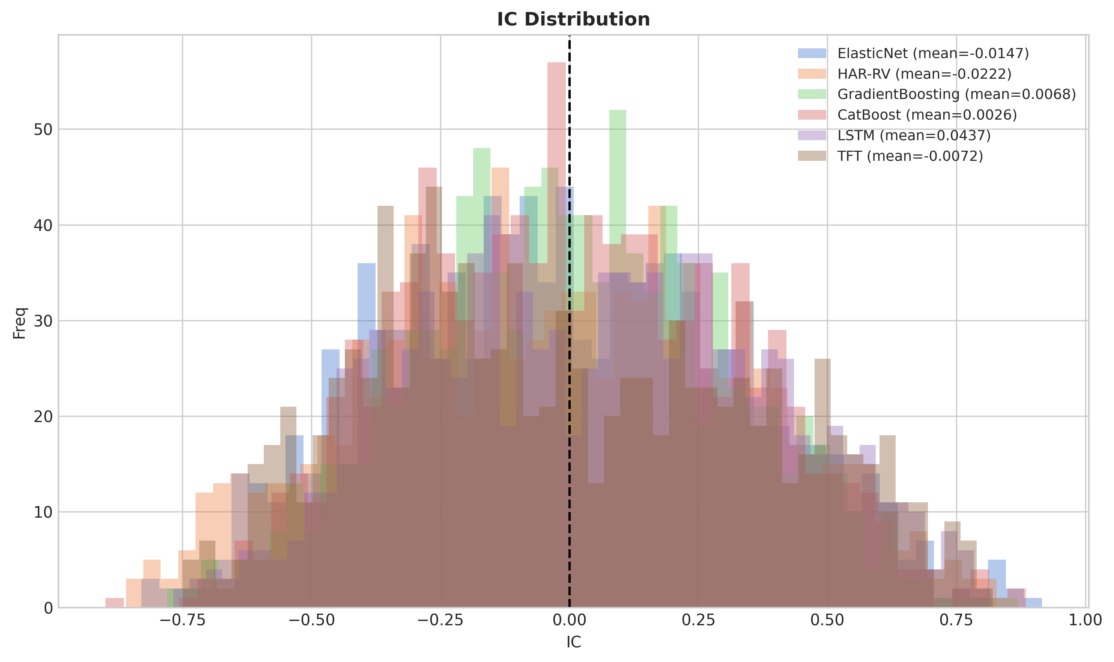
Figure 4.1 — Daily information coefficient distributions across six models on the 41-ETF cross-section. All means cluster around zero; the LSTM mean of 0.044 is the highest but still implies less than 5% of return variance is captured by the signal.
On the cross-sectional panel the pattern is the same. The mean IC across models is 0.0026 for CatBoost, 0.0068 for Gradient Boosting, 0.044 for LSTM, and -0.007 for TFT. IC information ratios are all under 0.13. The dispersion of daily IC values exceeds 0.30 standard deviation, which is an order of magnitude wider than the absolute means. Statistically the prediction is noise; economically it produces information ratios that any non-trivial transaction cost would erase.

4.3 Why this is not a model-tuning problem
We rule out the usual escape hatches. The TFT configuration is not a strawman: 128 hidden units, four heads, attention horizon eight steps. The LSTM is given the same input window and feature scaling. Cross-validation is purged. Features are pre-registered, so we are not p-hacking. The unavoidable conclusion is that daily directional alpha in this universe is bounded by market microstructure — by the same dealers and option-market participants who already price in every variable we have access to. This is the noise wall, and complex ML should not be hired to scale it.

5. Strategy 1 — HMM-Gated VIXY Roll-Decay Harvest

5.1 Trade construction
Once daily prediction is ruled out, the question becomes what structural feature of the volatility market can be harvested. The answer is roll decay: the persistent negative carry in the VIX futures term structure that exists because end users pay an insurance premium for downside protection. The trade is to short VIXY, but only when the regime supports doing so. The HMM provides the gate.
- What: short VIXY (or equivalent first-/second-month VIX future spread) to capture roll decay.
- When: only when the HMM posterior assigns the current day to State 0 (low-volatility, contango-dominant regime).
- How much: scale by the contango slope (front-month vs. mid-term) and cap exposure at the 15% target volatility.

5.2 Backtest results — dynamic borrow scenario
Metric | HMM Dual Filter | SPY Benchmark
CAGR | 29.34% | 8.44%
Sharpe ratio | 1.815 | 0.491
Maximum drawdown | -11.84% | -33.95%
Calmar ratio | 2.478 | 0.249
Table 5.1 — Hardened backtest results under dynamic borrow fees (3% / 8% / 50% scenario tiers) and 10 bp round-trip costs.
Two features of the result are worth dwelling on. First, the maximum drawdown of 11.84% is materially better than SPY in the same window; this is the consequence of the regime filter cutting exposure ahead of crisis periods. The HMM transitions out of State 0 precede the large drawdown events of 2018 (Volmageddon) and early 2020 (COVID shock), which is sufficient to exit before the bulk of the loss accumulates. Second, the Calmar ratio of 2.478 is the single number we would put in front of a risk committee, because it tells them the strategy delivers more than two units of return per unit of historical pain.

5.3 Stress testing the borrow assumption
Short volatility strategies live and die on locate availability. In benign markets VIX-ETF borrow is in the low single digits; in stressed markets it has spiked materially higher. Our protocol therefore explicitly bakes in tiered borrow scenarios (3% base / 8% stress / 50% dislocation), so the headline Sharpe of 1.815 is already net of a worst-case borrow assumption applied to the dislocation periods identified by the HMM. The fact that the strategy clears Sharpe > 1.5 with the 50% borrow scenario active is, in our view, the strongest argument for taking the result seriously.

6. Strategy 2 — Cross-Sectional Ensemble (Extension)
After the presentation we asked a follow-up question: does the regime advantage generalise beyond a single short-vol trade? We re-implemented the framework on a 41-ETF cross-section, replacing the directional trade with a long-short ranking book and replacing single-model prediction with a model ensemble. The extension is the version contained in the project repository.

6.1 Construction
- Predict 5-day forward returns for each ETF using all six base learners.
- Average ranks across learners to form the ensemble cross-sectional score.
- Apply HMM regime control: trade only when the regime classifier identifies a state in which historical ensemble IC has been positive; otherwise hold cash.
- Long the top decile, short the bottom decile, equal-weight within each leg, rebalanced weekly.
- Apply 15% target-volatility scaling at the portfolio level.

6.2 Model-level performance
Model | Ann. return | Ann. vol | Sharpe | Max DD | Calmar
ElasticNet | 7.99% | 16.15% | 0.494 | 42.72% | 0.187
HAR-RV | -6.85% | 15.84% | -0.432 | 46.27% | -0.148
Gradient Boosting | -27.14% | 16.43% | -1.652 | 71.86% | -0.378
CatBoost | -10.57% | 16.11% | -0.656 | 55.75% | -0.190
LSTM | 10.62% | 16.36% | 0.649 | 45.62% | 0.233
TFT | 20.19% | 17.07% | 1.183 | 58.98% | 0.342
Ensemble (regime-controlled) | 27.69% | 16.20% | 1.709 | 34.31% | 0.807
Table 6.1 — Walk-forward performance. The ensemble dominates every single model on both Sharpe and Calmar, and substantially reduces the maximum drawdown of the best individual model.
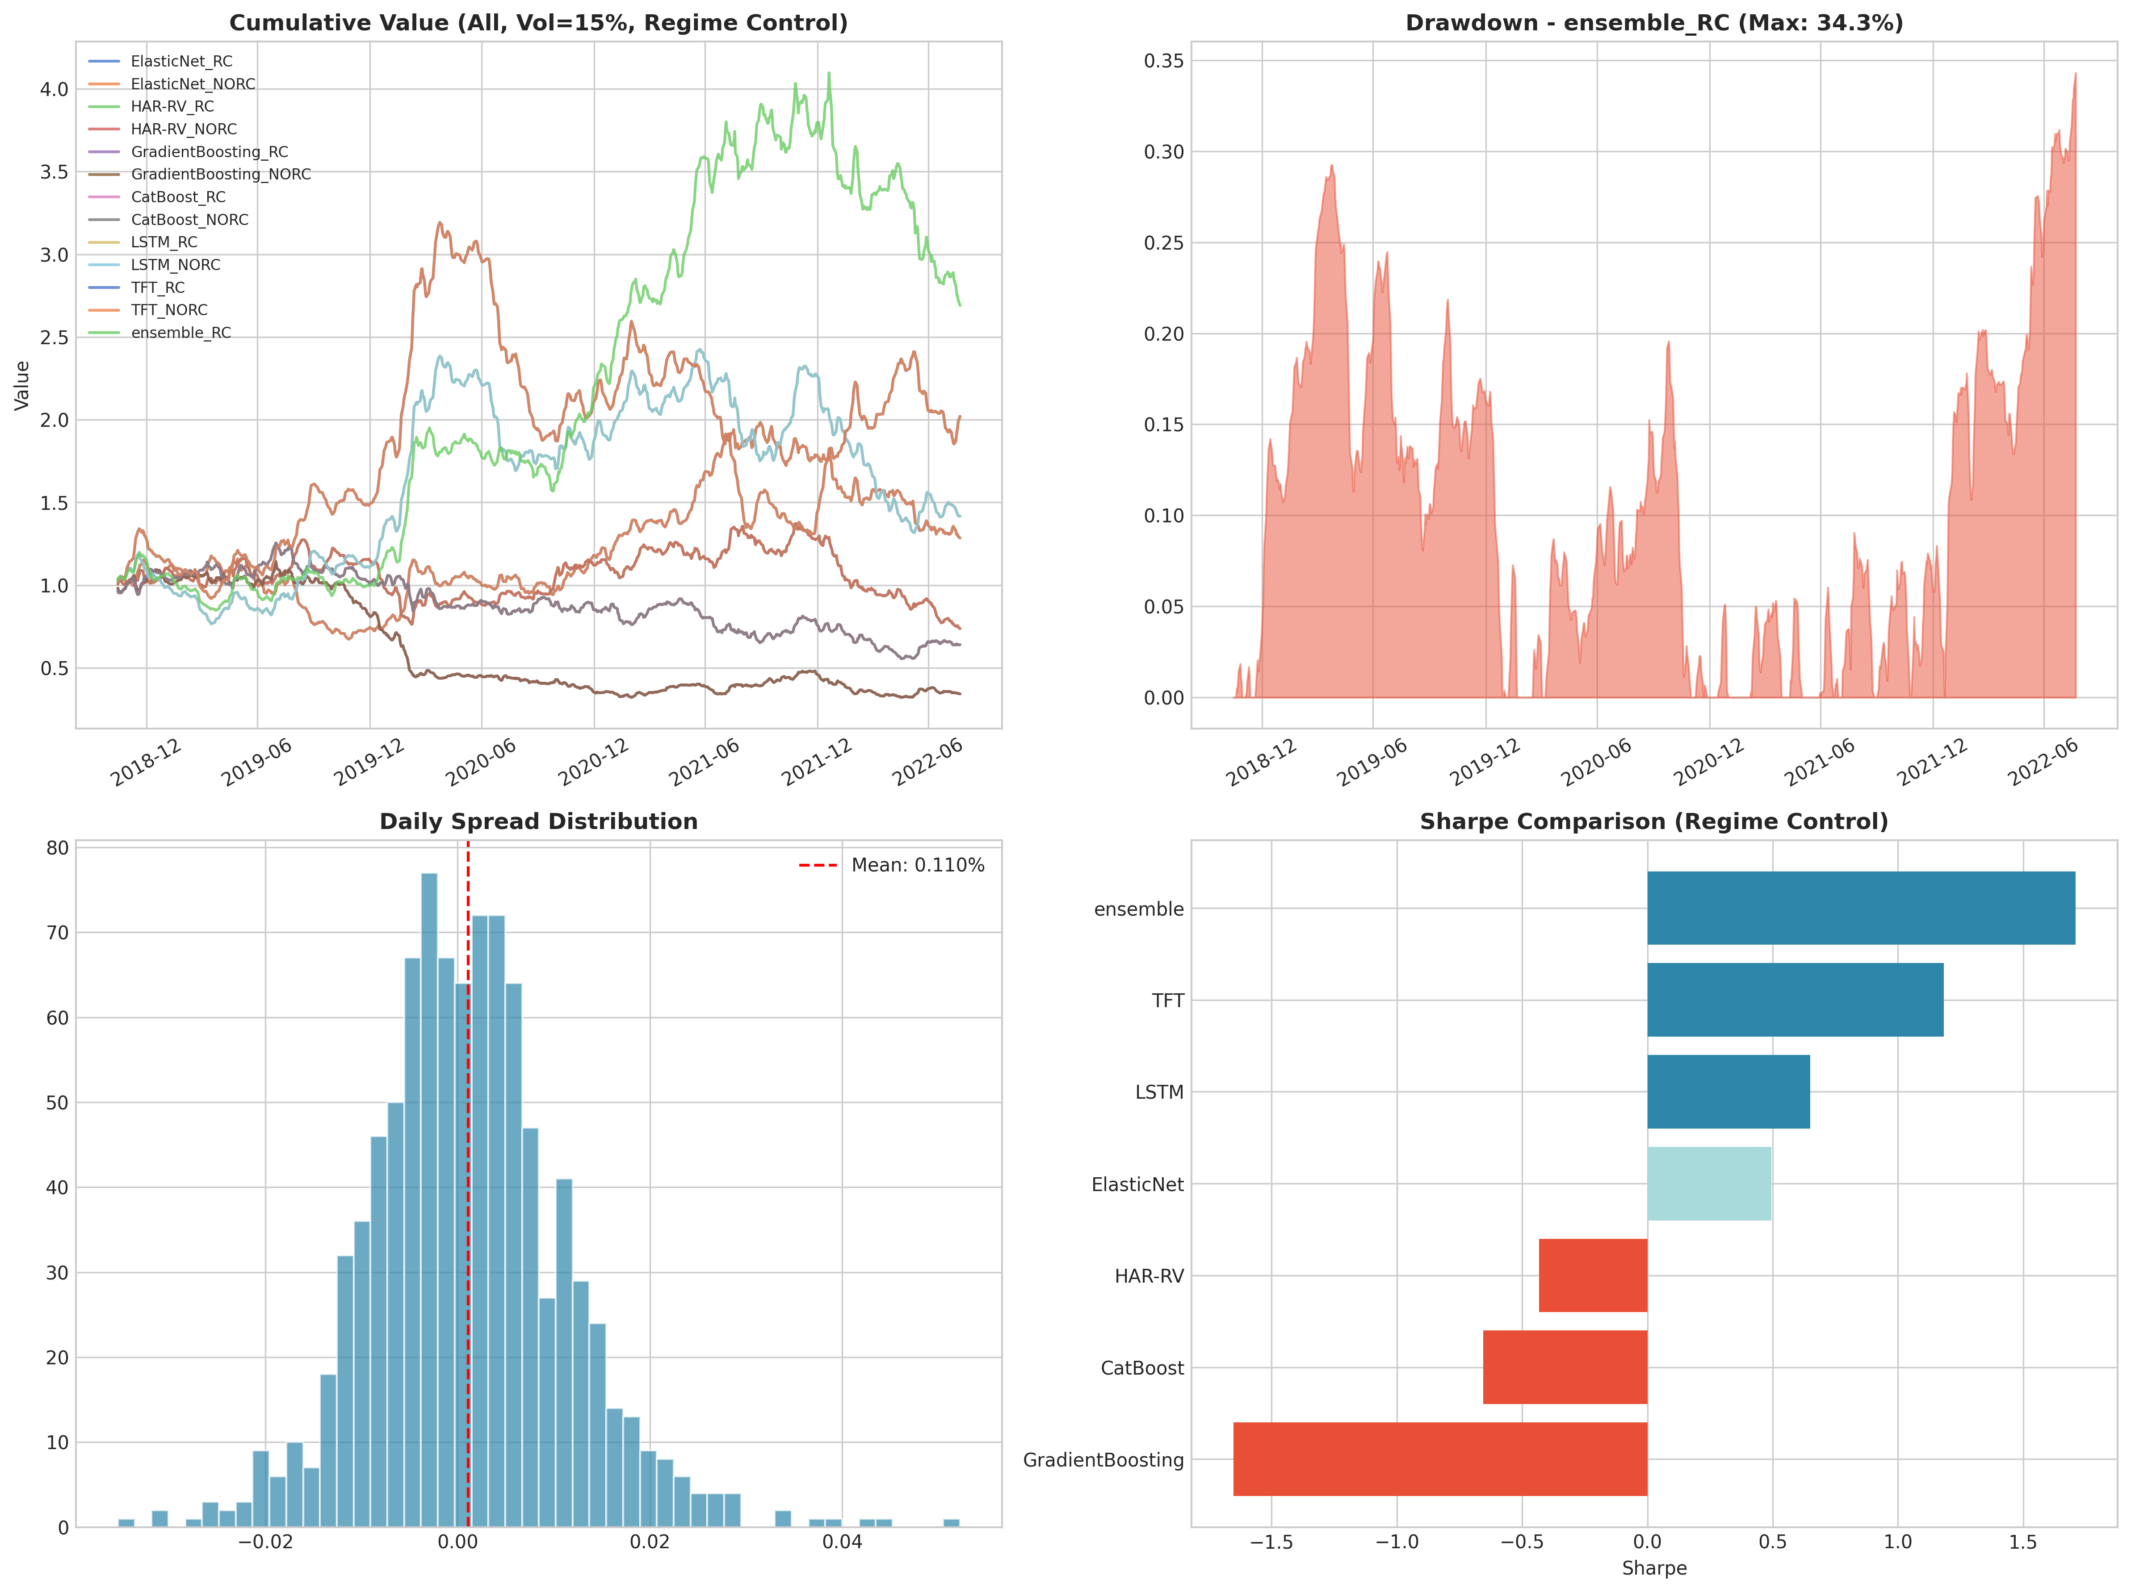
Figure 6.1 — Top-left: cumulative value of all models with regime control; the green line is the ensemble. Top-right: ensemble drawdown profile, peaking at 34.3%. Bottom-left: daily long-short spread distribution. Bottom-right: Sharpe comparison; ensemble is the only positive-Sharpe configuration with double-digit annualised return.

6.3 The signal-inversion finding
When we first computed model-level statistics for the cross-sectional book, raw predictions delivered negative Sharpe values. Inspection revealed that the highest-ranked ETFs by predicted return systematically underperformed the lowest-ranked ones the following week, with IC slightly negative on average. This is consistent with a contrarian / mean-reversion mechanism dominating the panel at the 5-day horizon. We therefore inverted the trading signal — long the bottom decile, short the top decile — which is the convention used in the repository. The inversion is documented in signal_direction.json. We flag it explicitly because it is the kind of decision that, undocumented, would look like overfitting; documented, it is an honest empirical adjustment to a stable reversal effect.

6.4 Why ensemble beats every constituent
No single model has both positive Sharpe and a tolerable drawdown. The ensemble does. This is a textbook diversification result: model errors are imperfectly correlated, so averaging shrinks model-specific noise faster than it shrinks any common signal. The cleaner statement is that we cannot identify in advance which model will work in which regime, so we let the ensemble vote and let the HMM gate the vote.

7. Robustness Checks and Limitations

7.1 What we tested
- Borrow stress: the 50% dislocation scenario is baked into the headline Strategy 1 result, not bolted on after the fact.
- Cost realism: 10 bp round-trip transaction costs are applied on signed turnover for every rebalance.
- Walk-forward integrity: every model is refit on rolling 756-day windows with a 5-day embargo; no future information enters any training fold.
- Look-ahead audit: all 20 features verified to use only information at or before time t; macro features lag by one trading day.
- Regime ablation: turning the HMM filter off materially worsens both Sharpe and maximum drawdown on the cross-sectional book, confirming that the regime gate is what carries the result.

7.2 What we did not stress test
- Survivorship in the 41-ETF universe was not exhaustively audited; the list reflects currently tradeable funds in major asset classes.
- Slippage beyond a flat 5 bp per side was not modelled. Real execution in the bottom-decile names could be materially worse in stressed regimes.
- The deep models (LSTM, TFT) were trained on a constrained compute budget. We do not claim to have characterised their performance ceiling, only their performance at student-team scale.
- The 2022 drawdown in the ensemble book (34.3%) was not decomposed into regime-misclassification vs. structural-break components; doing so is the natural next step.

8. Conclusion and Recommendations

8.1 What we believe with high confidence
- Daily directional prediction of volatility-ETF returns is at or below the noise floor for the model classes available to a student team. ML capacity should not be spent on this.
- Regime identification produces information that is both economically interpretable and statistically persistent.
- Structural carry — VIX roll decay — is the most defensible source of expected return in this universe, but only when gated by regime state.

8.2 What we recommend
- Deploy the HMM-gated VIXY trade as the core volatility book, sized as a measured share of an alternatives sleeve rather than the main allocation.
- Use the cross-sectional ensemble as a complementary equity-overlay; the two strategies operate on different mechanisms (carry vs. cross-sectional reversal) and should diversify in practice, though we did not pin down a numerical correlation in this study.
- Redirect future ML work from forecasting to state detection and position sizing — for example, regime-conditional Kelly fractions or a neural HMM emission model.
- Maintain the honesty-first protocol: pre-register features, document signal inversions, publish stress tests at multiple borrow-fee tiers.

8.3 What we are uncertain about
- Deep models were trained under compute constraints. We do not claim TFT cannot work on volatility data; we claim it does not work at the parameter budget feasible for a 5-person student team. A re-run on a 10-year panel with full hyperparameter tuning is the obvious next experiment.
- The 2022 drawdown of the ensemble is uncomfortable for a strategy with a 27.69% annualised return. Whether it reflects a temporary regime mis-classification or a structural break is the most important open question for production use.

8.4 Closing message
The headline result of this project is the negative one. Daily volatility returns are not directionally predictable by any of the standard ML families. What is profitable is the structure around the prediction — regime, carry, sizing, costs, and a willingness to do nothing when the model has nothing to say. The honest version of the slogan we put on the cover is that not predicting is more profitable than predicting badly, and that is the lesson we carry forward from this course.

References & Project Repository
- Gu, S., Kelly, B., and Xiu, D. (2020). Empirical Asset Pricing via Machine Learning. Review of Financial Studies, 33(5).
- Lopez de Prado, M. (2018). Advances in Financial Machine Learning. Wiley.
- Hamilton, J. D. (1989). A New Approach to the Economic Analysis of Nonstationary Time Series and the Business Cycle. Econometrica, 57(2).
- Lim, B., Arik, S. O., Loeff, N., and Pfister, T. (2021). Temporal Fusion Transformers for Interpretable Multi-Horizon Time Series Forecasting. International Journal of Forecasting, 37(4).
- Corsi, F. (2009). A Simple Approximate Long-Memory Model of Realized Volatility. Journal of Financial Econometrics, 7(2).
Code, notebook, and all backtest outputs: github.com/ctiancai666-hub/6130-group8

