|  |  |
| --- | --- |
| Multi Campus UnIVERSITY NETWORK DESIGN | Khalid Hasan Seum  COIT13236 |

Table of Contents

Objective: 2

Capacity: 2

Reliability: 2

Device Requirements: 2

The requirements for the Sydney Campus: 3

**Total Device Requirements for the Sydney Campus:** 7

The requirements for the Melbourne Campus: 8

**Total Device Requirements for the Melbourne Campus:** 12

The requirements for the Brisbane Campus: 13

**Total Device Requirements for the Brisbane Campus:** 16

Network Device Recommendations 17

Budget: 22

Budget for Sydney Campus: 23

Budget for Melbourne Campus: 23

Budget for Brisbane Campus: 24

Equipment and Design Selection: 24

Wired Connection: 25

Optical Fiber Cable: 26

Wireless Connection: 27

High Level Network Design: 28

Low Level Network Design: 29

Overall Network Design: 29

Detailed network Design: 30

Network Design for Study Room 31

References: 31

# Objective:

The main goal of the multi campus network is to provide a reliable and efficient network connection in the campuses for the students, teachers and staff. The multi campus network design must have enough security for the devices, backup for device failure, interconnection and so on. The network design also made by in a fixed budget. So, while choosing the network devices, iot devices, cloud and security we have to consider the budget and make a most efficient network design based on that.

# Capacity:

The university is mainly crowded with lots of users (students and staff) so we must consider this while doing the network design so that our network devices can handle the high amount of traffic without any delay and interruption. The multi-campus network design is designed for 3900 users. Among these 3900 users, Sydney campus has 1000 users, Melbourne campus has 1400 users, and Brisbane campus has 1500 users. So, the network traffic is much higher than in a normal place. Students and staff members can increase in the time being, so we also consider the upgrading the capacity of our network devices. To minimize the issues, we have to choose the network devices that can handle more traffic than normal network traffic so that we don’t have to upgrade the devices in the future time.

# Reliability:

In the university network design, we must follow the reliability of the network devices. Reliability refers to the consistency of the performance of the network devices according to the device specifications. Most of the network devices for the network design, we have chosen the cisco devices as it’s one of the most reliable brand and provider with the proper ecosystem for the network. These devices are highly reliable for performance and security.

# Device Requirements:

CQU University is a large university which has three campuses situated 1500 miles apart. The university’s students and staff are distributed in 4 faculties; these include the faculties of Health and Sciences; Business; Information Technology and Architecture and Civil. Each member of staff has a PC and students have access to PCs in the labs.

The campuses are Sydney campus, Brisbane campus and Melbourne campus.

## The requirements for the Sydney Campus:

**First Floor**

|  |  |  |  |  |  |  |  |  |
| --- | --- | --- | --- | --- | --- | --- | --- | --- |
| No. | Departments | No. of PC | No. of Printers | Security Camera | Motion Sensor | Switches | Wireless AP | VOIP Phone |
| 1 | Student Support Office | 15 | 10 | 4 | 1 | 2 | 1 | 2 |
| 2 | Admin Office | 10 | 10 | 2 | 1 | 1 | 1 | 2 |
| 3 | Servers Room | 2 | 1 | 2 | 1 | 1 | 1 | 1 |
| 4 | Students Club | 20 | 5 | 4 | 5 | 2 | 1 | 1 |

**Total Device Requirements for the First Floor of Sydney Campus:**

Total PC: 47

Total Printers: 26

Total Access Switches: 6

Total Wireless AP: 4

Total Security Camera: 12

Total Motion Sensor: 8

Total VOIP Phone: 6

**Second Floor**

|  |  |  |  |  |  |  |  |  |
| --- | --- | --- | --- | --- | --- | --- | --- | --- |
| No. | Departments | No. of PC | No. of Printers | Security Camera | Motion Sensor | Switches | Wireless AP | VOIP Phone |
| 1 | Library | 30 | 5 | 5 | 1 | 2 | 1 | 2 |
| 2 | Faculty Members Room | 40 | 10 | 5 | 1 | 3 | 1 | 2 |
| 3 | Silent Study Rooms | 40 | 2 | 2 | 1 | 2 | 1 | 1 |
| 4 | Meeting Room | 20 | 2 | 2 | 1 | 2 | 1 | 1 |

**Total Device Requirements for the Second Floor of Sydney Campus:**

Total PC: 130

Total Printers: 19

Total Access Switches: 9

Total Wireless AP: 4

Total Security Camera: 14

Total Motion Sensor: 4

Total VOIP Phone: 6

**Third Floor**

|  |  |  |  |  |  |  |  |  |
| --- | --- | --- | --- | --- | --- | --- | --- | --- |
| No. | Departments | No. of PC | No. of Printers | Security Camera | Motion Sensor | Switches | Wireless AP | VOIP Phone |
| 1 | Information Technology | 40 | 2 | 2 | 1 | 2 | 1 | 1 |
| 2 | Information Technology Lab | 40 | 2 | 2 | 1 | 2 | 1 | 1 |
| 3 | Architecture and Civil | 40 | 2 | 2 | 1 | 2 | 1 | 1 |
| 4 | Architecture and Civil Lab | 40 | 2 | 2 | 1 | 2 | 1 | 1 |
| 5 | Faculty of Information Technology admin | 10 | 5 | 2 | 1 | 1 | 1 | 1 |
| 6 | Faculty of Architecture and Civil Lab | 10 | 5 | 2 | 1 | 1 | 1 | 1 |

**Total Device Requirements for the Third Floor of Sydney Campus:**

Total PC: 180

Total Printers: 18

Total Access Switches: 10

Total Wireless AP: 6

Total Security Camera: 12

Total Motion Sensor: 6

Total VOIP Phone: 6

**Fourth Floor**

|  |  |  |  |  |  |  |  |  |
| --- | --- | --- | --- | --- | --- | --- | --- | --- |
| No. | Departments | No. of PC | No. of Printers | Security Camera | Motion Sensor | Switches | Wireless AP | VOIP Phone |
| 1 | Health and Sciences | 40 | 2 | 2 | 1 | 2 | 1 | 1 |
| 2 | Management and HR | 40 | 2 | 2 | 1 | 2 | 1 | 1 |
| 3 | Research Lab | 40 | 2 | 2 | 1 | 2 | 1 | 1 |
| 4 | Health and Sciences Lab | 25 | 2 | 2 | 1 | 2 | 1 | 1 |
| 5 | Faculty of Health and Sciences admin | 10 | 5 | 2 | 1 | 1 | 1 | 1 |
| 6 | Faculty of Management and HR admin | 10 | 5 | 2 | 1 | 1 | 1 | 1 |

**Total Device Requirements for the Fourth Floor of Sydney Campus:**

Total PC: 165

Total Printers: 18

Total Access Switches:10

Total Wireless AP:6

Total Security Camera:12

Total Motion Sensor:6

Total VOIP Phone: 6

### **Total Device Requirements for the Sydney Campus:**

Total PC: 522

Total Printers: 81

Total Access Switches: 35

Total Distribution Switches: 12

Total Core Switches: 2

Total Wireless AP: 20

Total Security Camera: 50

Total Motion Sensor: 24

Total VOIP Phone: 24

## The requirements for the Melbourne Campus:

**First Floor**

|  |  |  |  |  |  |  |  |  |
| --- | --- | --- | --- | --- | --- | --- | --- | --- |
| No. | Departments | No. of PC | No. of Printers | Security Camera | Motion Sensor | Switches | Wireless AP | VOIP Phone |
| 1 | Student Support Office | 20 | 10 | 4 | 1 | 2 | 1 | 2 |
| 2 | Admin Office | 15 | 10 | 3 | 1 | 2 | 1 | 2 |
| 3 | Servers Room | 2 | 1 | 2 | 1 | 1 | 1 | 1 |
| 4 | Students Club | 25 | 5 | 5 | 5 | 2 | 1 | 1 |

**Total Device Requirements for the First Floor of Melbourne Campus:**

Total PC: 62

Total Printers: 26

Total Access Switches: 7

Total Wireless AP: 4

Total Security Camera: 14

Total Motion Sensor: 8

Total VOIP Phone: 6

**Second Floor**

|  |  |  |  |  |  |  |  |  |
| --- | --- | --- | --- | --- | --- | --- | --- | --- |
| No. | Departments | No. of PC | No. of Printers | Security Camera | Motion Sensor | Switches | Wireless AP | VOIP Phone |
| 1 | Library | 50 | 5 | 5 | 1 | 3 | 1 | 2 |
| 2 | Faculty Members Room | 50 | 10 | 5 | 1 | 3 | 1 | 2 |
| 3 | Silent Study Rooms | 30 | 2 | 2 | 1 | 2 | 1 | 1 |
| 4 | Meeting Room | 20 | 2 | 2 | 1 | 2 | 1 | 1 |

**Total Device Requirements for the Second Floor of Melbourne Campus:**

Total PC: 150

Total Printers: 19

Total Access Switches: 10

Total Wireless AP: 4

Total Security Camera: 14

Total Motion Sensor: 4

Total VOIP Phone: 6

**Third Floor**

|  |  |  |  |  |  |  |  |  |
| --- | --- | --- | --- | --- | --- | --- | --- | --- |
| No. | Departments | No. of PC | No. of Printers | Security Camera | Motion Sensor | Switches | Wireless AP | VOIP Phone |
| 1 | Information Technology | 60 | 2 | 2 | 1 | 3 | 1 | 1 |
| 2 | Information Technology Lab | 60 | 2 | 2 | 1 | 3 | 1 | 1 |
| 3 | Architecture and Civil | 60 | 2 | 2 | 1 | 3 | 1 | 1 |
| 4 | Architecture and Civil Lab | 60 | 2 | 2 | 1 | 3 | 1 | 1 |
| 5 | Faculty of Information Technology admin | 15 | 5 | 2 | 1 | 1 | 1 | 1 |
| 6 | Faculty of Architecture and Civil Lab | 15 | 5 | 2 | 1 | 1 | 1 | 1 |

**Total Device Requirements for the Third Floor of Melbourne Campus:**

Total PC: 270

Total Printers: 18

Total Access Switches: 14

Total Wireless AP: 6

Total Security Camera: 12

Total Motion Sensor: 6

Total VOIP Phone: 6

**Fourth Floor**

|  |  |  |  |  |  |  |  |  |
| --- | --- | --- | --- | --- | --- | --- | --- | --- |
| No. | Departments | No. of PC | No. of Printers | Security Camera | Motion Sensor | Switches | Wireless AP | VOIP Phone |
| 1 | Health and Sciences | 60 | 2 | 2 | 1 | 3 | 1 | 1 |
| 2 | Management and HR | 60 | 2 | 2 | 1 | 3 | 1 | 1 |
| 3 | Research Lab | 60 | 2 | 2 | 1 | 3 | 1 | 1 |
| 4 | Health and Sciences Lab | 30 | 2 | 2 | 1 | 2 | 1 | 1 |
| 5 | Faculty of Health and Sciences admin | 15 | 5 | 2 | 1 | 1 | 1 | 1 |
| 6 | Faculty of Management and HR admin | 15 | 5 | 2 | 1 | 1 | 1 | 1 |

**Total Device Requirements for the Fourth Floor of Melbourne Campus:**

Total PC: 240

Total Printers: 18

Total Access Switches: 13

Total Wireless AP: 6

Total Security Camera: 12

Total Motion Sensor: 6

Total VOIP Phone: 6

### **Total Device Requirements for the Melbourne Campus:**

Total PC: 722

Total Printers: 81

Total Access Switches: 44

Total Distribution Switches: 12

Total Core Switches: 2

Total Wireless AP: 20

Total Security Camera: 52

Total Motion Sensor: 24

Total VOIP Phone: 24

## The requirements for the Brisbane Campus:

**First Floor**

|  |  |  |  |  |  |  |  |  |
| --- | --- | --- | --- | --- | --- | --- | --- | --- |
| No. | Departments | No. of PC | No. of Printers | Security Camera | Motion Sensor | Switches | Wireless AP | VOIP Phone |
| 1 | Student Support Office | 20 | 5 | 4 | 1 | 2 | 1 | 1 |
| 2 | Admin Office | 15 | 2 | 2 | 1 | 1 | 1 | 1 |
| 3 | Servers Room | 2 | 2 | 2 | 1 | 1 | 1 | 1 |
| 4 | Students Club | 20 | 2 | 5 | 1 | 2 | 1 | 1 |
| 5 | Faculty Members Room | 30 | 4 | 5 | 1 | 2 | 1 | 1 |
| 6 | Meeting Room | 20 | 2 | 2 | 1 | 2 | 1 | 1 |

**Total Device Requirements for the First Floor of Brisbane Campus:**

Total PC: 107

Total Printers: 15

Total Access Switches: 10

Total Wireless AP: 6

Total Security Camera: 20

Total Motion Sensor: 6

Total VOIP Phone: 6

**Second Floor**

|  |  |  |  |  |  |  |  |  |
| --- | --- | --- | --- | --- | --- | --- | --- | --- |
| No. | Departments | No. of PC | No. of Printers | Security Camera | Motion Sensor | Switches | Wireless AP | VOIP Phone |
| 1 | Library | 40 | 5 | 2 | 1 | 3 | 1 | 1 |
| 2 | Silent Study Rooms | 40 | 2 | 2 | 1 | 2 | 1 | 1 |
| 3 | Research Lab | 40 | 2 | 2 | 1 | 2 | 1 | 1 |
| 4 | Faculty of Health and Sciences admin | 15 | 5 | 2 | 1 | 1 | 1 | 1 |
| 5 | Faculty of Information Technology admin | 15 | 5 | 2 | 1 | 2 | 1 | 1 |
| 6 | Faculty of Architecture and Civil Lab | 15 | 5 | 2 | 1 | 2 | 1 | 1 |
| 7 | Faculty of Management and HR admin | 15 | 5 | 2 | 1 | 2 | 1 | 1 |

**Total Device Requirements for the Second Floor of Brisbane Campus:**

Total PC: 180

Total Printers: 29

Total Access Switches: 14

Total Wireless AP: 7

Total Security Camera: 14

Total Motion Sensor: 7

Total VOIP Phone: 7

**Third Floor**

|  |  |  |  |  |  |  |  |  |
| --- | --- | --- | --- | --- | --- | --- | --- | --- |
| No. | Departments | No. of PC | No. of Printers | Security Camera | Motion Sensor | Switches | Wireless AP | VOIP Phone |
| 1 | Information Technology | 70 | 2 | 2 | 1 | 4 | 1 | 1 |
| 2 | Information Technology Lab | 70 | 2 | 2 | 1 | 4 | 1 | 1 |
| 3 | Architecture and Civil | 70 | 2 | 2 | 1 | 4 | 1 | 1 |
| 4 | Architecture and Civil Lab | 70 | 2 | 2 | 1 | 4 | 1 | 1 |
| 5 | Health and Sciences | 70 | 2 | 2 | 1 | 4 | 1 | 1 |
| 6 | Health and Sciences Lab | 30 | 2 | 2 | 1 | 4 | 1 | 1 |
| 7 | Management and HR | 70 | 2 | 2 | 1 | 4 | 1 | 1 |

**Total Device Requirements for the Third Floor of Brisbane Campus:**

Total PC: 450

Total Printers: 14

Total Access Switches: 28

Total Wireless AP: 7

Total Security Camera: 14

Total Motion Sensor: 7

Total VOIP Phone: 7

### **Total Device Requirements for the Brisbane Campus:**

Total PC: 737

Total Printers: 58

Total Access Switches: 52

Total Distribution Switches: 14

Total Core Switches: 2

Total Wireless AP: 20

Total Security Camera: 48

Total Motion Sensor: 20

Total VOIP Phone: 20

# Network Device Recommendations

The following network assets were identified for use in the cutting edge multi campus network.

|  |  |  |
| --- | --- | --- |
| **Device Type** | **Device** | **Justification** |
| **Access Switches** | Cisco Nexus 93180YC-FX3H (24 port) | The switch has a sufficient number of ports for our university campus room. But even if we need more ports, we can use two or more of this switches. This switch is part of the Cisco Nexus 9300-FX3 Series, which is the latest generation of access switches based on the Cisco Cloud Scale technology. The series supports cost-effective cloud-scale deployments, an increased number of endpoints, and is capable of wire-rate security and telemetry. |
| **Distribution Layer Switches** | Cisco Catalyst C9500-24Q-A (24 port) | All the access layer switches will connect to the Distribution layer switch. The Cisco Catalyst C9500-24Q-A is a switch from the Cisco Catalyst 9500 Series. It is a next-generation enterprise-class core and aggregation layer switch. It includes non-blocking 40 and 100 Gigabit Ethernet Quad Small Form-Factor Pluggable (QSFP+, QSFP28) and 1, 10, and 25 Gigabit Ethernet Small Form-Factor Pluggable Plus (SFP/SFP+/SFP28) switches with granular port densities that fit diverse campus needs |
| **Core Switches** | Cisco Catalyst C9500X-28C8D | All the distribution switches will connect to the core switches. The Cisco Catalyst C9500X-28C8D is a switch from the Cisco Catalyst 9500 Series. It is a next-generation enterprise-class core and aggregation layer switch. It includes non-blocking 50 Gigabit Ethernet Small Form-Factor Pluggable (SFP-56) and non-blocking 400 Gigabit Ethernet Quad Small Form-Factor Pluggable Double Density (QSFP-DD) switches with granular port densities that fit diverse campus needs |
| **Core Routers** | Cisco 8000 Series. | All the core switches will connect to the core routers. The Cisco 8000 Series Routers are a new class of routing systems designed to support the internet for the future. The routers provide breakthrough density and massive scale, building the foundation of a new network for the next decade. They offer 400G optimized platforms that scale from 10.8 Tbps to 260 Tbps. |
| **Wi-Fi Access Points:** | Cisco Catalyst 9100 Access Points. | For the secure and wireless network connectivity I have used this wireless access point. It comes with the WI-Fi 6 capabilities. It also comes with a better industrial design, and improved RF performance. |
| **Fiber Cable:** | Nenco LC-ST MM Duplex Fiber Patch Networking Cable | The advantage of a Nenco LC-ST MM Duplex Fiber Patch Networking Cable is the capacity for simultaneous bidirectional communication1. This means data can be sent and received at the same time, improving the efficiency of data transmission. |
| **Network Connection Cables:** | UGREEN Cat 6 Ethernet Cable | The UGREEN Cat 6 Ethernet Cable supports high-speed data transfer up to 1000Mbps. It also supports 250MHz bandwidth. This cable provides smooth high speed data transfer. |
| **Security Cameras:** | Cisco Meraki MV | Cisco Meraki MV are easy to deploy and configure due to their integration into the Meraki Dashboard, and their use of cloud augmented edge storage. This security camera is cloud managed security camera. |
| **Motion Sensors** | FrogMotion1-1 | frogMotion1-1 is easy to configure and deploy and this sensor is cloud managed sensors. |
| **VOIP phone:** | Cisco IP Phone 8841 | **The Cisco** IP Phone 8841 delivers reliable, secure and scalable voice communication and this ip phone is ideal for large universities. It offers high quality voice communication and also offers simpler administration. |

**Cisco Nexus 93180YC-FX3H (24 port):**

The capabilities of the Cisco Nexus 93180YC-FX3H switch are as follows:

Switch ports/stacking ports:

* The switch has 24 downlink ports that are capable of supporting 1-, 10-, or 25-Gbps Ethernet.
* It also has 6 uplink ports that can be configured as 40 and 100-Gbps Ethernet, offering flexible migration options.

Power/PoE:

* The switch includes two power supplies (1-to-1 redundancy with current sharing) in one of the following combinations: Two 650-W AC power supplies (NEBS compliant), Two 1200-W HVAC/HVDC power supplies, Two 930-W DC power supplies45.

Hardware platform:

* The Cisco Nexus 93180YC-FX3H is a 1RU switch.
* It supports 3.6 Tbps of bandwidth and over 1.2 Bpps.
* The switch also supports standard PTP Telecom profiles with SyncE and PTP boundary clock functionality for Telco data center edge environments.

Cloud management:

* The Cisco Nexus 93180YC-FX3H is based on the Cisco Cloud Scale technology.
* It supports cost-effective cloud-scale deployments, an increased number of endpoints, and is capable of wire-rate security and telemetry.

Switching capabilities:

* The switch is designed to provide high performance and meet the evolving needs of highly scalable data enterprise level university campus.

This switch has sufficient number of ports as required by our multi campus university design scenario. The switch includes two power supplies and is based on the Cisco Cloud Scale technology. It is designed to provide high performance and meet the evolving needs of highly scalable multi campus university networks.

**Cisco Catalyst C9500-24Q-A (24 port) :**

The capabilities of the **Cisco Catalyst C9500-24Q-A :**

Switch ports/stacking ports:

* The switch has 24 ports that support 40 Gigabit Ethernet.
* Please note that the switch does not support stacking.

Power/PoE:

* The switch includes two power supplies. The power supplies are platinum-rated and support 1:1 power redundancy.
* The switch also supports UPOE (Universal Power Over Ethernet).

Hardware platform:

* The Cisco Catalyst C9500-24Q-A is a 1RU rack-mountable device345.
* It supports Layer 3 switching.
* The switch is based on an x86 CPU and comes with a 4-core x86, 2.4-GHz CPU, 16-GB DDR4 memory, and 16-GB internal storage.

Cloud management:

* The Cisco Catalyst C9500-24Q-A is based on the Cisco Cloud Scale technology.
* It supports cost-effective cloud-scale deployments, an increased number of endpoints, and is capable of wire-rate security and telemetry.

Switching capabilities:

* The switch is designed to provide high performance and meet the evolving needs of highly scalable data for enterprise level university campus.

This switch has sufficient number of ports as required by our multi campus university design distribution layer scenario. It will provide seamless connectivity among the network devices.

**Cisco 8000 Series**

The capabilities of the Cisco 8000 Series routers:

Switch ports/stacking ports:

* The routers range from 10.8 to 25.6 Tbps in a 1 RU footprint.
* They are also available in an industry-leading, rack-mountable modular system capable of 518.4 Tbps of full-duplex, line rate forwarding.
* The 8000 Series includes two distinct router architectures that both utilize the Cisco Silicon One ASICs.
* The 8800 Series provides the highest bandwidth via modular chassis with a redundant control plane and switch fabric.
* The Cisco 8100 and 8200 Series utilize Cisco’s Router-on-Chip (RoC) architecture to deliver full routing functionality with a single ASIC per router.

Power/PoE:

* The HVAC/HVDC power supply has 2 redundant input power lines. It can provide a power output of 6.3 kW from each input power line with 2 inputs operating or provide 4.8 kW (30A) or 3.15 kW (20A) output from either input with one input operating.

Hardware platform:

* The Cisco 8000 Series routers are high-performance networking systems that deliver provider-class routing functionality at unmatched density, performance, and power.
* They are designed to be deployed into an unprecedented range of routing roles, all supported with a single ASIC architecture and operating system.

Cloud management:

* The Cisco 8000 Series Routers are cloud-enhanced systems powered by groundbreaking Cisco Silicon One™ application-specific integrated circuits (ASICs).
* These systems deliver routing performance and functionality that scale to meet the needs of critical infrastructure.

Switching capabilities:

* The switch is designed to provide high performance and meet the evolving needs of highly scalable data centers and growing enterprises.

The routers provide breakthrough density and massive scale, building the foundation of a new network for the next decade. They offer 400G optimized platforms that scale from 10.8 Tbps to 260 Tbps. So, this is the best router in the multi campus university scenario. Besides we also can easily upgrade our network devices and upgrade the network scale.

**Cisco Catalyst 9100 Access Points:**

The capabilities of the Cisco Catalyst 9100 Access Points:

* They are Wi-Fi 6 certified, supporting 802.11ax on both 2.4GHz and 5GHz bands.
* They have up to four Wi-Fi radios: a flexible 5GHz radio (single 8x8 or dual 4x4), a 2.4GHz (4x4) radio, and a Cisco RF ASIC.
* They support OFDMA and MU-MIMO.
* They offer multigigabit support.
* They are IoT ready, with support for BLE and other 802.15.4 protocols like Zigbee.

For the secure wireless connection this wireless ap is one of the best for the university and it’s network connectivity will provide seamless connectivity.

**Cisco Meraki MV:**

* The third generation of smart cameras from Cisco Meraki bring faster edge analytics, up to 4K video recording, and machine learning for custom computer vision and camera intelligence.
* These cameras also introduce the ability to deploy outdoors, as well as wirelessly allowing for seamless deployment in almost any environment.
* They include IR illumination to ensure visibility in a dark environment and during the night.

For the optimum security and top-notch security for the university campus and iot devices Cisco Meraki MV provides almost everything we needed.

**Cisco IP Phone 8841:**

* It offers a 5-inch high-resolution (800 x 480) widescreen VGA backlit color display.
* It supports a built-in Gigabit Ethernet switch for your PC connection.
* The phone offers five programmable line keys. You can configure keys to support either multiple directory numbers or call features such as speed dial.
* It provides “always-on” reliability, encrypted voice communications to enhance security, and access to a comprehensive suite of unified communication features from Cisco on-premises and hosted infrastructure platforms and third party hosted call control.

The CiscoIP Phone 8841 delivers reliable, secure and scalable voice communication and this ip phone is ideal for large universities.

# Budget:

Budget is a crucial element for the network design. We have to consider the budget before designing the university network and must finish designing a network within the budget.

For the reliability of the network design, we can choose the most expensive network devices but for the budget we have to consider that is fit into the budget and best in the budget so that we don’t have to upgrade the network devices.

After a calculation of the requirements, we have estimated that we need a total $164,606.52 for the device implementation in the network design.

In the below I will provide the estimate budget of the network devices:

## Budget for Sydney Campus:

1. **Total Access Switches:** 35 x $19,434.99 (cost of Cisco Nexus 93180YC-FX3H switch) = $680224.65
2. **Total Distribution Layer Switches:** 12 x $41,451.21 (cost of Cisco Catalyst C9500-24Q-A) = $497,414.52
3. **Core Switches:**  2 x $67,072.72 (Cost of Cisco Catalyst C9500X-28C8D) = $134145.44
4. **Core Router:** 2 x $95,000 (Cost of Cisco 8000 Series) = $190000
5. **Total Wireless AP:** 20 x $ $2,190.39 (average cost per Cisco Catalyst 9100 Access Points) = $43807.8
6. **Total Security Camera:** 50 x $391.12 (cost of Cisco Meraki MV series camera) = $19,556
7. **Total Motion Sensor:** 24 x $259.23 (cost of Cisco Meraki MT series sensor) = $6,221.52
8. **Total VOIP phone:** 24 x $509,95 (cost of Cisco IP Phone 8841) = $12238.80
9. **Total Network Connection Cables:** We need a total of 500m Cable. So, 500m x $25(cost of UGREEN Cat 6 Ethernet Cable) = $12,500
10. **Total Fiber Cables:** We need a total of 510M cable. So, 510 x $46.04 (cost of Nenco LC-ST MM Duplex Fiber Patch Networking Cable) = $23,480.40

**So, the total budget for Sydney Campus $ 1,616,588.73**

## Budget for Melbourne Campus:

1. **Total Access Switches:** 44 x $19,434.99 (cost of Cisco Nexus 93180YC-FX3H switch) = $854,739.56
2. **Total Distribution Layer Switches:** 12 x $41,451.21 (cost of Cisco Catalyst C9500-24Q-A) = $497,414.52
3. **Core Switches:** 2 x $67,072.72 (Cost of Cisco Catalyst C9500X-28C8D) = $134,145.44
4. **Core Router:** 2 x $95,000 (Cost of Cisco 8000 Series) = $190,000
5. **Total Wireless AP:** 20 x $2,190.39 (average cost per Cisco Catalyst 9100 Access Points) = $43,807.8
6. **Total Security Camera:** 52 x $391.12 (cost of Cisco Meraki MV series camera) = $20,338.24
7. **Total Motion Sensor:** 24 x $259.23 (cost of Cisco Meraki MT series sensor) = $6,221.52
8. **Total VOIP phone:** 24 x $509,95 (cost of Cisco IP Phone 8841) = $12238.80
9. **Total Network Connection Cables:** We need a total of 500m Cable. So, 500m x $25(cost of UGREEN Cat 6 Ethernet Cable) = $12,500
10. **Total Fiber Cables:** We need a total of 510M cable. So, 510 x $46.04 (cost of Nenco LC-ST MM Duplex Fiber Patch Networking Cable) = $23,480.40

**So, the total budget for Melbourne campus: $ 1,791,885.88**

## Budget for Brisbane Campus:

1. **Total Access Switches:** 52 x $19,434.99 (cost of Cisco Nexus 93180YC-FX3H switch) = $1,010,619.48
2. **Total Distribution Layer Switches:** 14 x $41,451.21 (cost of Cisco Catalyst C9500-24Q-A) = $497,414.52
3. **Core Switches:** 2 x $67,072.72 (Cost of Cisco Catalyst C9500X-28C8D) = $134,145.44
4. **Core Router:** 2 x $95,000 (Cost of Cisco 8000 Series) = $190,000
5. **Total Wireless AP:** 20 x $2,190.39 (average cost per Cisco Catalyst 9100 Access Points) = $43,807.8
6. **Total Security Camera:** 48 x $391.12 (cost of Cisco Meraki MV series camera) = $18,773.76
7. **Total Motion Sensor:** 20 x $259.23 (cost of Cisco Meraki MT series sensor) = $5,184.6
8. **Total VOIP phone:** 20 x $509,95 (cost of Cisco IP Phone 8841) = $10199
9. **Total Network Connection Cables:** We need a total of 500m Cable. So, 500m x $25(cost of UGREEN Cat 6 Ethernet Cable) = $12,500
10. **Total Fiber Cables:** We need a total of 510M cable. So, 510 x $46.04 (cost of Nenco LC-ST MM Duplex Fiber Patch Networking Cable) = $23,480.40

**So, the total budget for Brisbane campus: $1,948,125**

So, in the fixed budget we have selected the best in the budget devices and for the device Security, we have chosen the most effective and efficient IOT devices. We didn’t compromise any quality of the network devices and security aspect for the Multi campus university.

# Equipment and Design Selection:

**Choose the Equipment**

All the pcs, servers and all other network devices needed a medium to transfer data between them. This medium also transfers the data from one node to another and also determines the data transfer speed of the network. As example, cat6 and cat8 cable have different transfer speeds. So, it’s so crucial and important to choose the network connection medium. For the connection medium, we have two options, one is wired and another one is wireless medium.

## Wired Connection:

There are different types of cables for the wired connection for connecting the network devices (routers, wireless ap, switch) together. For the multi campus university network we have used the optical fiber cable, coaxial cable, cat 6 cable (twisted pair cable). The cable price and purpose are different from each other's in terms of the network, speed, distance between devices and installation.

**Twisted pair cable (Cat 6 Cable):**

A cat 6 cable is also known as ethernet cable which is being used for connection devices such as pc, laptop, wireless ap to a local area network (LAN). We have chosen to use the Ugreen Cat6 cable for the multi campus network design. It can accommodate 10 Gbps in 180 feet distance for a single cable and use the Rj45 cable for the connection.

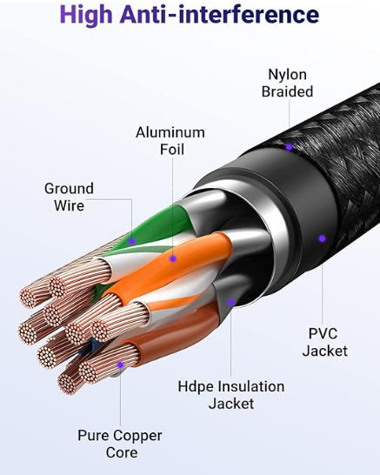

Figure 1: The figure shows the cat 6 cable construction.

**The reason of choosing to use the cat6 cable over the cat 5e cable:**

There are also different kinds of cable for the ethernet connection such as cat 5e. But cat 5e only supports 1 Gigabit per second whereas the cat 6 cable supports up to 10 Gbps which is future proof as well. We don’t need to upgrade cable if we go for higher bandwidth. Cat 6 also reduced the crosstalk (single transfer that make disruption in communication channels). Cat 5e only supports 100 Mhz where cat 6 upto 250 MHz.

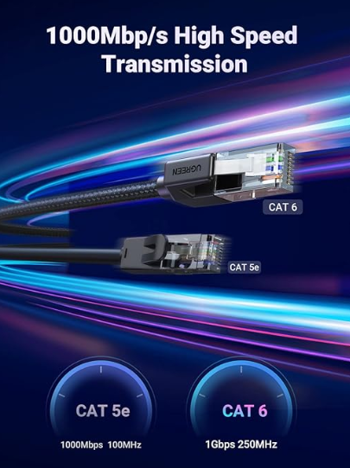

Figure 2: The diagram shows the difference between the cat5e cable and cat 6 cable.

## Optical Fiber Cable:

Fiber optical is generally used for long-distance and high-performance data networking and it is generally used for telecommunication services and internet. It is an assembly similar to electrical cable but containing sometimes one or more optical fibers to carry the lights and it is coated with plastic layers and it also contains the protective tube depending on the environment that we are going to use it. This cable is the fastest type of cable that transfers information from one node to another. This cable is more expensive than others cable and needs an expert to install these cables. For the multi campus university we are using Nenco LC-ST MM Duplex Fibre Patch Networking Cable.

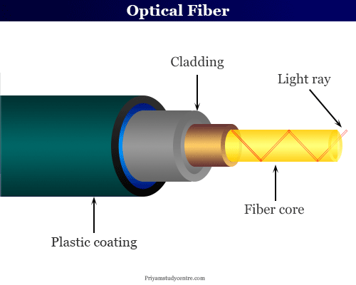

Figur 3: The diagram shows the optical fiber construction.

## Wireless Connection:

Wireless connection is used for to more flexible connection from device to network devices and there is very little type of wire needed to establish this type of connection. Only a twisted pair cable is needed to connect the wireless ap to the switch. So wireless connection saves money from buying the ethernet cable with a very less installation time.

In this multi campus university network we have used Cisco Catalyst 9100 Access Points.

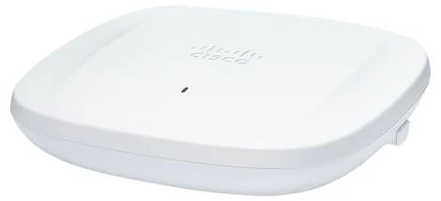

Figure 4: The figure shows the Cisco Catalyst 9100 Access Points.

# High Level Network Design:

Figure 5: The diagram shows the high-level design of the multi campus network.

In the diagram we can see the access layer switch is connected with the wireless ap, pc, VOIP phone, Security Camera. The wireless device is connected to the laptop, printer, mobile phone. After that the access layer switch is connected with the distribution layer switch and access layer switch is connected to the core layer router. In the core layer we provided a firewall for the security of the network, data and communication. In addition, the core layer router is connected to the other two campus core layer routers and data center core layer router to make a WAN connection. All the campuses and data center core router are connected to the ISP for the internet connection.

# Low Level Network Design:

## Overall Network Design:

In the low-level network design, I will show the full 3 campuses with data center ISP’s internal network connectivity. In a low-level network design, we usually get an idea of what the overall network will look like.

We can see a cutting edge multicampus network design. If we look at the very left side of the design, we can see the Brisbane campus which has 3 floors. In the middle we can see the Sydney campus with 4 floors and on the very left is showing the Melbourne campus with the 4 floors. In the top right corner, we can see the Data center where we have all the servers. In the left side of the data center, we can see the ISP. Each floor has 2 distribution layer switch. So, Brisbane has 6 distribution layer switch, Sydney and Melbourne both have 8 for the floors. But the total distribution switch for both Sydney and Melbourne are 12 whereas the Brisbane campus has a total of 14 distribution layer switches. In the network design we can see each and every campus is connected with each other through the WAN. Each and every campus has Internet coverage through ISP. In the core layer router, we implemented the firewall to protect the campus internal communication, upcoming threat and data safety.

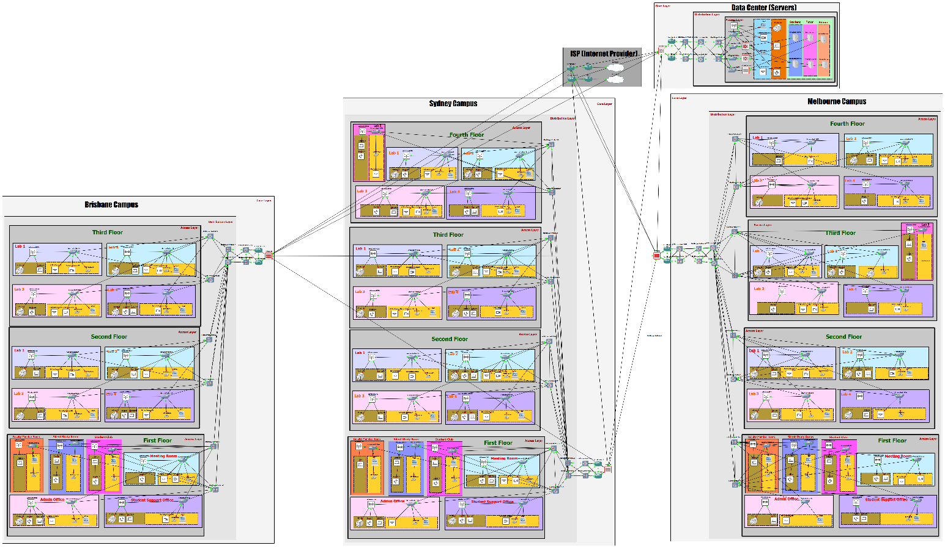

Figure 6: The figure shows the overall cutting edge multi campus university network design.

## Detailed network Design:

The detailed network design of the cutting edge multi campus network design consists of Sydney campus First floor, Brisbane campus Third floor, and Melbourne campus third floor. Each and every room is differentiated by a different color. In each room wired and wireless connection and devices marked by different color. If we look at the top right corner, we will see there is an index with the network devices that I have used in the network design. Each floor has 2 distribution switches, and these 2 switches are connected with another distribution switch. and this distribution switch is connected with the core layer switch and core layer switch is connected with the core router. We have firewall in the core layer router for upcoming potential threat protection. Each campus and data center are connected with each other through WAN and besides each and every campus is connected with the ISP. We have chosen 2 ISP for better performance, internet failure and constant high performance. If we look at the data center on the right side and above the Melbourne campus, we can see we have wireless and wired connection for the network devices and, every access switch for the servers has a firewall for access control and threat control. We have a total of 3 categories for the server. one is for students; one is for tutor, and another is for admin. The Firewall ensures that an unauthorized person cannot gain access to a particular server.

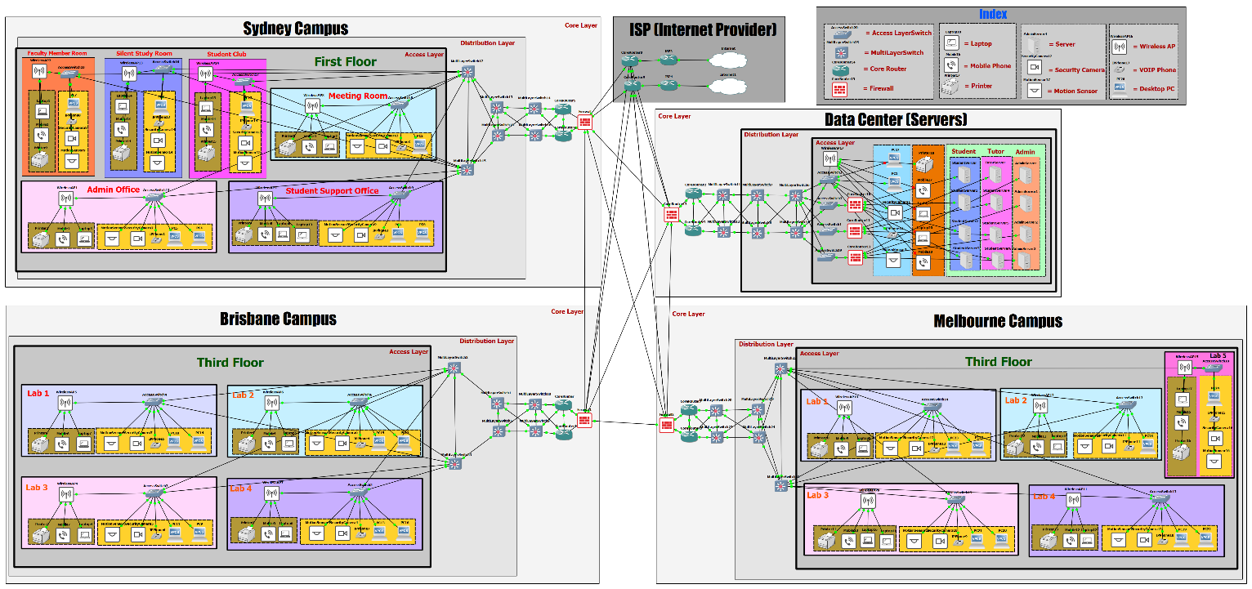

Figure 7: The figure shows the detailed cutting edge multi campus university network design.

## Network Design for Study Room

In the multicampus design we also have to design and implement the in-class network design and plan. The one of the most important for the university network design is to plan a network architecture and design for the room that are in there in the campus. In a study room which is shown below is consists of desktop pc, laptop, mobile device, wireless camera, security camera, motion sensor, VOIP phone, switch and wireless access point. The switch is connected to the desktop pc, security camera, VOIP phone, motion sensor, and wireless ap. The wireless ap then connects the laptop, mobile phone, wireless printer.

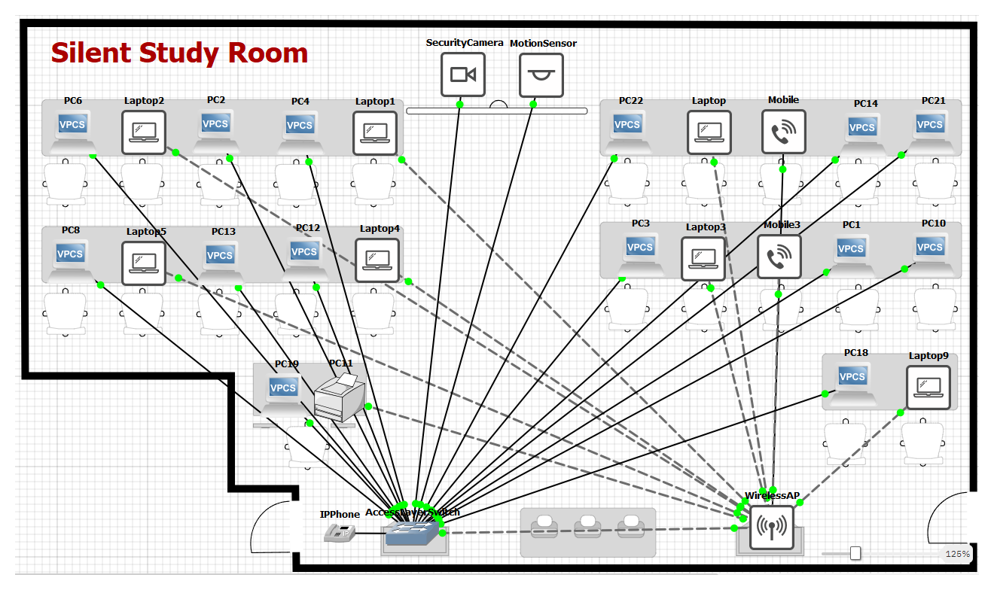

Figure 8: The figure shows the Silent study room network design.

# References:

1. Cisco. (n.d.). Cisco Catalyst 9166 Series Access Points Data Sheet. [online] Available at: https://www.cisco.com/c/en/us/products/collateral/wireless/catalyst-9166-series-access-points/catalyst-9166-series-access-points-ds.html?oid=dstwls029540.
2. community.cisco.com. (2022). Introducing Cisco Catalyst C9500X-28C8D. [online] Available at: https://community.cisco.com/t5/networking-blogs/introducing-cisco-catalyst-c9500x-28c8d/ba-p/4558130 [Accessed 8 Oct. 2023].
3. Cisco. (2018). Cisco IP Phone 8841. [online] Available at: https://www.cisco.com/c/en/us/products/collaboration-endpoints/ip-phone-8841/index.html.

‌

‌