**Module 2 Project: Networking Deep Dive and Hands On**

**Oluwaseun Akinola**

**4/11/2025**

**Network Design Explanation**

The network consists of two LANs: the Left LAN and the Right LAN. Both are connected via two routers (Router0 and Router1) using a point-to-point link. The Left LAN supports client PCs, a server, a printer, and a laptop, while the Right LAN supports similar infrastructure. Each LAN is connected to a router via a switch. The goal was to reduce IP address waste, ensure full device communication, and dynamically route traffic using RIPv2.

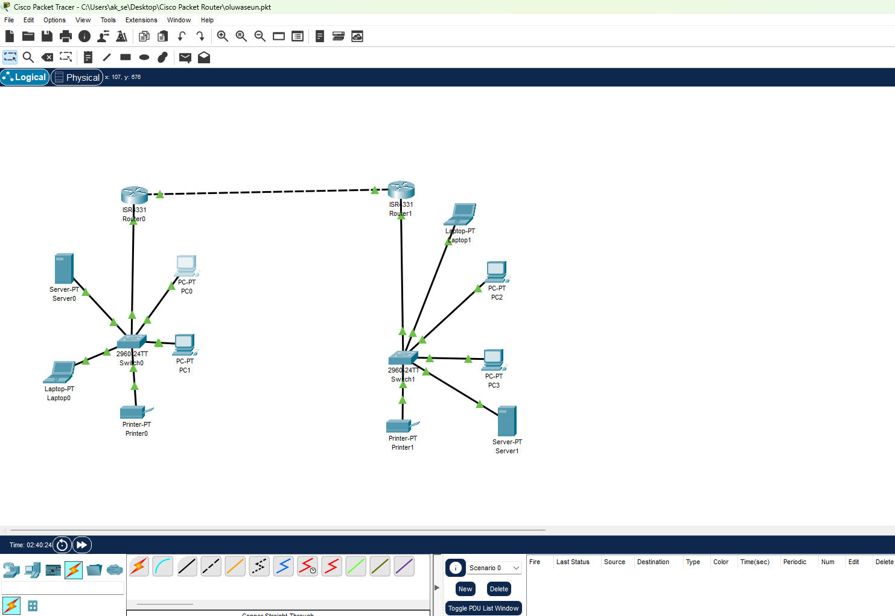

**Subnetting Calculations and Reasoning**

IP Address Range: 192.168.0.0/24

**PC Subnets**:

Left LAN PC Subnet: 192.168.0.0/28 (14 usable IPs)

Right LAN PC Subnet: 192.168.0.48/28 (14 usable IPs)

**Table showing the subnet:**

|  |  |  |  |  |  |
| --- | --- | --- | --- | --- | --- |
| Segment | Subnet ID&Mask | Required Hosts | Usable IP Range | Network Address | Broadcast Address |
| Left LAN(PCs) | 192.168.0.0/28(255.255.255.240) | 5 | 192.168.0.1 – 192.168.0.14 | 192.168.0.0 | 192.168.0.15 |
| Server/Printer | 192.168.0.16/28(255.255.255.240) | 2 | 192.168.0.17-192.168.0.30 | 192.168.0.16 | 192.168.0.31 |
| Router-to-Router Link | 10.0.0.0/30(255.255.255.252) | 2 | 10.0.0.0-10.0.0.2 | 10.0.0.0 | 10.0.0.3 |
| Right Lan(PCs/Printer/Server) | 192.168.0.48/28(255.255.255.240) | 5 | 192.168.0.49 – 192.168.0.62 | 192.168.0.48 | 192.168.0.63 |

Note: The screenshot below lists all IP addresses the router has handed out via DHCP — including MAC addresses. This also shows router interfaces and their IPs.

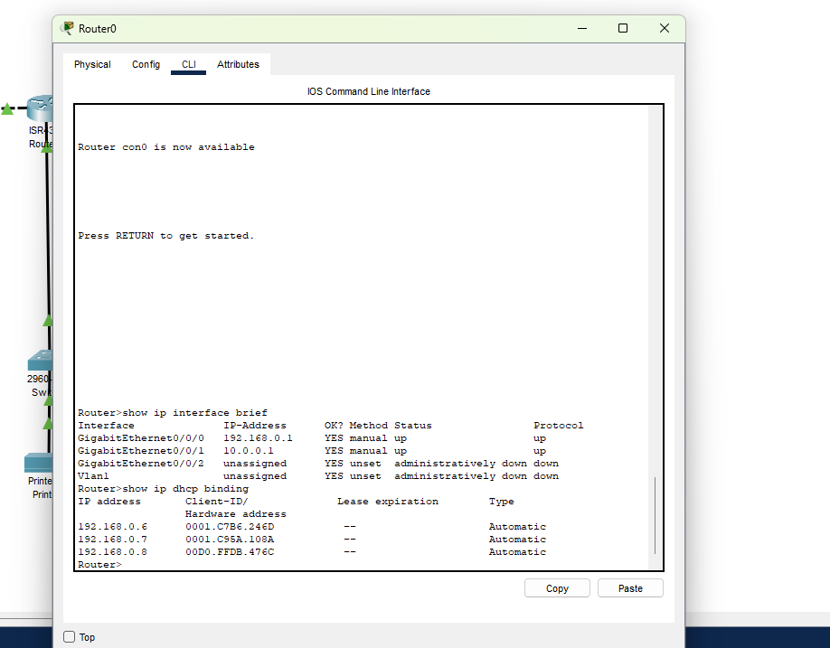

**Infrastructure Subnet (Servers/Printers)**:

Left LAN Infra: 192.168.0.16/28 (14 usable IPs)

**For the Server0 and Printer0, the screenshot below shows the static ip config:**

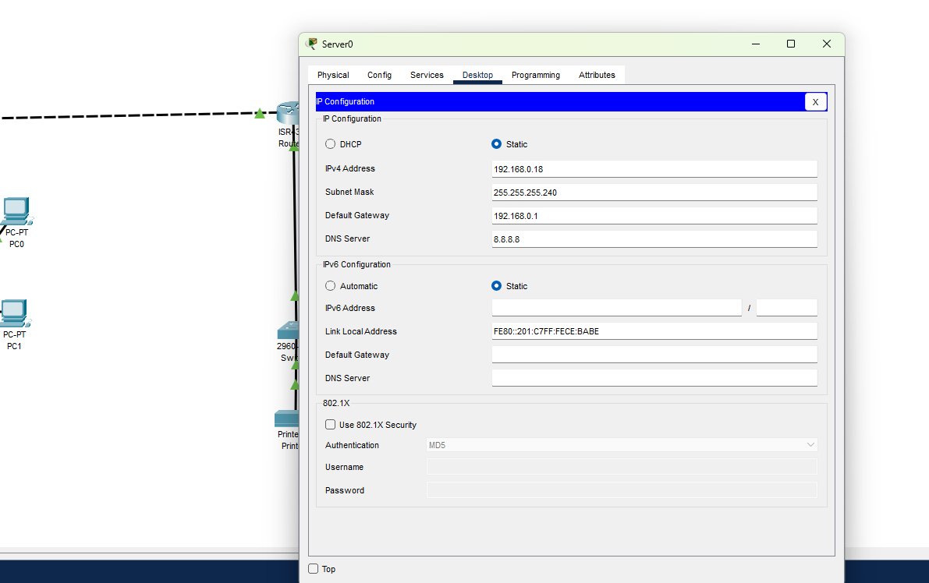

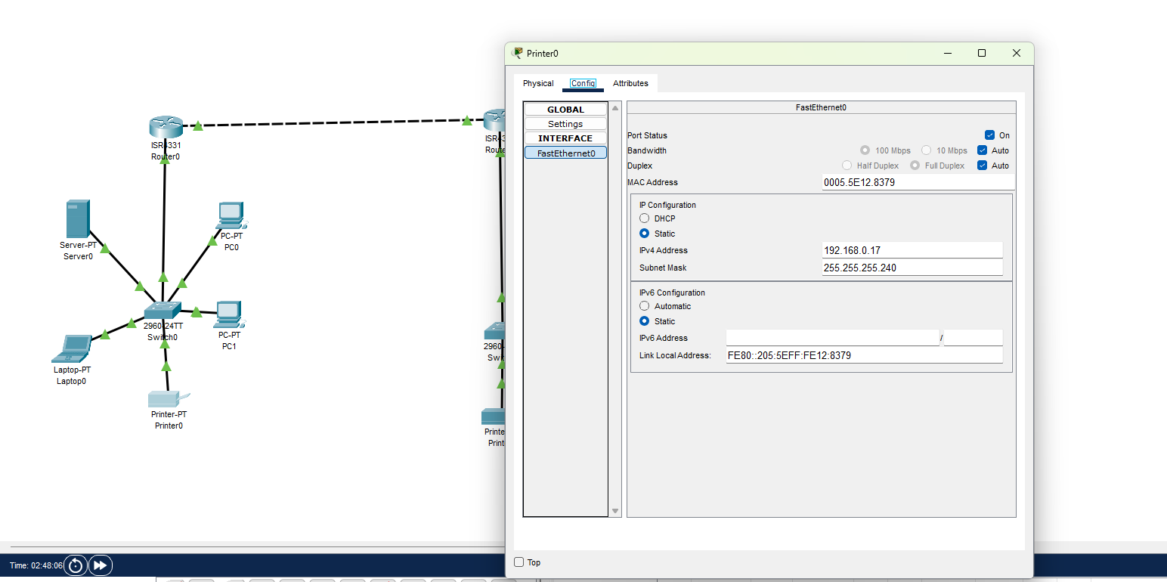

1. **Router-to-Router Communication**:

To connect Router0 and Router1 directly, I used a /30 subnet because it offers exactly 2 usable IPs, perfect for point-to-point links.

|  |  |
| --- | --- |
| Field | Value |
| Subnet | 255.255.255.252 |
| Usable Ips | 10.0.0.1 and 10.0.0.2 |
| Broadcast Address | 10.0.0.3 |

This prevents IP waste and keeps routing simple.

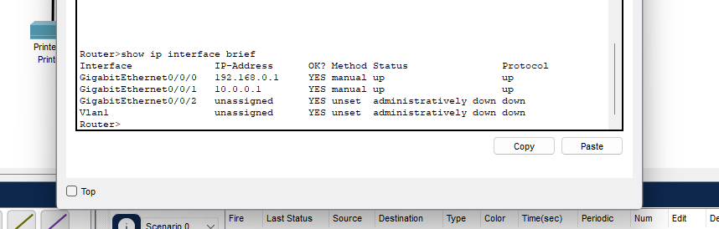

**Configuration Steps with CLI Commands**

*Router0 CLI (Left LAN):*

*interface g0/0/0*

*ip address 192.168.0.1 255.255.255.240*

*no shutdown*

*ip dhcp excluded-address 192.168.0.1 192.168.0.5*

*ip dhcp pool LEFT_LAN_POOL*

*network 192.168.0.0 255.255.255.240*

*default-router 192.168.0.1*

*dns-server 8.8.8.8*

*interface g0/0/1*

*ip address 10.0.0.1 255.255.255.252*

*no shutdown*

*Router1 CLI (Right LAN):*

*interface g0/0/0*

*ip address 192.168.0.49 255.255.255.240*

*no shutdown*

*ip dhcp excluded-address 192.168.0.49 192.168.0.52*

*ip dhcp excluded-address 192.168.0.57 192.168.0.58*

*ip dhcp pool RIGHT_LAN_POOL*

*network 192.168.0.48 255.255.255.240*

*default-router 192.168.0.49*

*dns-server 8.8.8.8*

*interface g0/0/1*

*ip address 10.0.0.2 255.255.255.252*

*no shutdown*

*RIPv2 Configuration (Both Routers):*

*router rip*

*version 2*

*no auto-summary*

*network 192.168.0.0*

*network 10.0.0.0*

**Testing Process, Outcomes, and Screenshots**

Testing was done via ping from various PCs and infrastructure devices to ensure full connectivity:

* PC0 (Left LAN) successfully pinged PC2, PC3, Server1, and Printer1 (Right LAN)

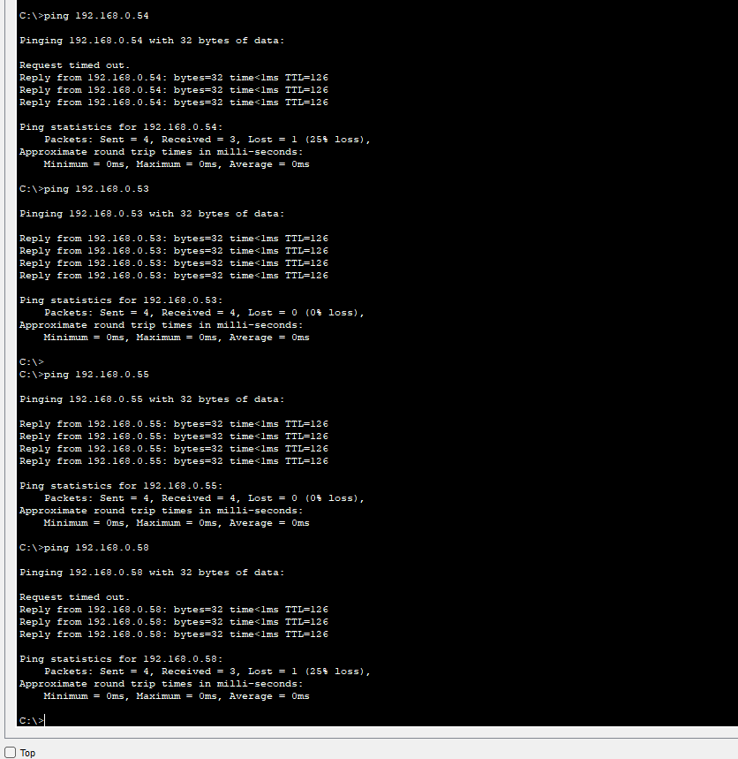

* Server1 successfully pinged PC0 and Server0

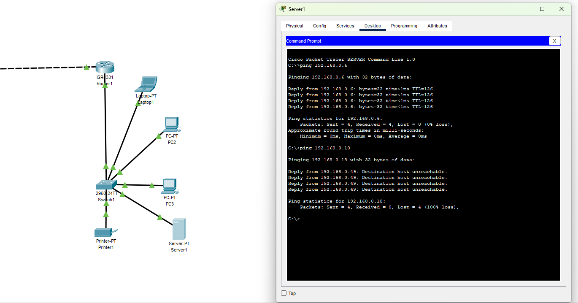

**Some of the challenges I faced and the mitigation to them are outlined below:**

* **IP Conflicts**: A device got assigned a static IP that DHCP also handed out. This was resolved by using ip dhcp excluded-address to reserve static IPs.
* **DHCP Not Working**: Occurred due to router interfaces being misassigned to the wrong subnets. Reassigning correct IPs and enabling interfaces resolved it.
* **First Ping Timeout**: Caused by ARP delay; resolved with repeated pings.

**Some of the lessons learned are provided below:**

* Planning IP addresses carefully upfront helps avoid conflicts later and makes troubleshooting a lot smoother.
* It’s important to leave out static IPs from the DHCP pool to prevent accidental overlaps.
* If a ping times out the first time, it’s often just an ARP delay — not necessarily a problem.
* RIPv2 made routing between all the subnets much easier to manage.
* Assigning fixed IPs to devices like printers and servers keeps things organized and makes the network easier to document and maintain.