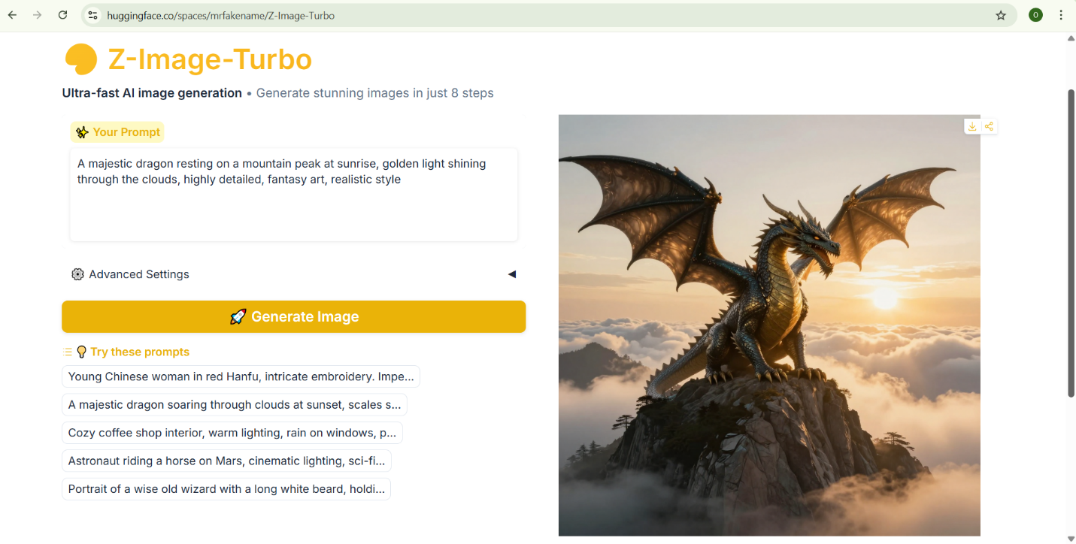
PART 1



PART 2
https://www.kaggle.com/datasets/gidutz/autotel-shared-car-locations
Having a large dataset on autotel shared car location would help train an AI to understand customer preferences and predict product ratings.

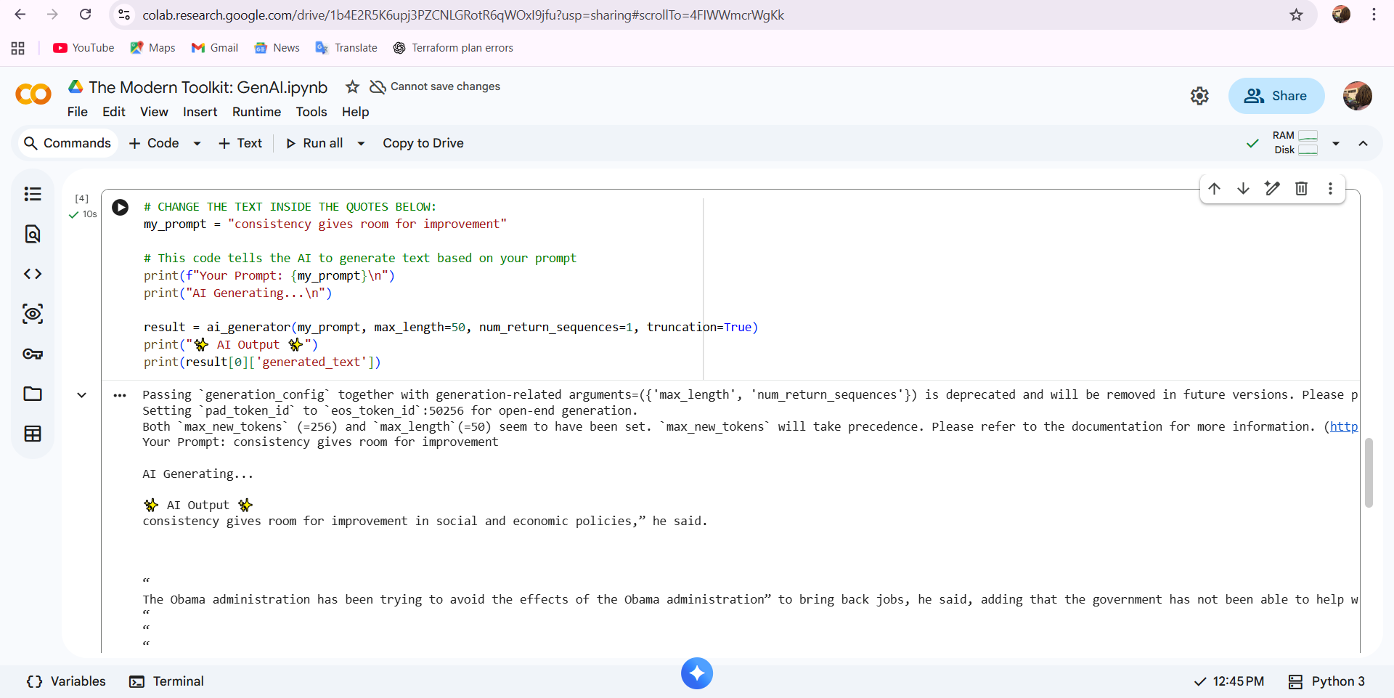
PART 3

