**Fish Philosophy**

Be there

Make their day

Choose their attitude

Have Fun

Cloud is a computing service model that uses a network of remote servers hosted on the internet to store, manage and process data. it allows us to consume IT services which helps businesses to focus on more important things that adds value to the organization

**Benefits of Cloud computing**

Speed

Scale

Economy

Image refers to OS

Provisioning to the Cloud

Management Portals

Scripting (Windows. Linux, Mac)

Azure resource manager

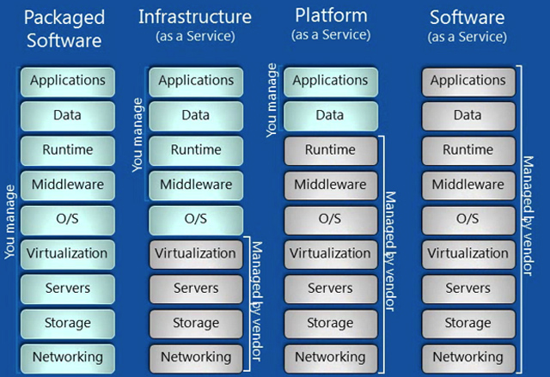

ADRMOVSSN

NRP- Network resource provide

CRP – Compute resource provider

Blob storage used for VHD

**Series of VM sizes**

A series Basic – for entry level

Only HDD

No load balancing

No auto scaling

AV2

-More RAMS and CPU

D-Series

-high compute power and temp disk performance

DS and DSv2

-SSD

FS series

G Series

H

-High Performance computing

N series

-GPU accelerated Workloads

**Availability Set**

**Fault Domain (3)**

Group of resources anticipated to fail together. same rack, same server

**Update Domain (4 – 20)**

Group of resources that will be updated together

Available set = 99.95%

Availability Zone 99.99%

Standalone VM – 99.90%

*Separate VMS to different update and fault domain*

**VM DISK LAYOUT**

Data disk

Temporary disk (Not in cluster) – Volatile and does not store persistent data

Persistent disk

Disk caching

**Cloning can be done**

-Generalized method (Coming from on prem) - do **sysprep**. Convert VHD to image

-Specialized

-Do not put unattend.xml on the disk

-Do not install Microsoft Azure integration components

-No Microsoft Azure agent

Scale sets

++++++++++++++++++++++++++++++++++++++++++++++++++++++++++++++++++++++++++++

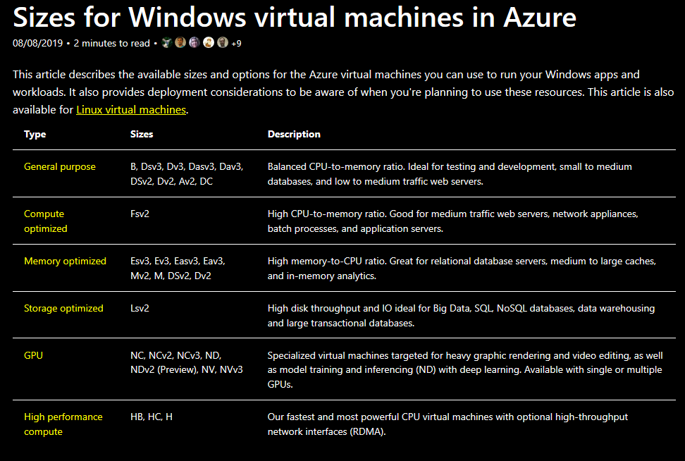

**Azure Regions**

54 regions

Worldwide 140 available in 140 countries

**Availability Zones**

Availability Zones are physically separate locations within an Azure region. Each Availability Zone is made up of one or more datacenters equipped with independent power, cooling, and networking.

Availability Zones allow customers to run mission-critical applications with high availability and low-latency replication

**Azure Storage**

-Storage account- Accumulation of data disk

**Microsoft.storage

Shrinking not advisable

Workaround is to create a snapshot and lower convert

500 I/O PS (Input output per seconds) and throughput = 60gb – **Managed disk by Microsoft**

**Storage Type**

Blob

File service

Tables

Queue

-Massively scalable

-Elastic

-Auto partitioning

-Accessible worldwide

**Storage Account**

1. **General purpose V1 & V2**

a. Standard

b. Premium

e.g.

Files – Fully Managed File Shares in the cloud,

Blobs- Binary Large Objects (For Unstructured data),

Tables

Queue

1. **Blob Storage Account**
2. Hot access Tier
3. Cool Access Tier

e.g. Blobs only

**Data Replication type**

**LRS** = Local Redundancy storage is default

3 copies of your storage in separate **fault domain and update domain.**

-cheaper, data location policy, easy to reconstruct

**ZRS** = Zonal Redundant Storage

**GRS** – Geo-Redundant storage

-replicates to a secondary storage hundreds of miles away from the primary region

Another 3 copies of your storage in separate **fault domain and update domain.**

**RAGRS** – Read-access geo redundant storage

Read only from secondary region

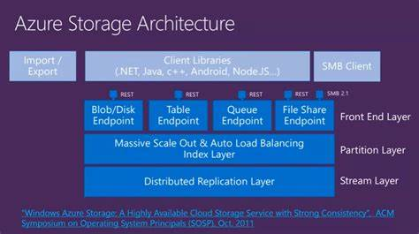

Blob storage limit – 500 TB

-Any number of containers

**SMB – Server Message Block**

The Server Message Block (SMB) Protocol is a network file sharing protocol, and as implemented in Microsoft Windows is known as Microsoft SMB Protocol. The set of message packets that defines a particular version of the protocol is called a dialect. The Common Internet File System (CIFS) Protocol is a dialect of SMB. Both SMB and CIFS are also available on VMS, several versions of Unix, and other operating systems.

**Types of Blob Storage**

Block blob

Page Blob

Append Blob (deprecated)

Save your on-prem disk as page blob.vhdx

File storage – SMB 2.1 AND 3.0

File storage API

**Blob storage structure**

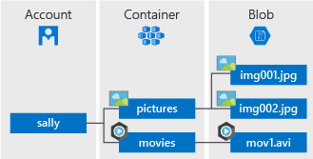

http://<account>.blob.core.windows.net/<container>/<name>

**File Storage**

http://<account>.file.core.windows.net/<share>/<directories>/<files>

**Queue storage**

Stores large number of messages that can be accessed from anywhere using HTTP and HTTPS

Passing messages from Azure web role to Azure worker role

**Table storage**

Key-attribute storage

**Premium Storage**

High performance, Low latency

64 TB of storage per VM

80,000 IOPS per VM

2000 MBPS disk throughput per VM

<https://docs.microsoft.com/en-us/azure/virtual-machines/windows/managed-disks-overview>

<https://docs.microsoft.com/en-us/azure/virtual-machines/windows/disks-types#premium-ssd>

**Data Transfer**

AzCopy – command line to copy to and from Microsoft Azure Blob

Azure import/export service – courier service of data disk

3rd party tools

**Storage Management**

Azure generates **two 512-bit** storage access keys used for authentication

**Shared Access Signature (SAS)**

Provides delegated access to limited resources in your storage account.

Types

-Ad hoc SAS

-SAS with stored access policy

Azure storage explorer

<http://storageexplorer.com>