*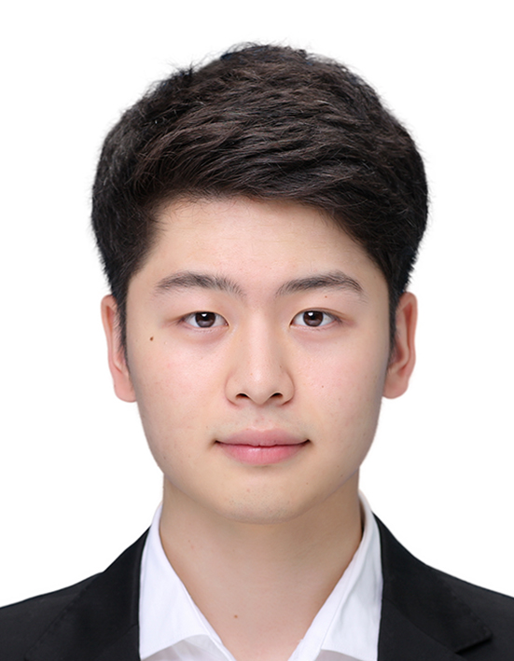***SEUNGJUN LEE**

*Curriculum Vitae*

**PERSONAL DETAILS**

*Birth* November 25, 1993

*E-Mail*  [daekwan6@naver.com](mailto:daekwan6@naver.com)

*Git Address* <https://github.com/sjlee1125>

**EDUCATION**

**Bachelor of Arts in Media 2012 ~ 2019**

*Ajou University in korea*

I graduated from Ajou University in Republic of Korea. And I majored in Media, especially Computer Science. I had worked on several project about Mobile, Blockchain, Web, Design

**SKILLS**

*Languages* Korean

English

*Programming* C, JAVA, Android, JSP, HTML, CSS, Javascript, PHP, Hyperledger Fabric, Docker, NodeJS, Go, AWS, GCP, MySQL, Git, Python, C++

*Design Ilustrator, Photoshop*

**CLASSES**

*Spring 2012* – Basic Design

*Spring 2015* – Computer Program Design

Computer Programming

*Fall 2015* – Game Programming

Social Media Programming

Object-oriented Programming

Graphic Design

*Spring 2016* – Mobile Programming

Web App Programming

Data Structures

*Fall 2016* – Operating System

Social App Project

*Spring 2018* – Computer Network

Computer Structure

Database

Algorithm

Media Project

**PROJECTS**

Android Game – My app development team made an app that children play. The app is game of learning letters. It helps children write and read letters on tablet pc

Android App – We made an app that informs tourist attractions in korea. The app informs users of the tourist attractions and check where they have been using the gps

HTML & PHP – I’m making webpage that manages academic things like student, subject… using html and php. It helps users check their student and register courses and manage grade