­­­­­­­­­­­­­­­­­­­­

Successfully create the entity relationship model (ERD) for the product table

This is a 1 to 1 relationship

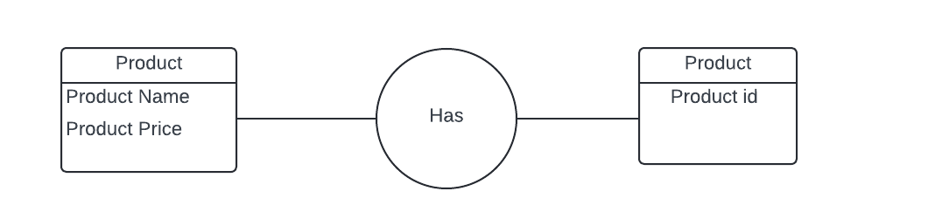­­­

Successfully create an entity relationship model for the customer table

This is a 1 to 1 relationship

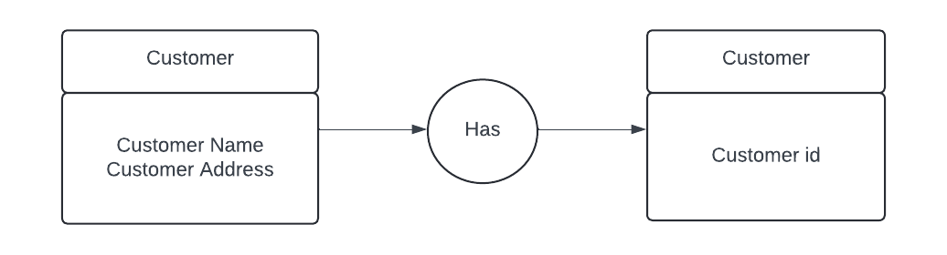

Successfully create the Entity Relationship Model (ERD) for the order table

This is a 1 to many relatonship

