**ViT 멘토링 실습**

국민대학교 BIT대학원 DELab. 석사과정 이승건

**dataset**: fashion_mnist(HuggingFace, 28x28 grayscale image)

6만개의 dataset, 10개의 class label



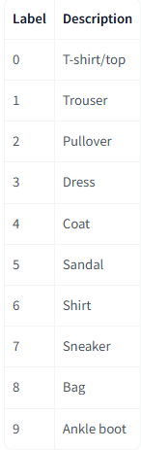

**Model = deit_tiny_patch16_224**



**Parameter**

* Train size = 80%
* Test size = 20%
* Batch size = 32

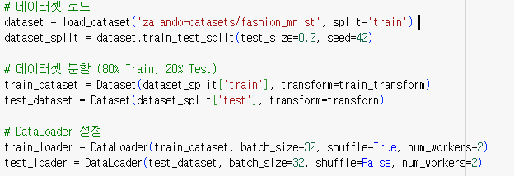

* Optimizer = Adam
* Learning rate = 1e-4
* Loss = Cross Entropy Loss



* Epoch = 3





**Epoch별 Loss, Accuracy**

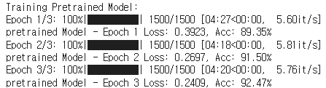

* 최종 Loss: 0.2409, Accuracy: 92.47%

**Attention Map**

* INTER_NEAREST

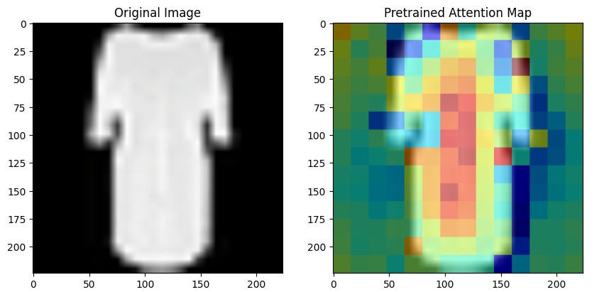

* INTER_CUBIC

