Fuel Efficiency vs. Horsepower

Sanghoon Lee

3/25/2020

### Introduction

We study the relationship between fuel efficiency and horsepower.

### Data

We use the mtcars data set that comes with R.

head(mtcars)

### Analysis

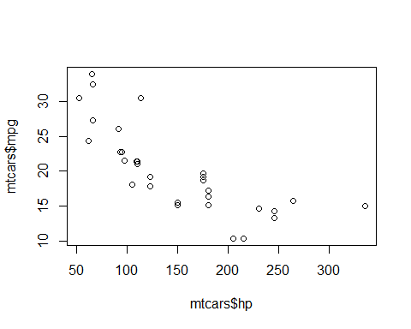

### Conclusion

**The plot shows that *higher* horsepower cars tend to have *poorer* fuel efficiency.**