Vancouver Housing Market Analysis

Sanghoon Lee

3/29/2020

library(tidyverse)

## -- Attaching packages ----------------------------------------------------- tidyverse 1.3.0 --

## v ggplot2 3.3.0 v purrr 0.3.3  
## v tibble 2.1.3 v dplyr 0.8.5  
## v tidyr 1.0.2 v stringr 1.4.0  
## v readr 1.3.1 v forcats 0.5.0

## -- Conflicts -------------------------------------------------------- tidyverse_conflicts() --  
## x dplyr::filter() masks stats::filter()  
## x dplyr::lag() masks stats::lag()

library(lubridate)

##   
## Attaching package: 'lubridate'

## The following object is masked from 'package:base':  
##   
## date

library(scales)

##   
## Attaching package: 'scales'

## The following object is masked from 'package:purrr':  
##   
## discard

## The following object is masked from 'package:readr':  
##   
## col_factor

# Introduction

We study price trends in Vancouver housing market.

# Data

We use BC Assessment housing transaction data. The data is available for January 2000 to August 8 2018. We have 867,216 observations.

bca <- read_rds("Data/bca_sm.rds")  
bca$sale_date %>% summary()

## Min. 1st Qu. Median Mean 3rd Qu. Max.   
## "2000-01-01" "2004-06-29" "2008-04-10" "2008-12-24" "2013-11-12" "2018-08-08"

bca %>% count()

## # A tibble: 1 x 1  
## n  
## <int>  
## 1 867216

# Analysis

The following graph shows how average transaction price has changed over time.

tb <- bca %>%   
 group_by(sale_year=year(sale_date), act_use_cat) %>%   
 summarise(avg_p = mean(price))

ggplot(tb, aes(sale_year, avg_p, color=act_use_cat)) +   
 geom_text(aes(label=comma(avg_p, accuracy=1, scale=0.001)), color="grey", vjust=0) +   
 geom_line() + geom_point() +   
 scale_y_continuous("Average transaction price ($1,000)",   
 breaks=c(500000, 1000000, 1500000),  
 labels=comma_format(accuracy=1, scale=0.001)) +   
 scale_x_continuous(NULL)+  
 scale_color_discrete(NULL, breaks=c("S/F Res", "Strata Res"), labels=c("Single Family Detached", "Condo, Townhouse"))+  
 theme_bw() + theme(legend.position = c(0.25,0.8))

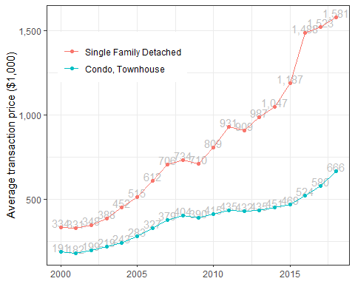

The graph shows that average price has increased about 450 % for Single Family houses and 350 % for condos and townhouses.